PAGE 1 — WINDOWS SERVER AND WINDOWS 7 INSTALLATION
Topic: Windows Server and Windows 7 Installation
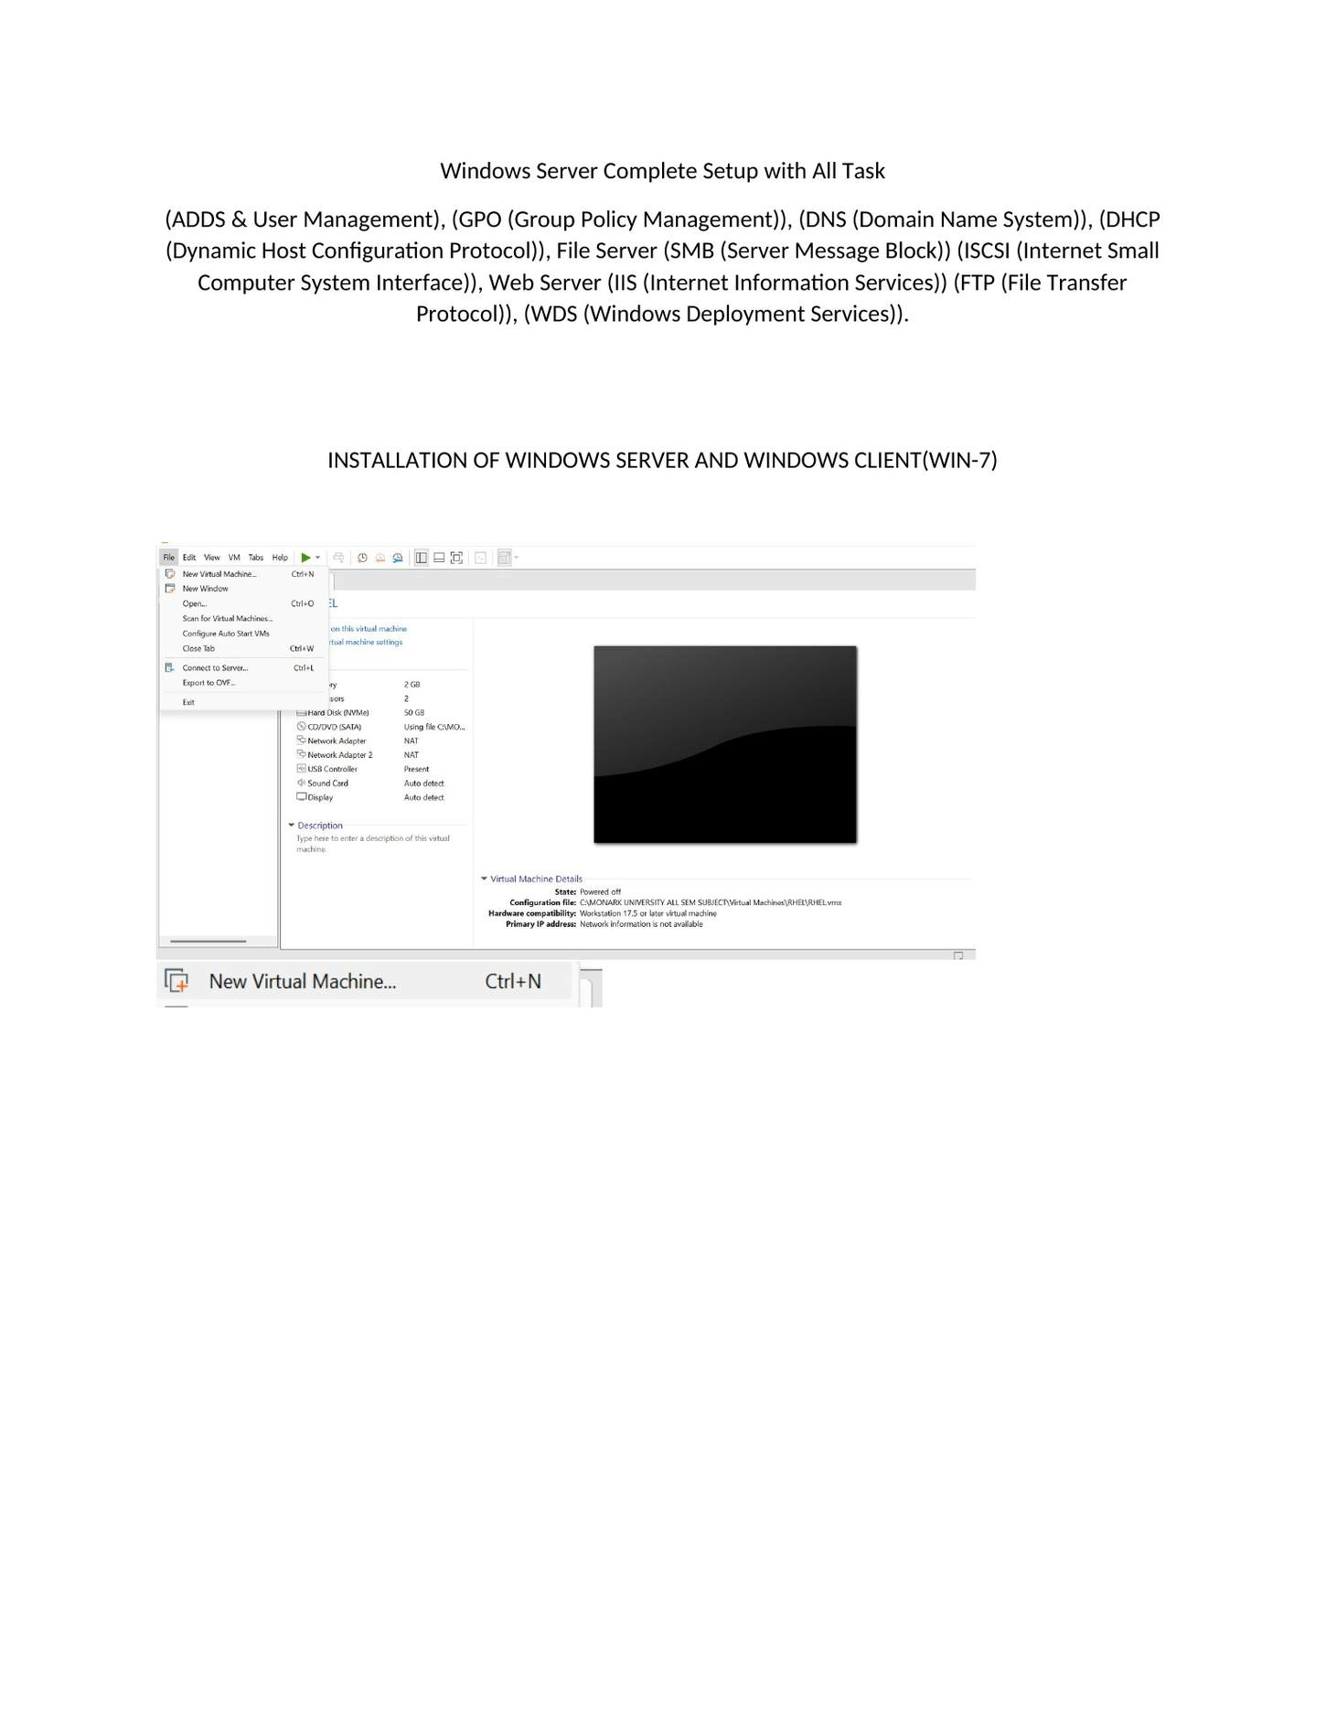
What I did: This page shows the complete Windows Server practical task list covering ADDS, GPO, DNS, DHCP, SMB, iSCSI, IIS/FTP and WDS.

PAGE 2 — WINDOWS SERVER AND WINDOWS 7 INSTALLATION
Topic: Windows Server and Windows 7 Installation
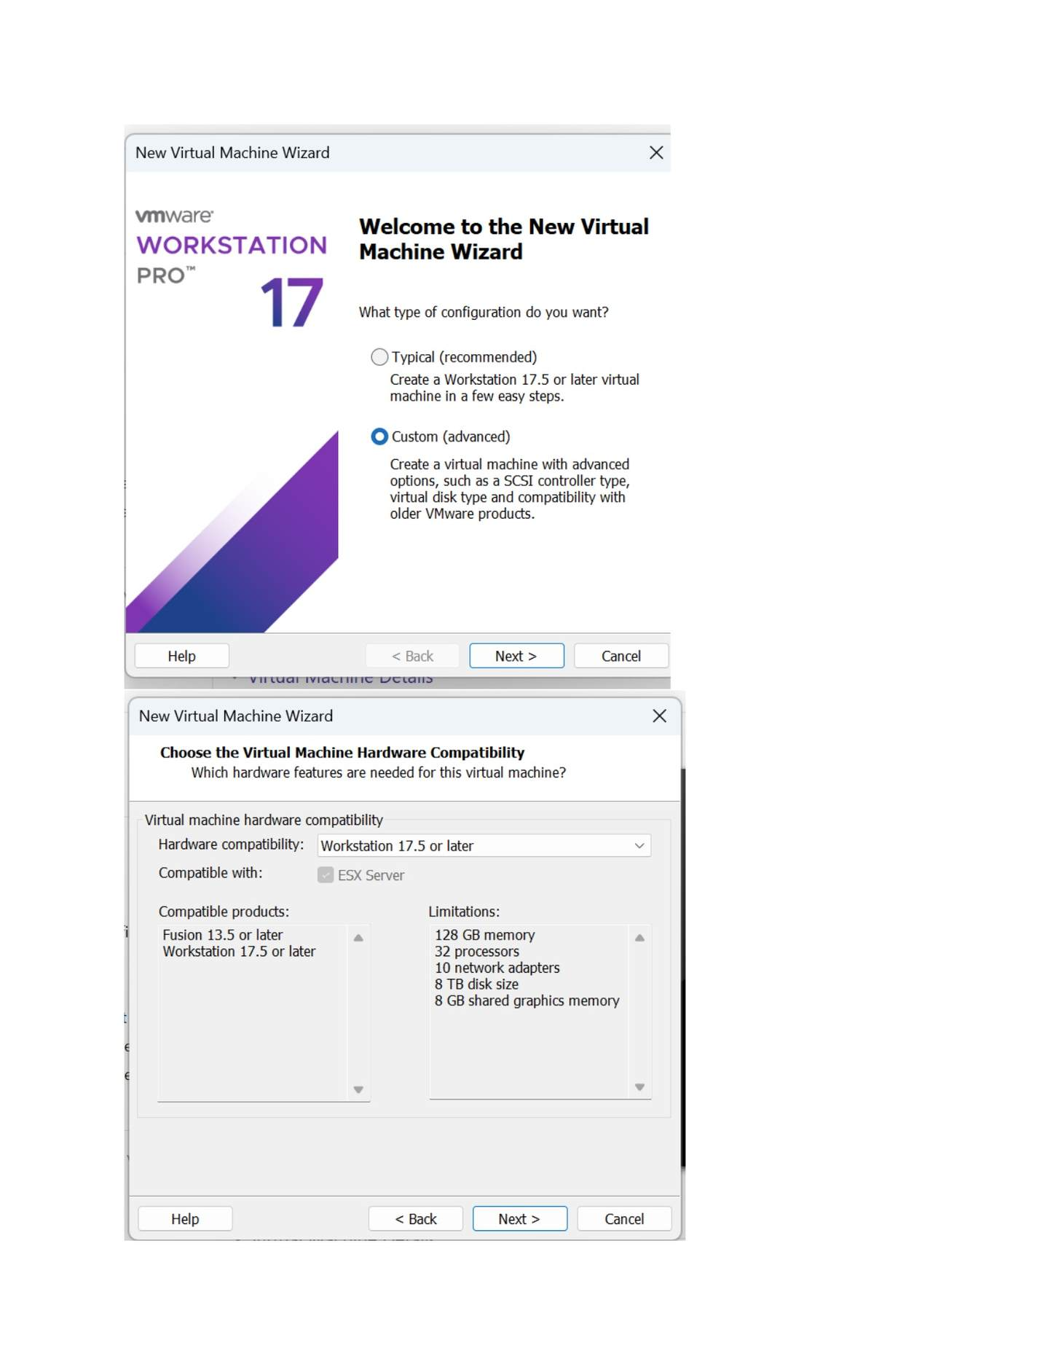
What I did: Opened VMware's New Virtual Machine Wizard and selected the recommended Typical setup option.

PAGE 3 — WINDOWS SERVER AND WINDOWS 7 INSTALLATION
Topic: Windows Server and Windows 7 Installation
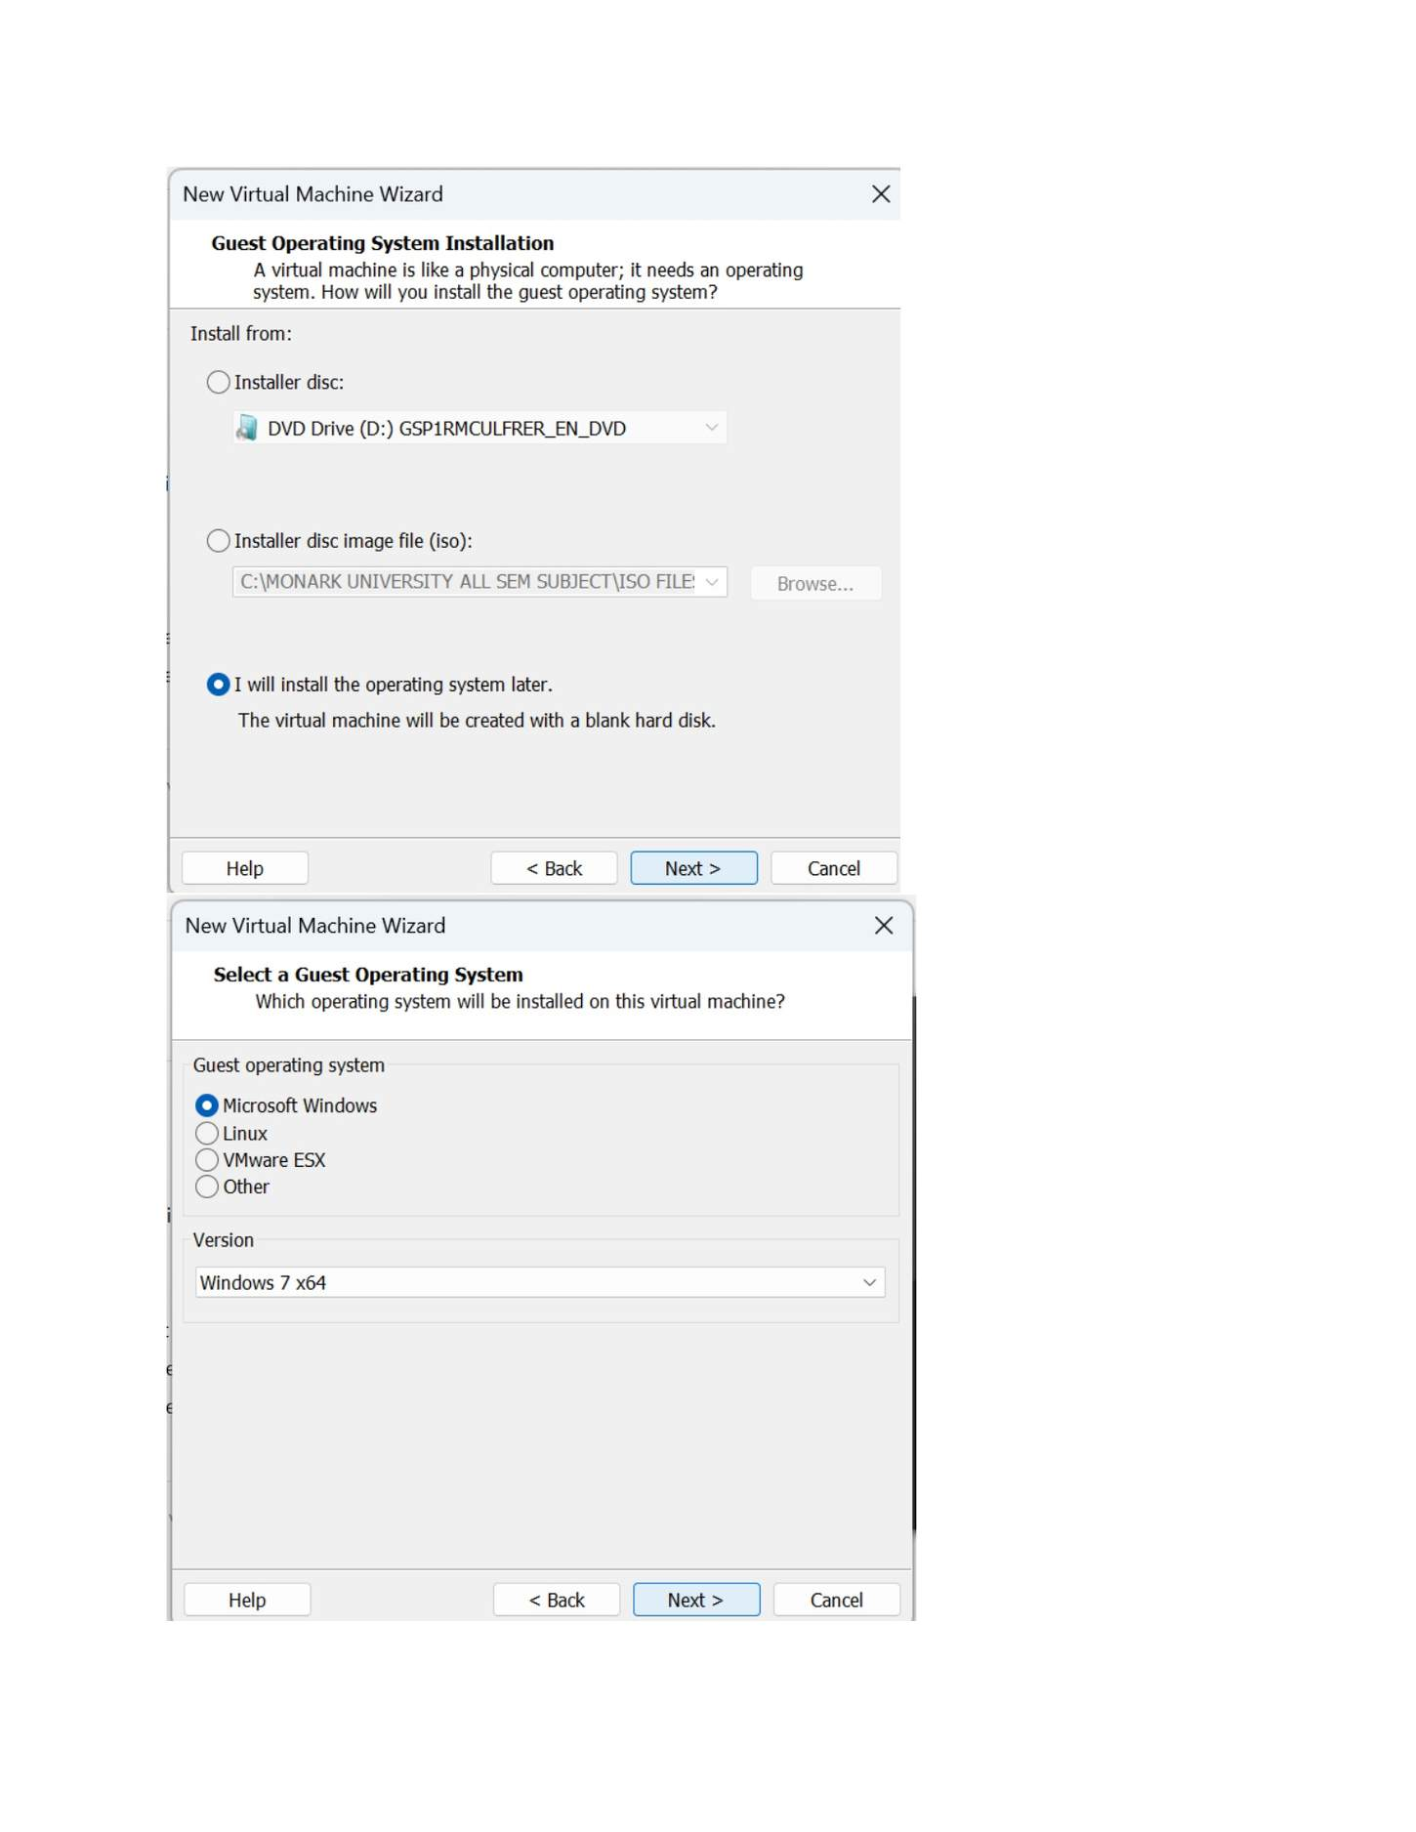
What I did: Selected the installation method for the Windows 7 guest operating system and pointed the wizard to the installation media.

PAGE 4 — WINDOWS SERVER AND WINDOWS 7 INSTALLATION
Topic: Windows Server and Windows 7 Installation
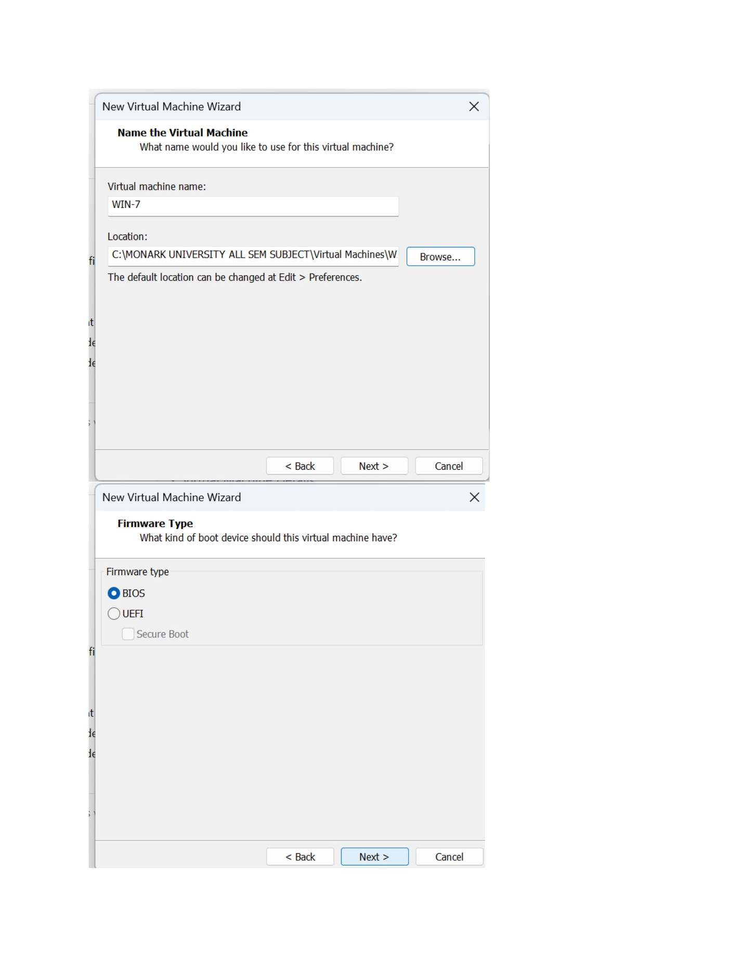
What I did: Entered the Windows 7 virtual-machine name and selected the folder where the VM would be stored.

PAGE 5 — WINDOWS SERVER AND WINDOWS 7 INSTALLATION
Topic: Windows Server and Windows 7 Installation
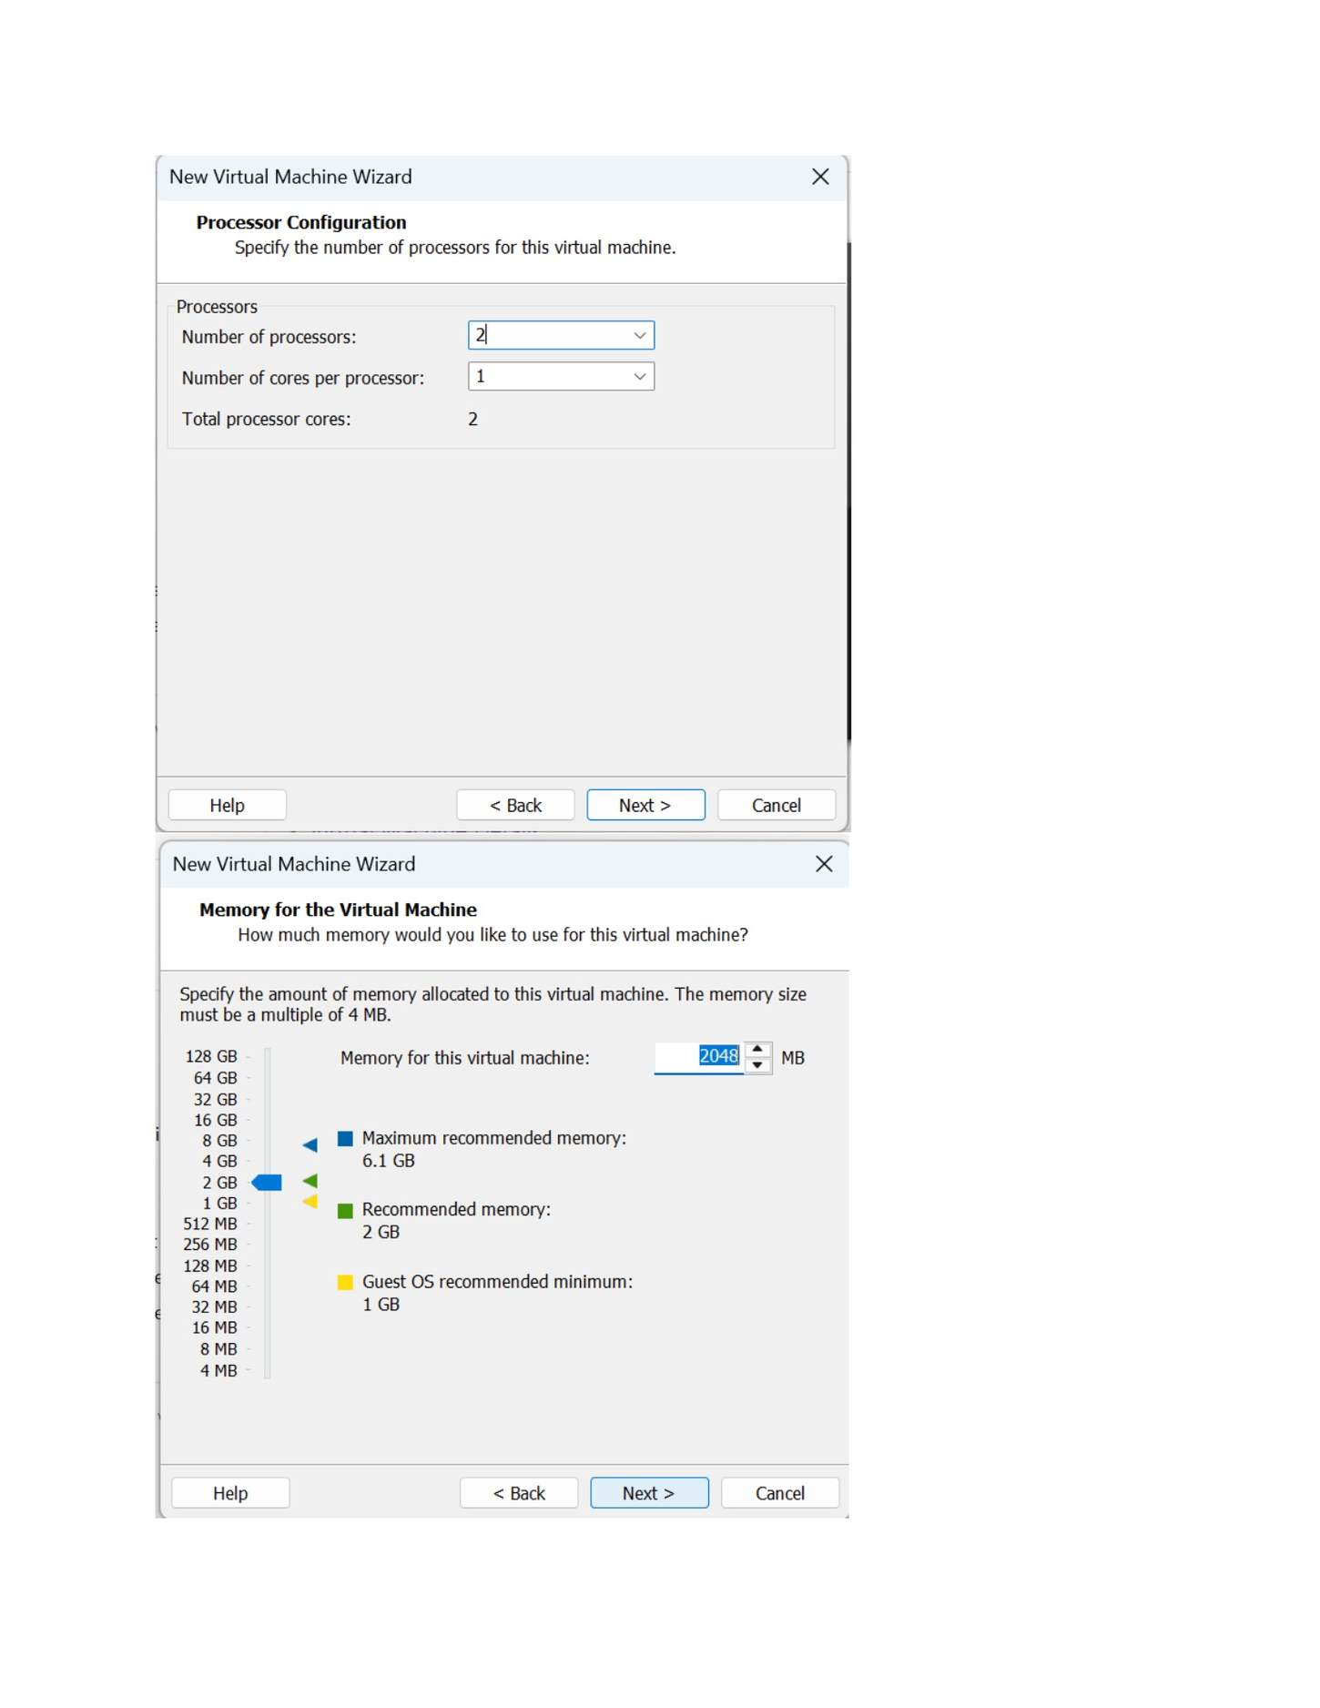
What I did: Configured the processor allocation for the Windows 7 virtual machine.

PAGE 6 — WINDOWS SERVER AND WINDOWS 7 INSTALLATION
Topic: Windows Server and Windows 7 Installation
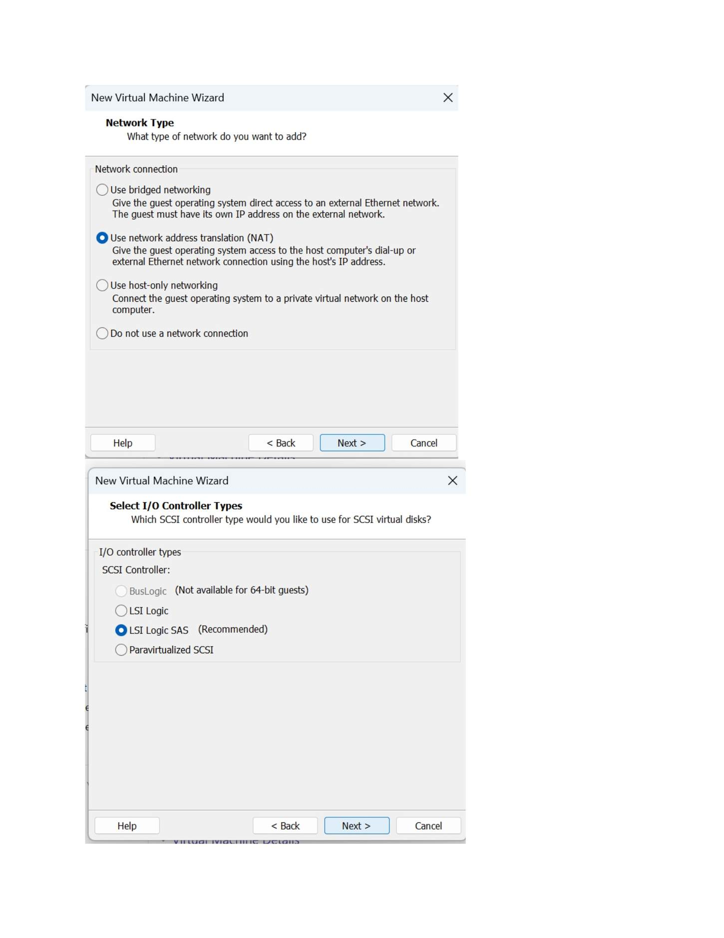
What I did: Selected the virtual network connection type for the Windows 7 VM.

PAGE 7 — WINDOWS SERVER AND WINDOWS 7 INSTALLATION
Topic: Windows Server and Windows 7 Installation
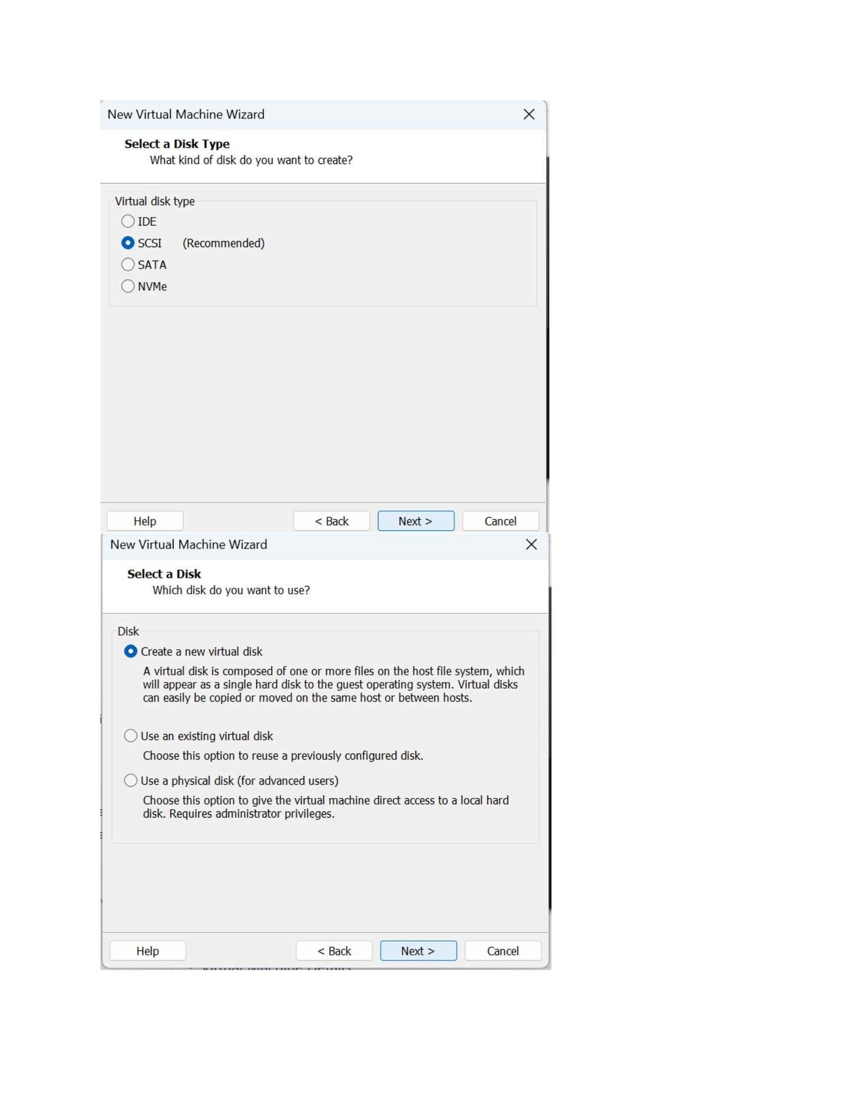
What I did: Selected SCSI as the virtual disk controller/type for the new disk.

PAGE 8 — WINDOWS SERVER AND WINDOWS 7 INSTALLATION
Topic: Windows Server and Windows 7 Installation
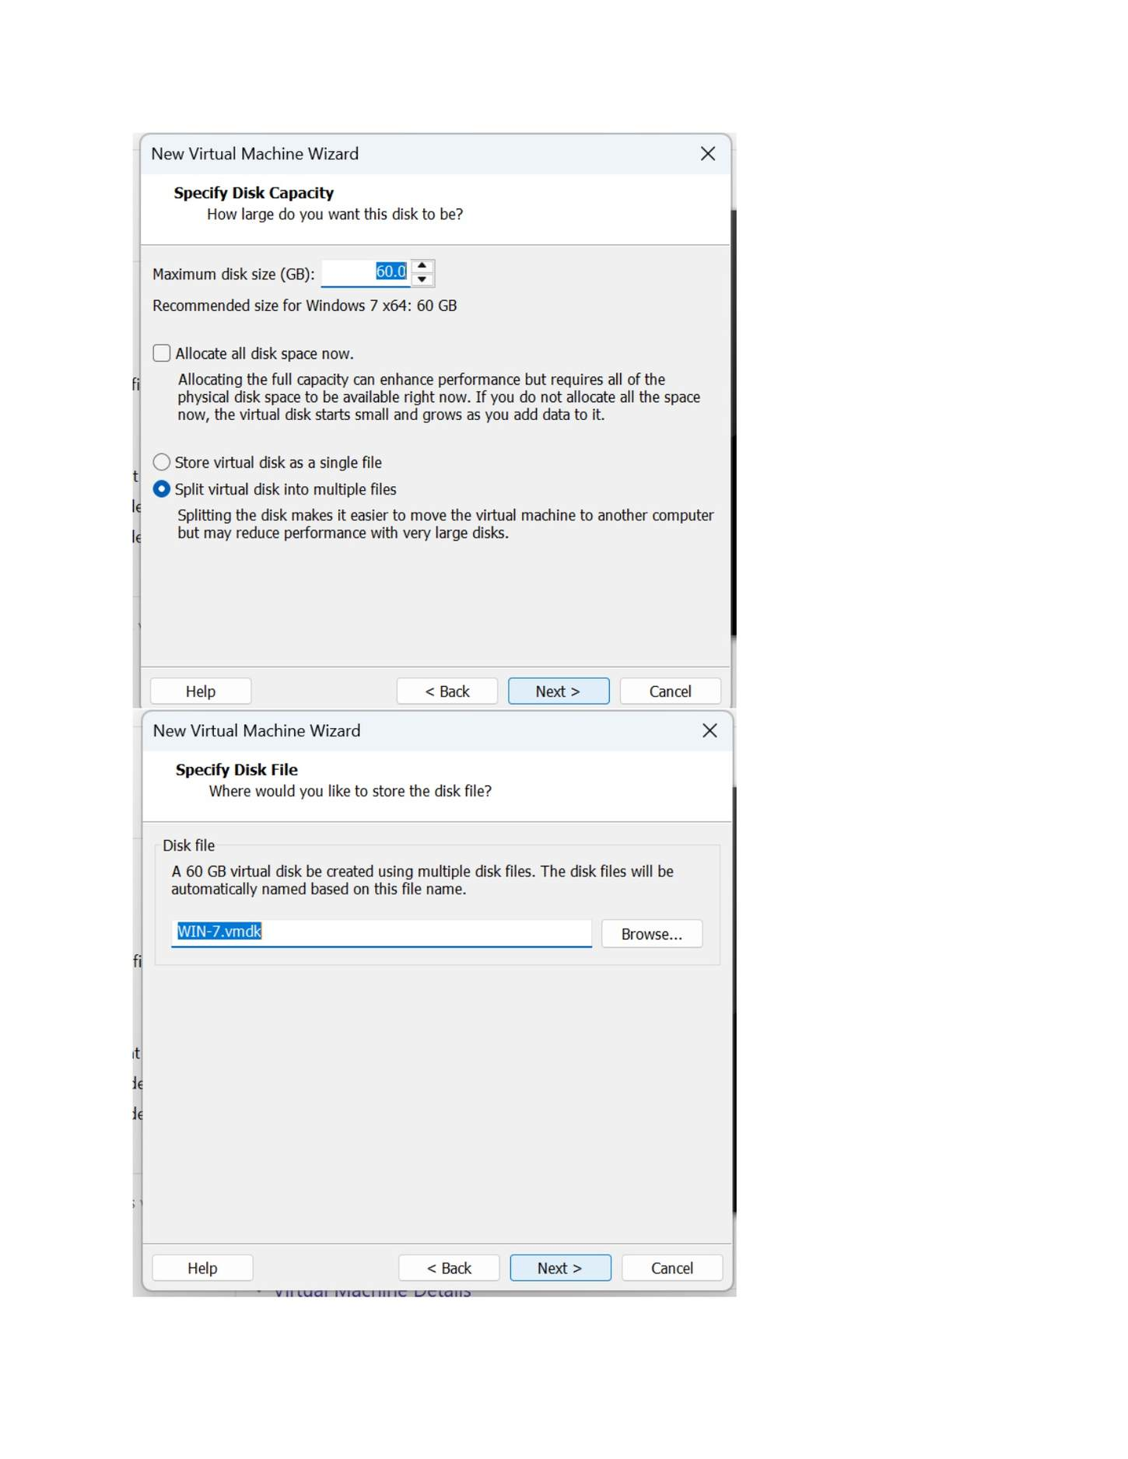
What I did: Selected the option to create a new virtual disk.

PAGE 9 — WINDOWS SERVER AND WINDOWS 7 INSTALLATION
Topic: Windows Server and Windows 7 Installation
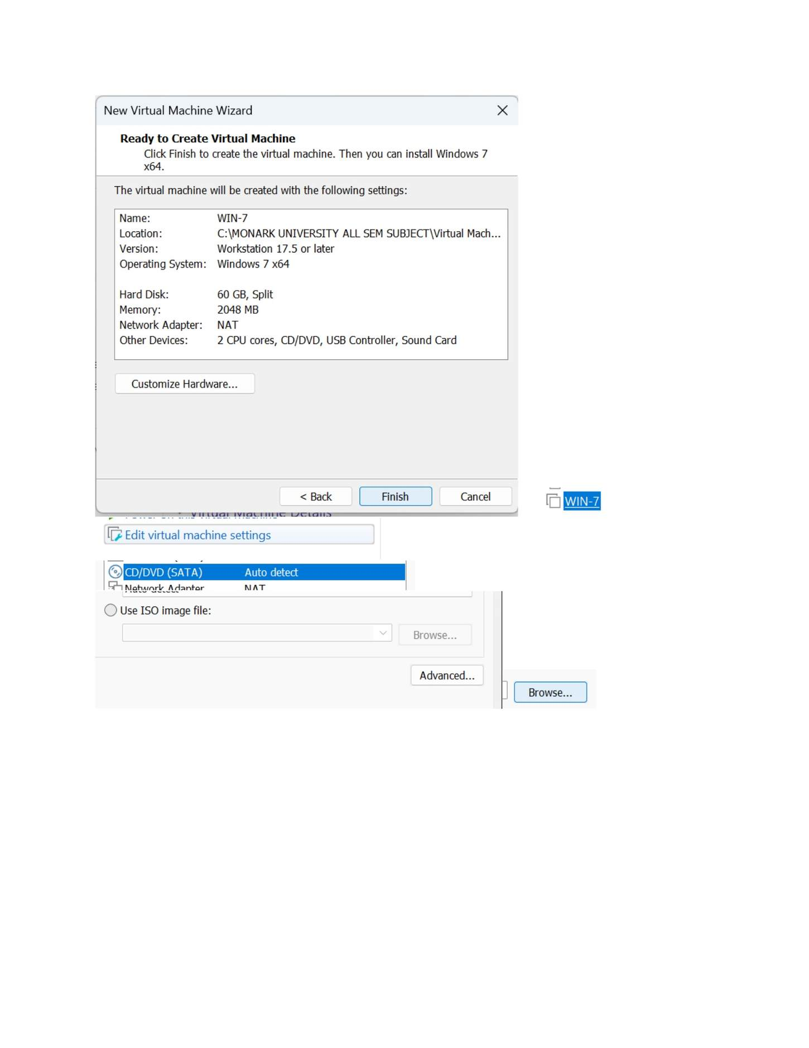
What I did: Specified the virtual disk capacity for the Windows 7 VM.

PAGE 10 — WINDOWS SERVER AND WINDOWS 7 INSTALLATION
Topic: Windows Server and Windows 7 Installation
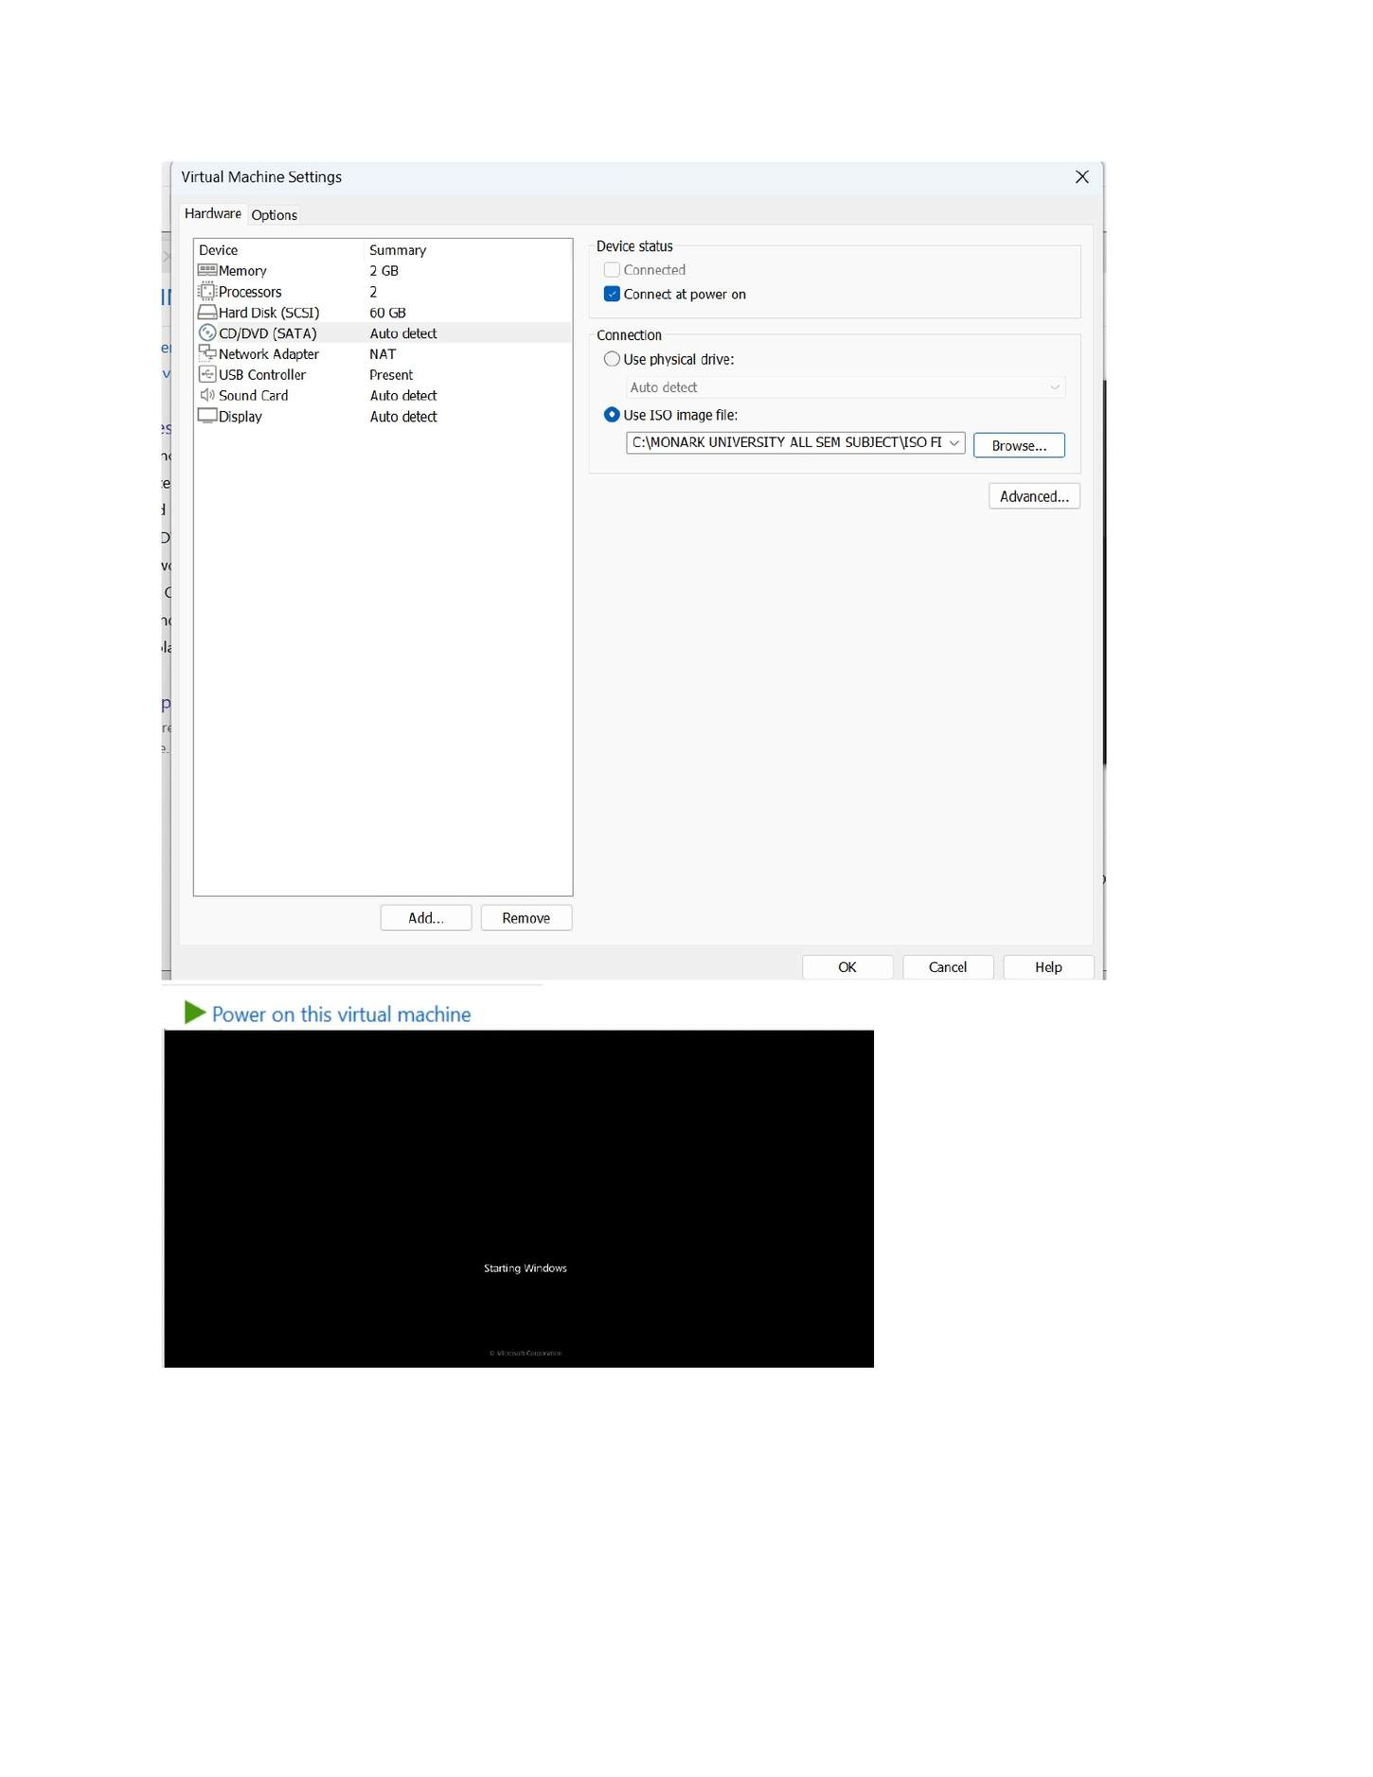
What I did: Reviewed the final Windows 7 VM settings before clicking Finish to create it.

PAGE 11 — WINDOWS SERVER AND WINDOWS 7 INSTALLATION
Topic: Windows Server and Windows 7 Installation
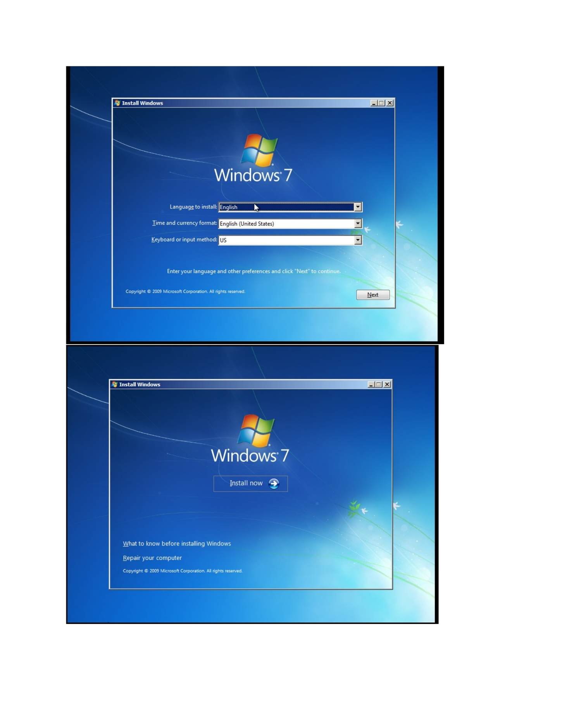
What I did: Started Windows 7 setup and selected the required language/time/keyboard settings.

PAGE 12 — WINDOWS SERVER AND WINDOWS 7 INSTALLATION
Topic: Windows Server and Windows 7 Installation
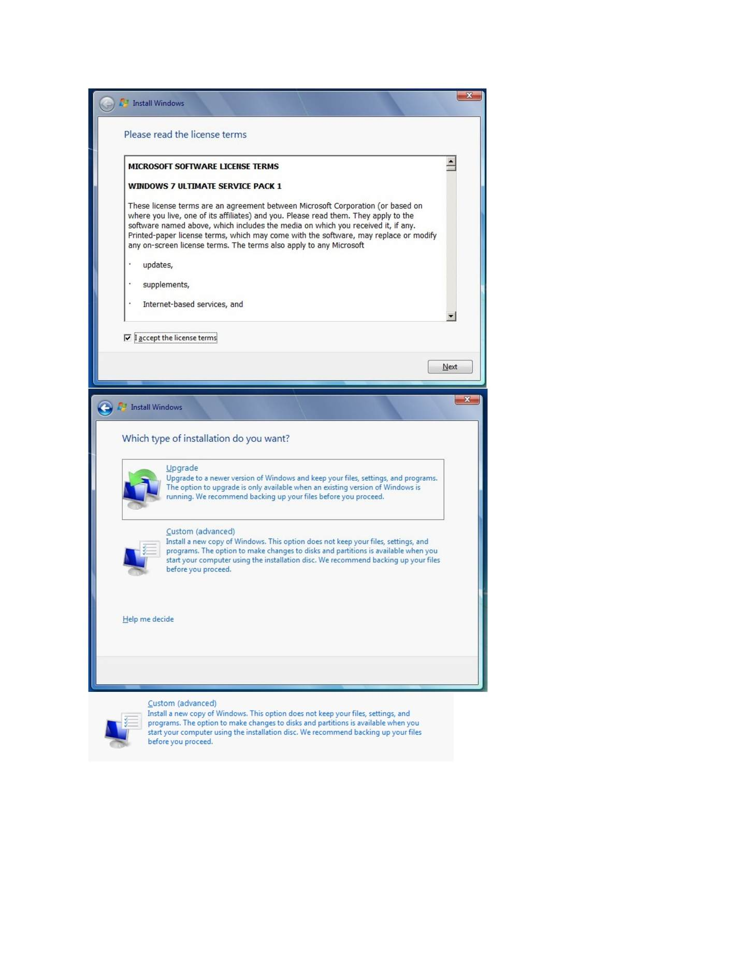
What I did: Accepted the Windows license terms to continue installation.

PAGE 13 — WINDOWS SERVER AND WINDOWS 7 INSTALLATION
Topic: Windows Server and Windows 7 Installation
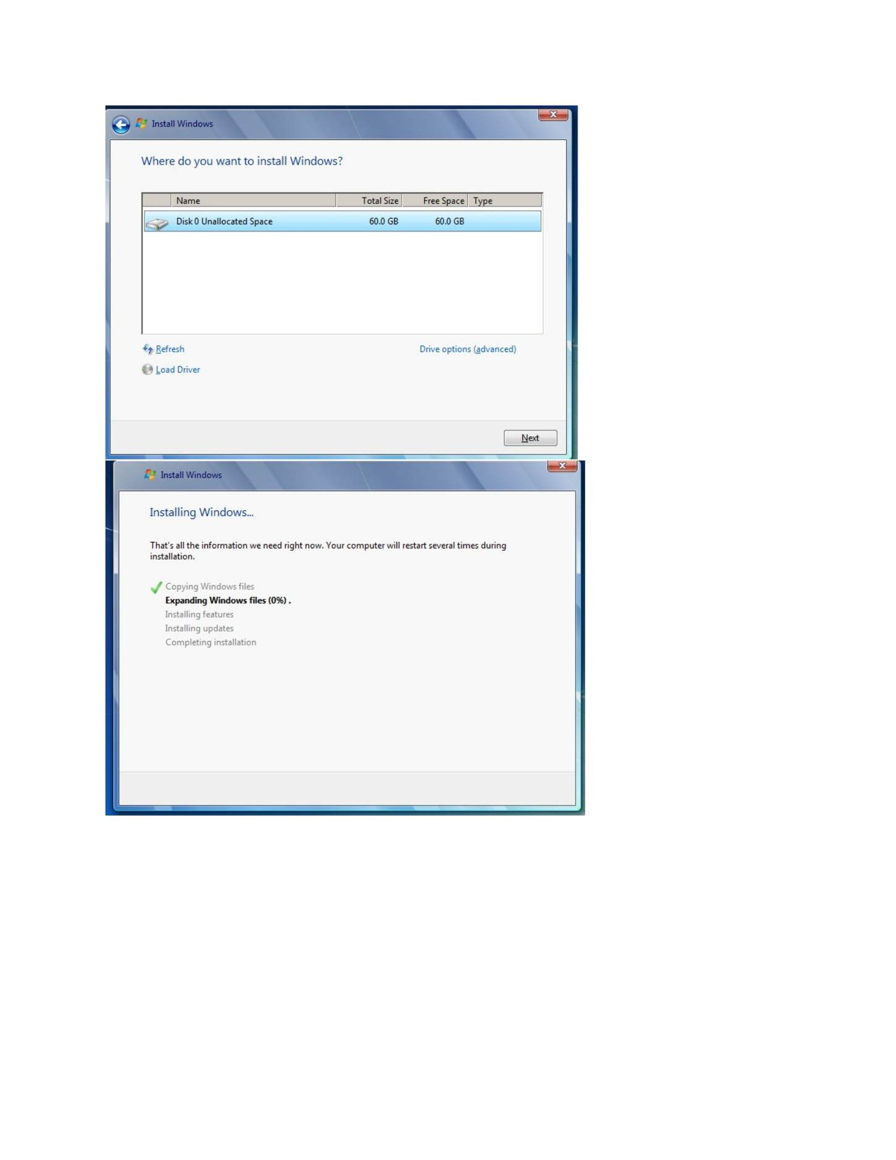
What I did: Selected the target disk/partition for installing Windows 7.

PAGE 14 — WINDOWS SERVER AND WINDOWS 7 INSTALLATION
Topic: Windows Server and Windows 7 Installation
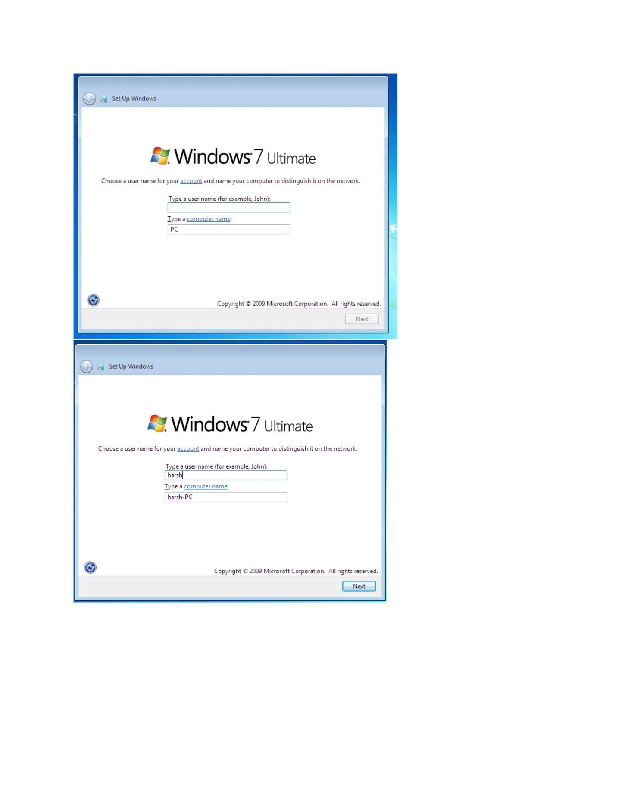
What I did: Continued the Windows 7 installation while Windows copied and installed the required files.

PAGE 15 — WINDOWS SERVER AND WINDOWS 7 INSTALLATION
Topic: Windows Server and Windows 7 Installation
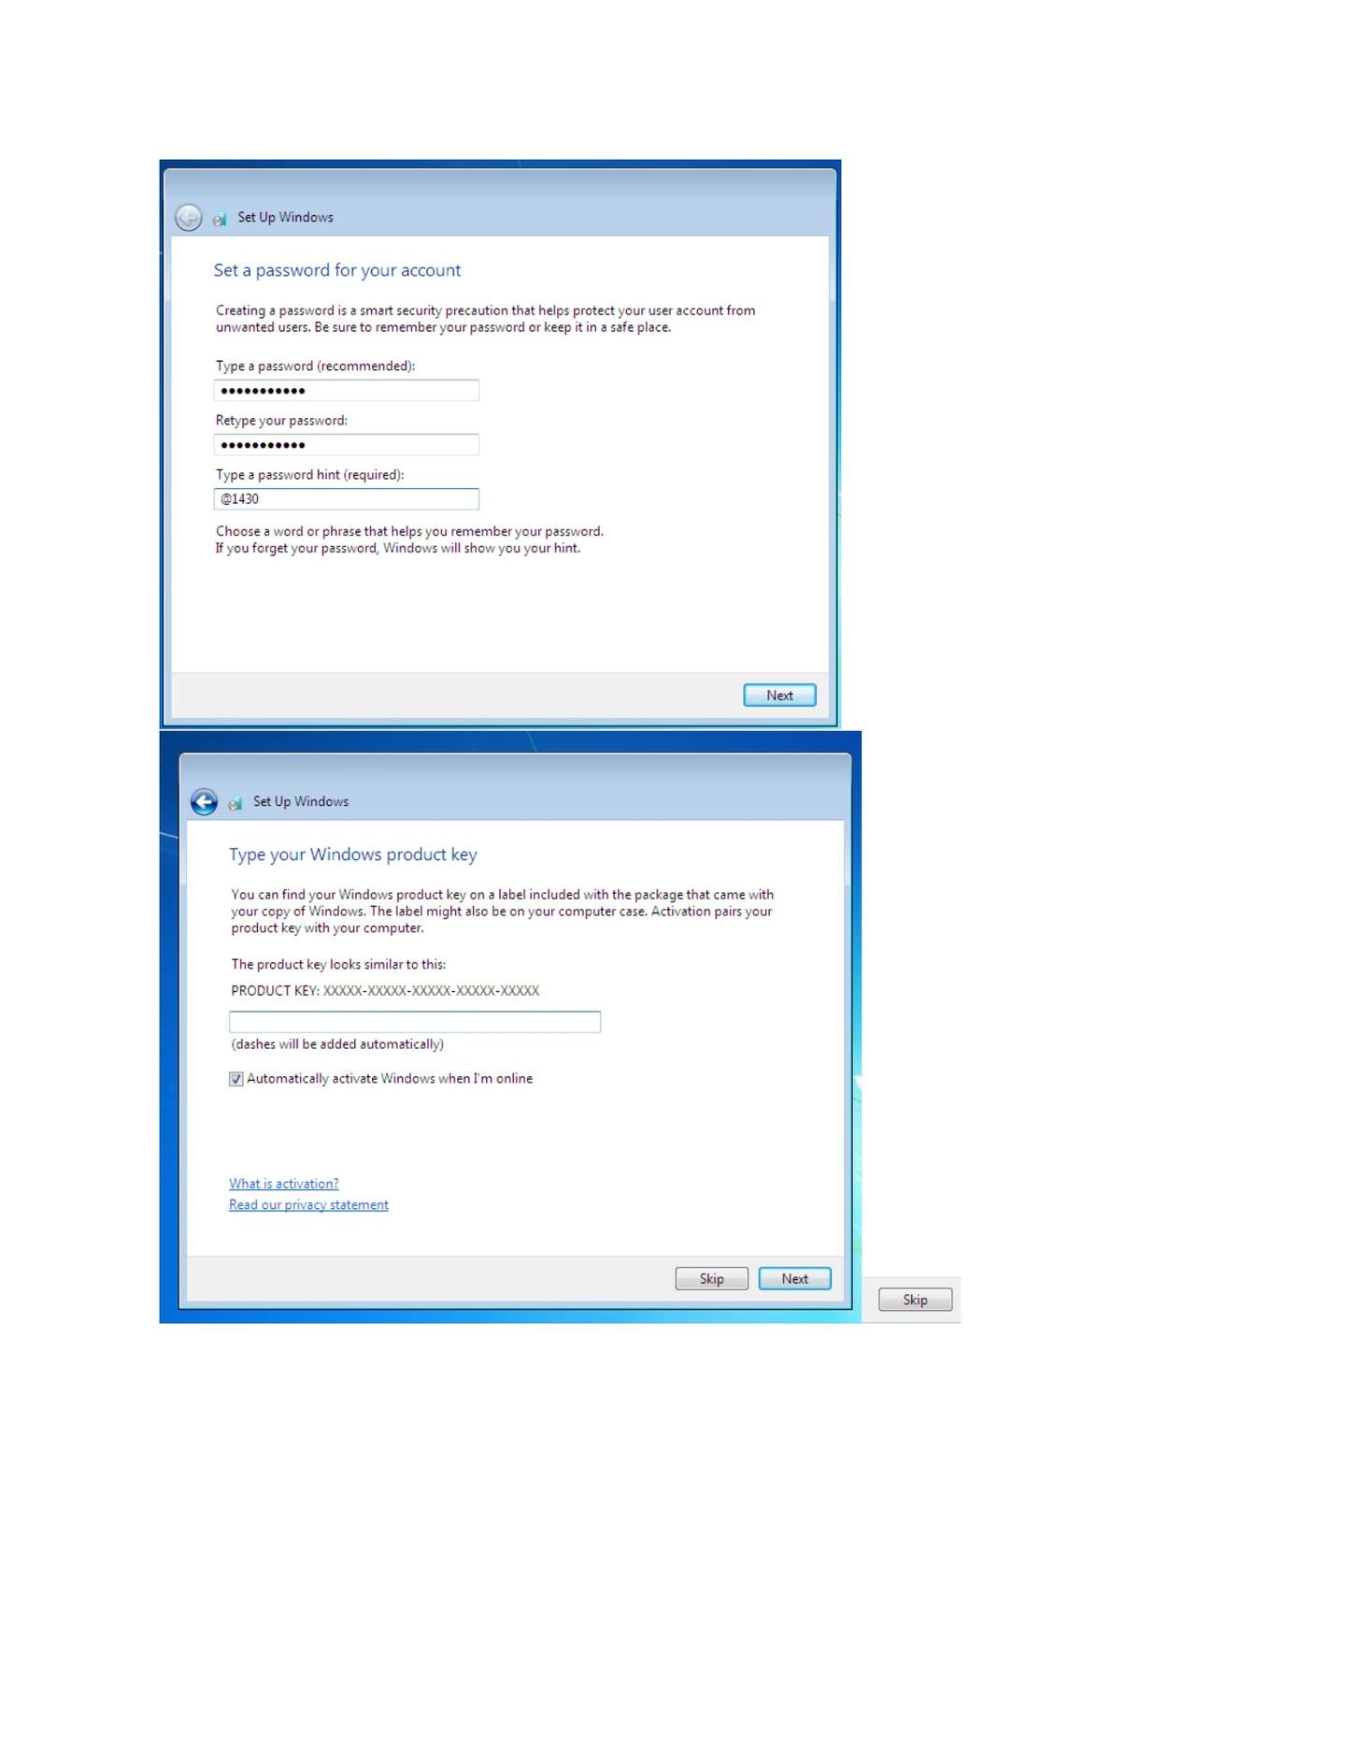
What I did: Entered the Windows 7 product-key/account information shown during setup.

PAGE 16 — WINDOWS SERVER AND WINDOWS 7 INSTALLATION
Topic: Windows Server and Windows 7 Installation
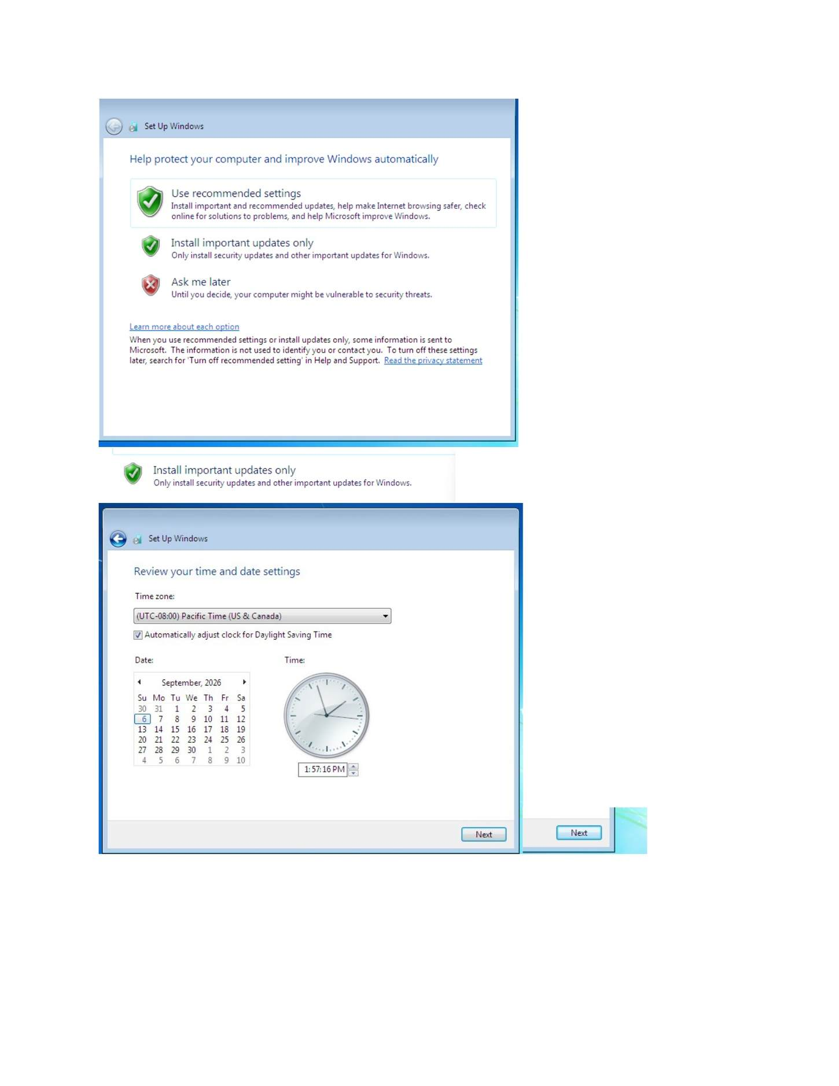
What I did: Configured the Windows 7 initial security/update settings.

PAGE 17 — WINDOWS SERVER AND WINDOWS 7 INSTALLATION
Topic: Windows Server and Windows 7 Installation
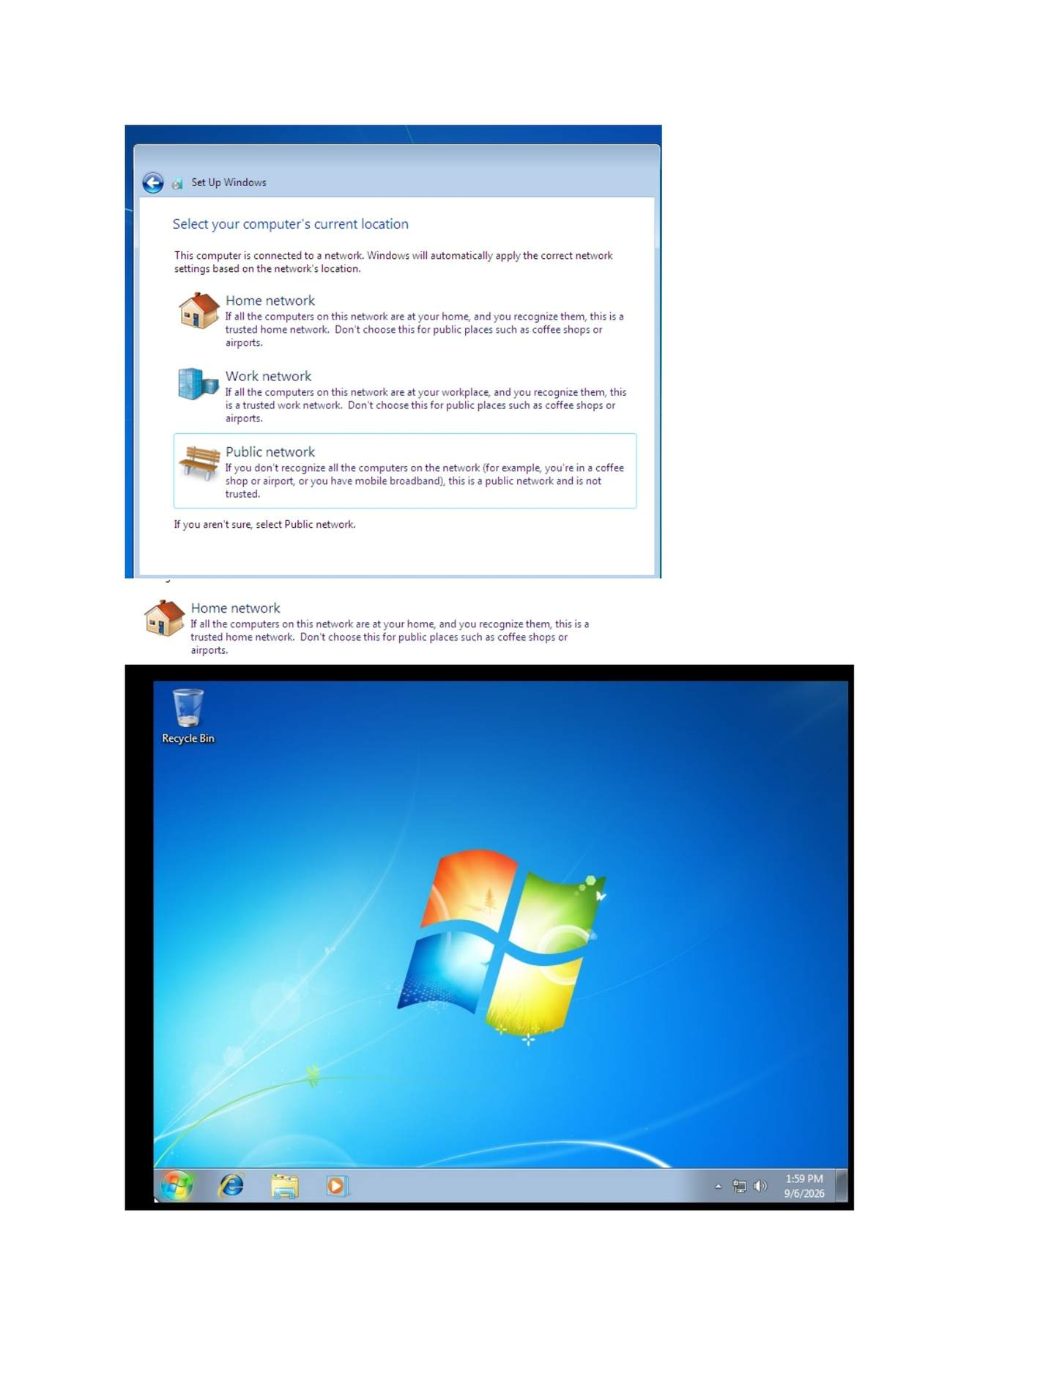
What I did: Completed the Windows 7 setup and reached the configured system.

PAGE 18 — WINDOWS SERVER AND WINDOWS 7 INSTALLATION
Topic: Windows Server and Windows 7 Installation
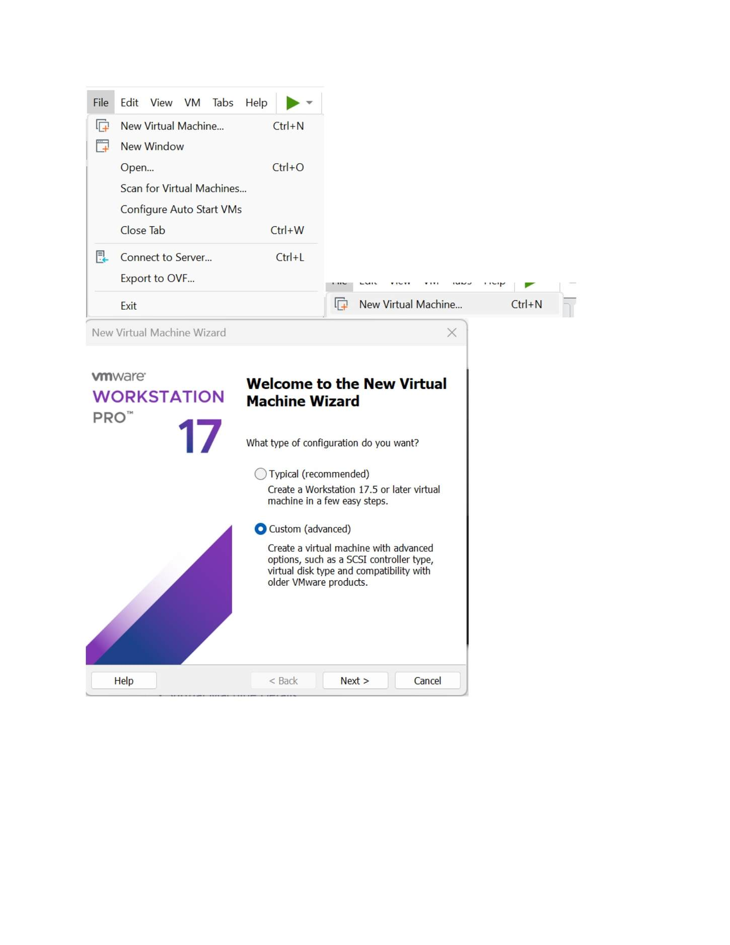
What I did: Opened VMware Workstation and started the New Virtual Machine Wizard for the Windows Server VM.

PAGE 19 — WINDOWS SERVER AND WINDOWS 7 INSTALLATION
Topic: Windows Server and Windows 7 Installation
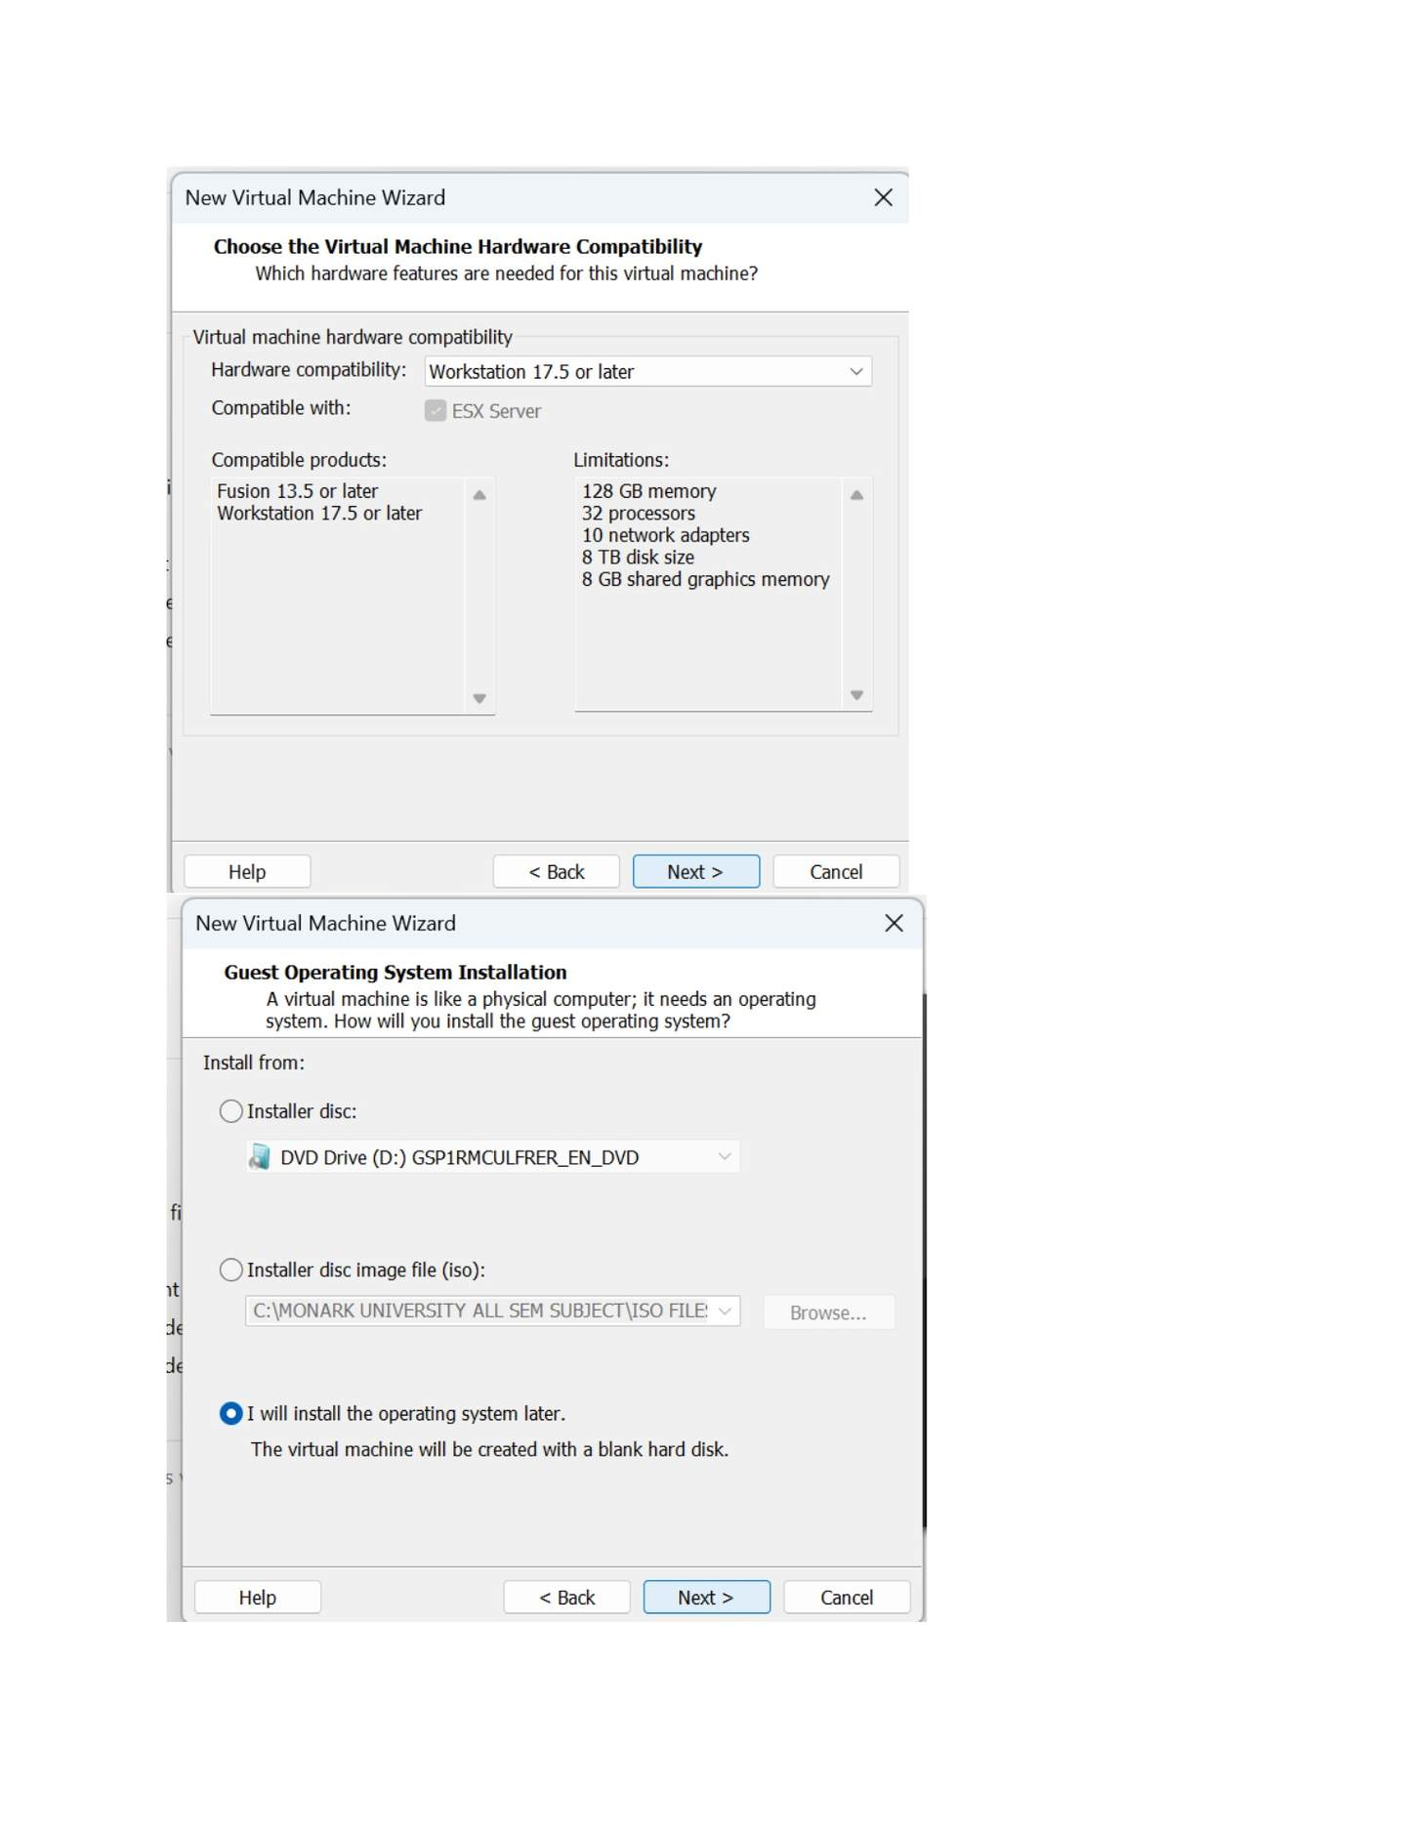
What I did: Selected the virtual hardware compatibility level for the server VM.

PAGE 20 — WINDOWS SERVER AND WINDOWS 7 INSTALLATION
Topic: Windows Server and Windows 7 Installation
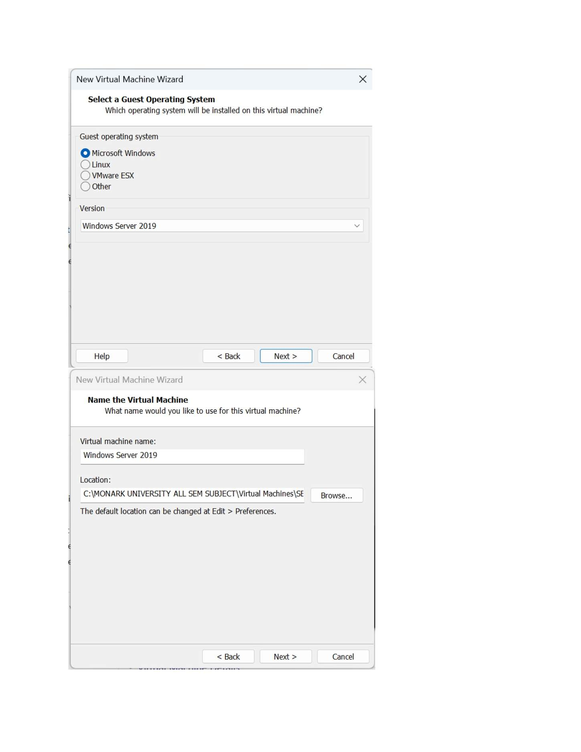
What I did: Selected Windows Server 2019 as the guest operating system.

PAGE 21 — WINDOWS SERVER AND WINDOWS 7 INSTALLATION
Topic: Windows Server and Windows 7 Installation
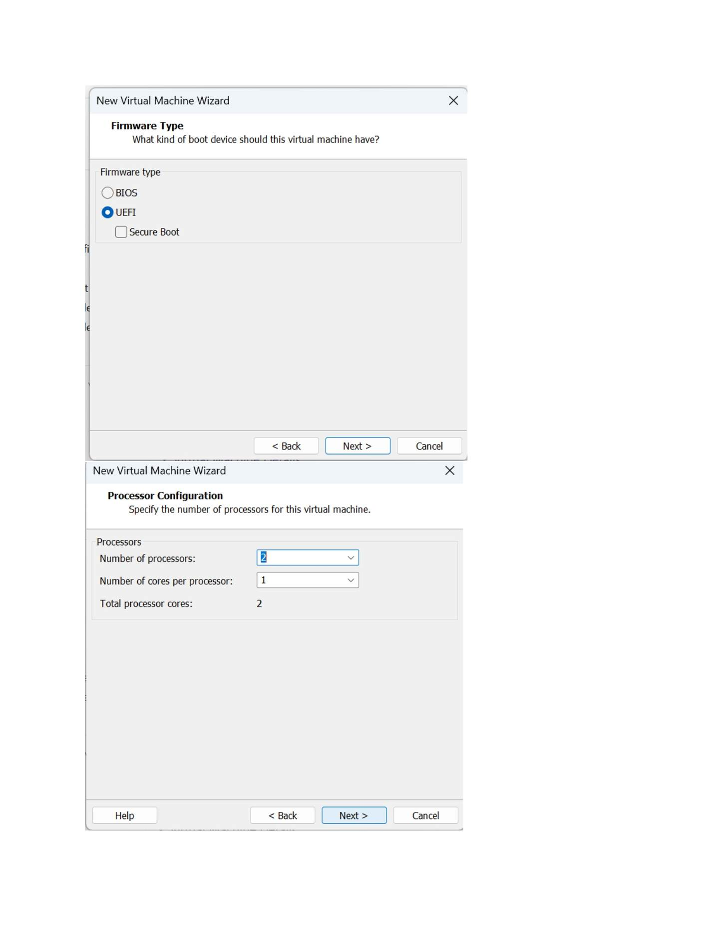
What I did: Selected the firmware/boot mode for the server virtual machine.

PAGE 22 — WINDOWS SERVER AND WINDOWS 7 INSTALLATION
Topic: Windows Server and Windows 7 Installation
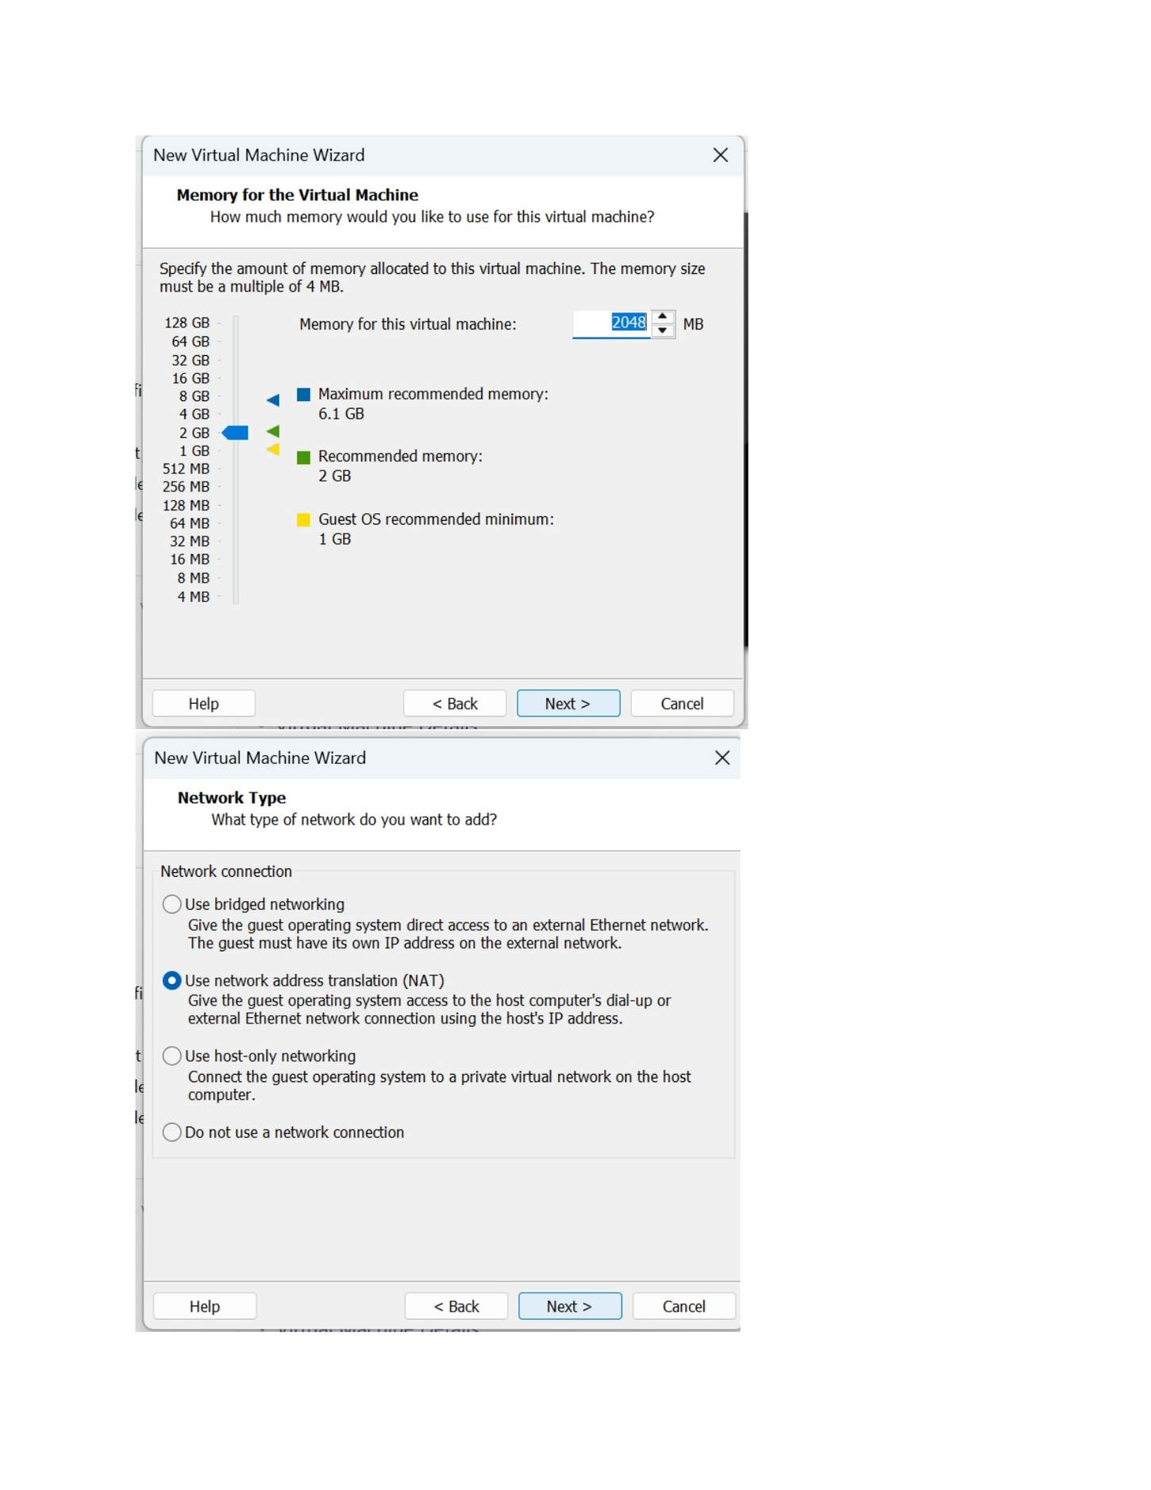
What I did: Configured the memory assigned to the Windows Server VM.

PAGE 23 — WINDOWS SERVER AND WINDOWS 7 INSTALLATION
Topic: Windows Server and Windows 7 Installation
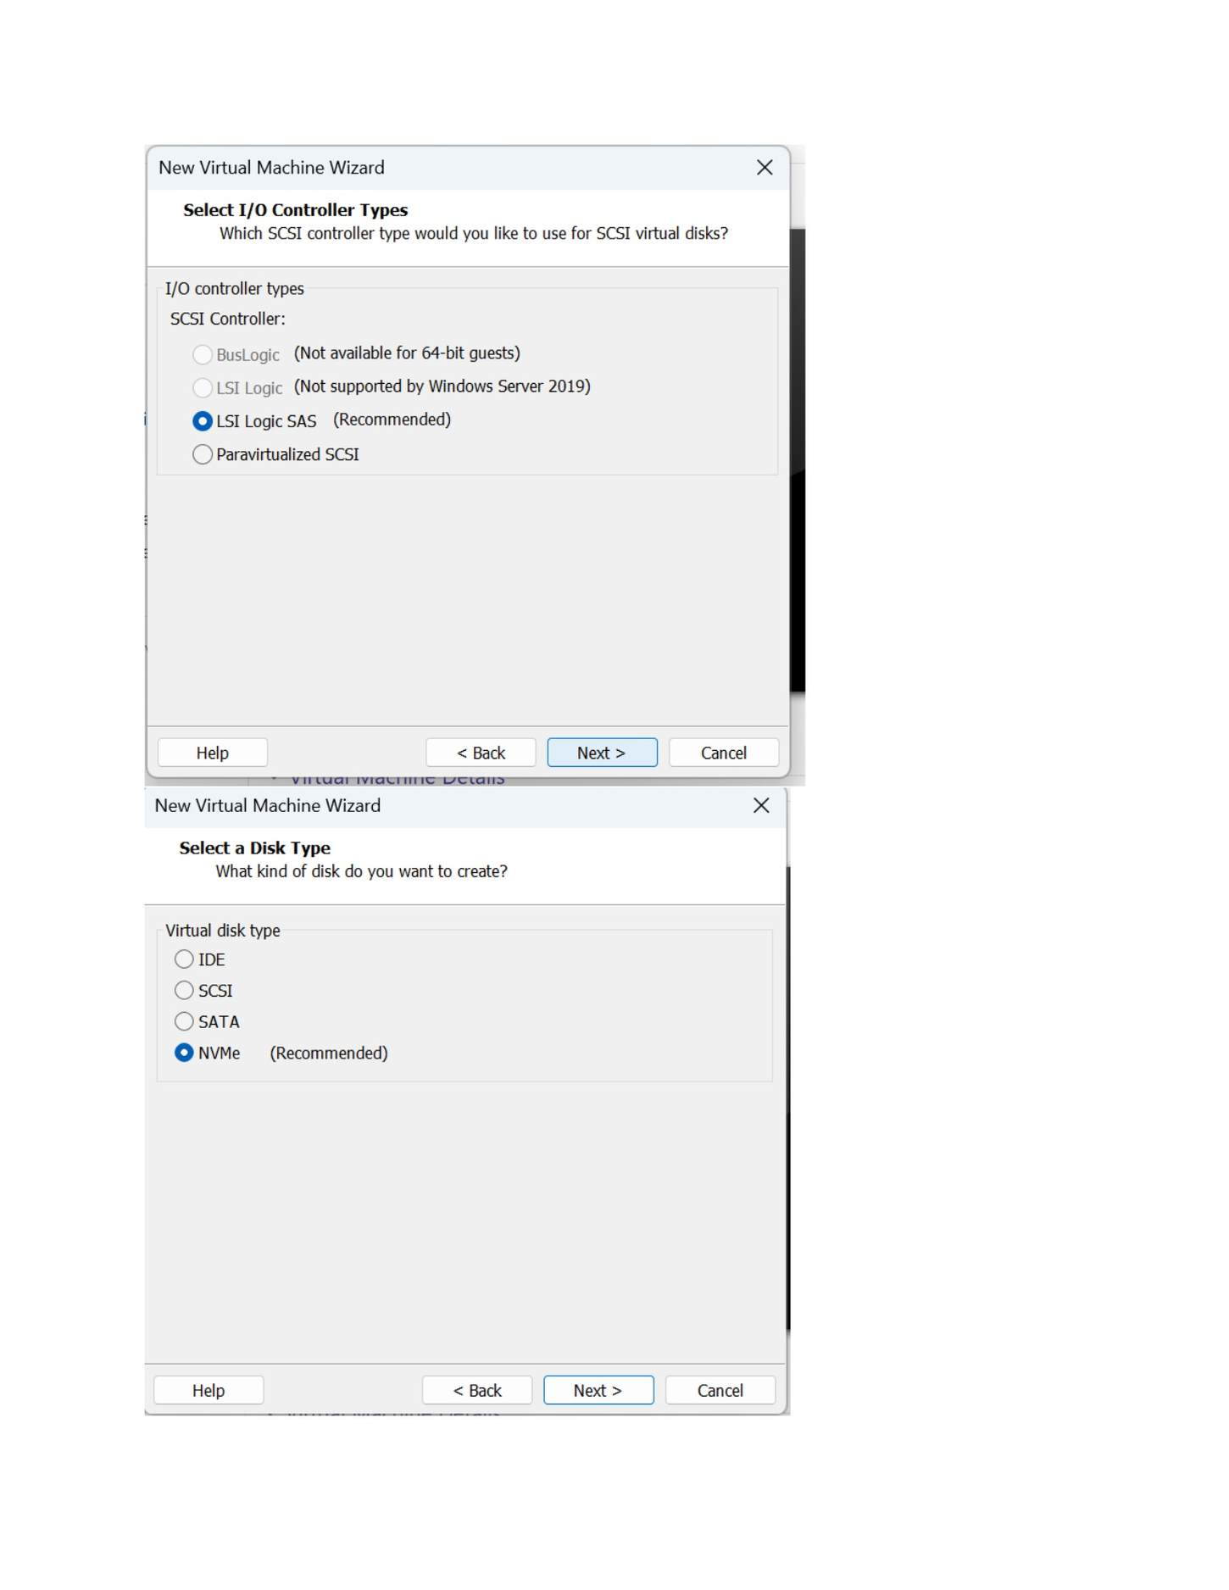
What I did: Selected the SCSI I/O controller required for the server virtual disk.

PAGE 24 — WINDOWS SERVER AND WINDOWS 7 INSTALLATION
Topic: Windows Server and Windows 7 Installation
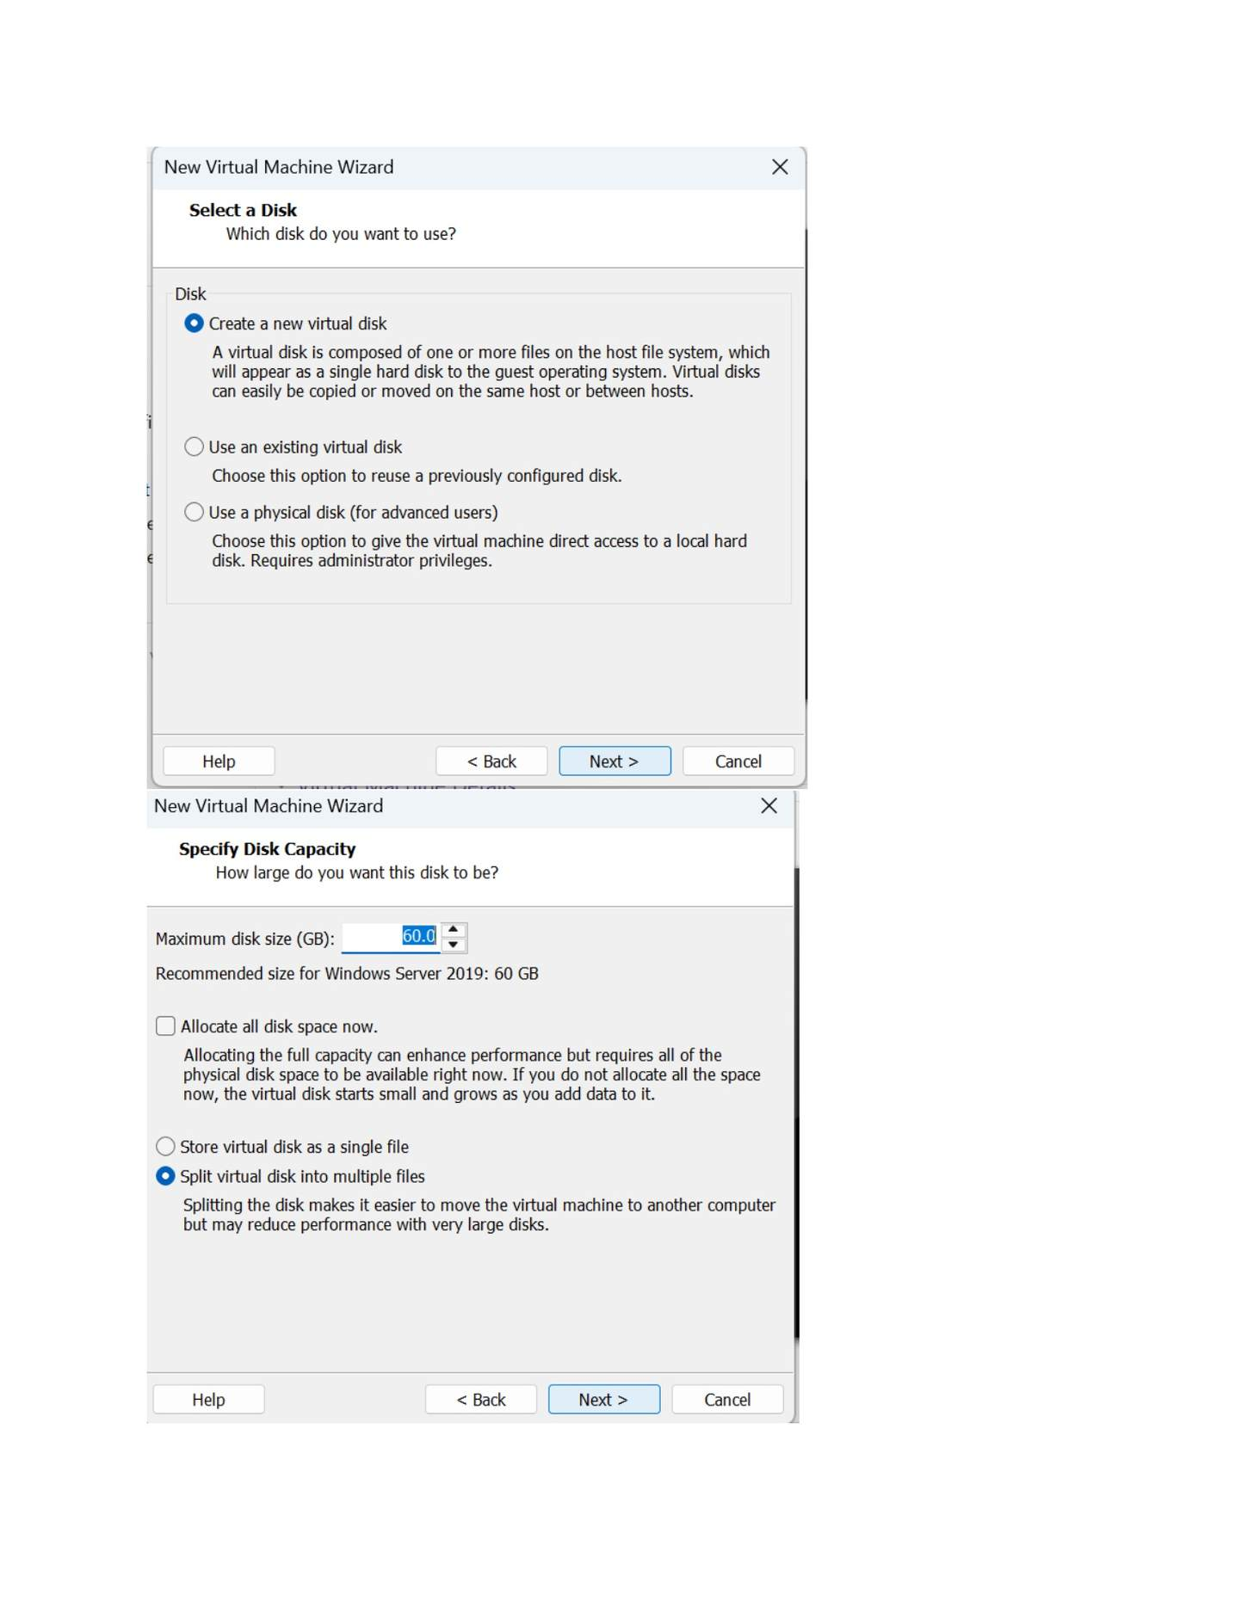
What I did: Selected the option to create a new virtual disk for the server.

PAGE 25 — WINDOWS SERVER AND WINDOWS 7 INSTALLATION
Topic: Windows Server and Windows 7 Installation
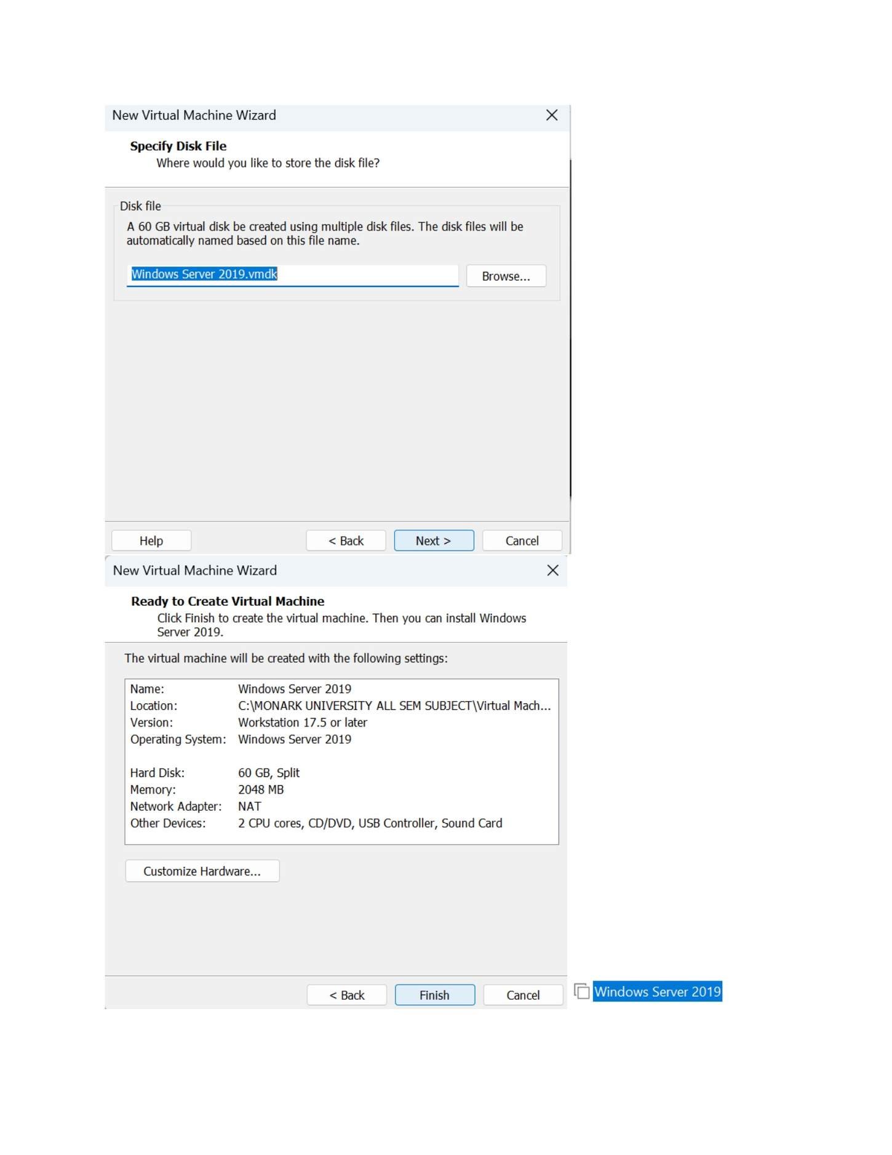
What I did: Specified the server virtual disk file and storage location.

PAGE 26 — WINDOWS SERVER AND WINDOWS 7 INSTALLATION
Topic: Windows Server and Windows 7 Installation
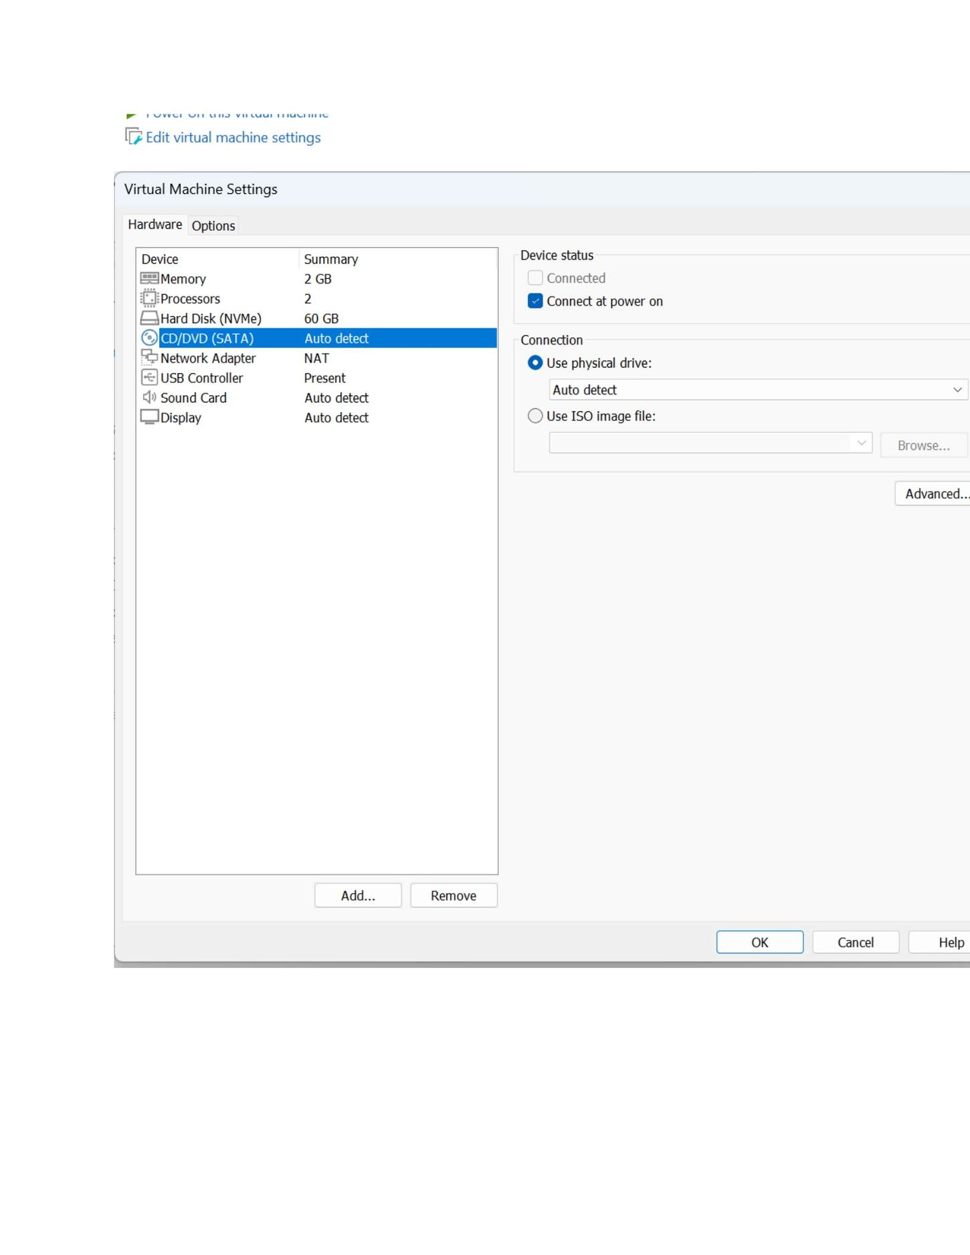
What I did: Reviewed the server VM hardware settings, including memory, processors, disk and network adapter.

PAGE 27 — WINDOWS SERVER AND WINDOWS 7 INSTALLATION
Topic: Windows Server and Windows 7 Installation
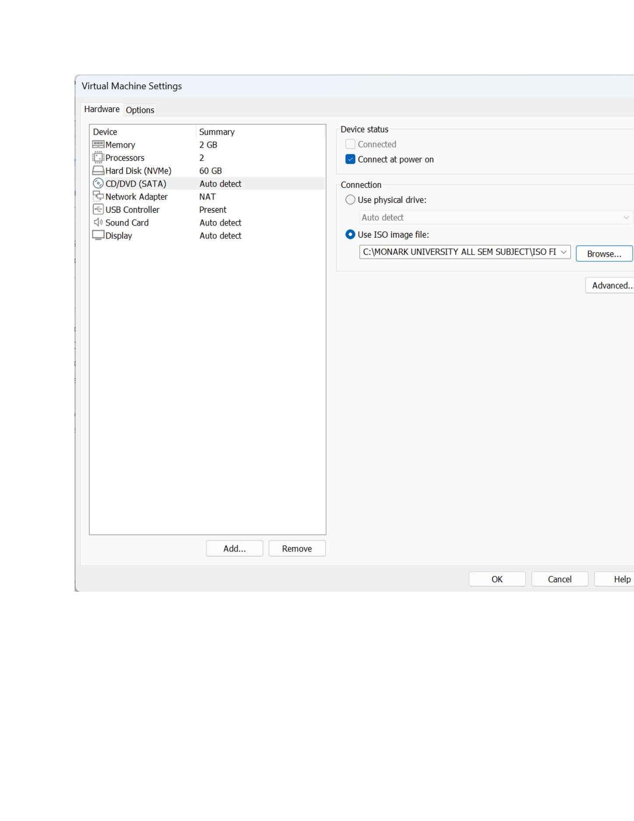
What I did: Verified the server VM hardware/network configuration before starting it.

PAGE 28 — WINDOWS SERVER AND WINDOWS 7 INSTALLATION
Topic: Windows Server and Windows 7 Installation
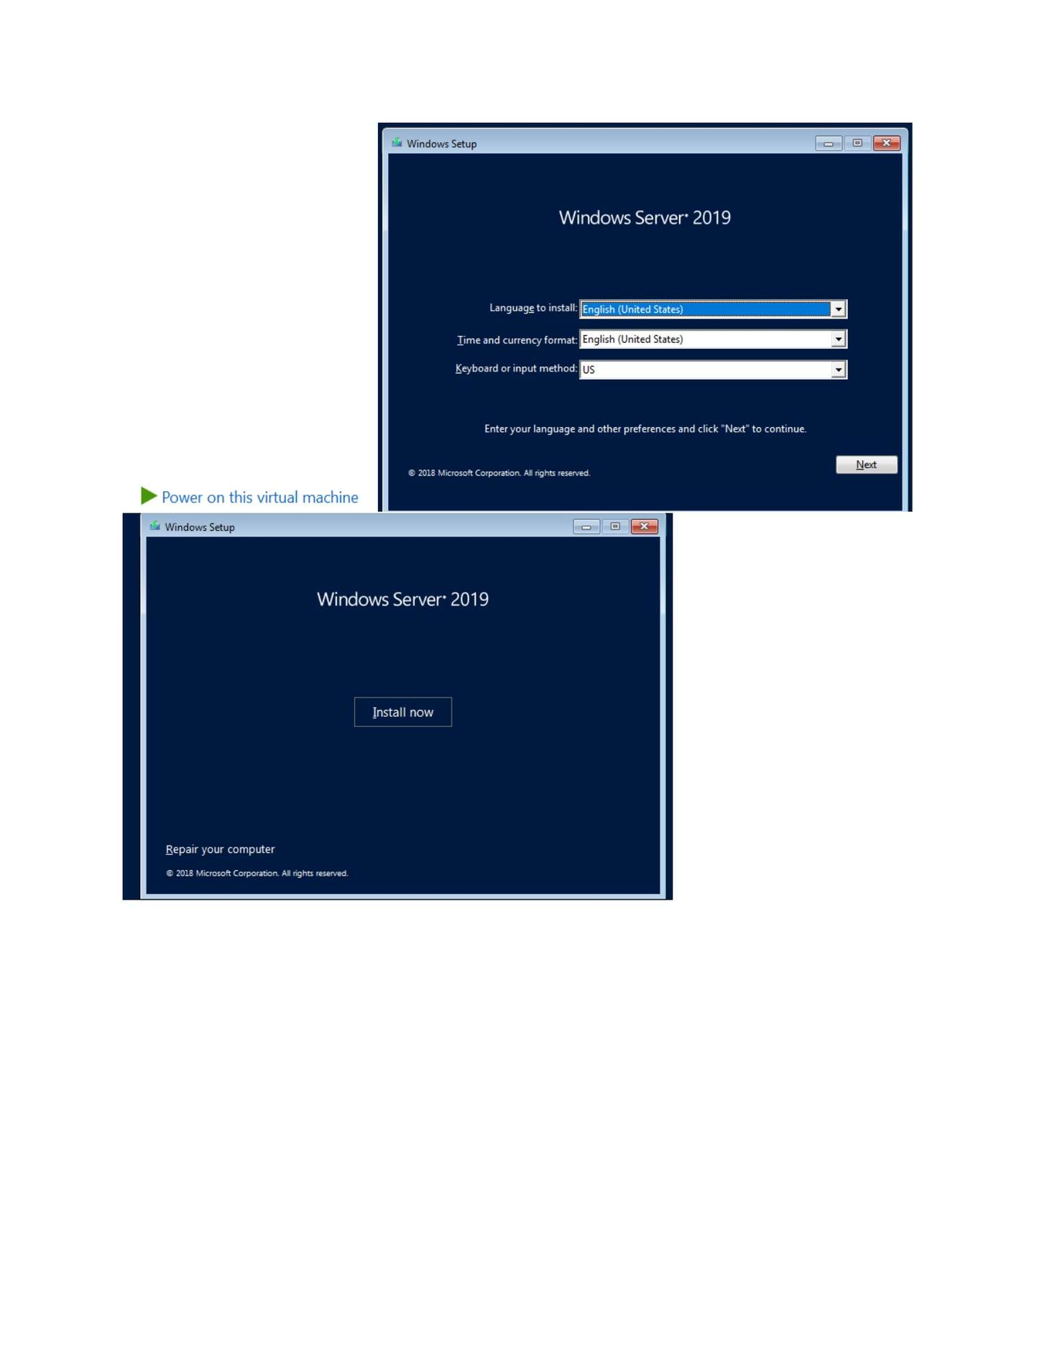
What I did: Started Windows Server 2019 installation from the selected installation media.

PAGE 29 — WINDOWS SERVER AND WINDOWS 7 INSTALLATION
Topic: Windows Server and Windows 7 Installation
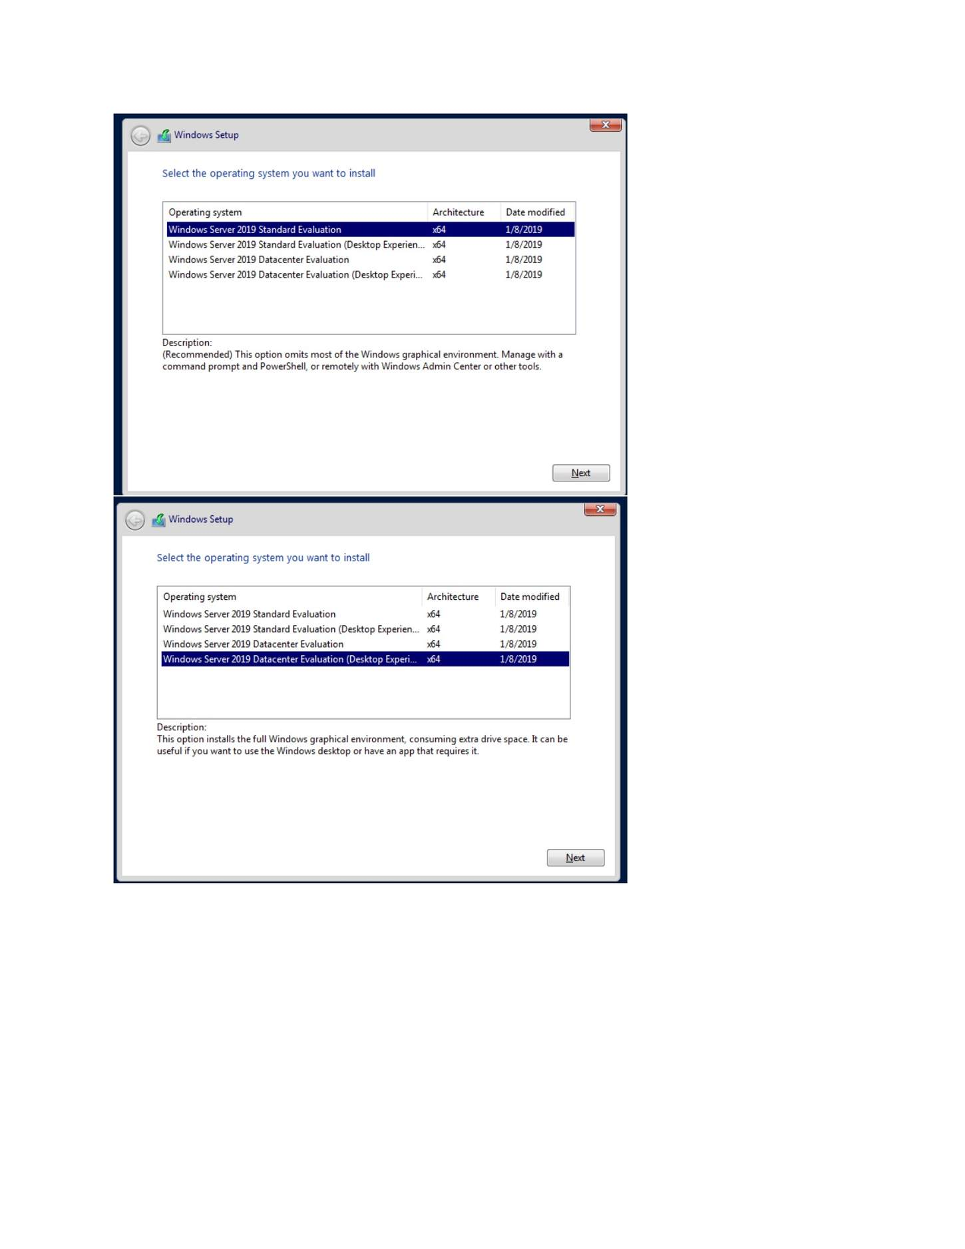
What I did: Continued Windows Server setup at the operating-system installation screen.

PAGE 30 — WINDOWS SERVER AND WINDOWS 7 INSTALLATION
Topic: Windows Server and Windows 7 Installation
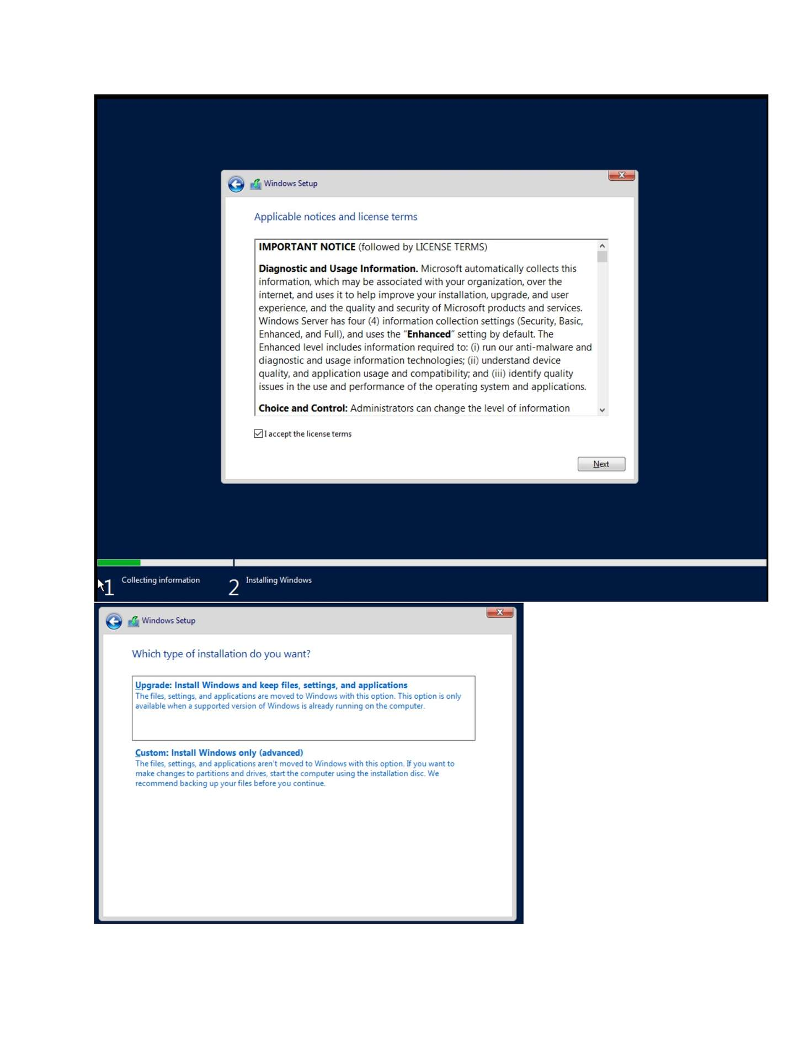
What I did: Accepted/reviewed the Windows Server license and setup options shown.

PAGE 31 — WINDOWS SERVER AND WINDOWS 7 INSTALLATION
Topic: Windows Server and Windows 7 Installation
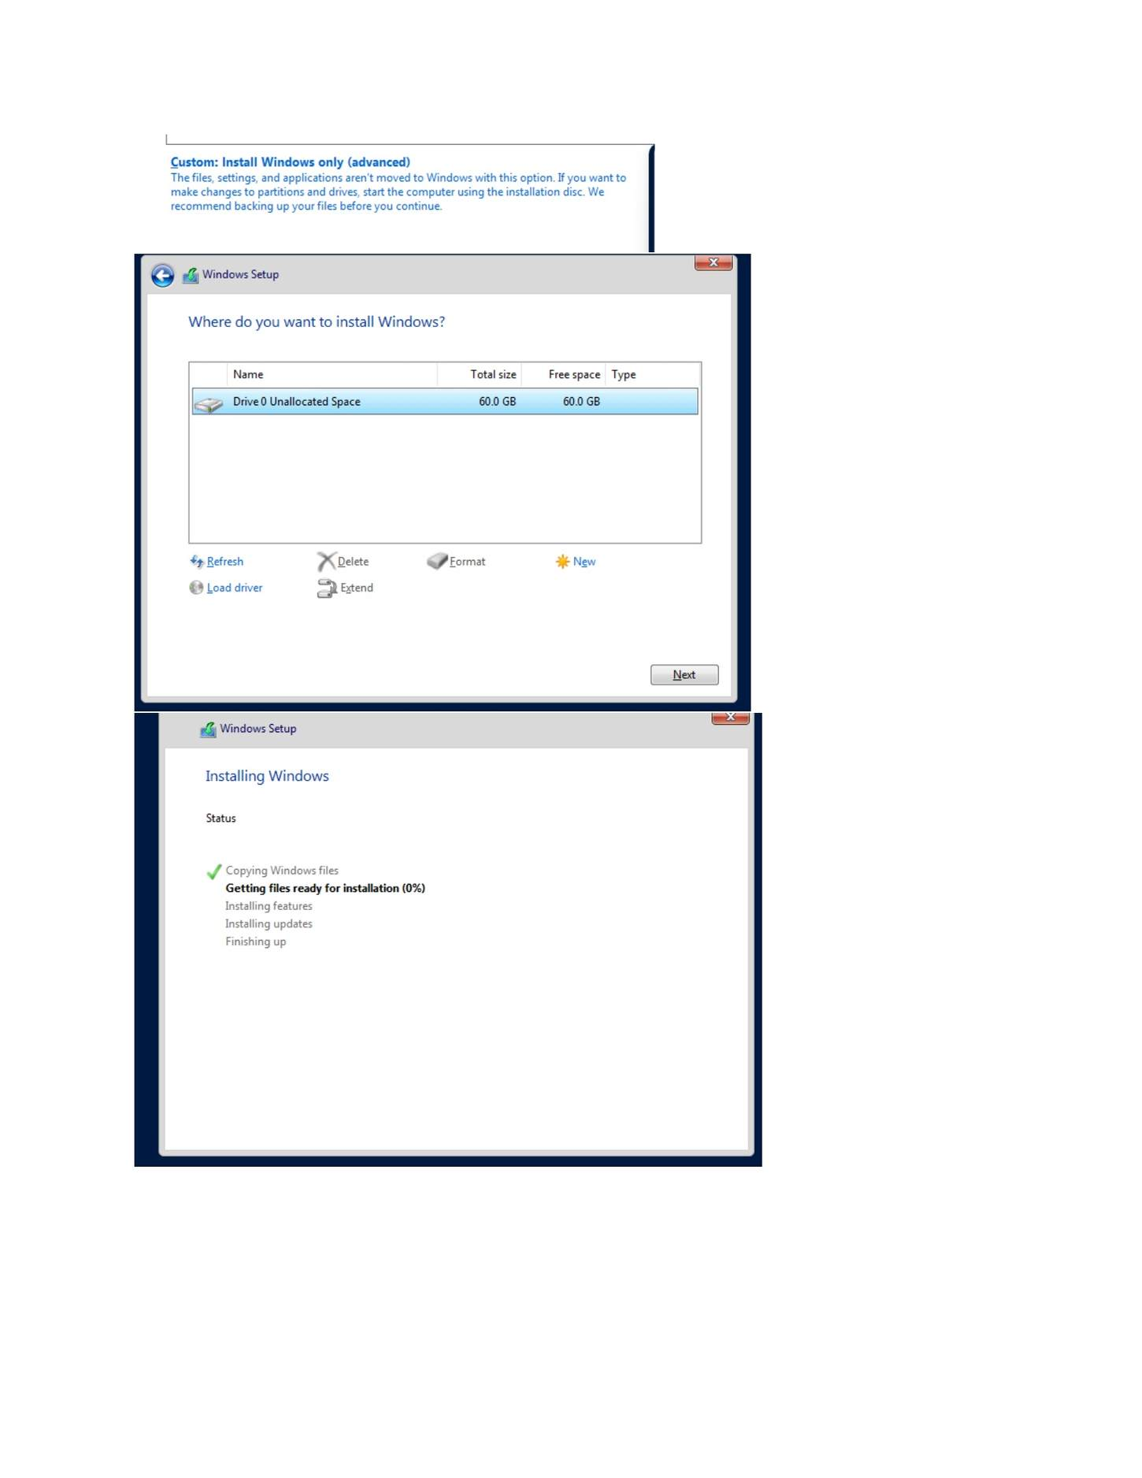
What I did: Selected the disk/partition used for Windows Server installation.

PAGE 32 — WINDOWS SERVER AND WINDOWS 7 INSTALLATION
Topic: Windows Server and Windows 7 Installation

What I did: Continued the Windows Server installation process.

PAGE 33 — WINDOWS SERVER AND WINDOWS 7 INSTALLATION
Topic: Windows Server and Windows 7 Installation
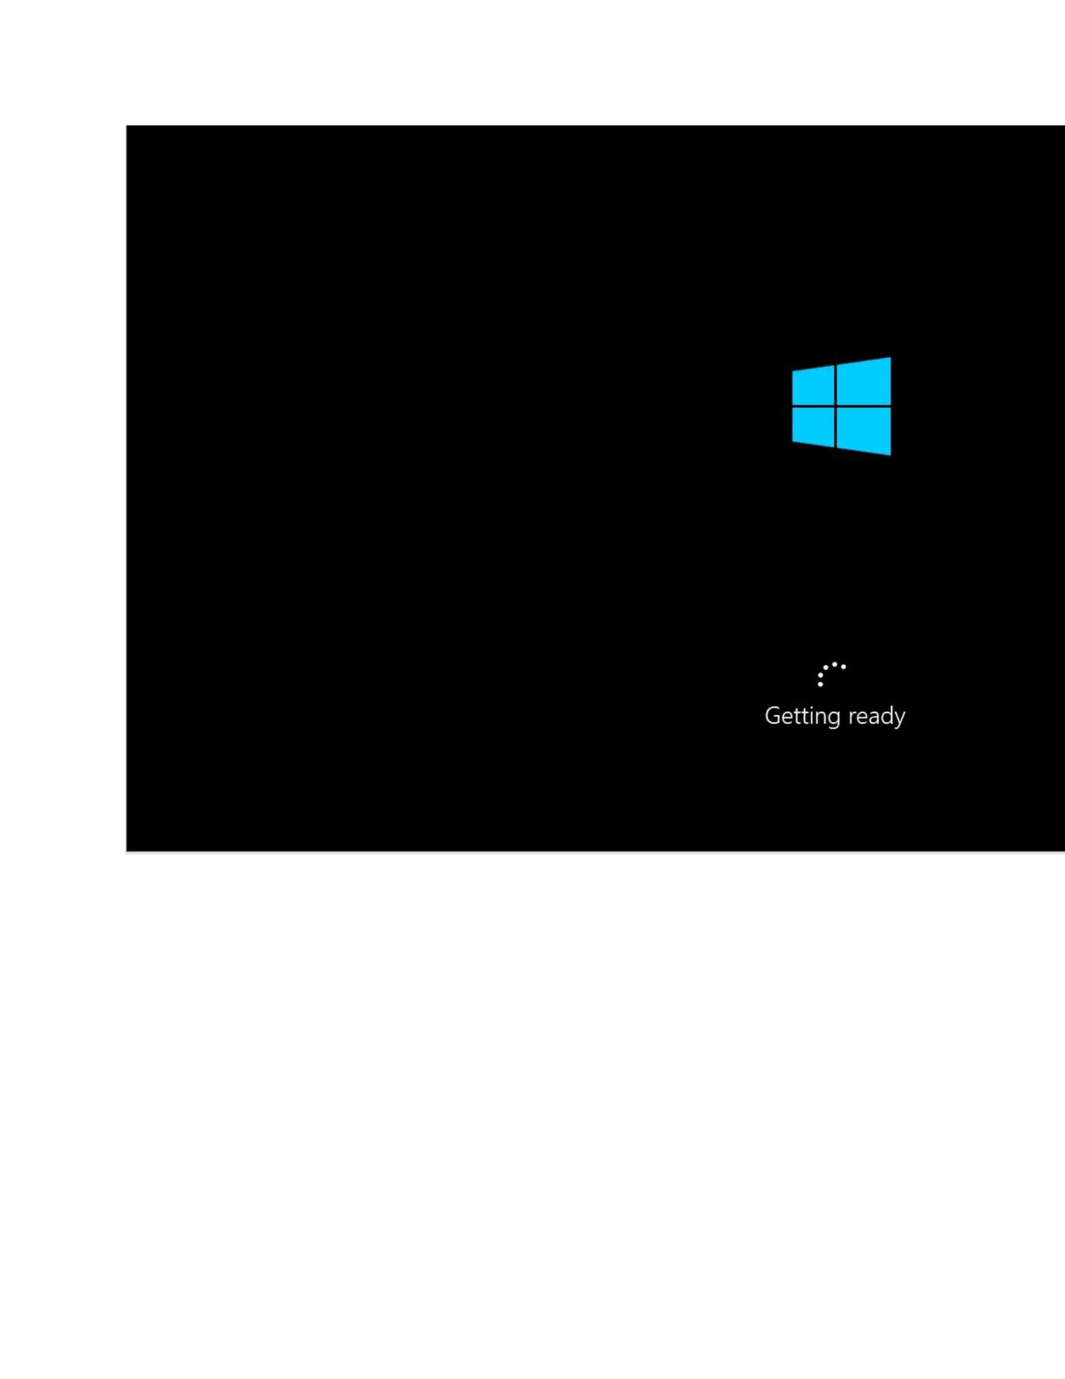
What I did: Waited for Windows Server to complete the installation/preparation stage.

PAGE 34 — WINDOWS SERVER AND WINDOWS 7 INSTALLATION
Topic: Windows Server and Windows 7 Installation
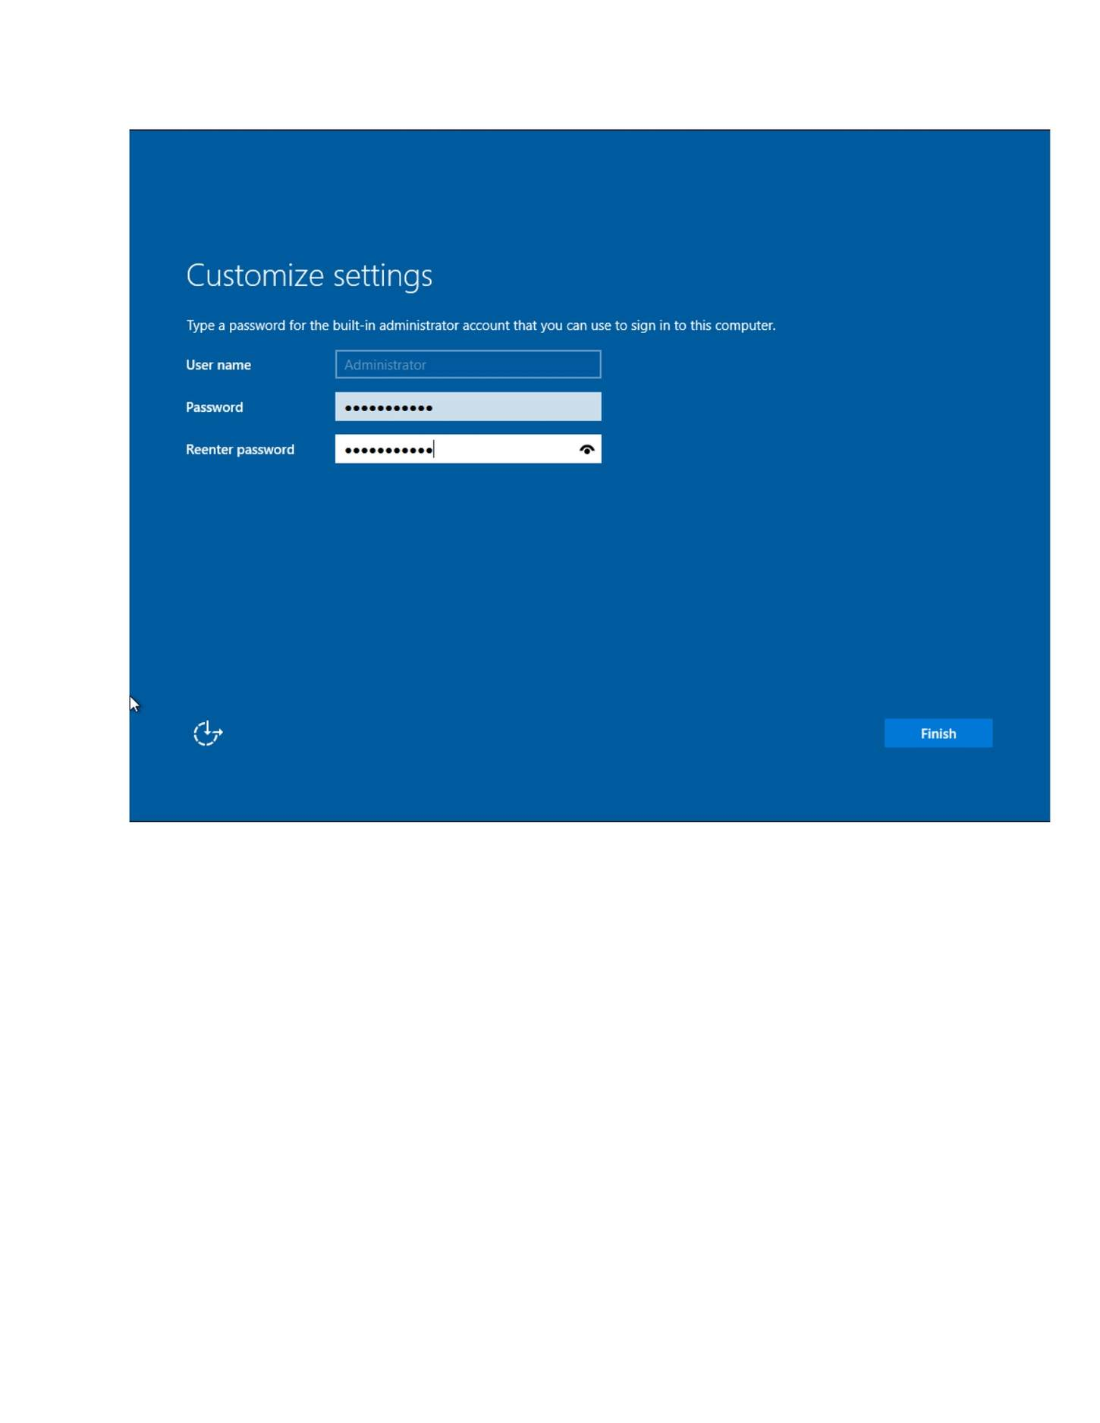
What I did: Opened the initial Windows Server configuration screen after installation.

PAGE 35 — CONNECTIVITY BETWEEN WINDOWS SERVER AND WINDOWS 7
Topic: Connectivity Between Windows Server and Windows 7
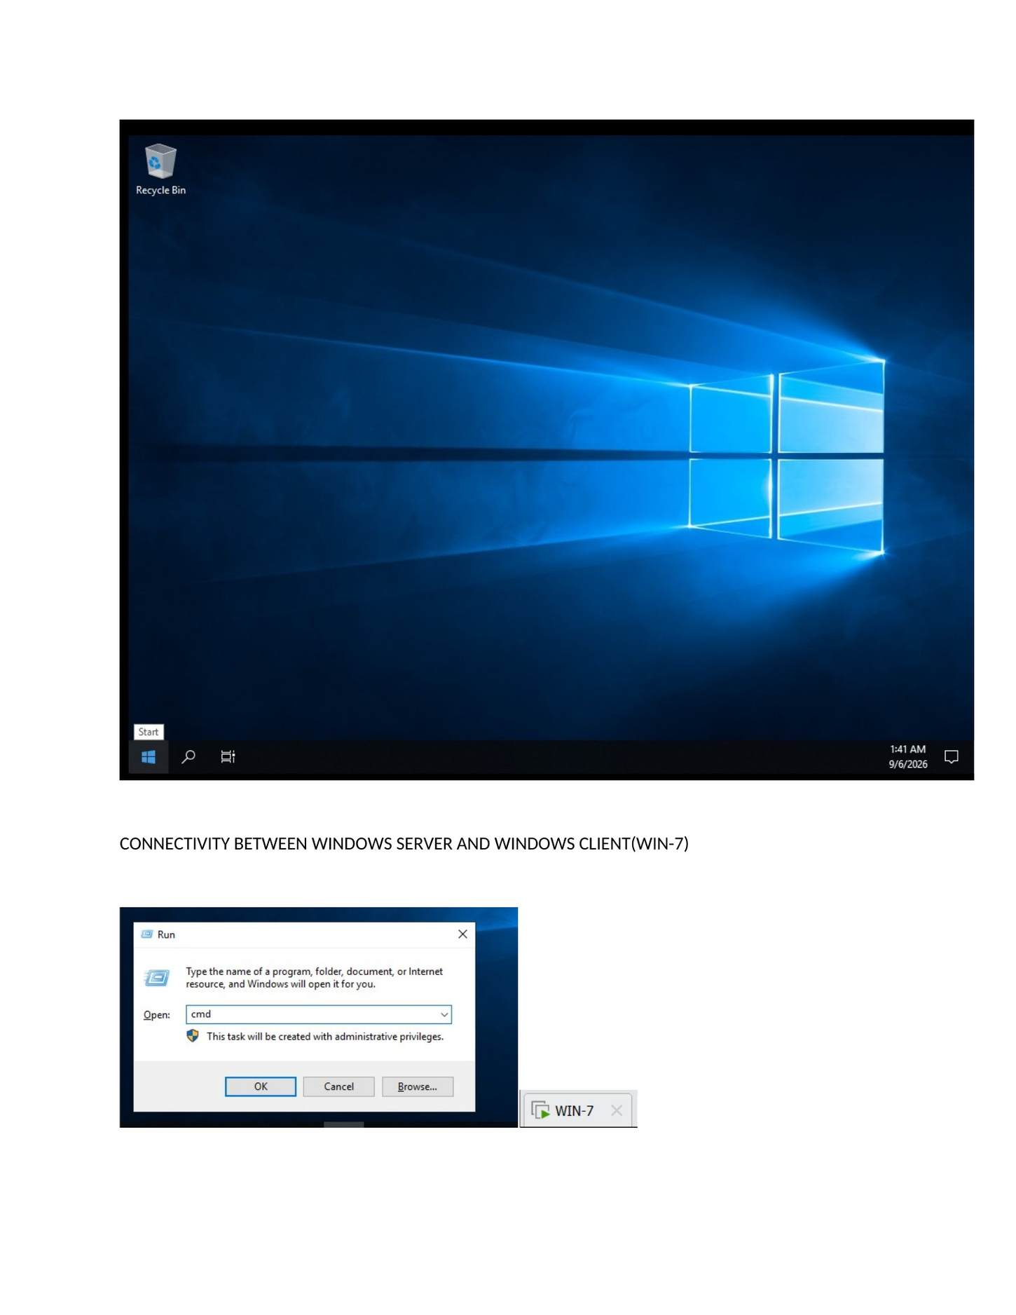
What I did: Opened the connectivity section for testing communication between Windows Server and the Windows 7 client.

PAGE 36 — CONNECTIVITY BETWEEN WINDOWS SERVER AND WINDOWS 7
Topic: Connectivity Between Windows Server and Windows 7
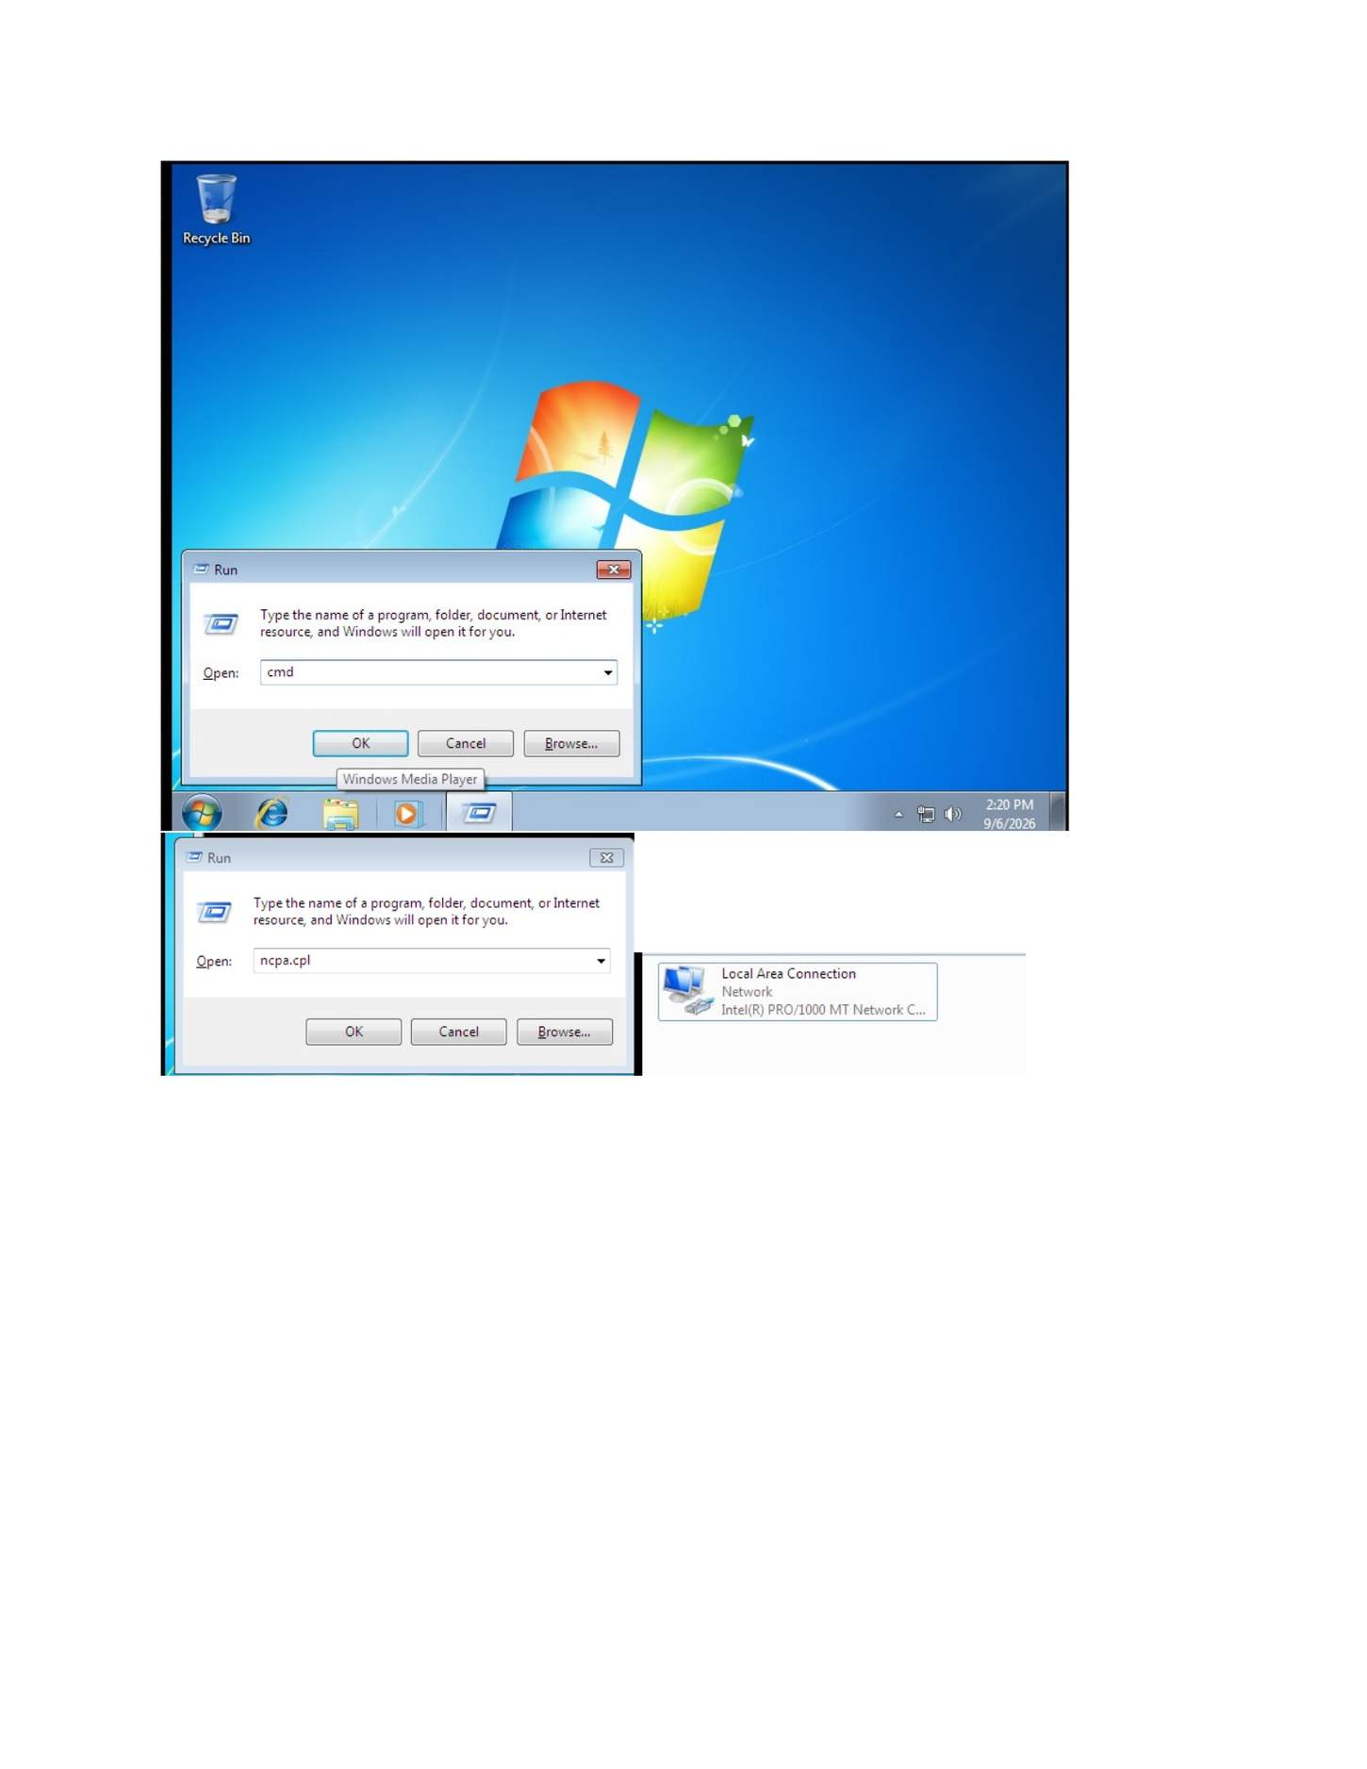
What I did: Checked the Windows Server/client network configuration before testing communication.

PAGE 37 — CONNECTIVITY BETWEEN WINDOWS SERVER AND WINDOWS 7
Topic: Connectivity Between Windows Server and Windows 7
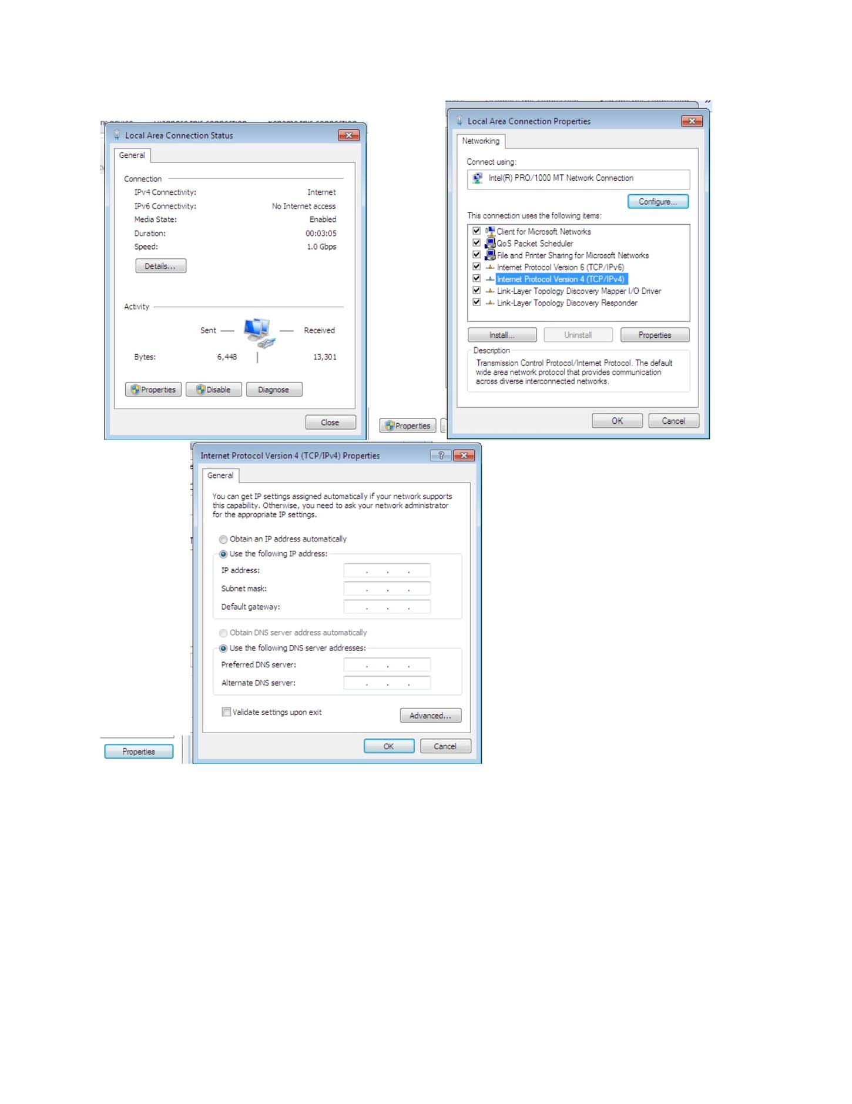
What I did: Reviewed the IPv4 configuration on the Windows machines.

PAGE 38 — CONNECTIVITY BETWEEN WINDOWS SERVER AND WINDOWS 7
Topic: Connectivity Between Windows Server and Windows 7
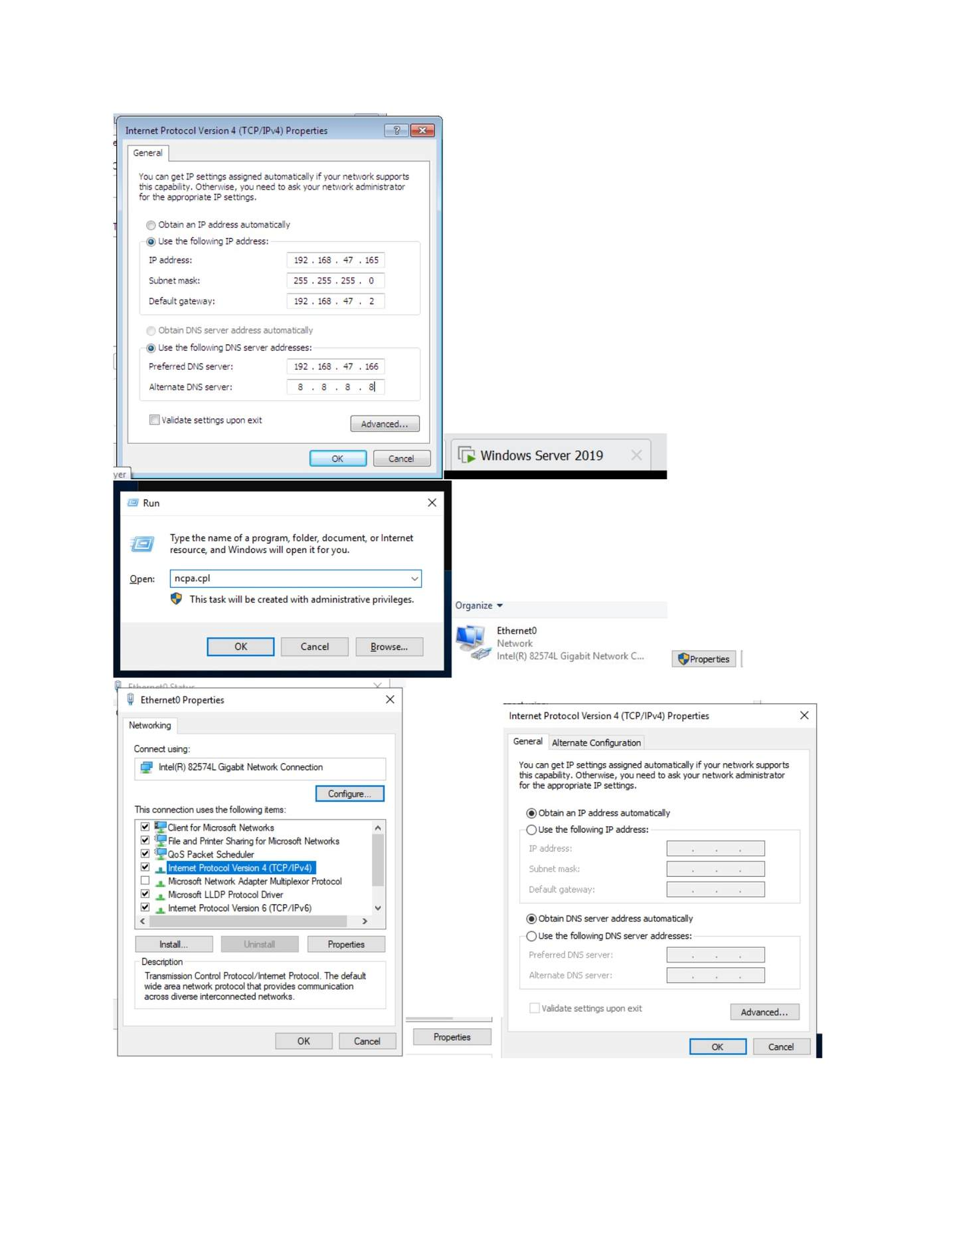
What I did: Opened IPv4 Properties to view the assigned IP address, subnet mask and related settings.

PAGE 39 — CONNECTIVITY BETWEEN WINDOWS SERVER AND WINDOWS 7
Topic: Connectivity Between Windows Server and Windows 7
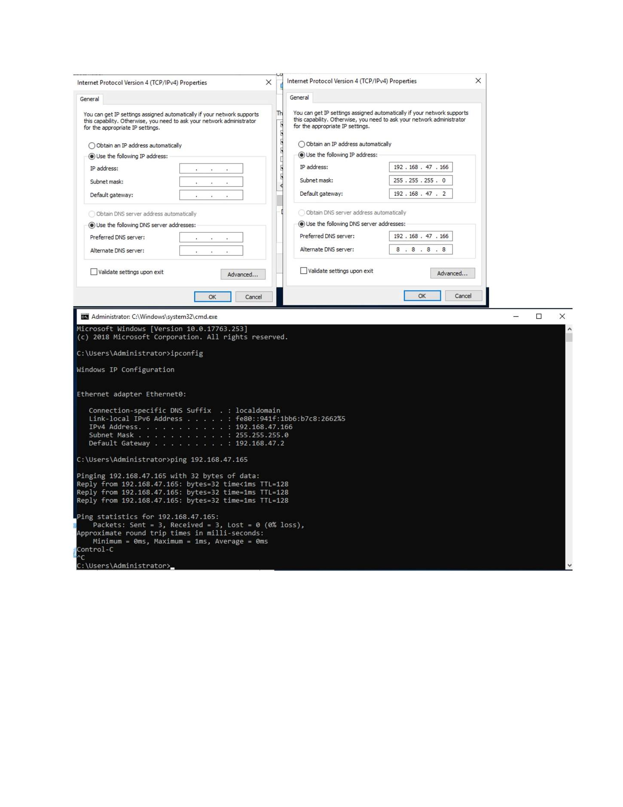
What I did: Checked the server/client IP configuration used for the lab network.

PAGE 40 — CONNECTIVITY BETWEEN WINDOWS SERVER AND WINDOWS 7
Topic: Connectivity Between Windows Server and Windows 7
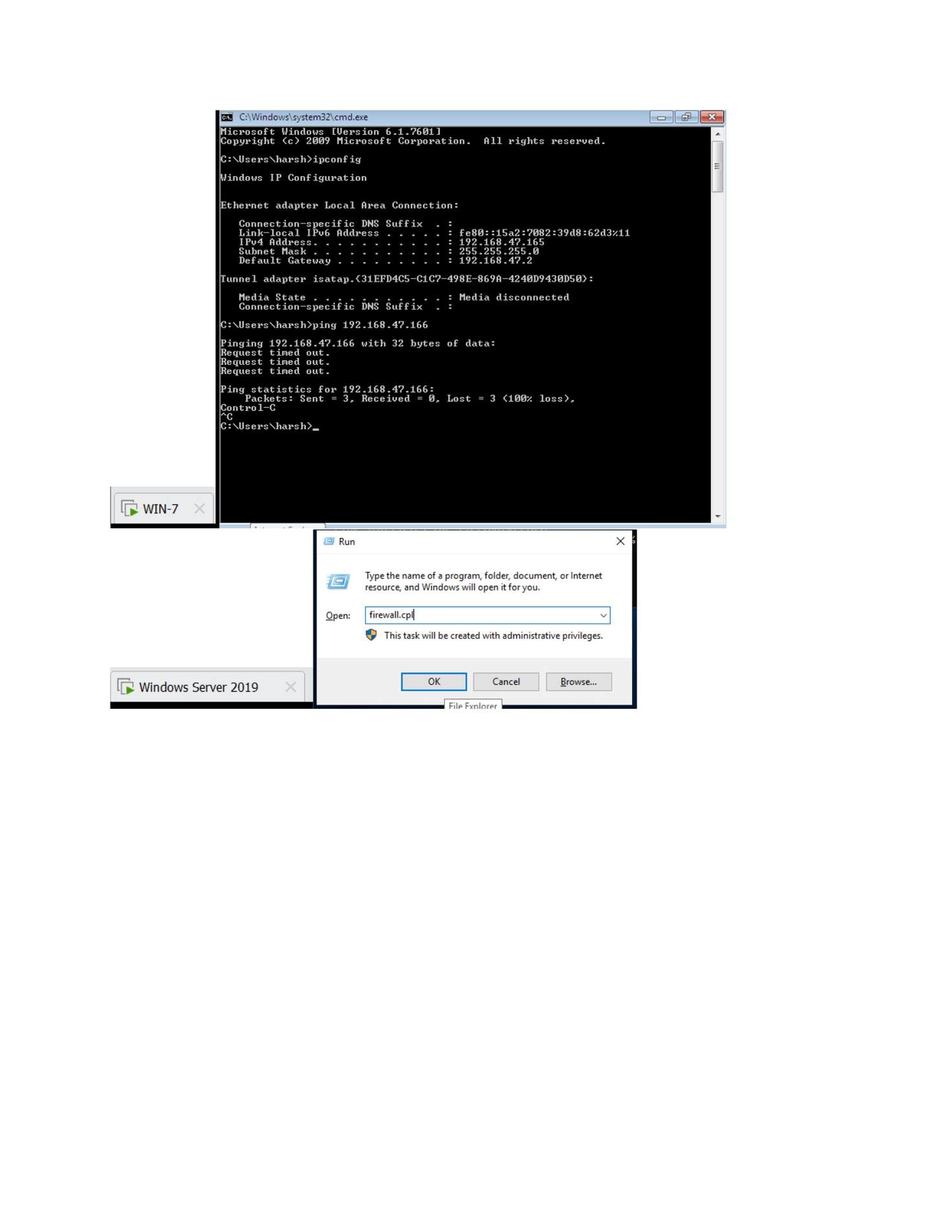
What I did: Used the Windows client to test communication with Windows Server.

PAGE 41 — CONNECTIVITY BETWEEN WINDOWS SERVER AND WINDOWS 7
Topic: Connectivity Between Windows Server and Windows 7
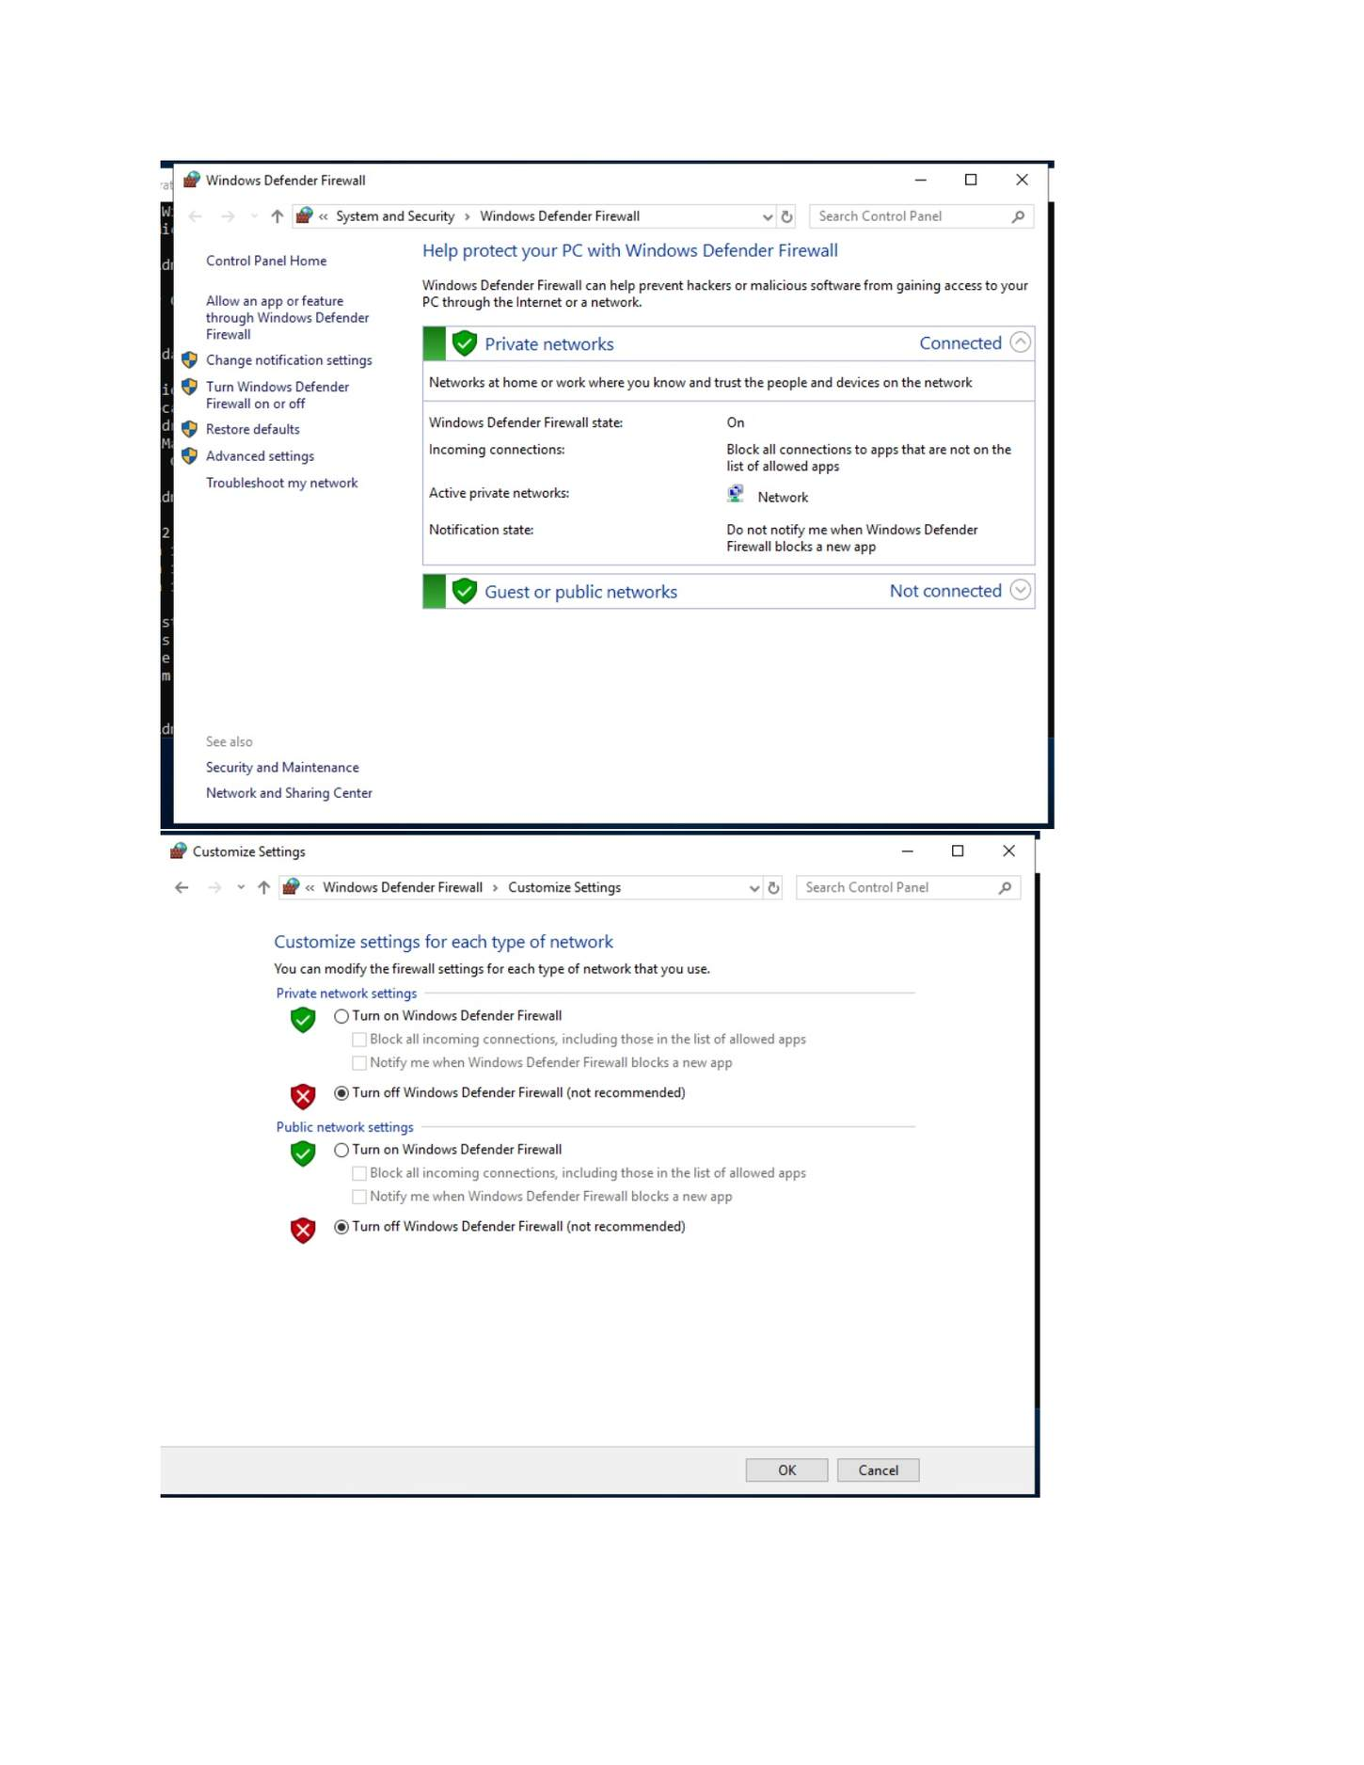
What I did: Ran the ping test and verified the Windows Server address responded.

PAGE 42 — WINDOWS SERVER NAME CHANGE TO WINDOWS SERVER-2019
Topic: Windows Server Name Change to Windows Server-2019
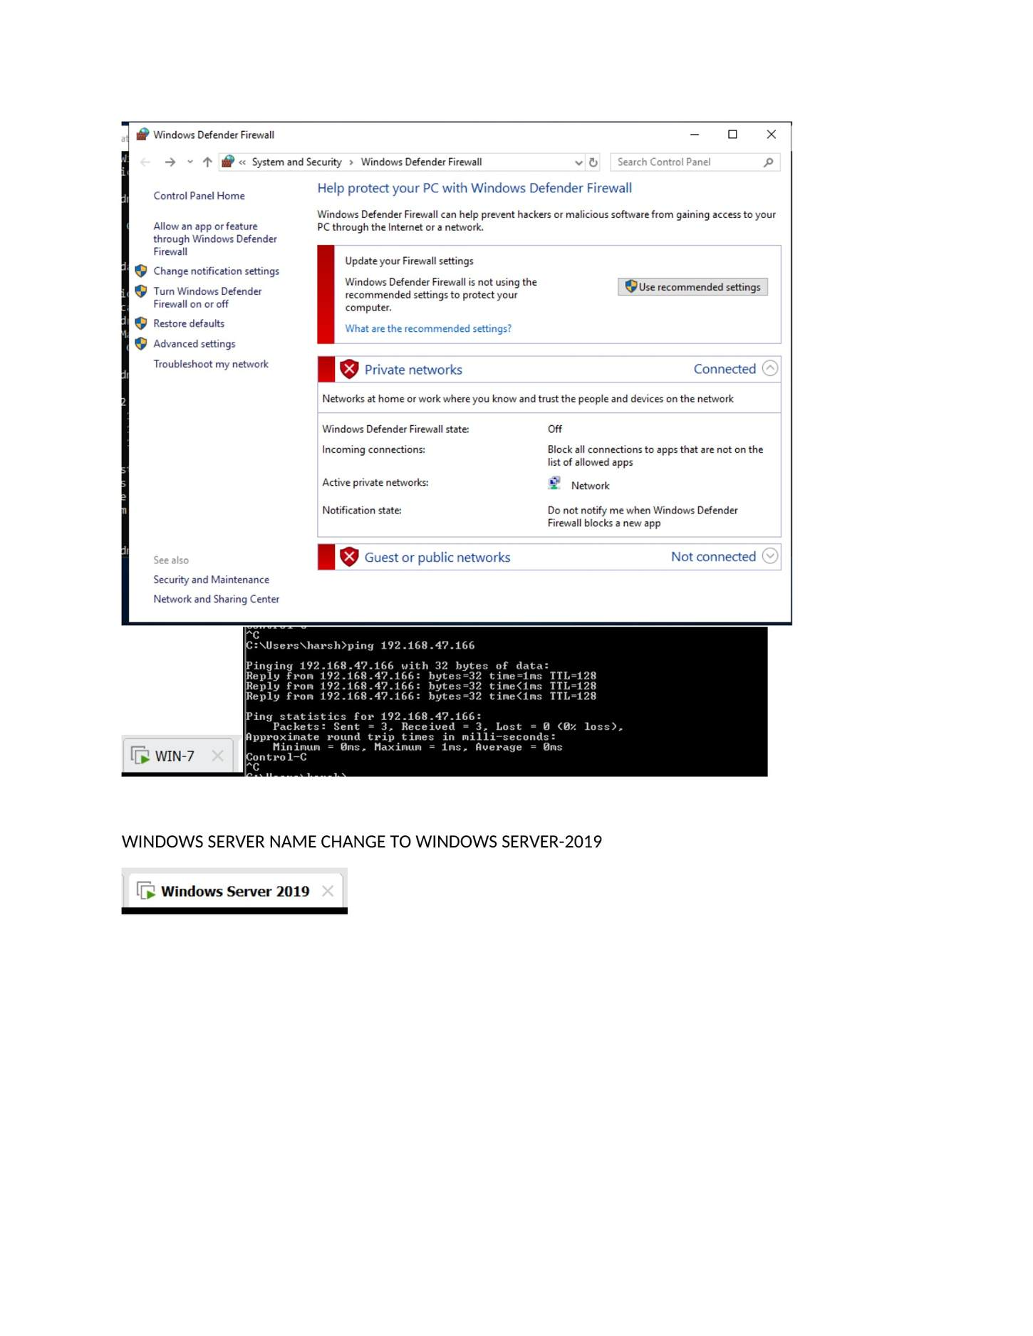
What I did: Opened Windows Server system properties to begin changing the computer name.

PAGE 43 — WINDOWS SERVER NAME CHANGE TO WINDOWS SERVER-2019
Topic: Windows Server Name Change to Windows Server-2019
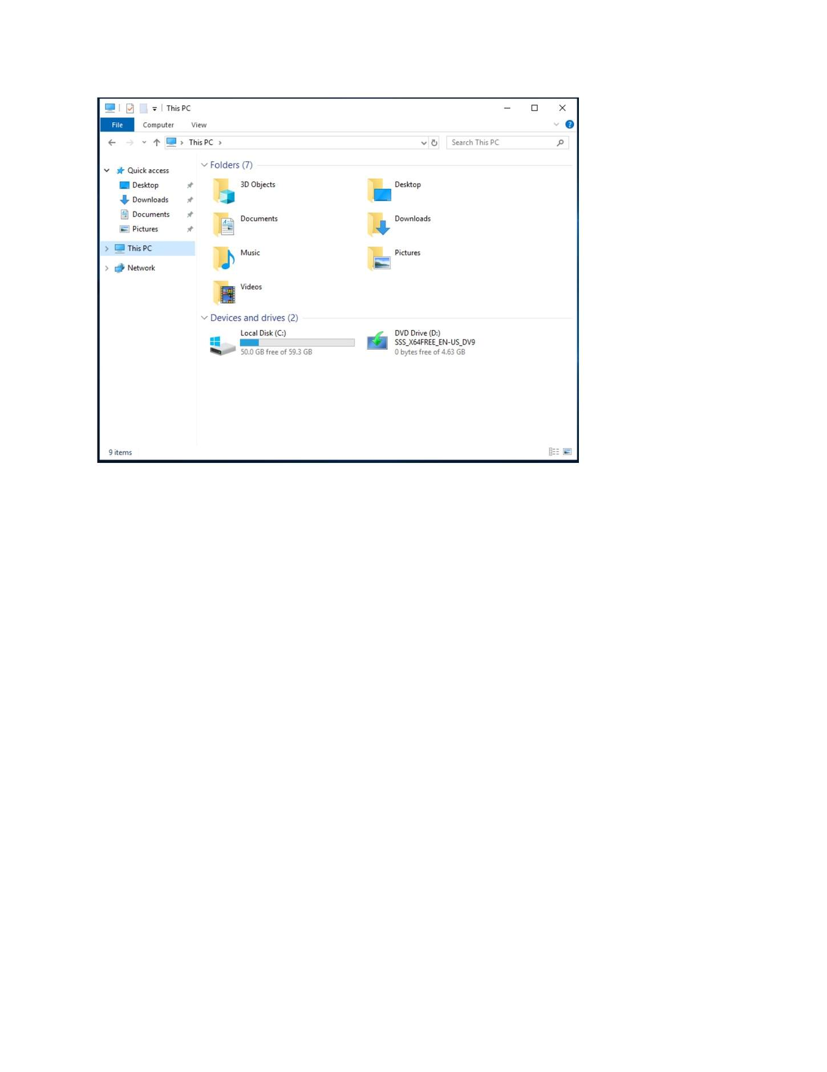
What I did: Opened the Computer Name/Domain Changes dialog and entered the new server computer name.

PAGE 44 — WINDOWS SERVER NAME CHANGE TO WINDOWS SERVER-2019
Topic: Windows Server Name Change to Windows Server-2019
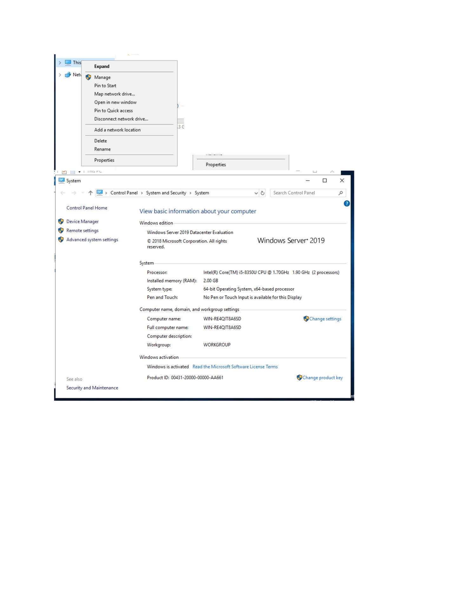
What I did: Applied the computer-name change and reviewed the restart requirement.

PAGE 45 — WINDOWS SERVER NAME CHANGE TO WINDOWS SERVER-2019
Topic: Windows Server Name Change to Windows Server-2019
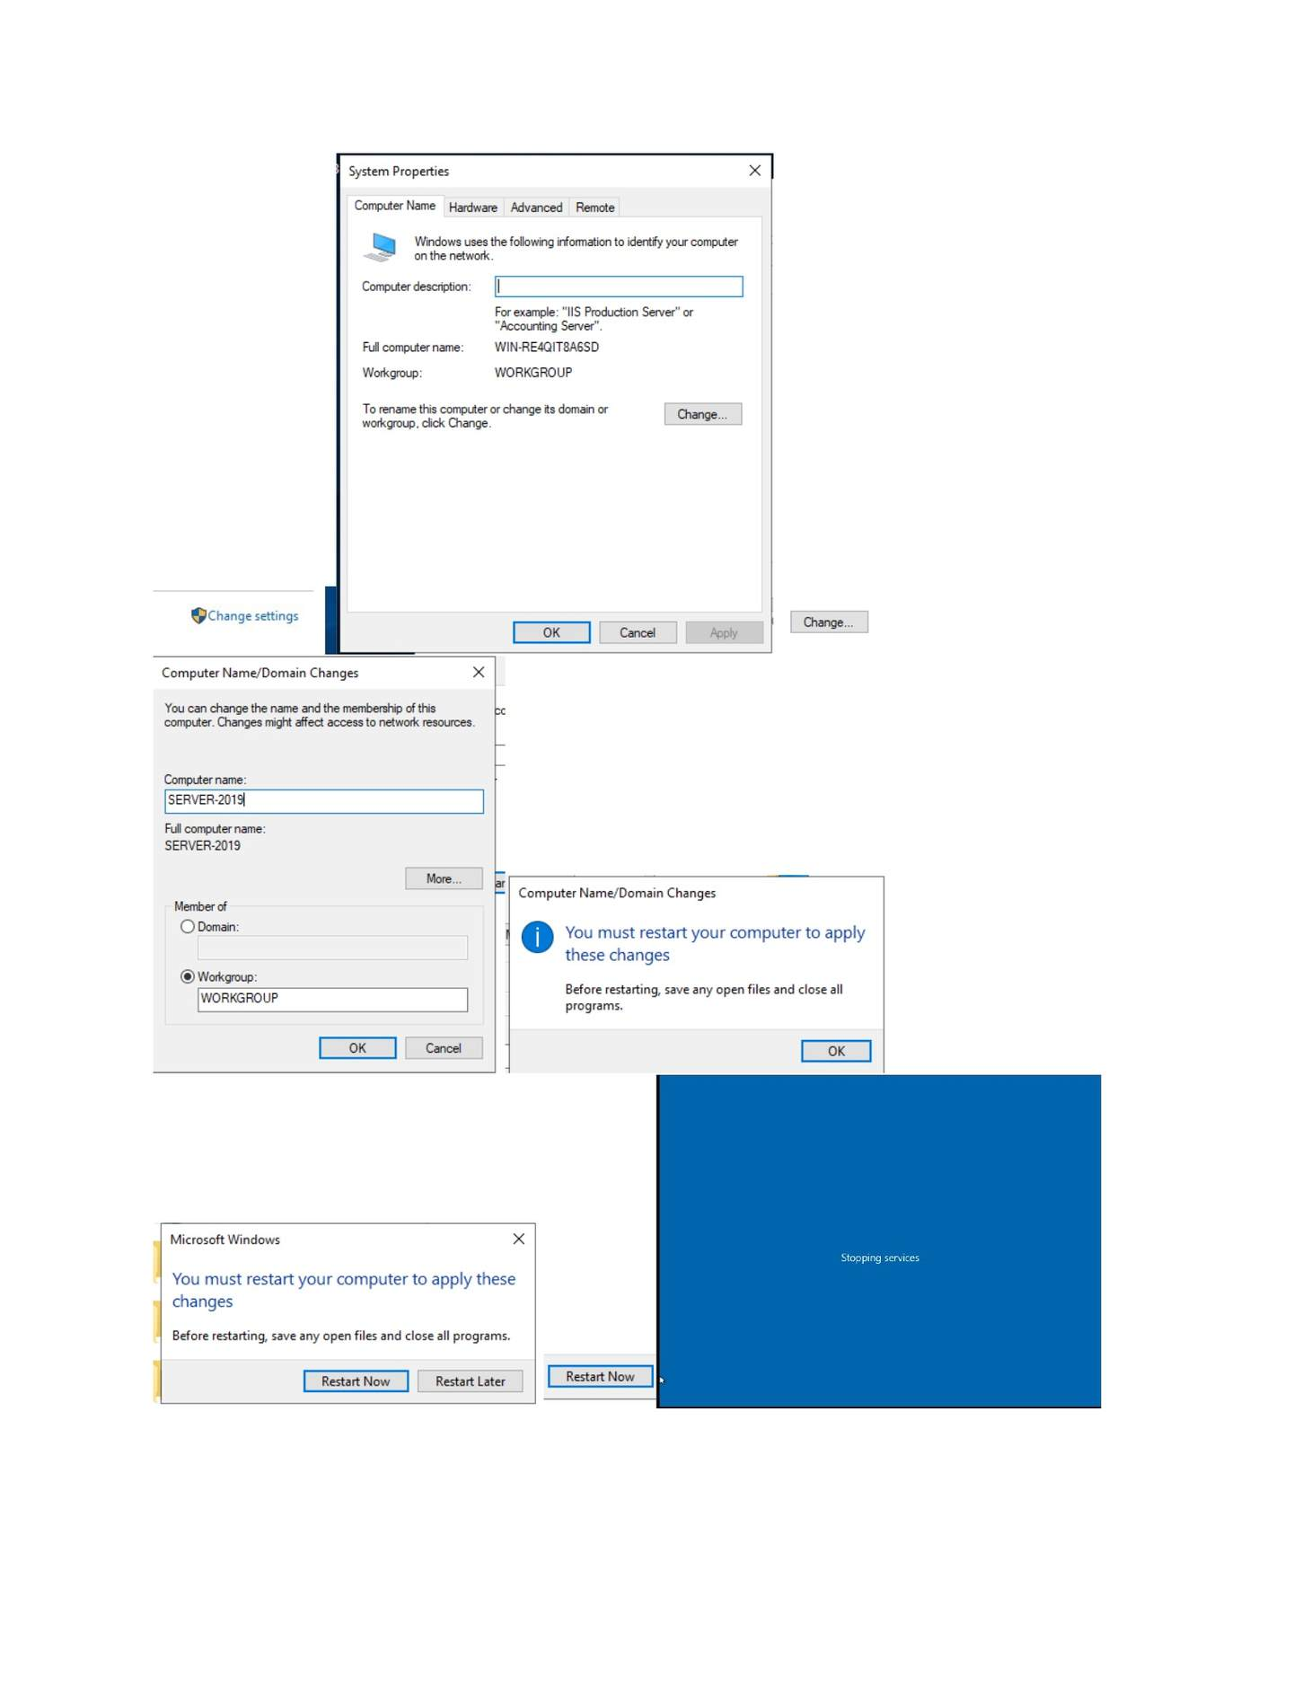
What I did: Confirmed the Windows Server name/domain information after the change.

PAGE 46 — ADDS AND USER MANAGEMENT
Topic: ADDS and User Management
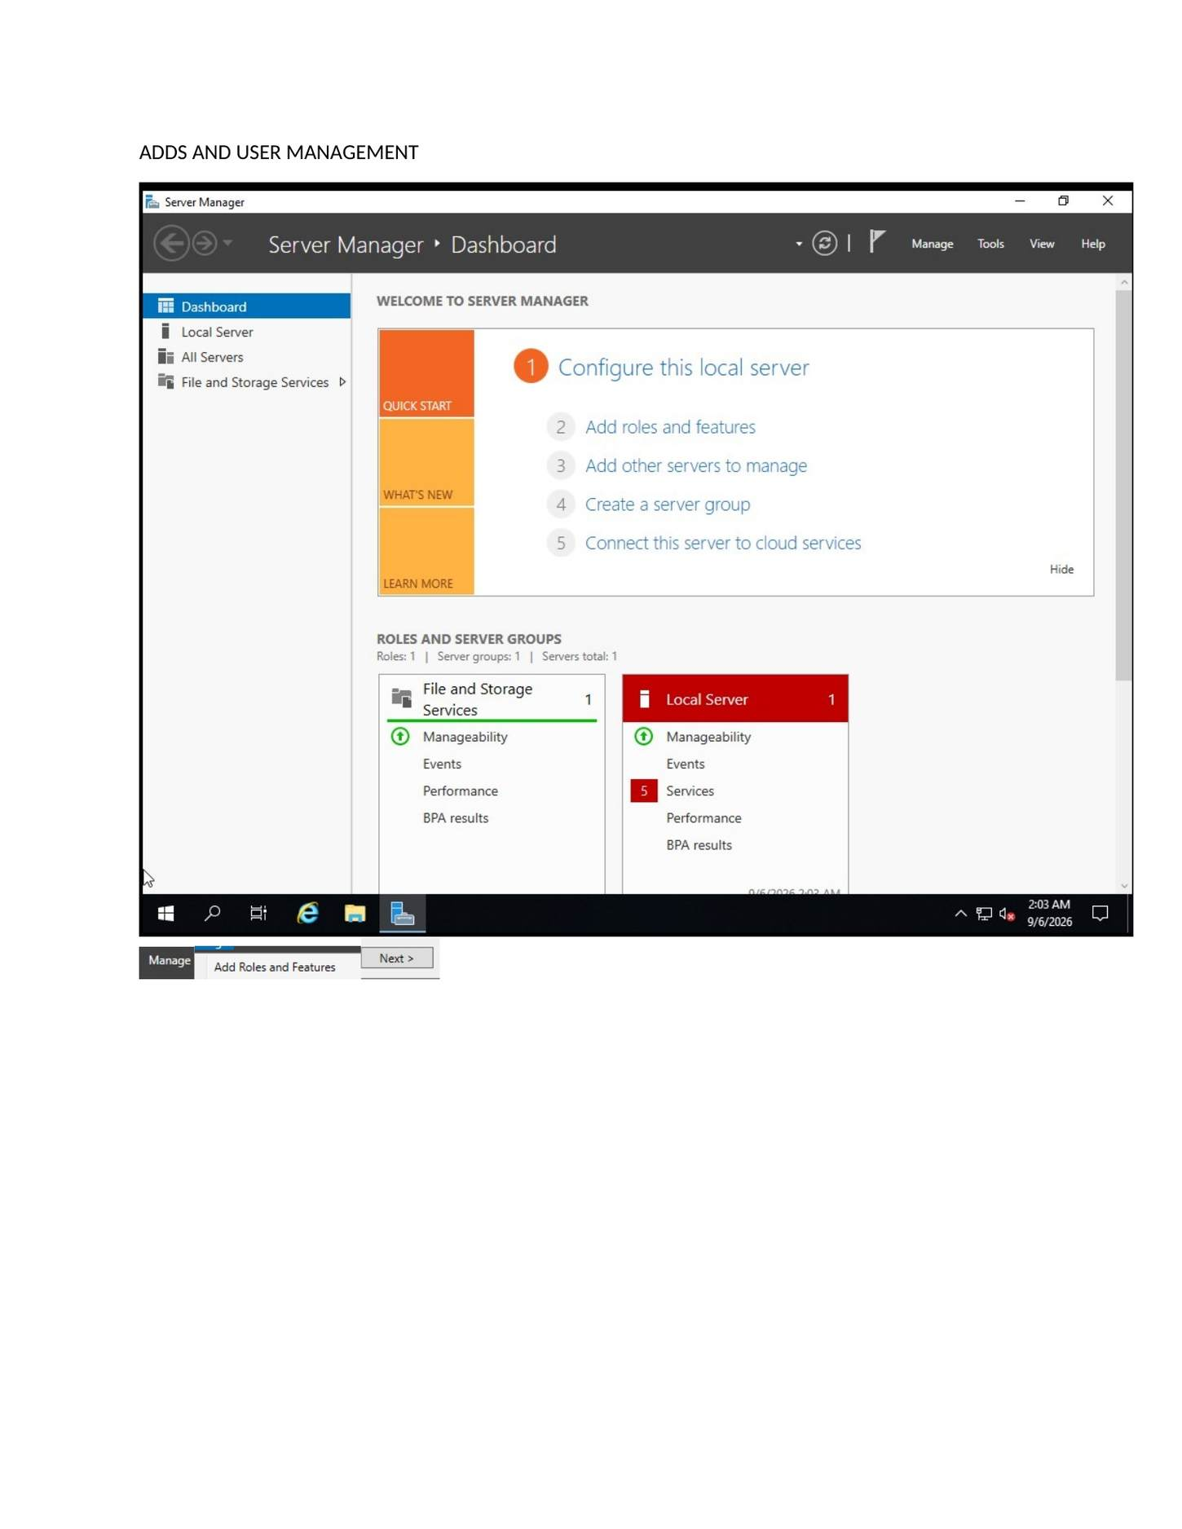
What I did: Opened Server Manager and started the Add Roles and Features wizard for AD DS.

PAGE 47 — ADDS AND USER MANAGEMENT
Topic: ADDS and User Management
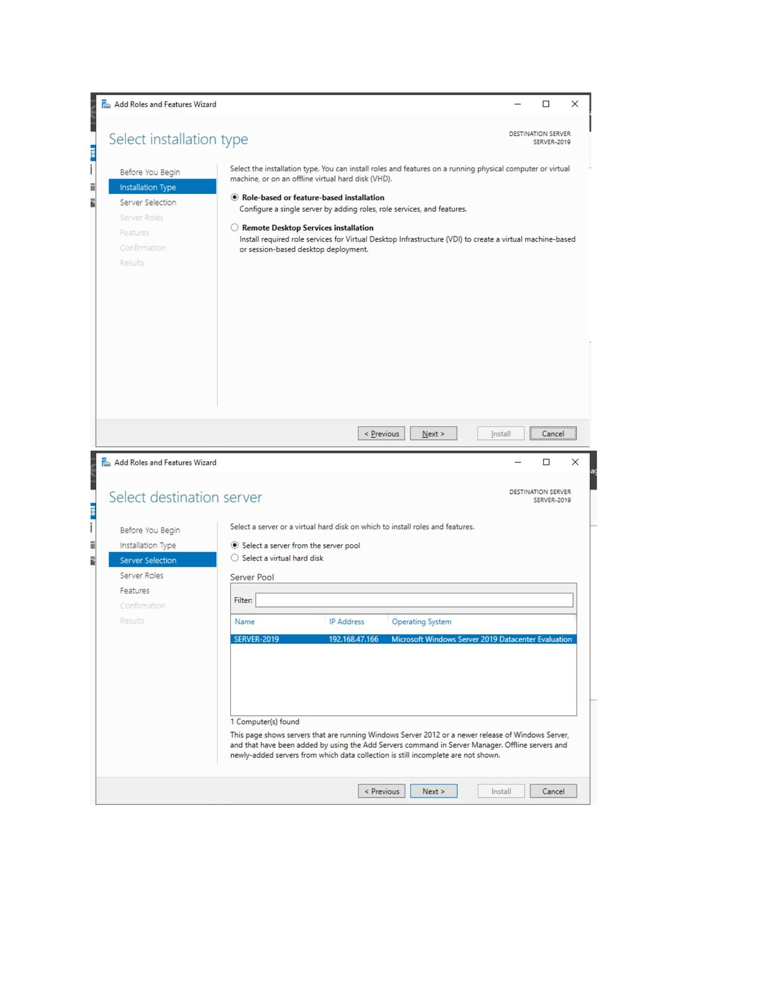
What I did: Selected the Role-based or feature-based installation option.

PAGE 48 — ADDS AND USER MANAGEMENT
Topic: ADDS and User Management
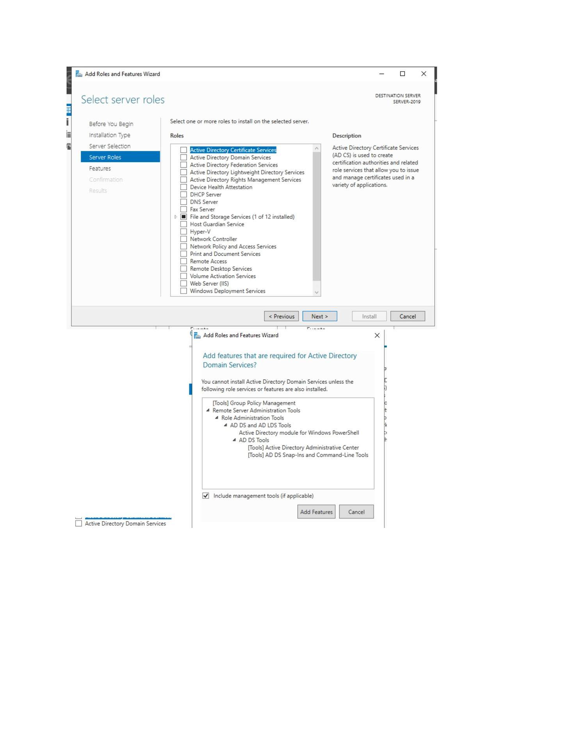
What I did: Selected the destination server for the AD DS role installation.

PAGE 49 — ADDS AND USER MANAGEMENT
Topic: ADDS and User Management
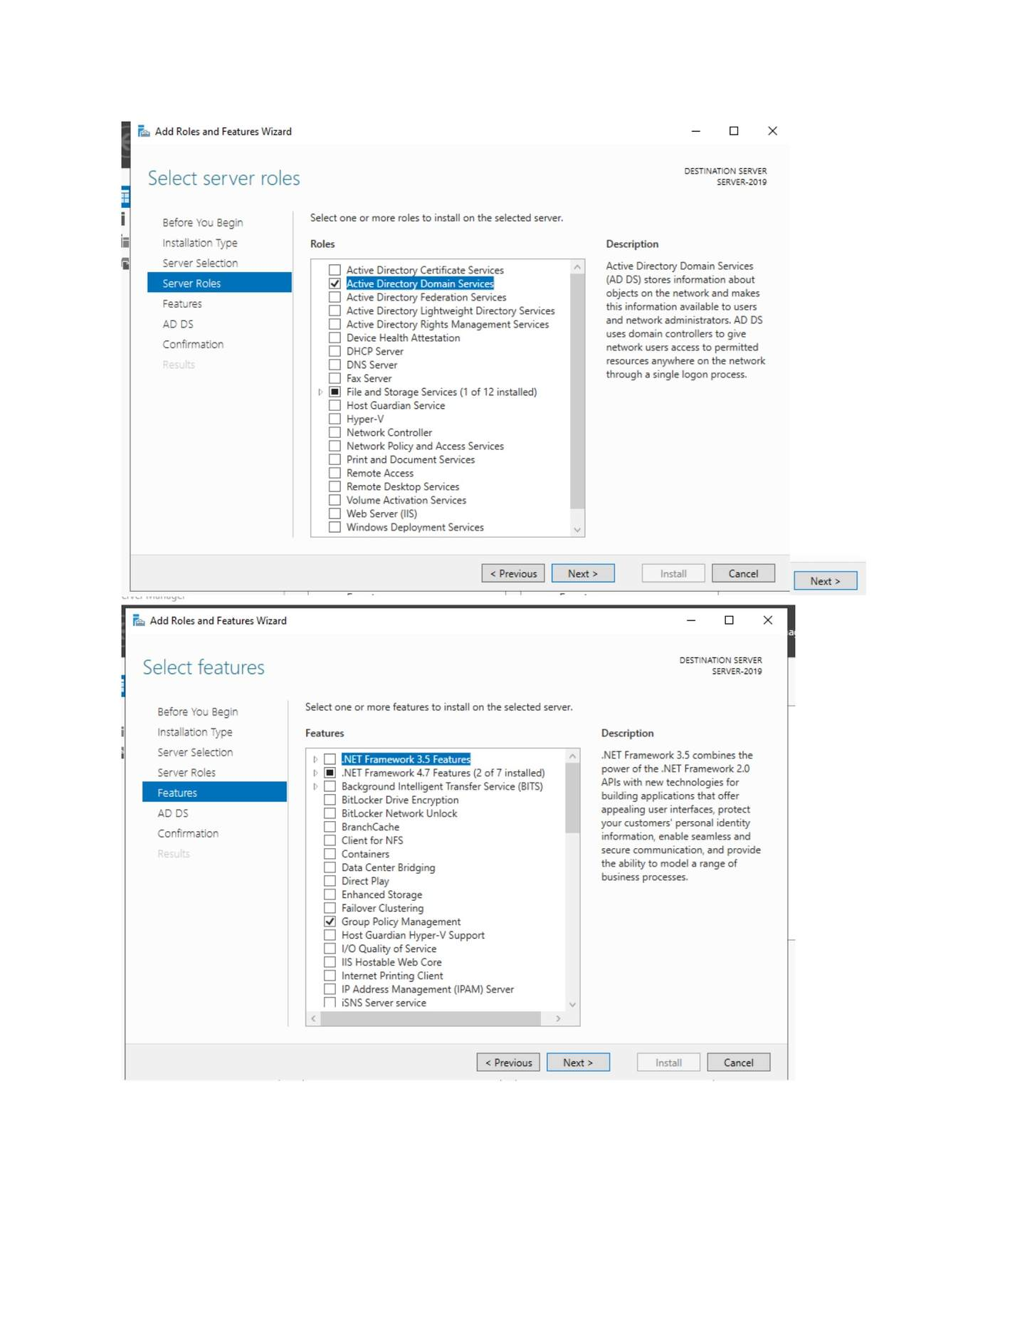
What I did: Selected Active Directory Domain Services from the server roles list.

PAGE 50 — ADDS AND USER MANAGEMENT
Topic: ADDS and User Management
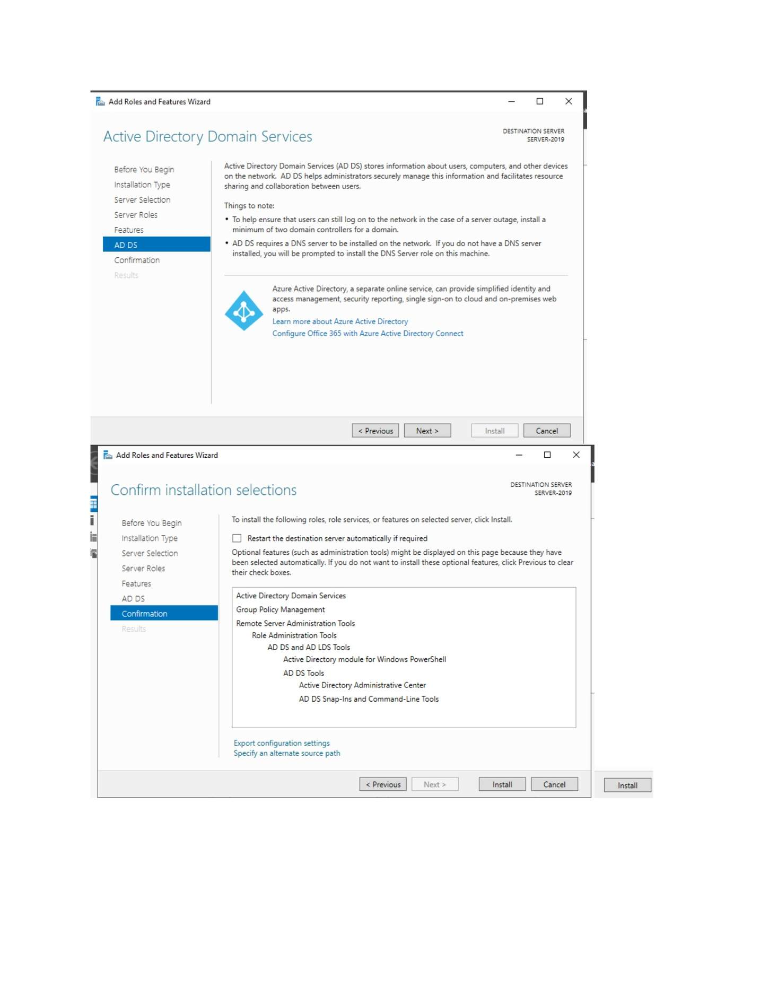
What I did: Reviewed the AD DS role information and continued to the installation selections.

PAGE 51 — ADDS AND USER MANAGEMENT
Topic: ADDS and User Management
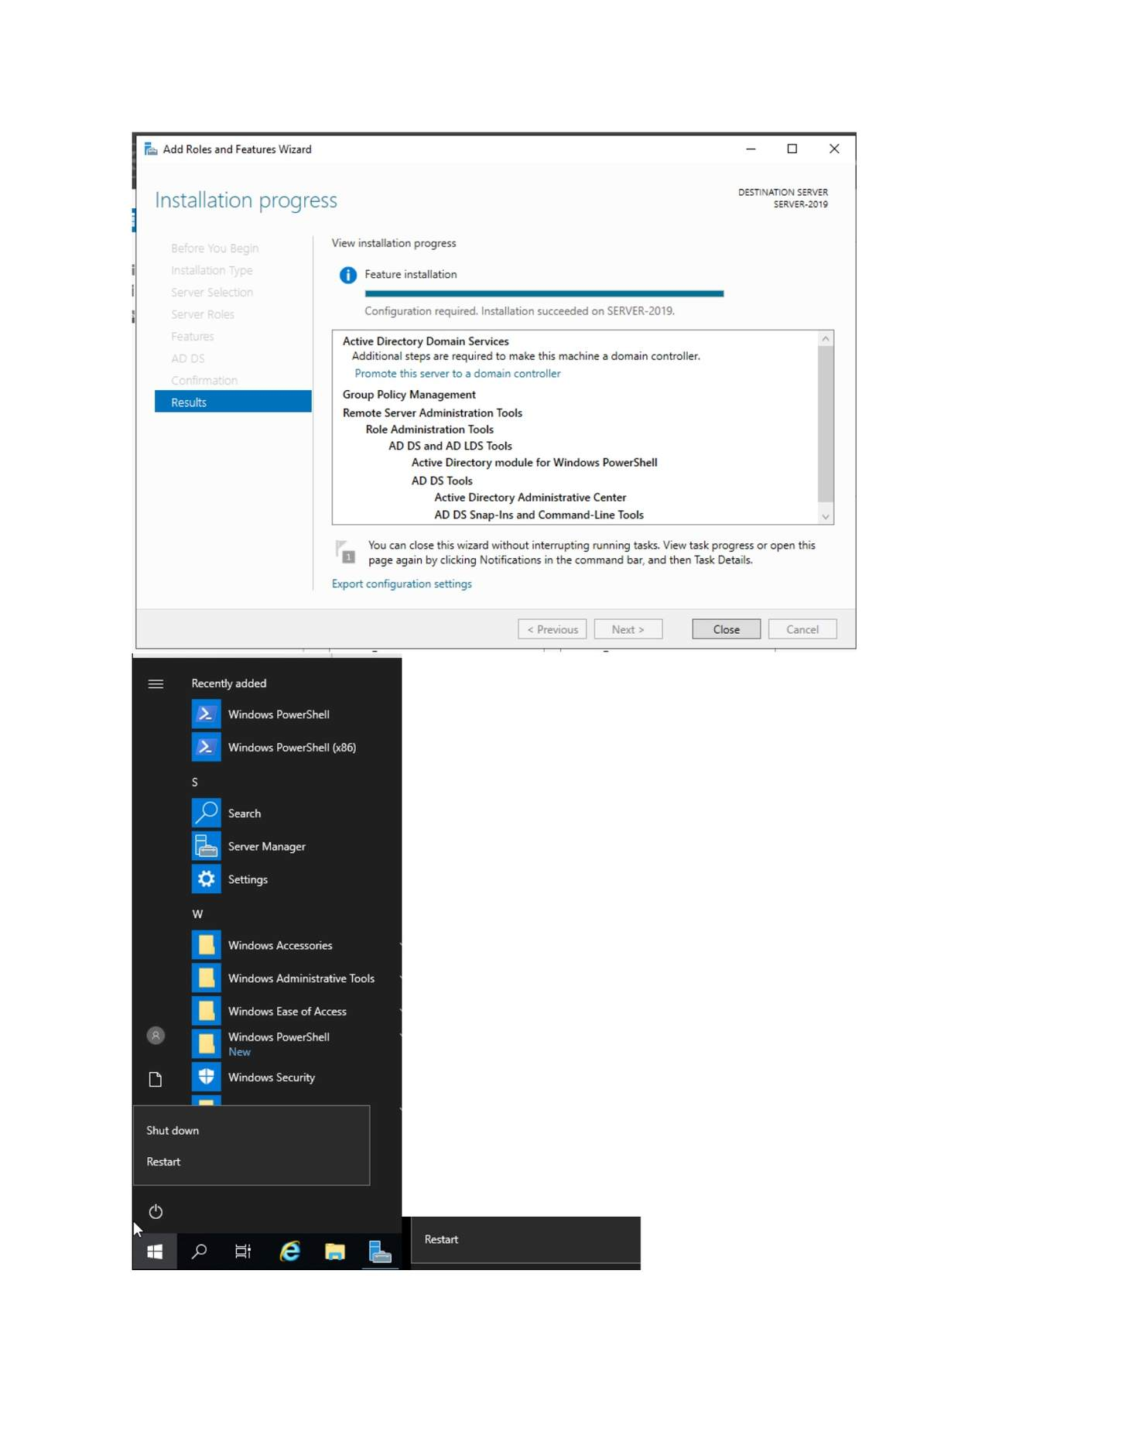
What I did: Confirmed the AD DS installation selections and started installation.

PAGE 52 — ADDS AND USER MANAGEMENT
Topic: ADDS and User Management
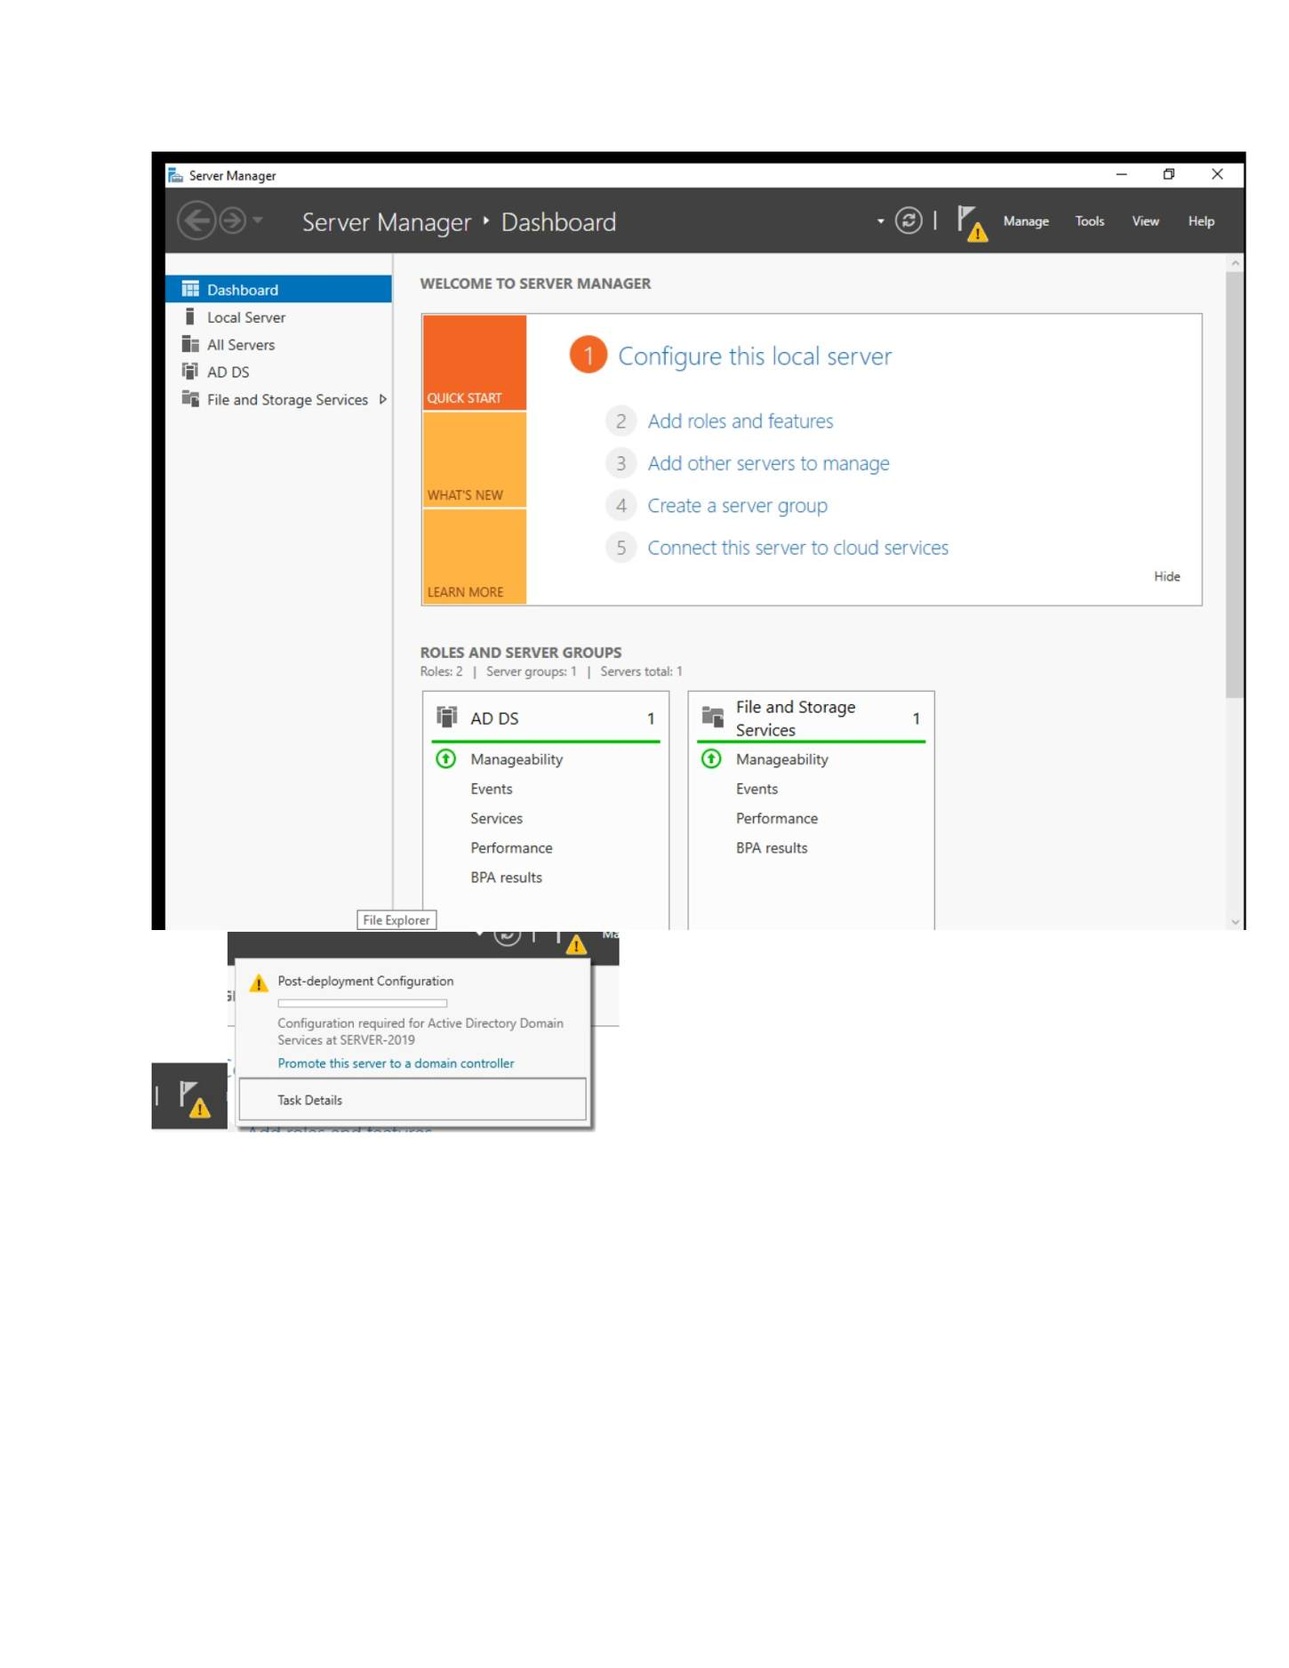
What I did: Waited while the AD DS role installation completed.

PAGE 53 — ADDS AND USER MANAGEMENT
Topic: ADDS and User Management
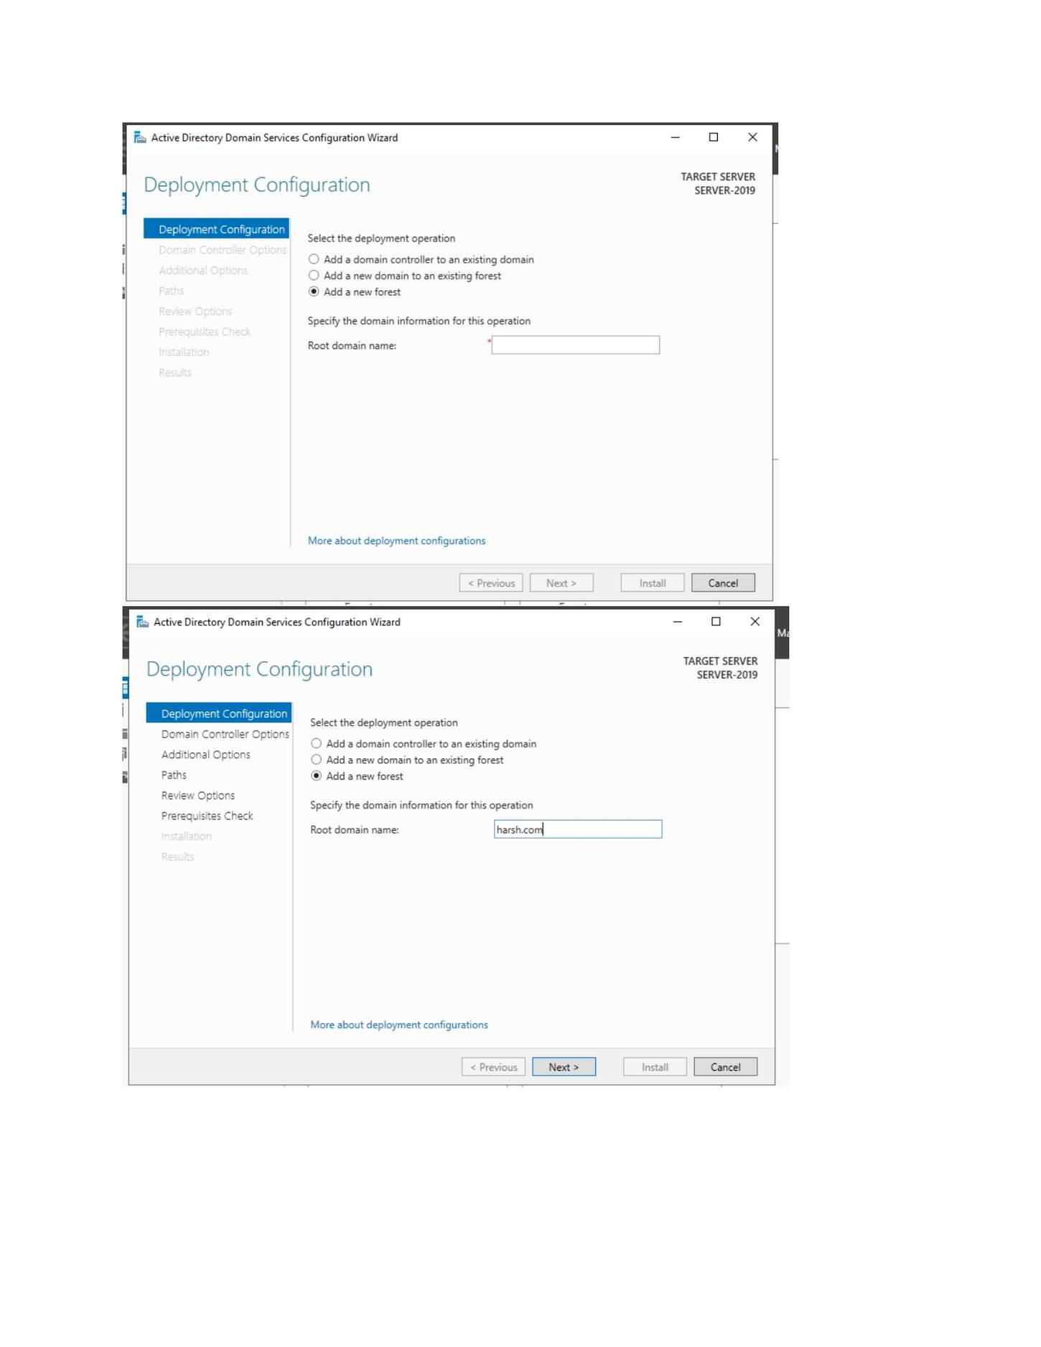
What I did: Returned to Server Manager after AD DS installation.

PAGE 54 — ADDS AND USER MANAGEMENT
Topic: ADDS and User Management
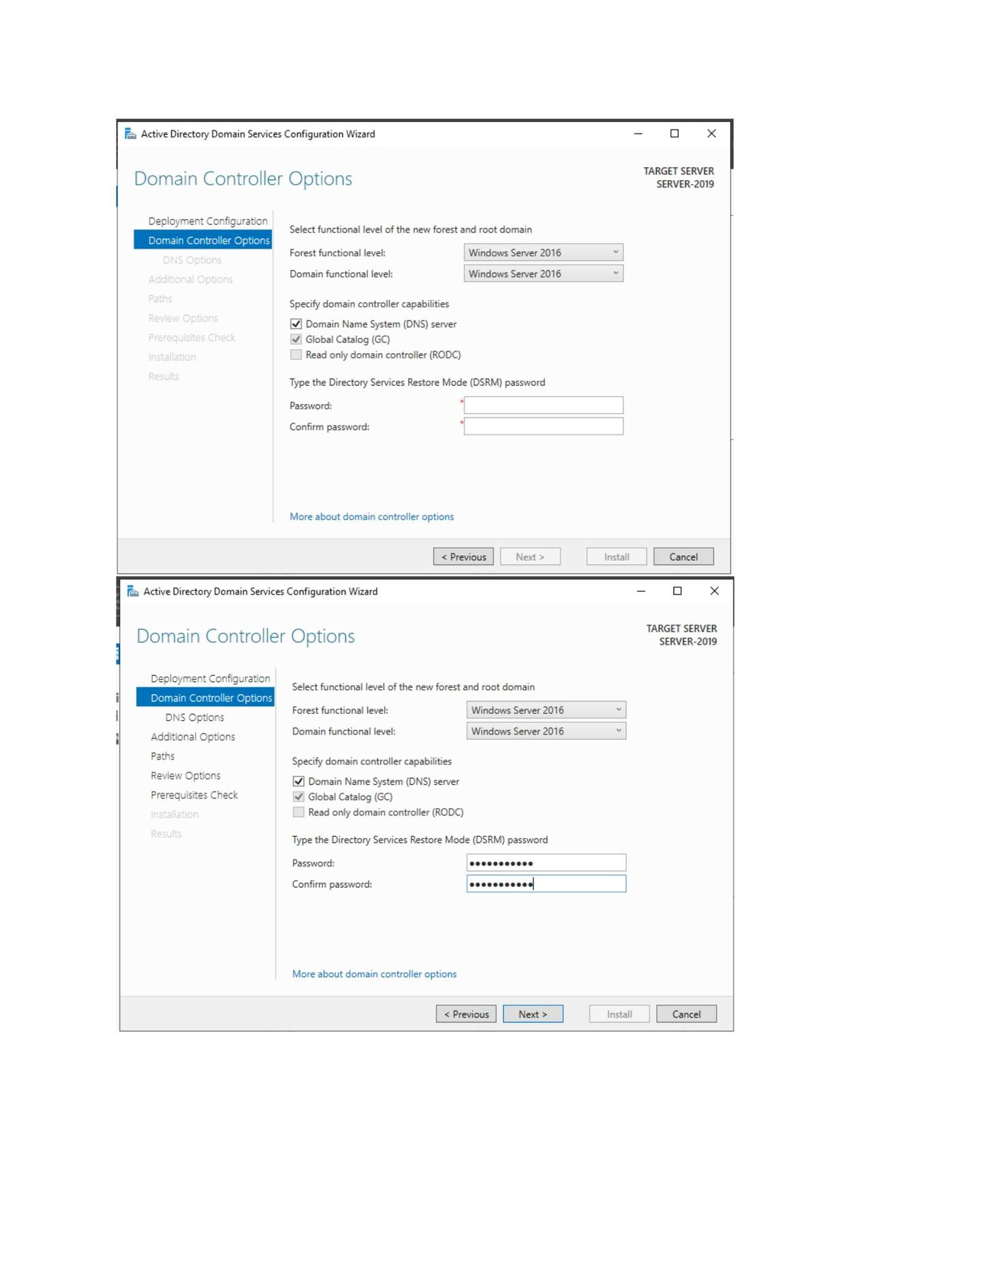
What I did: Opened the AD DS deployment configuration and selected the new-forest/domain-controller setup.

PAGE 55 — ADDS AND USER MANAGEMENT
Topic: ADDS and User Management
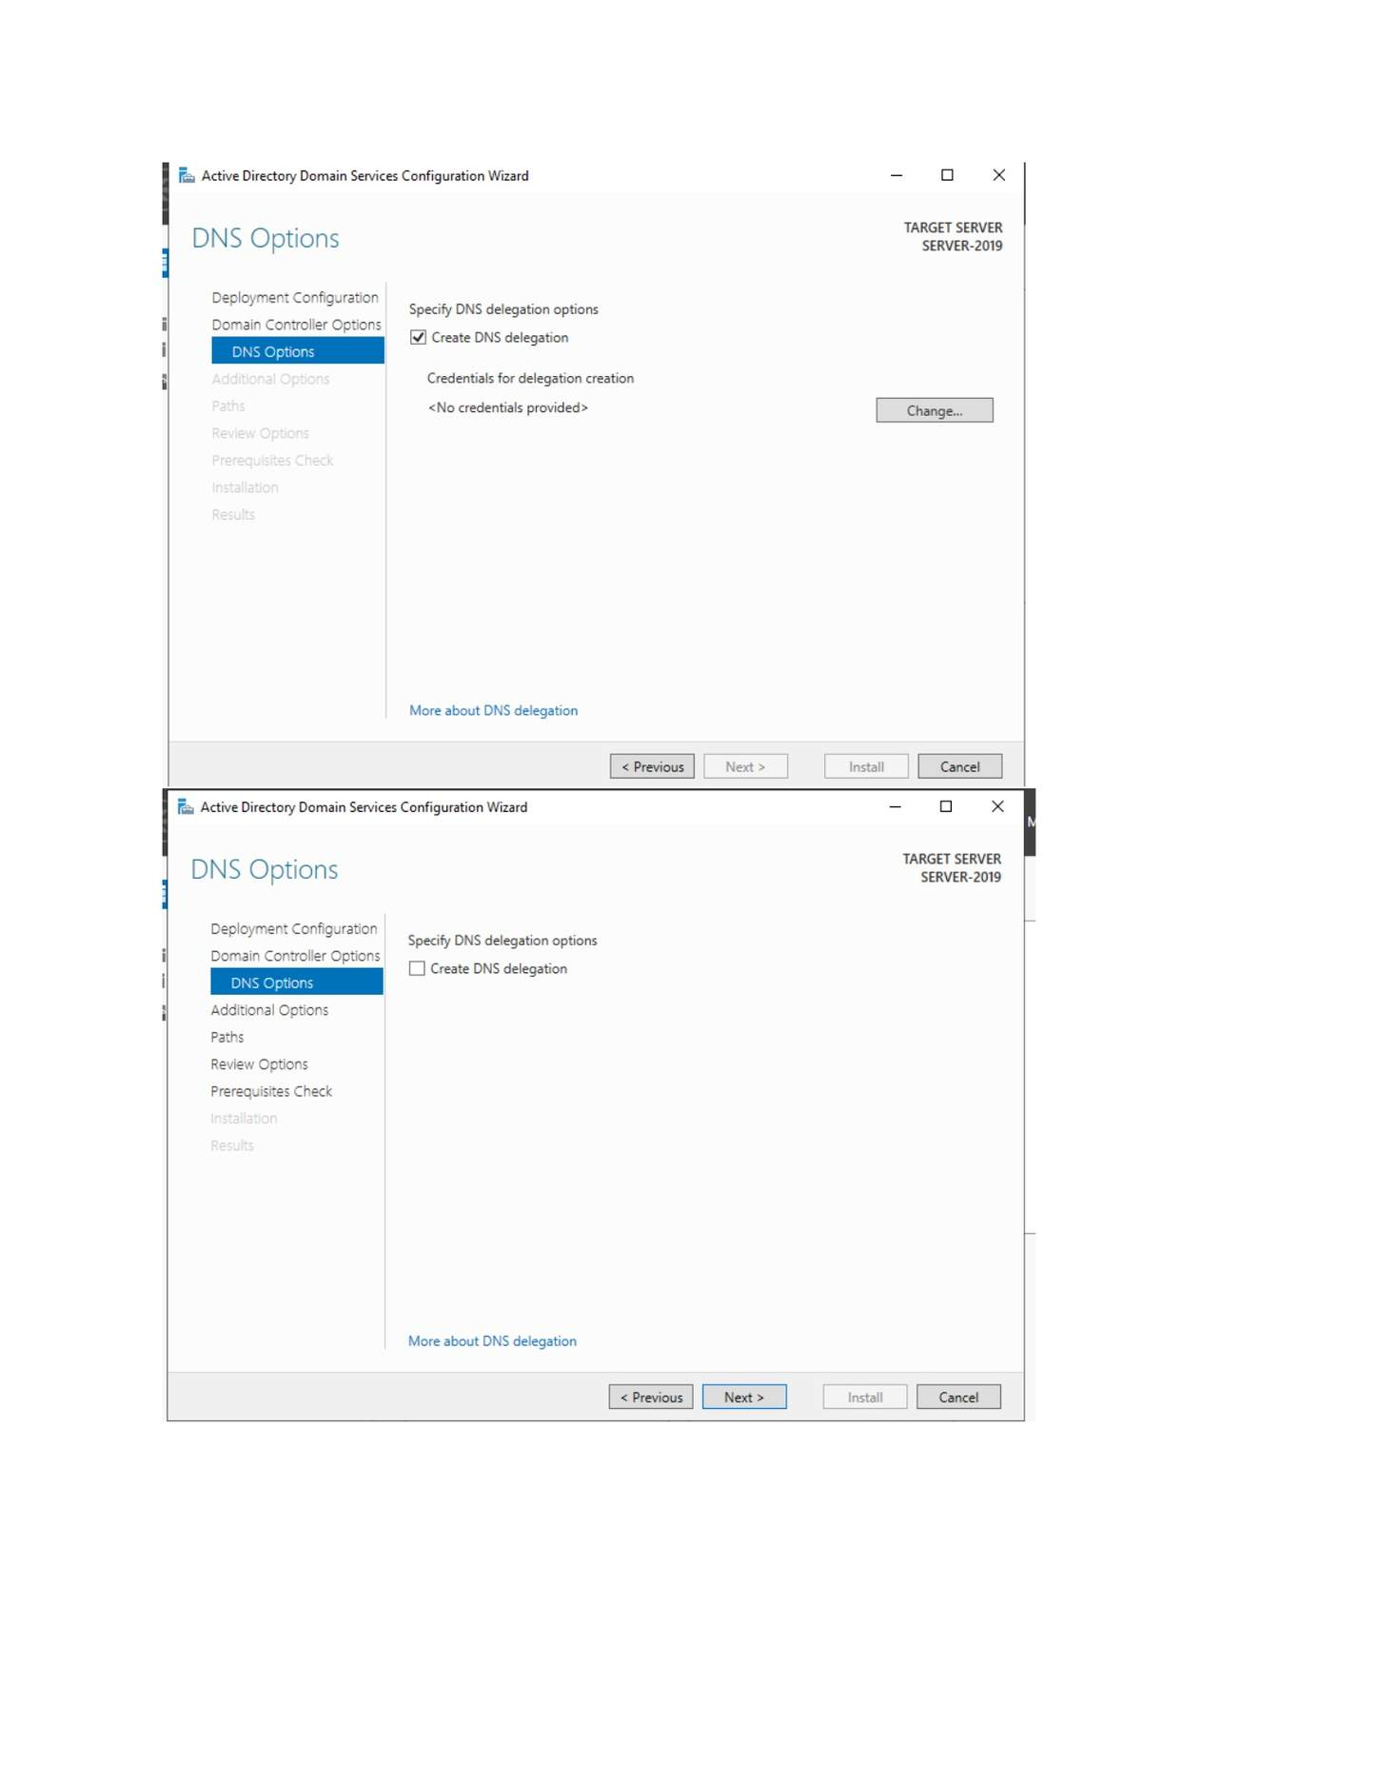
What I did: Configured the domain-controller options and functional levels.

PAGE 56 — ADDS AND USER MANAGEMENT
Topic: ADDS and User Management
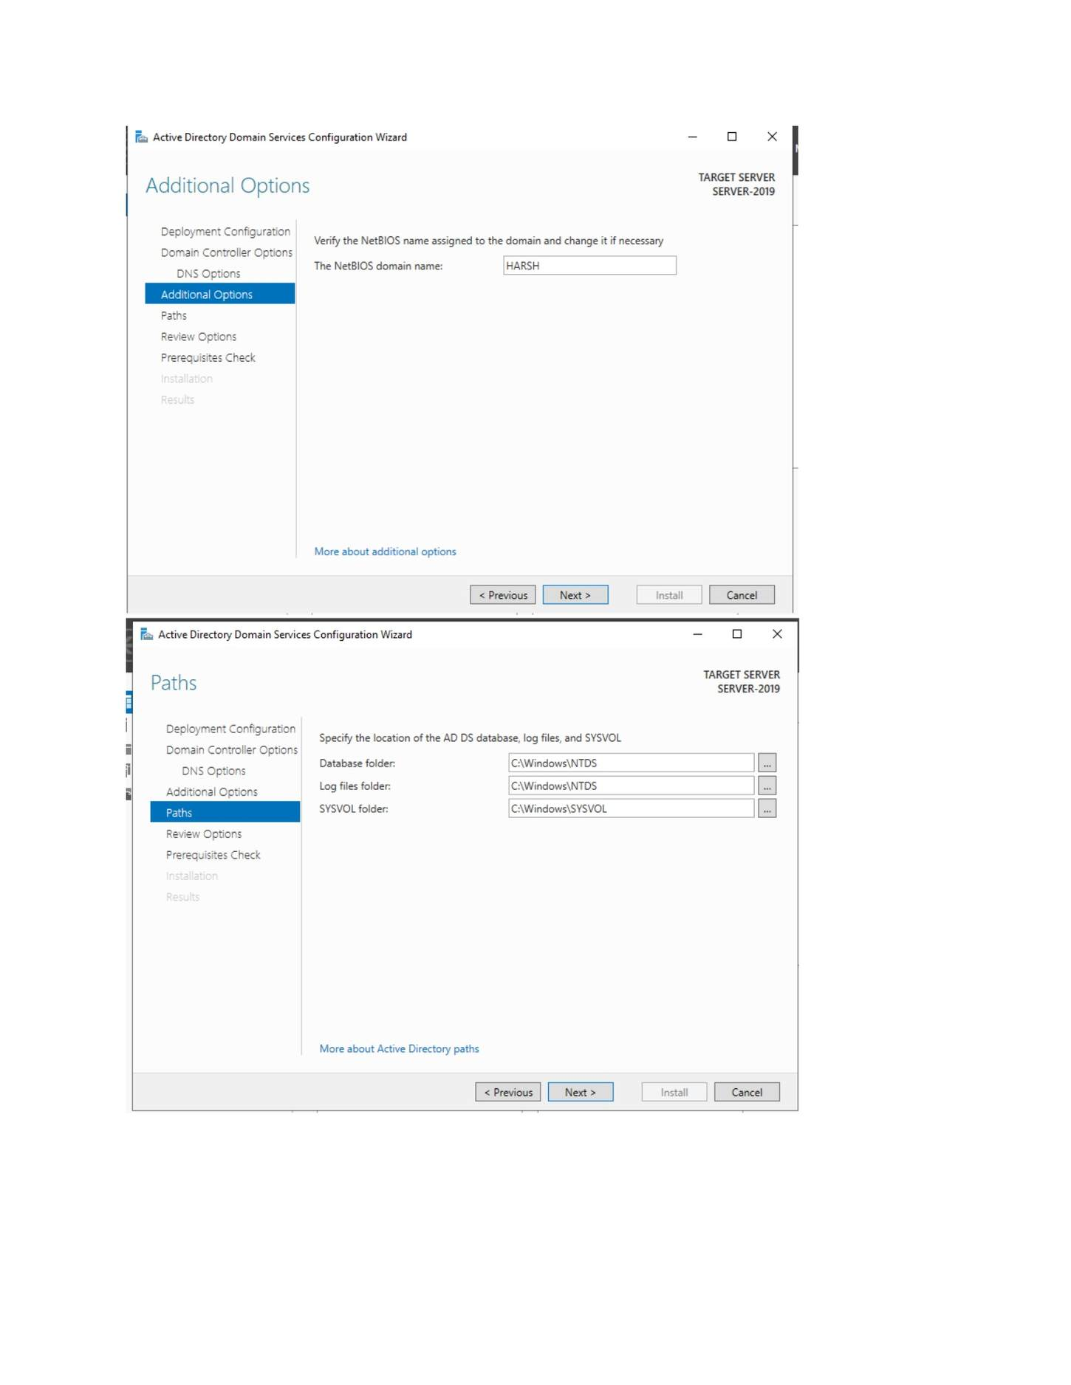
What I did: Configured the DNS options required during domain-controller promotion.

PAGE 57 — ADDS AND USER MANAGEMENT
Topic: ADDS and User Management
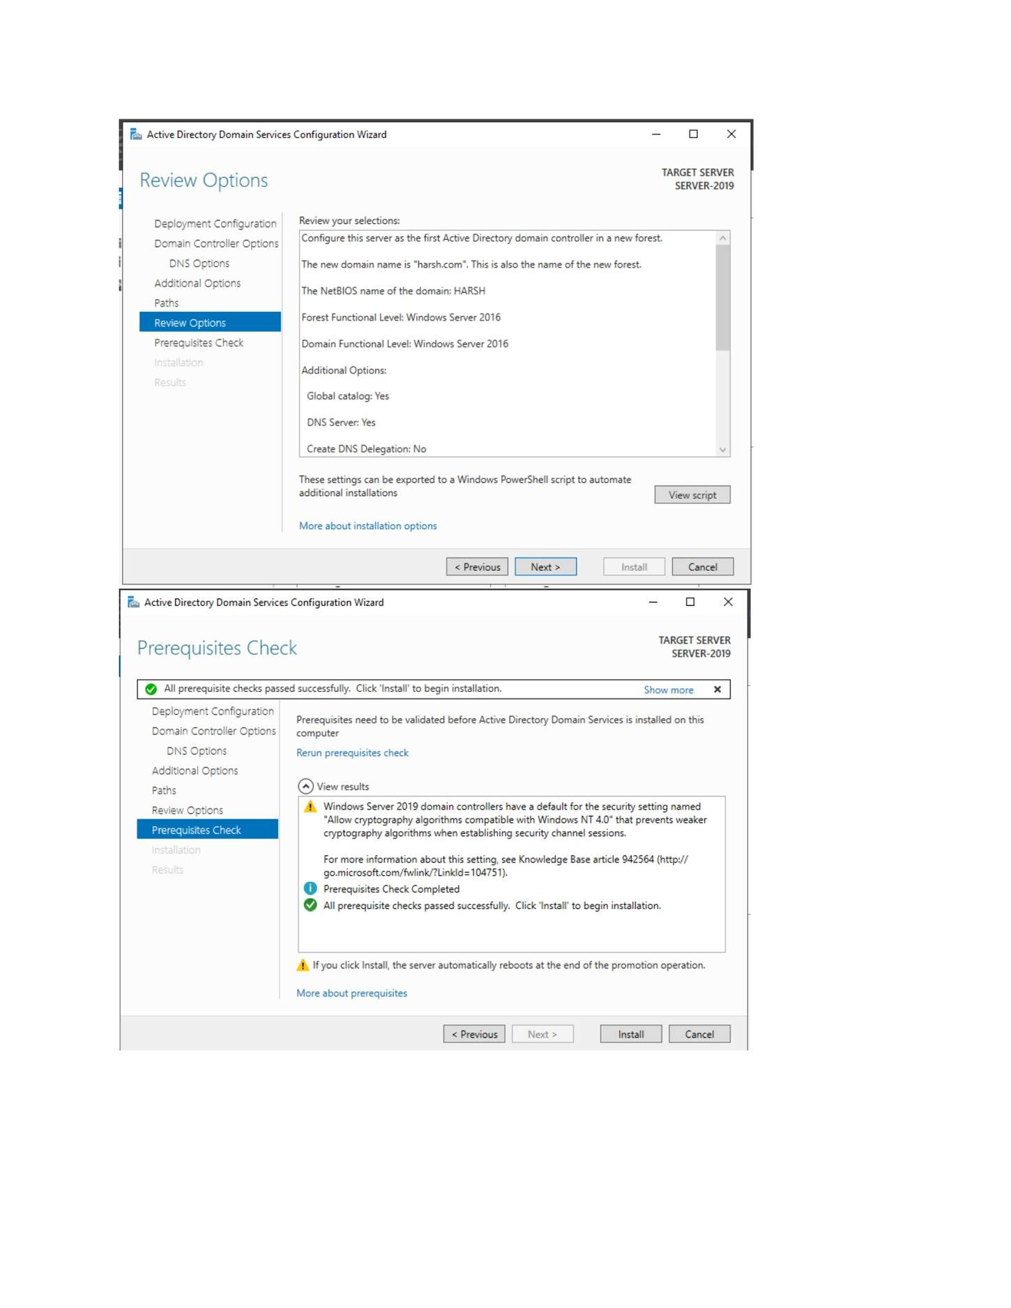
What I did: Entered the additional domain/NetBIOS information for the new domain.

PAGE 58 — ADDS AND USER MANAGEMENT
Topic: ADDS and User Management
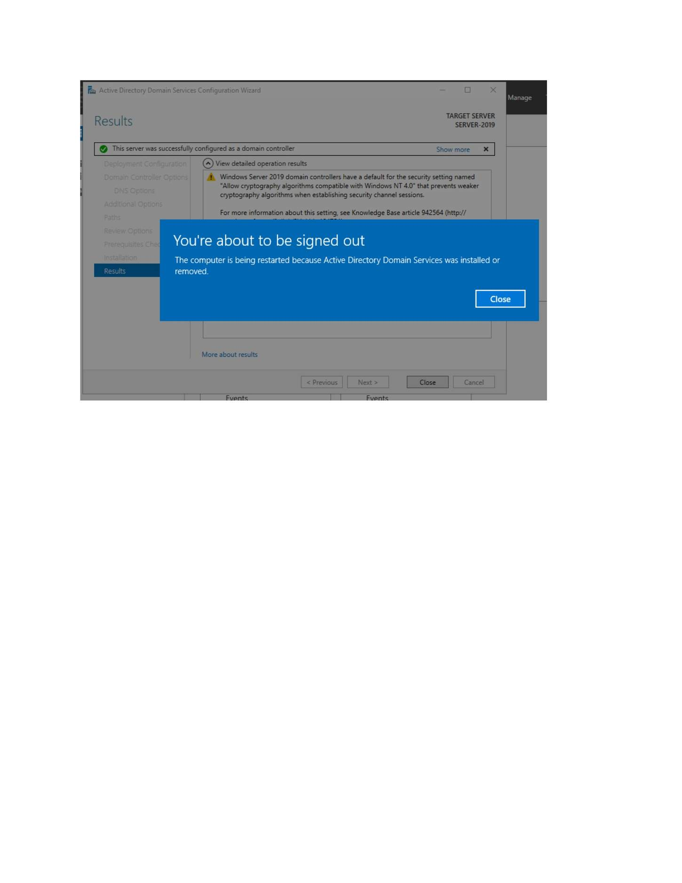
What I did: Reviewed the AD DS database, log and SYSVOL path settings.

PAGE 59 — ADDS AND USER MANAGEMENT
Topic: ADDS and User Management
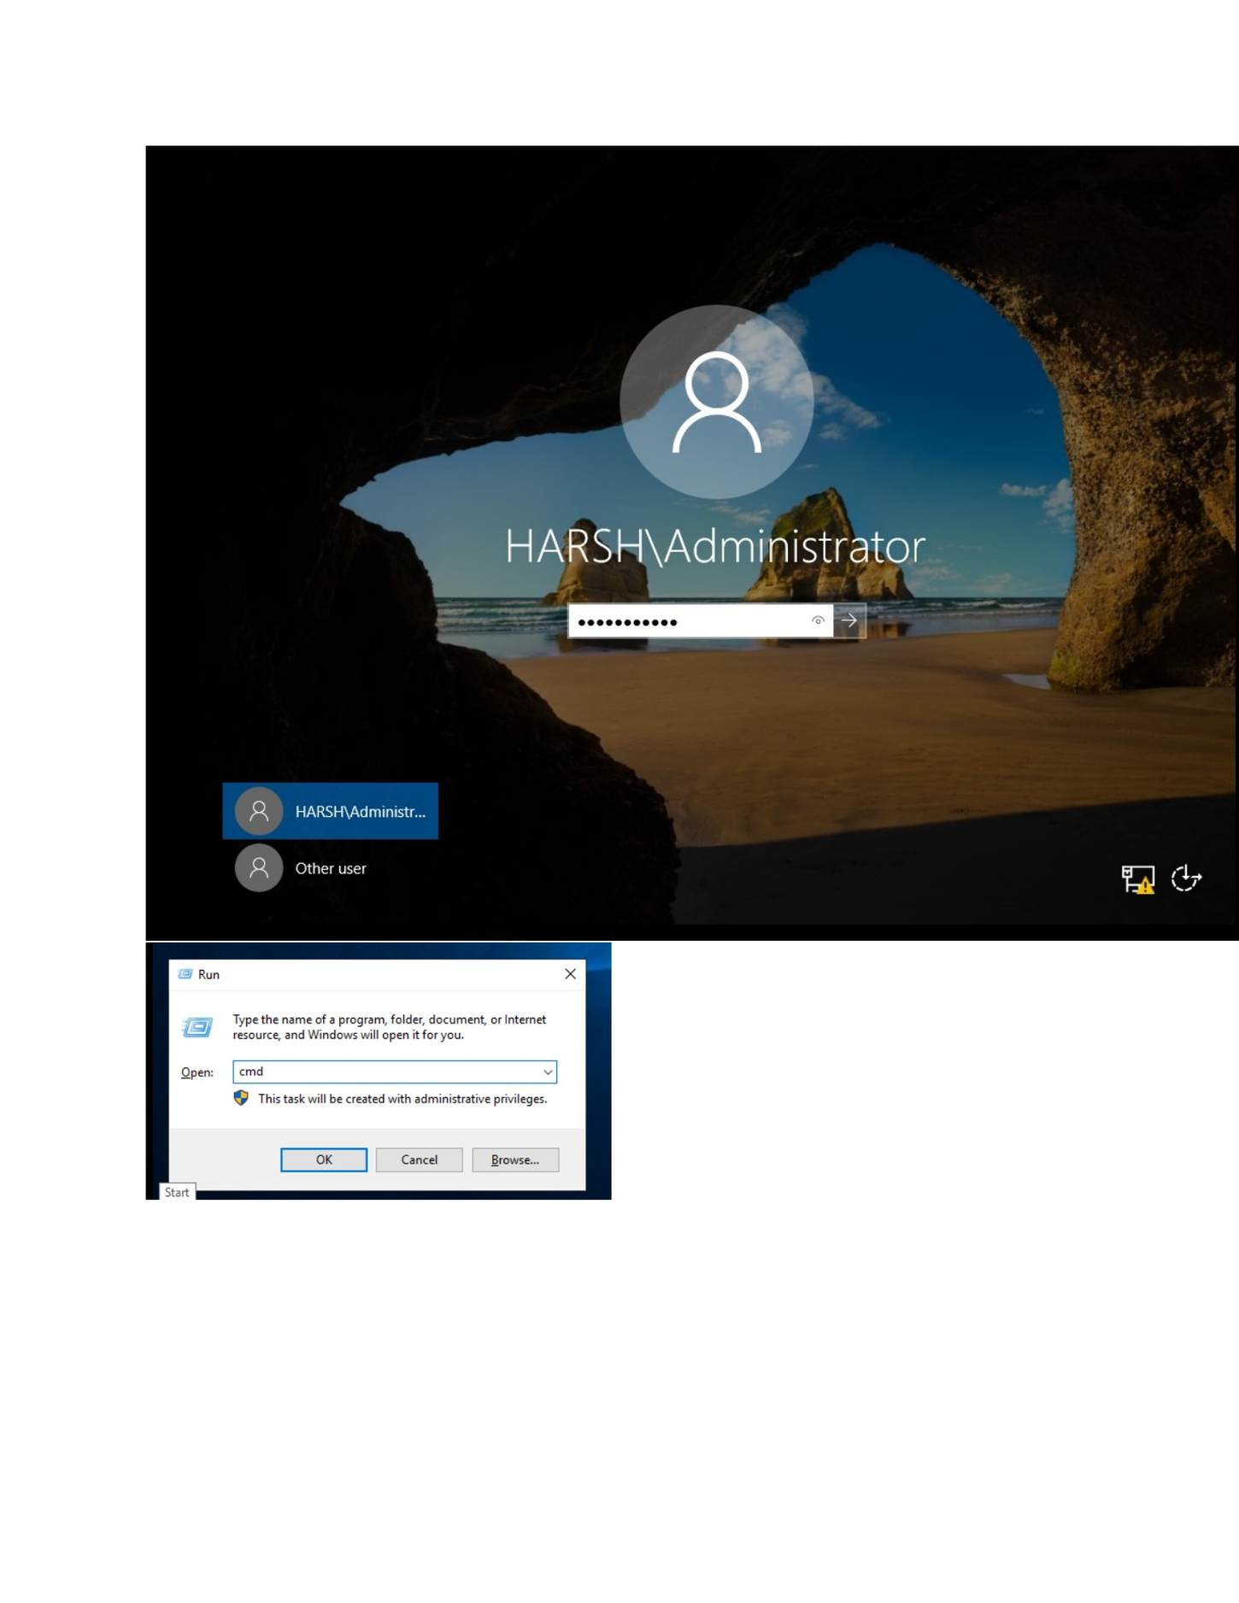
What I did: Reviewed the complete promotion configuration before installing the domain controller.

PAGE 60 — ADDS AND USER MANAGEMENT
Topic: ADDS and User Management
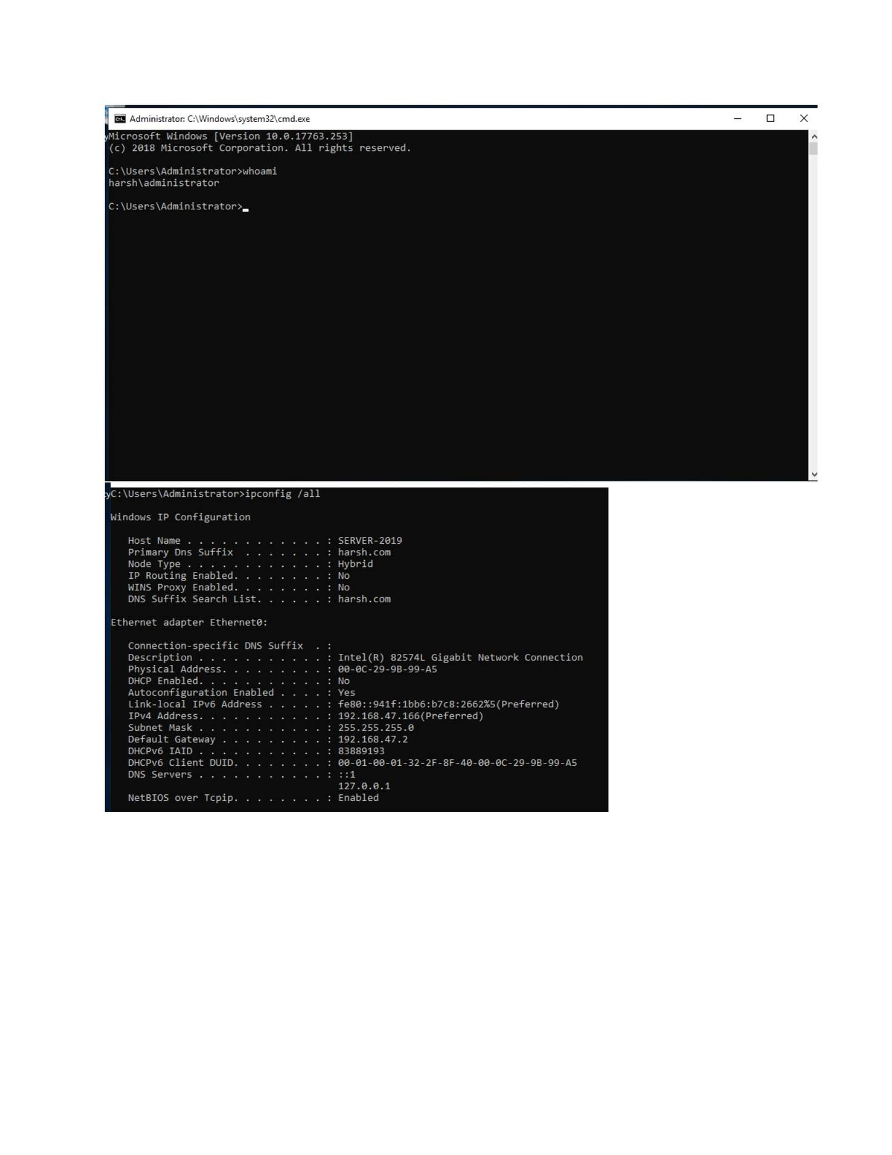
What I did: Started the domain-controller promotion process.

PAGE 61 — ADDS AND USER MANAGEMENT
Topic: ADDS and User Management
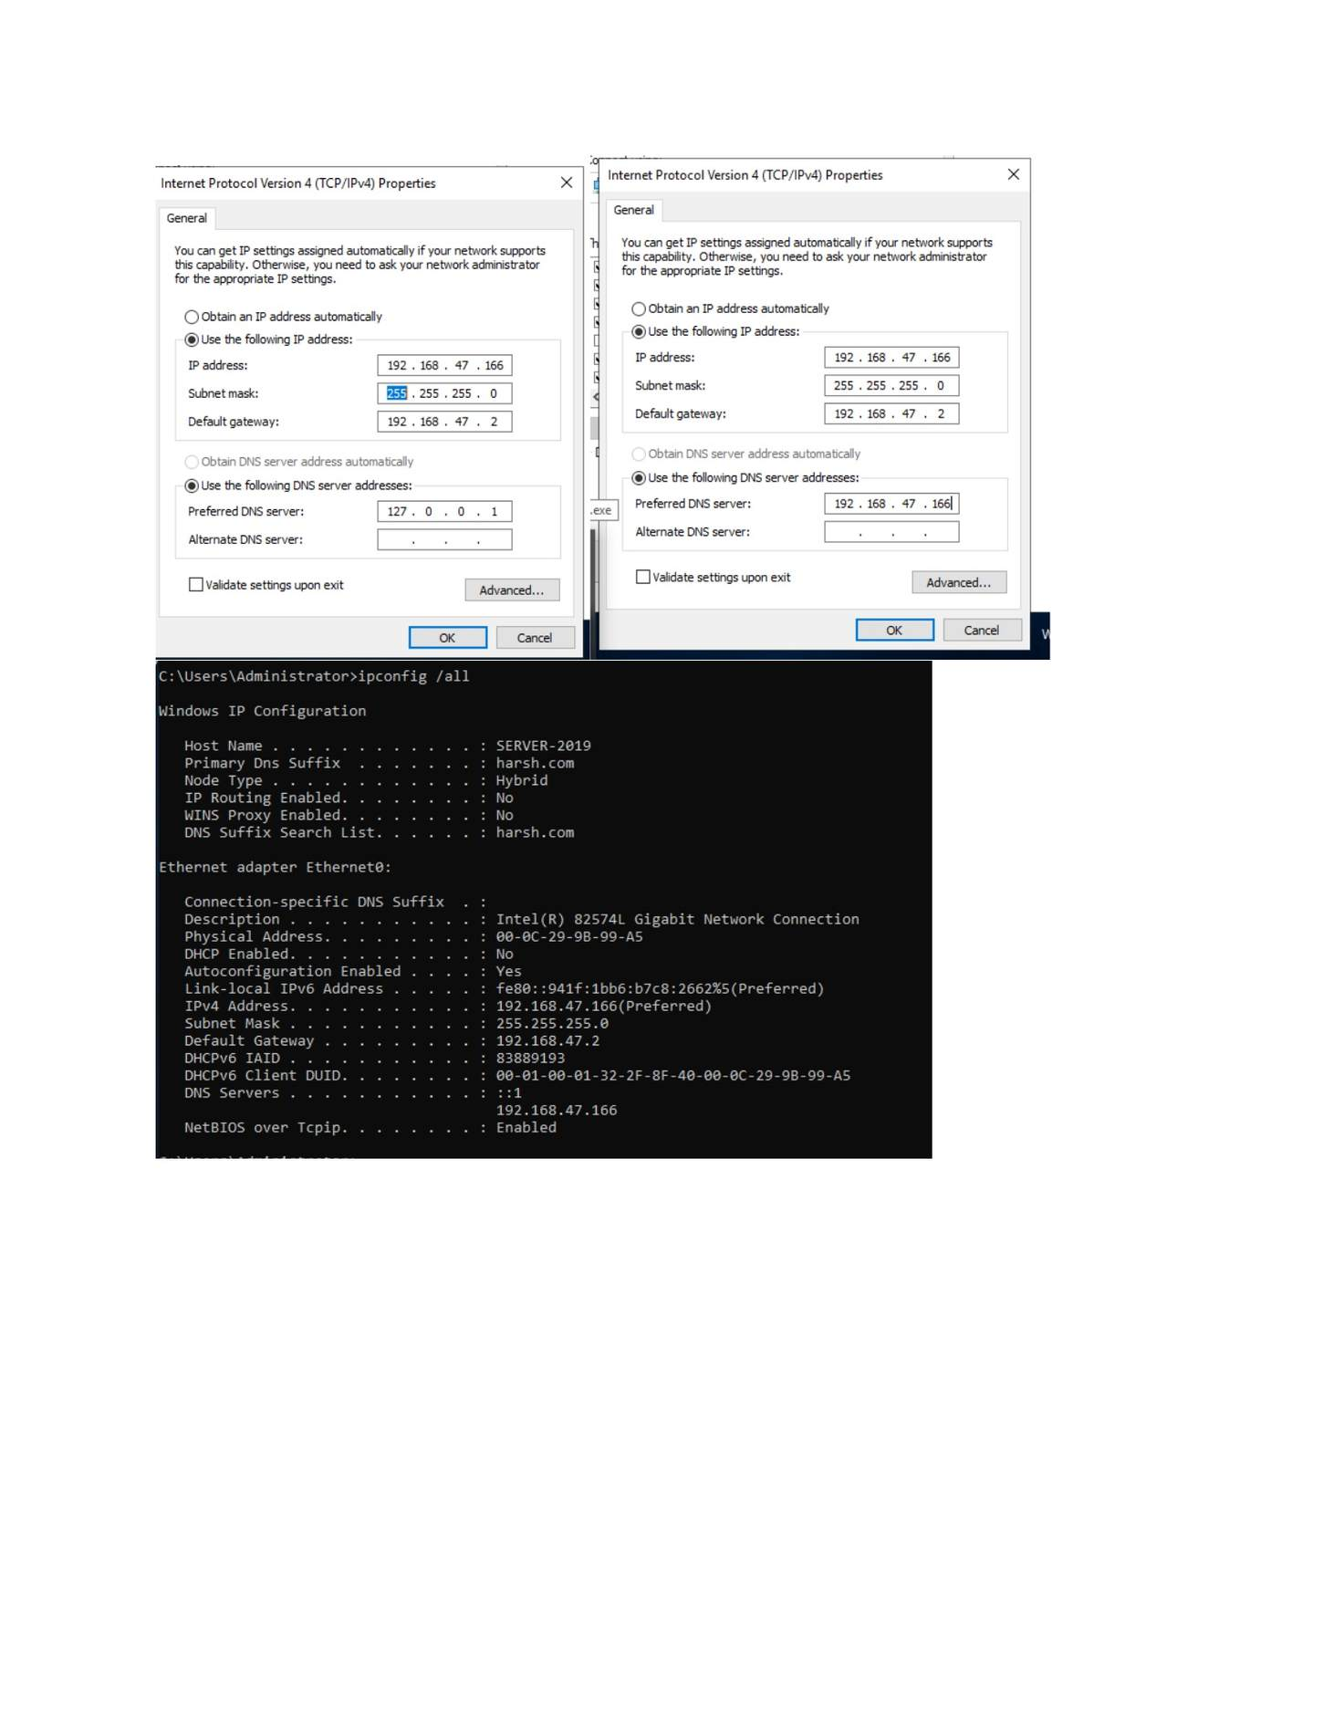
What I did: Confirmed the restart/sign-out required after domain-controller promotion.

PAGE 62 — ADDS AND USER MANAGEMENT
Topic: ADDS and User Management
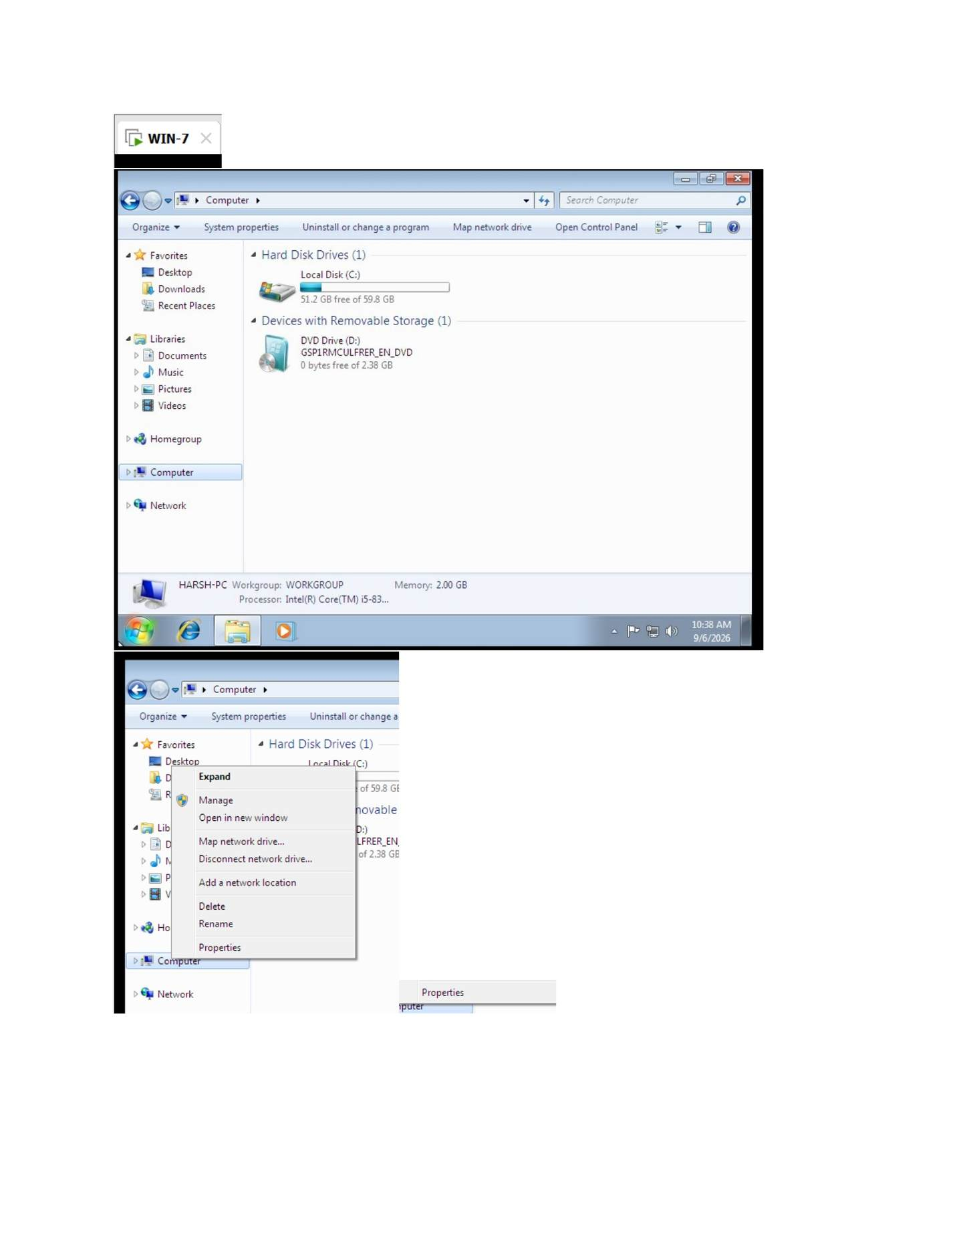
What I did: Signed in with the domain Administrator account after the server restart.

PAGE 63 — ADDS AND USER MANAGEMENT
Topic: ADDS and User Management
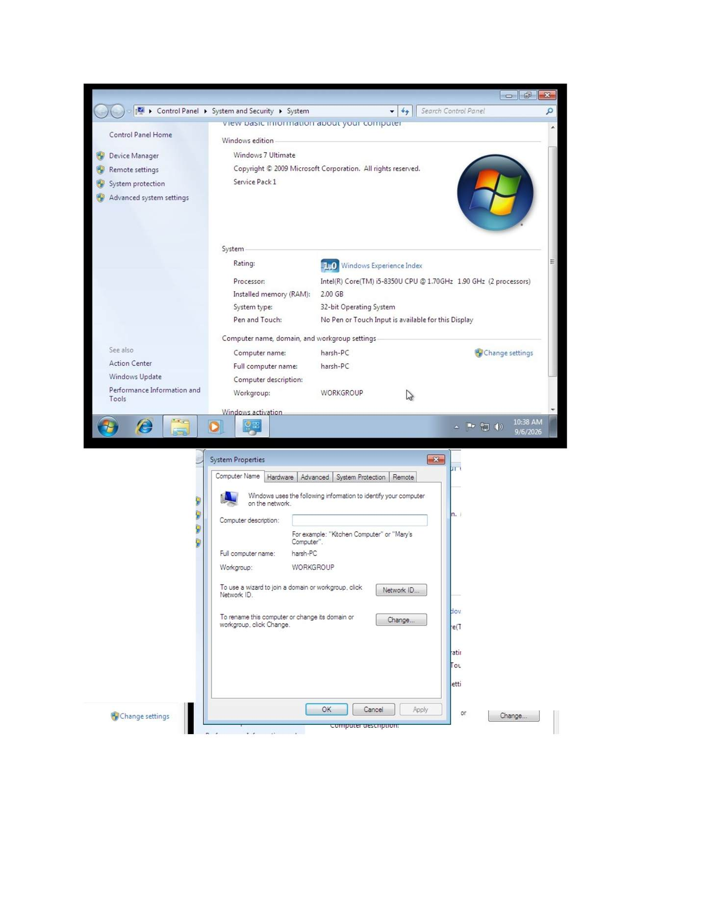
What I did: Opened the Windows 7 client and reviewed its computer/system settings.

PAGE 64 — ADDS AND USER MANAGEMENT
Topic: ADDS and User Management
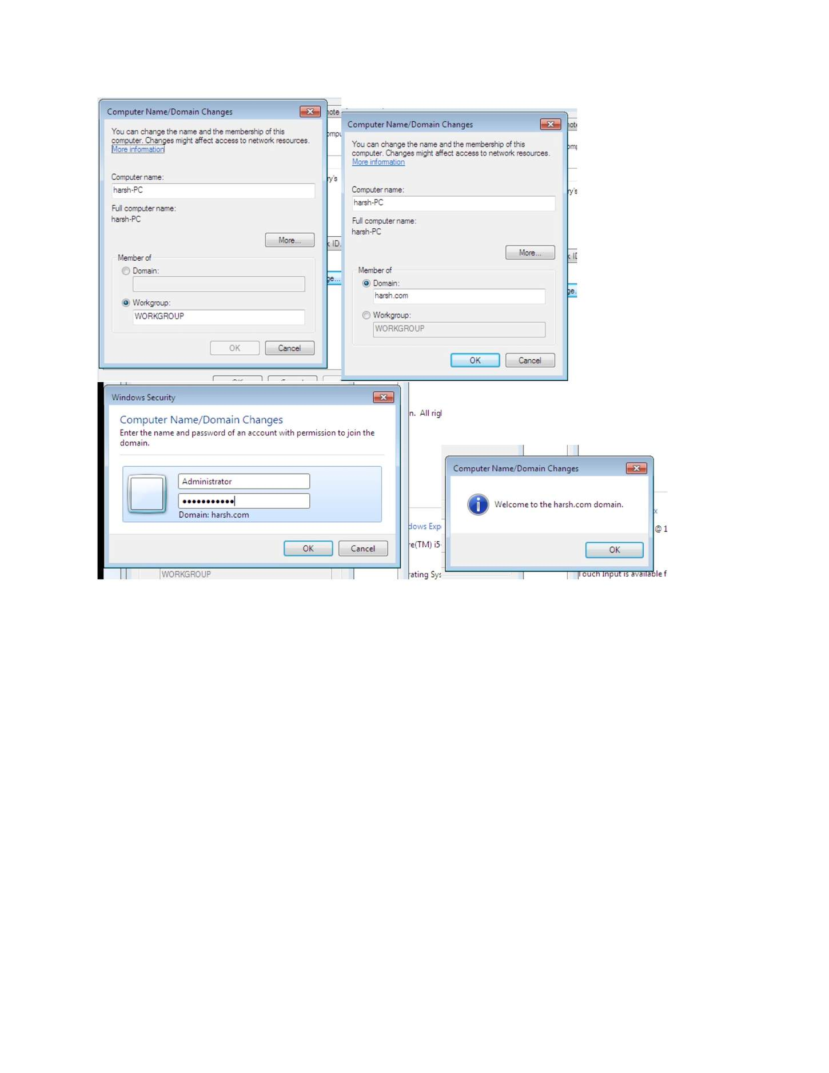
What I did: Opened Windows 7 System Properties to prepare the client for the domain.

PAGE 65 — ADDS AND USER MANAGEMENT
Topic: ADDS and User Management
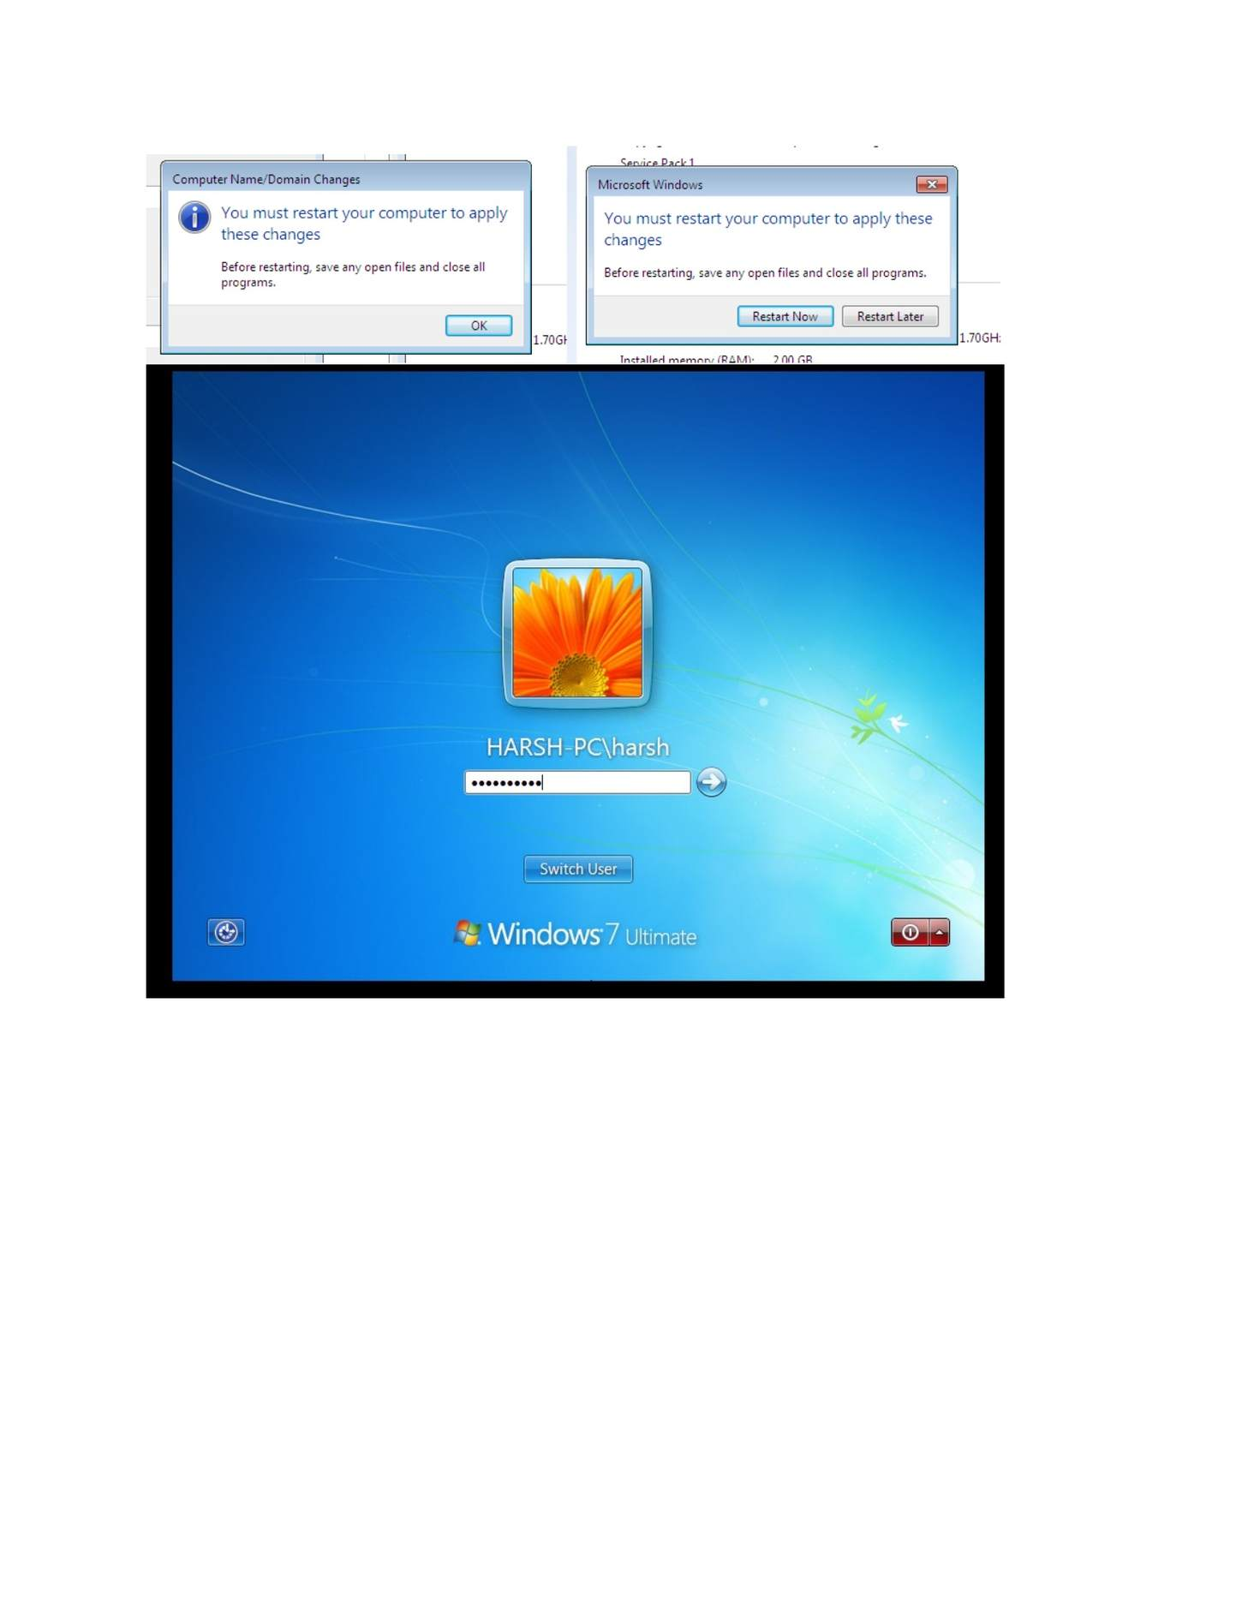
What I did: Opened Computer Name/Domain Changes and entered the domain information.

PAGE 66 — ADDS AND USER MANAGEMENT
Topic: ADDS and User Management
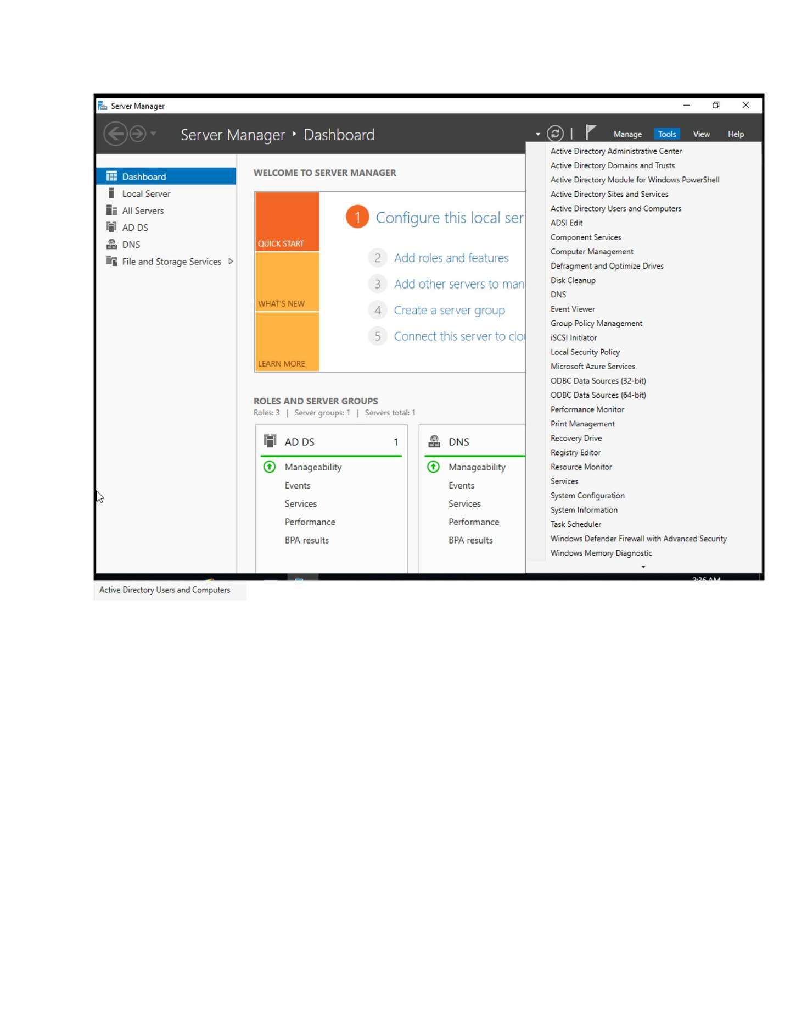
What I did: Confirmed the domain join/computer-name change on the Windows 7 client.

PAGE 67 — ADDS AND USER MANAGEMENT
Topic: ADDS and User Management
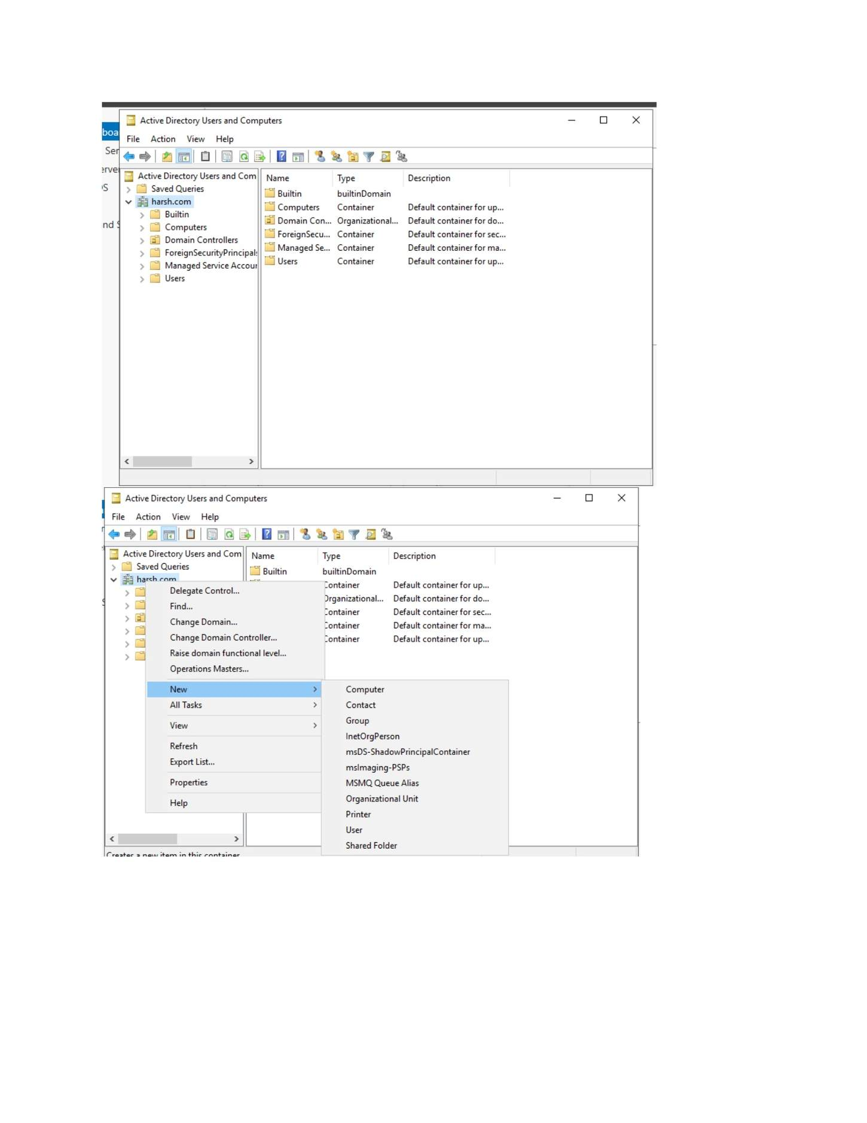
What I did: Verified the client computer after the domain configuration.

PAGE 68 — ADDS AND USER MANAGEMENT
Topic: ADDS and User Management
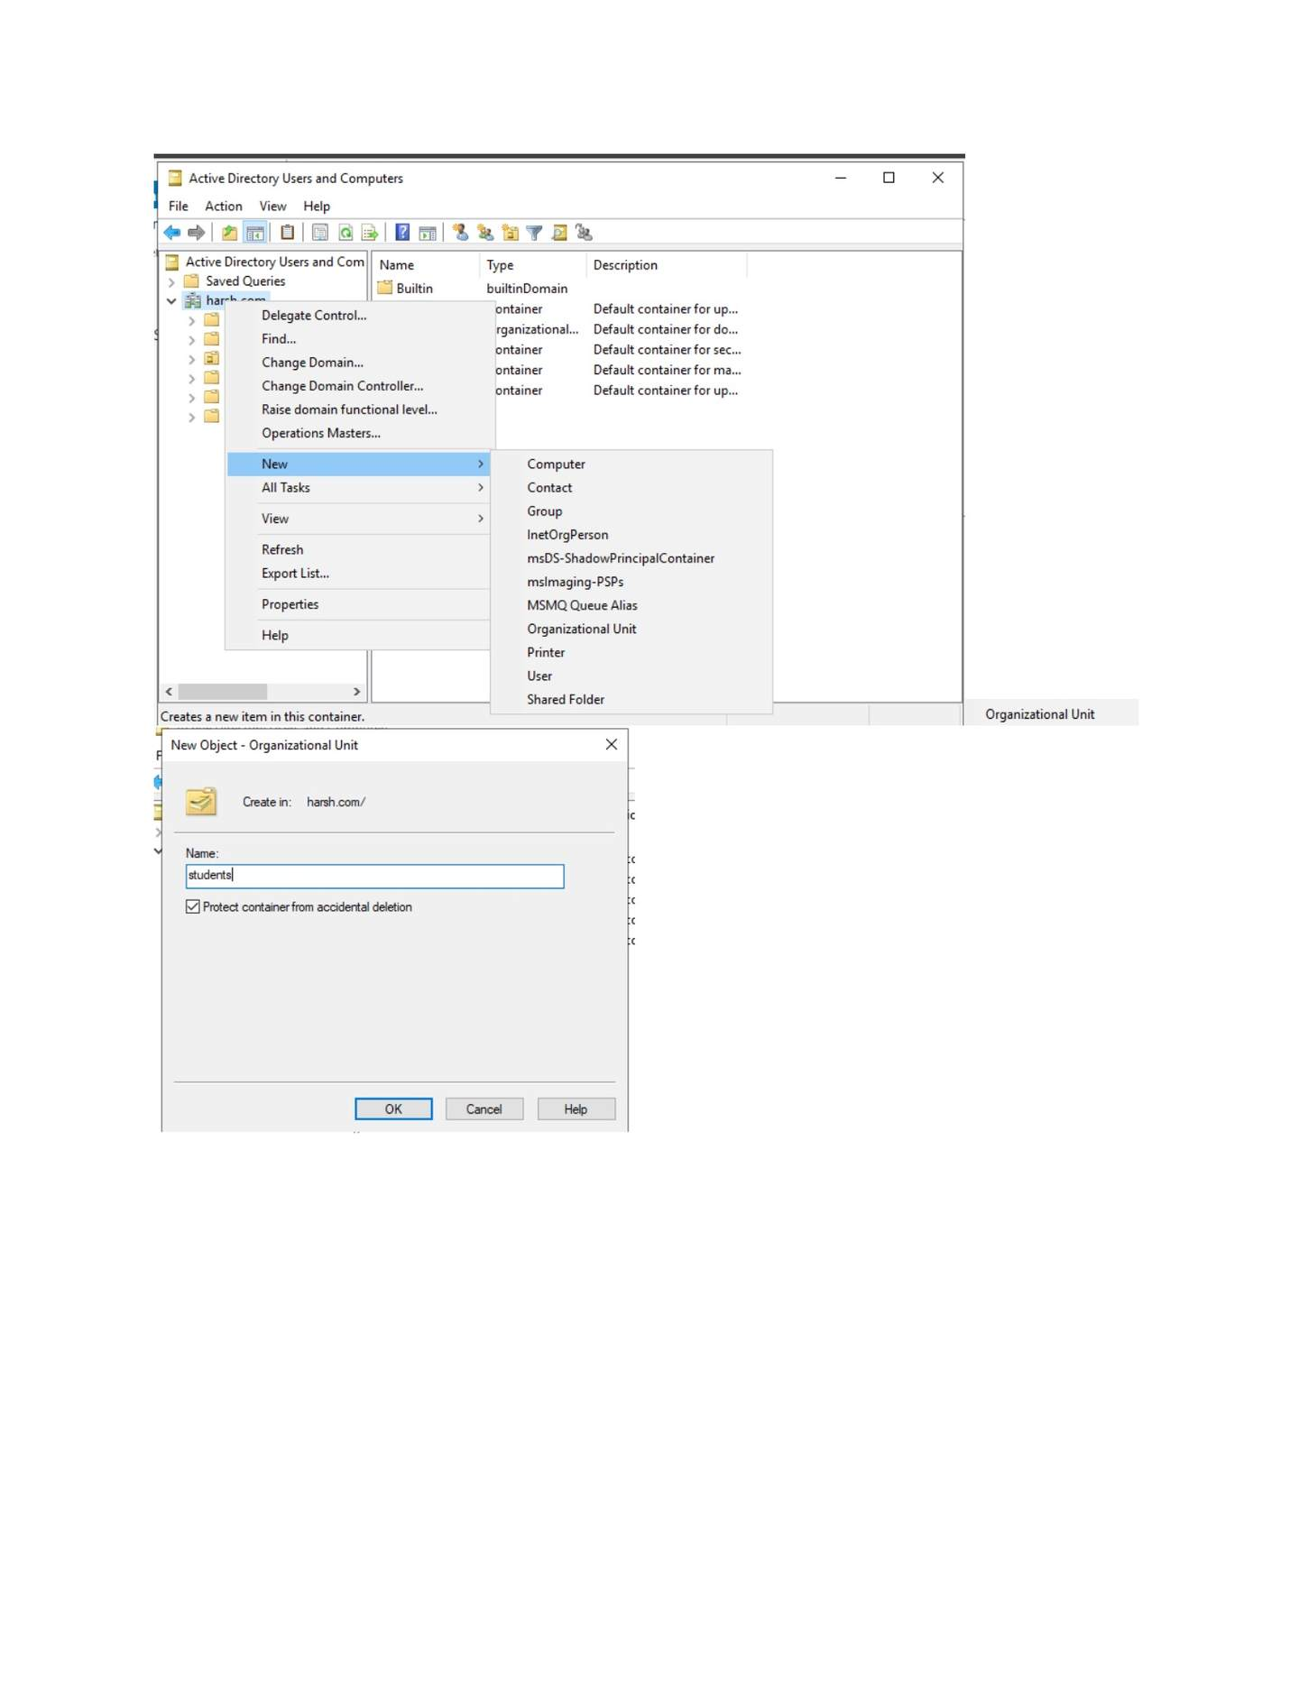
What I did: Opened Active Directory Users and Computers from the administrative tools.

PAGE 69 — ADDS AND USER MANAGEMENT
Topic: ADDS and User Management
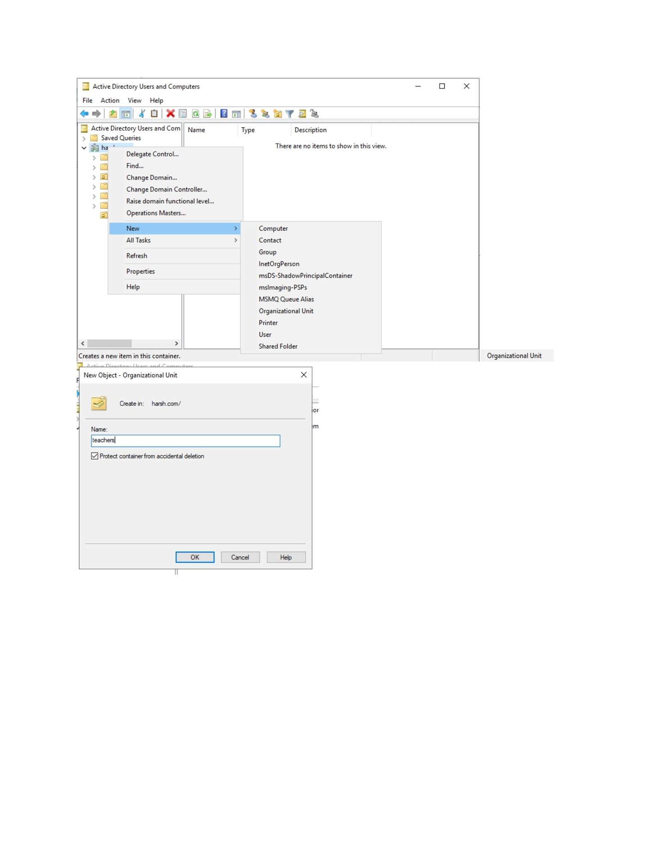
What I did: Expanded the domain tree and reviewed the available containers/OUs.

PAGE 70 — ADDS AND USER MANAGEMENT
Topic: ADDS and User Management
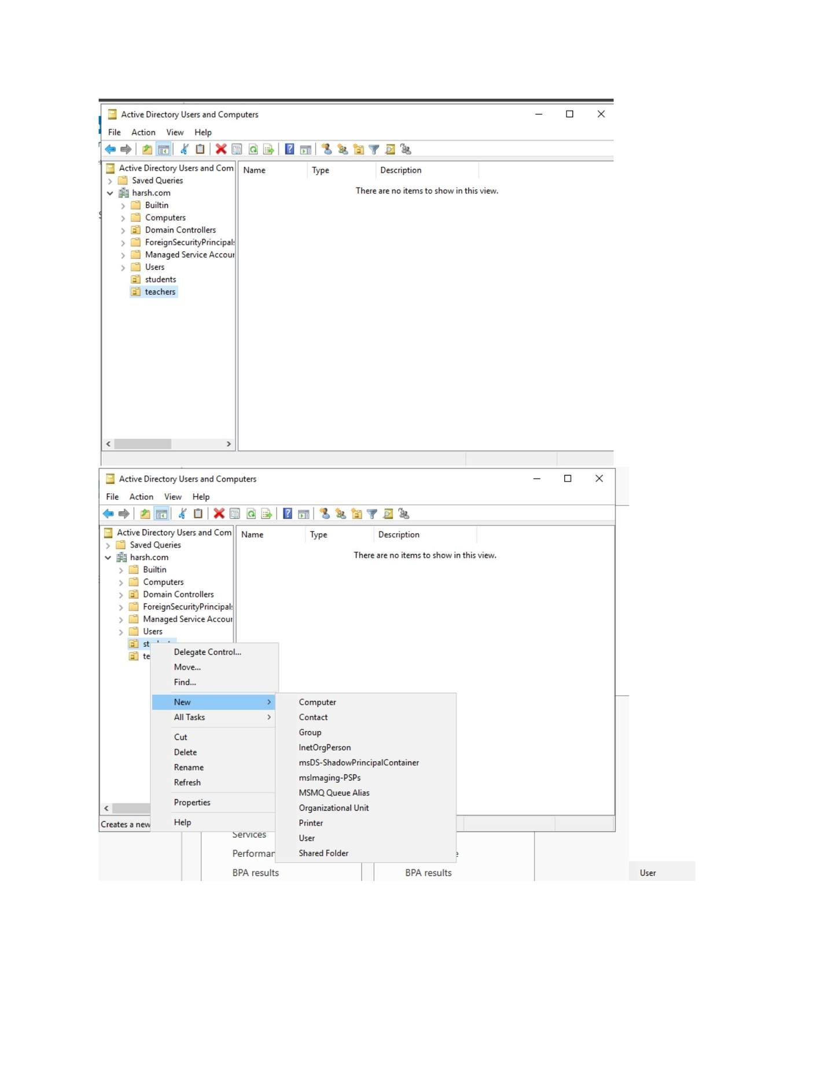
What I did: Opened the domain/Students area where the user account would be created.

PAGE 71 — ADDS AND USER MANAGEMENT
Topic: ADDS and User Management
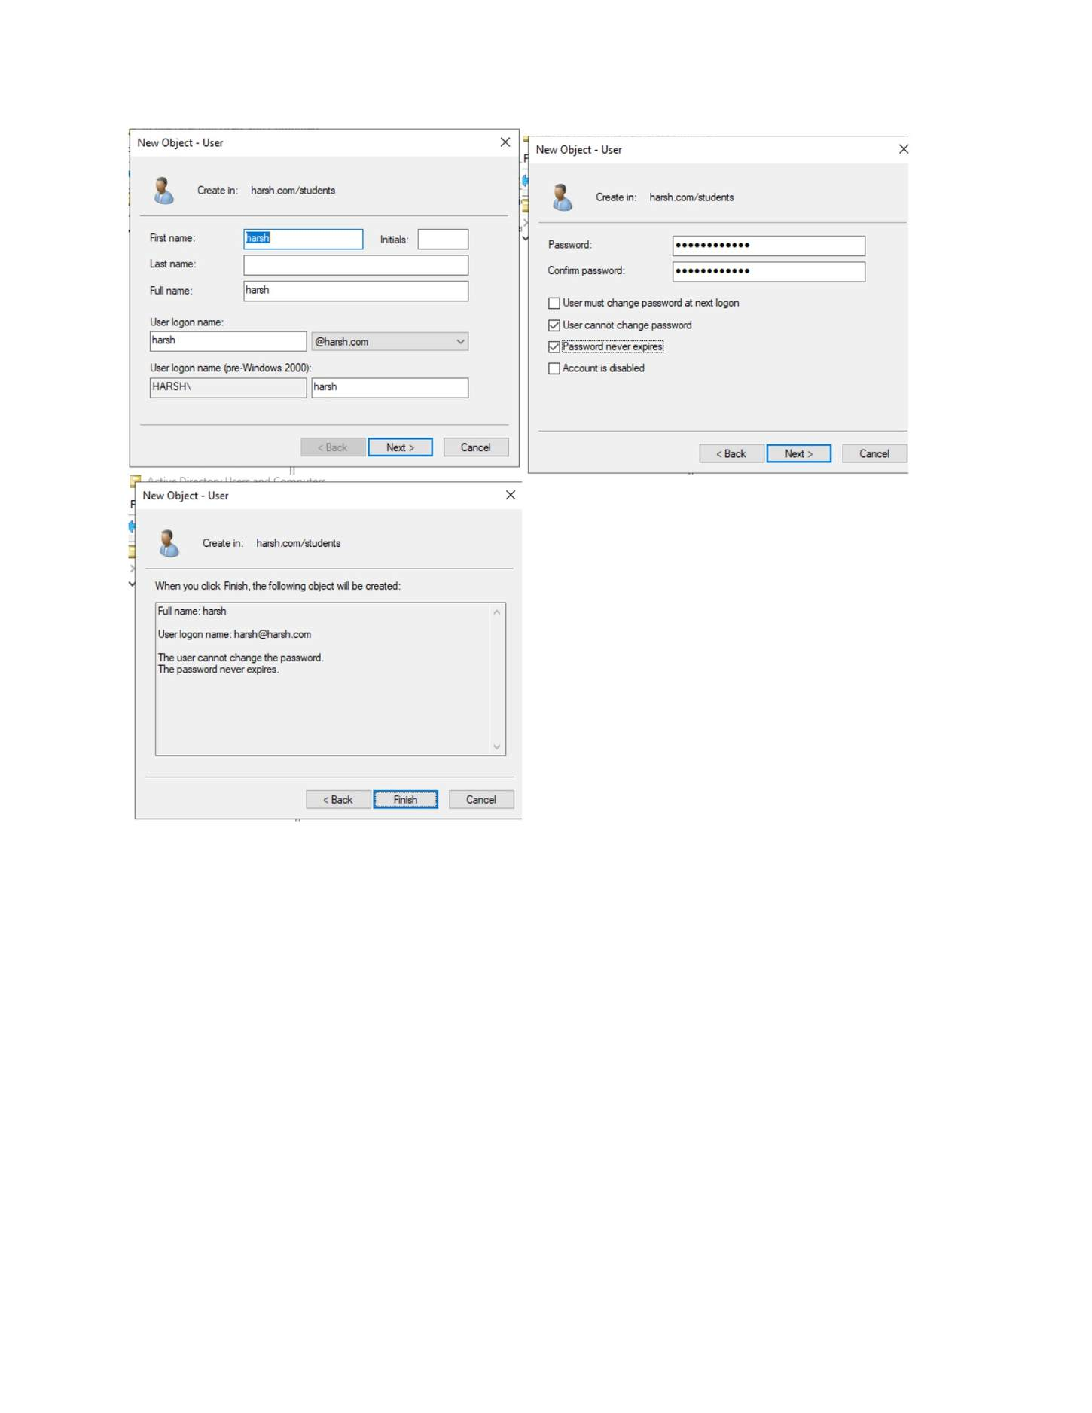
What I did: Started the New Object - User wizard.

PAGE 72 — ADDS AND USER MANAGEMENT
Topic: ADDS and User Management
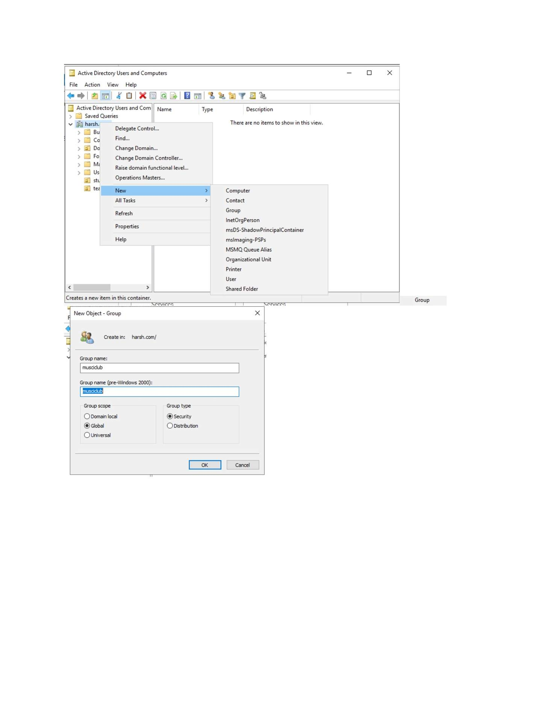
What I did: Entered the new domain user's account information in the New Object - User window.

PAGE 73 — ADDS AND USER MANAGEMENT
Topic: ADDS and User Management
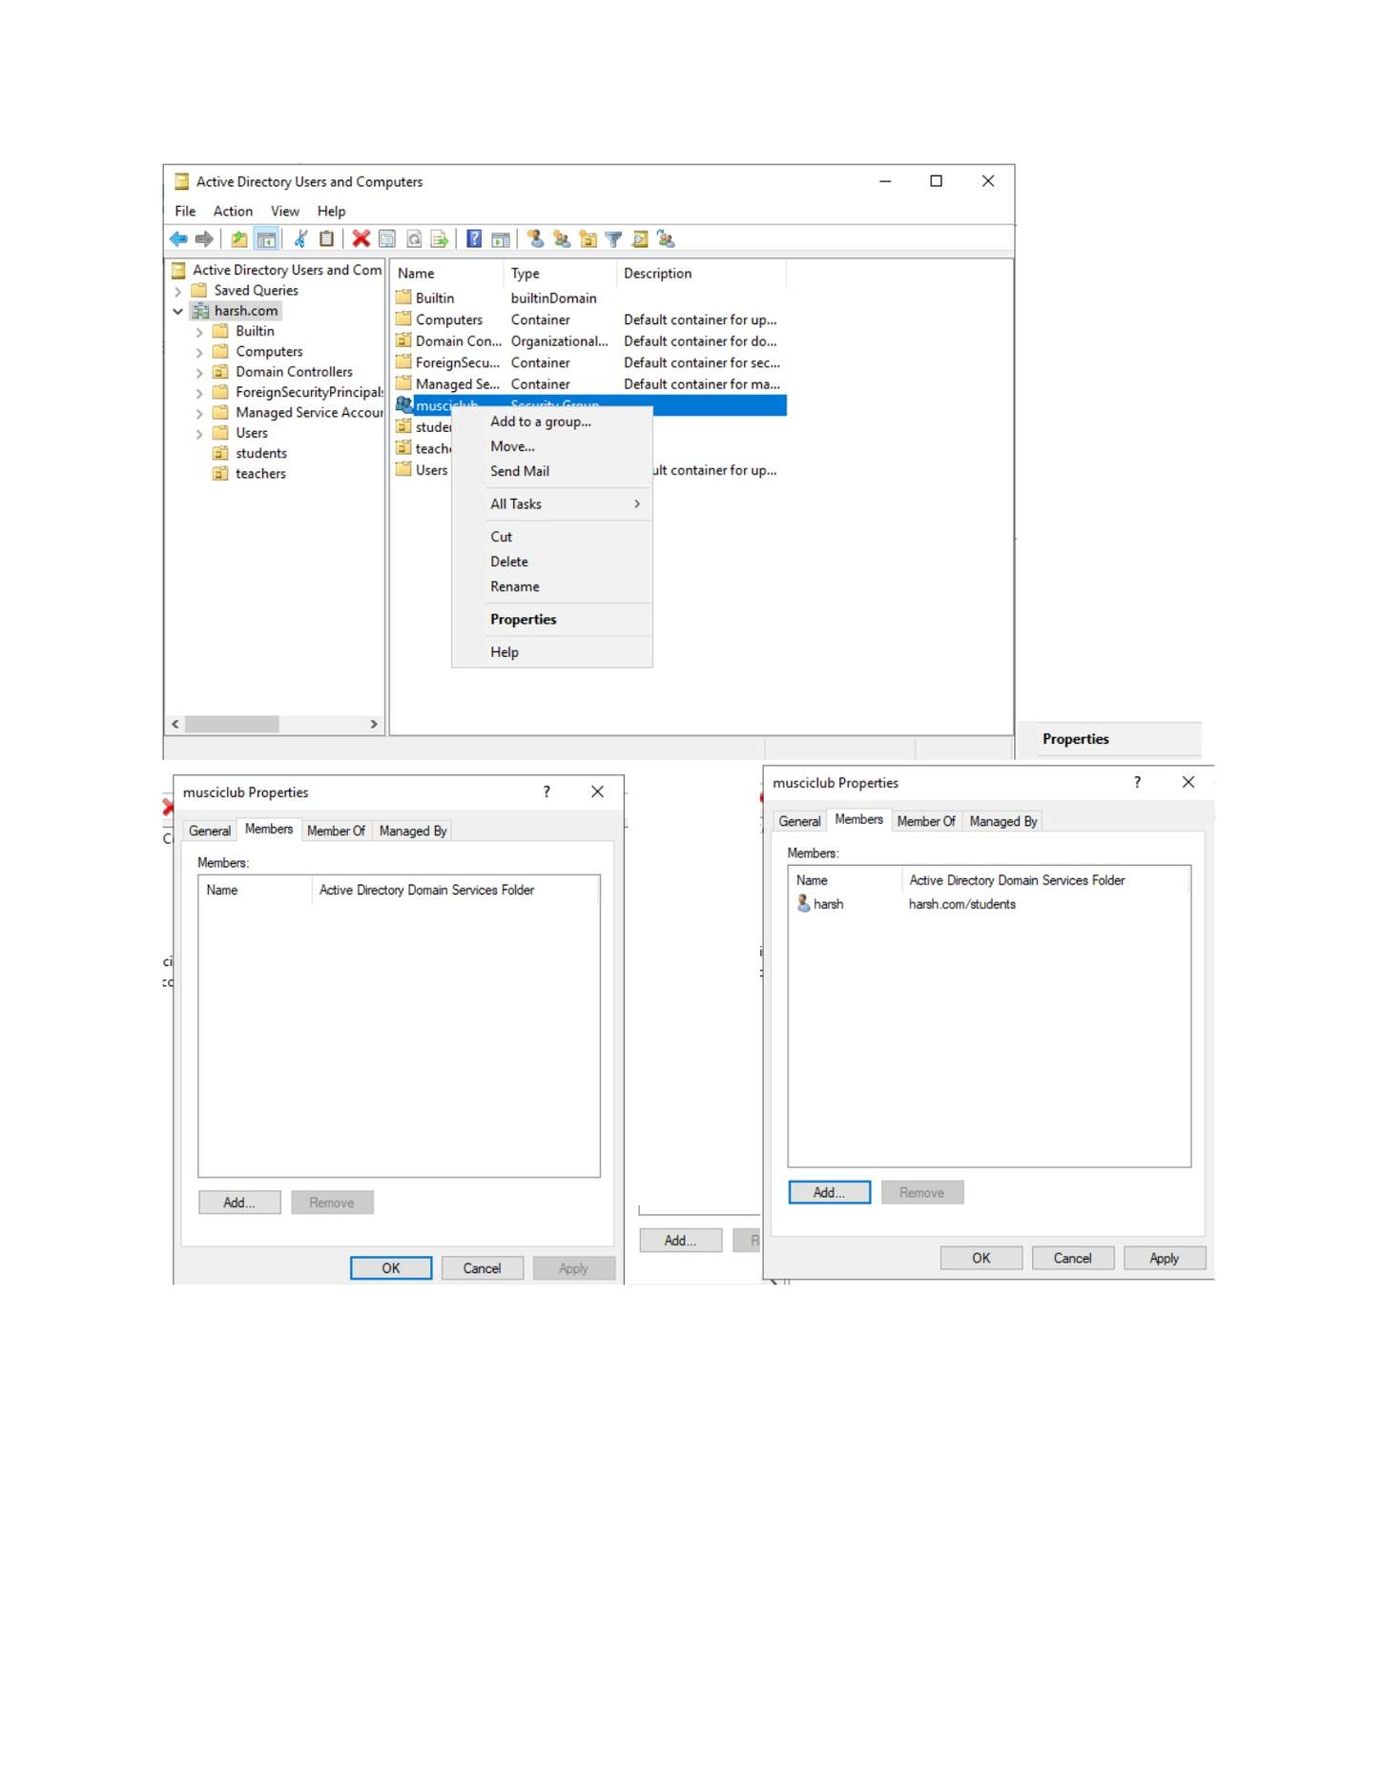
What I did: Configured the user's password and account options.

PAGE 74 — GPO (GROUP POLICY OBJECT)
Topic: GPO (Group Policy Object)
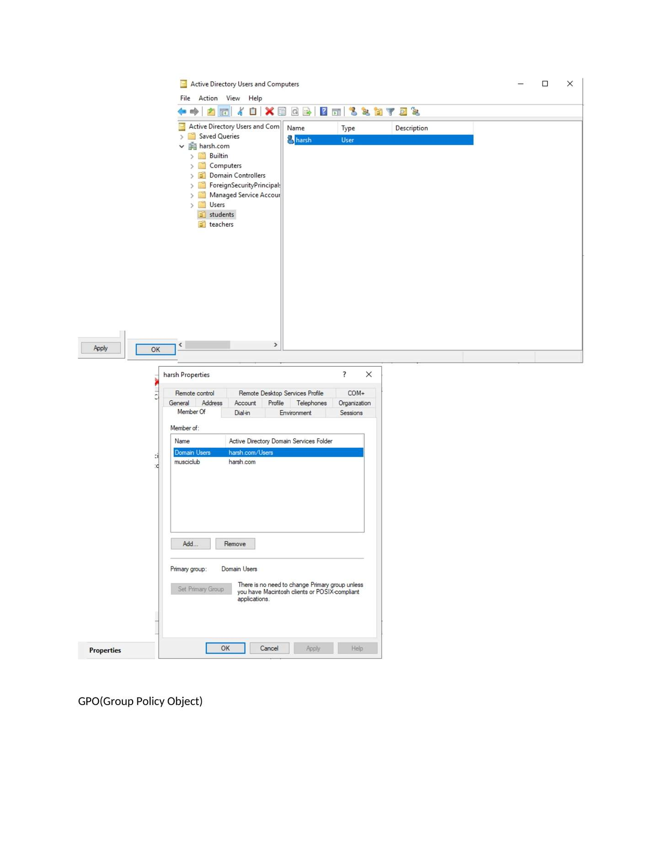
What I did: Opened the Group Policy Management/management tools from Server Manager.

PAGE 75 — GPO (GROUP POLICY OBJECT)
Topic: GPO (Group Policy Object)
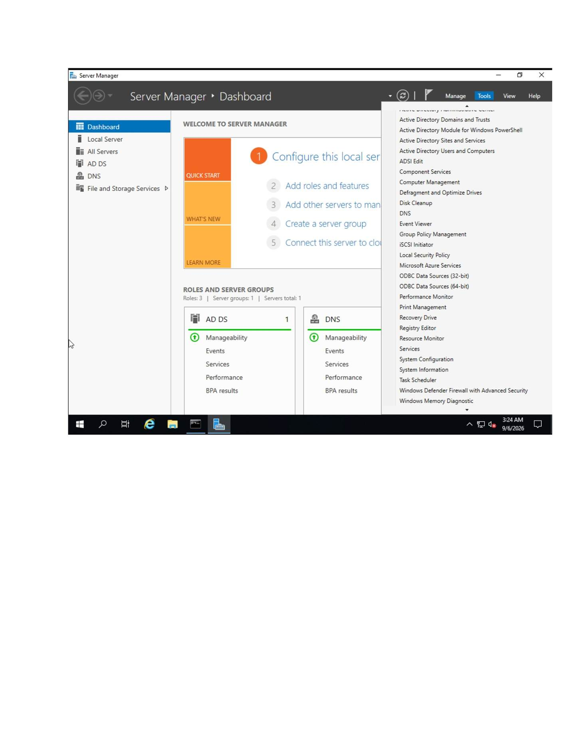
What I did: Opened Group Policy Management and selected the domain/OU for policy configuration.

PAGE 76 — GPO (GROUP POLICY OBJECT)
Topic: GPO (Group Policy Object)
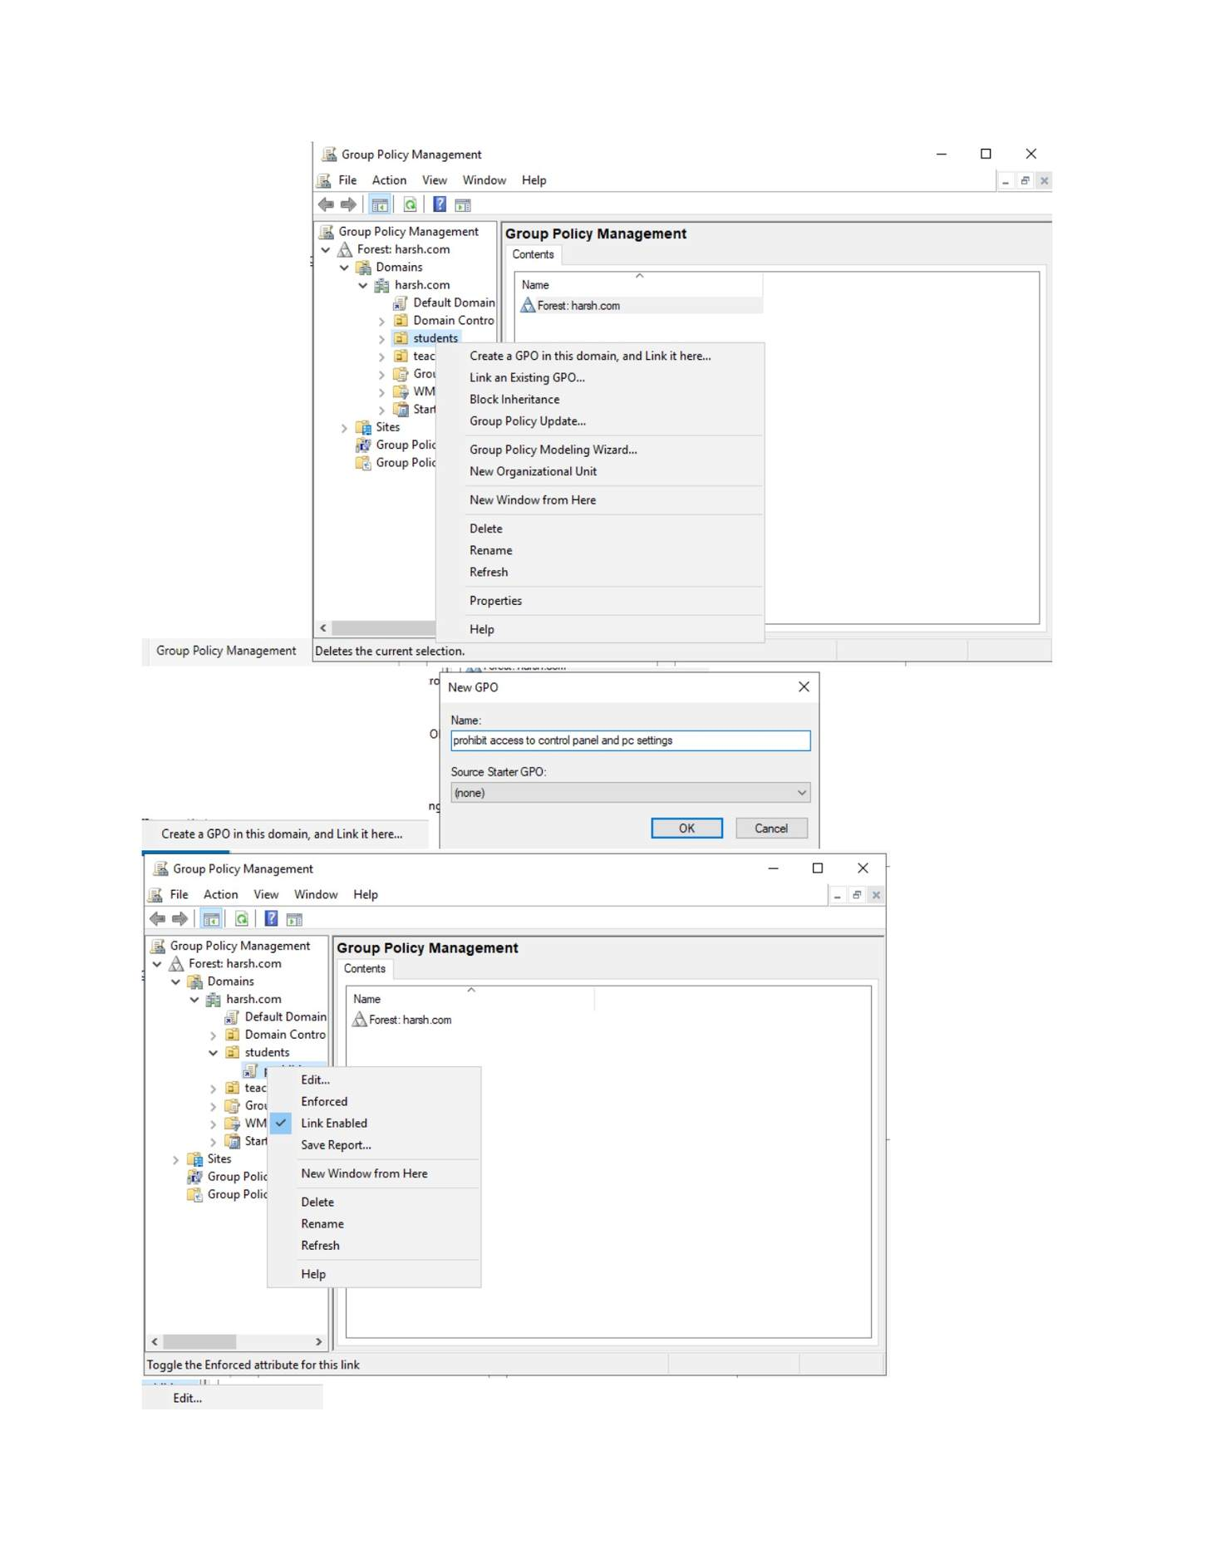
What I did: Started creating a new Group Policy Object for the selected domain/OU.

PAGE 77 — GPO (GROUP POLICY OBJECT)
Topic: GPO (Group Policy Object)
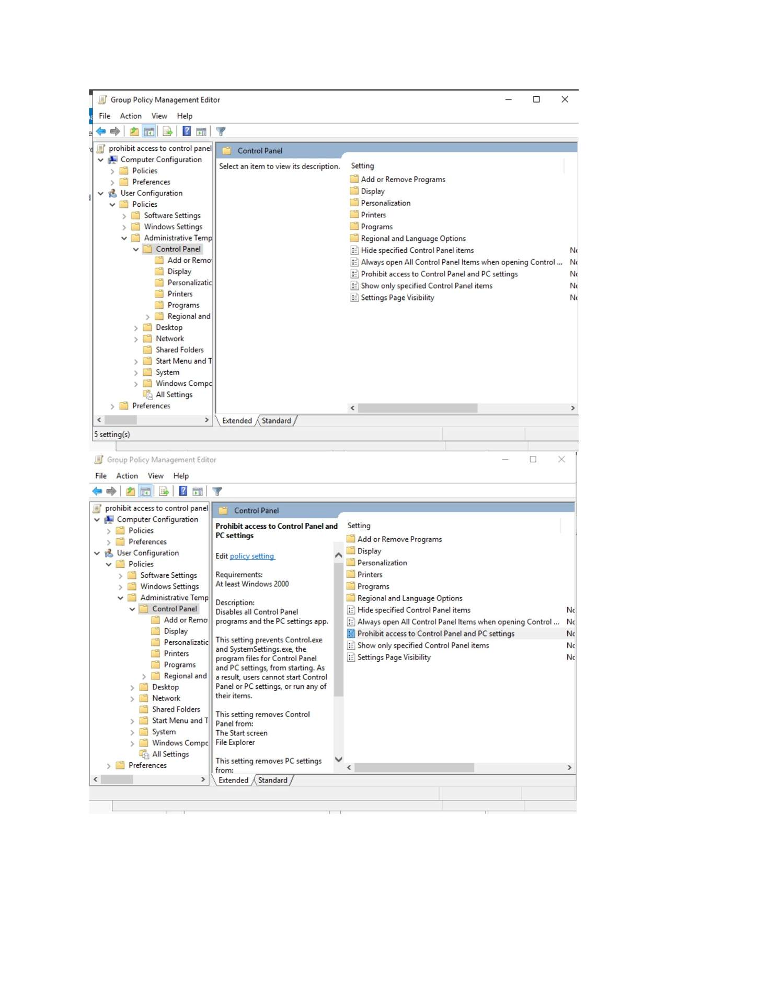
What I did: Entered the name of the new GPO and created it.

PAGE 78 — GPO (GROUP POLICY OBJECT)
Topic: GPO (Group Policy Object)
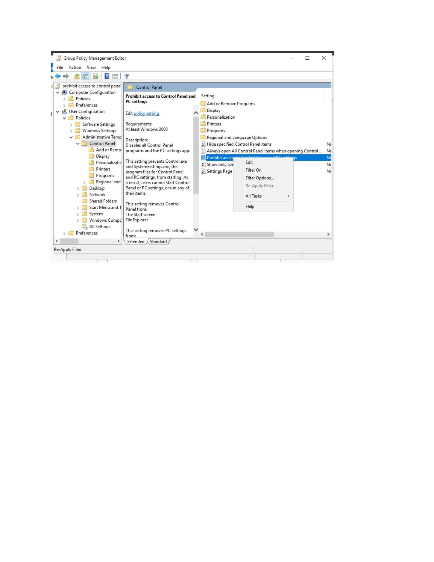
What I did: Opened the GPO's context menu and selected the edit option.

PAGE 79 — GPO (GROUP POLICY OBJECT)
Topic: GPO (Group Policy Object)
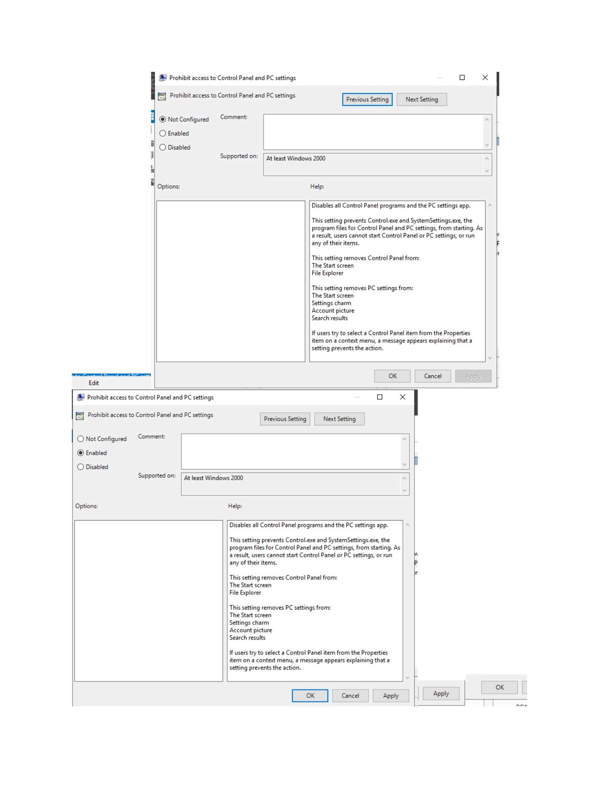
What I did: Opened the Group Policy Management Editor and navigated to the required policy area.

PAGE 80 — GPO (GROUP POLICY OBJECT)
Topic: GPO (Group Policy Object)
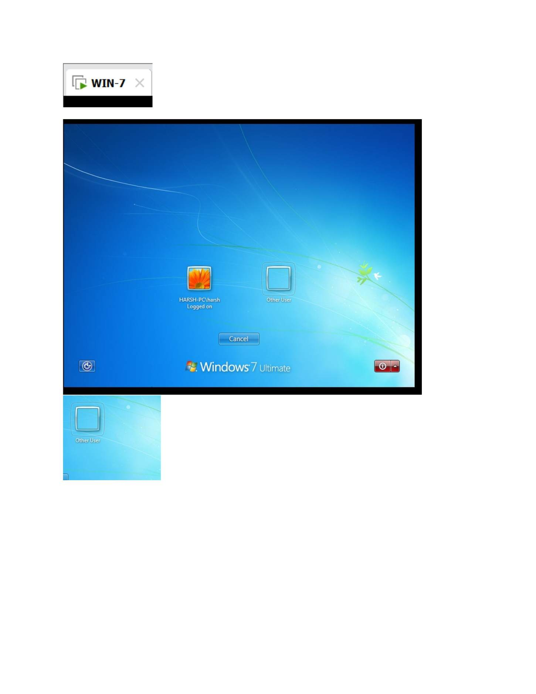
What I did: Selected/configured the required administrative policy setting shown in the editor.

PAGE 81 — GPO (GROUP POLICY OBJECT)
Topic: GPO (Group Policy Object)
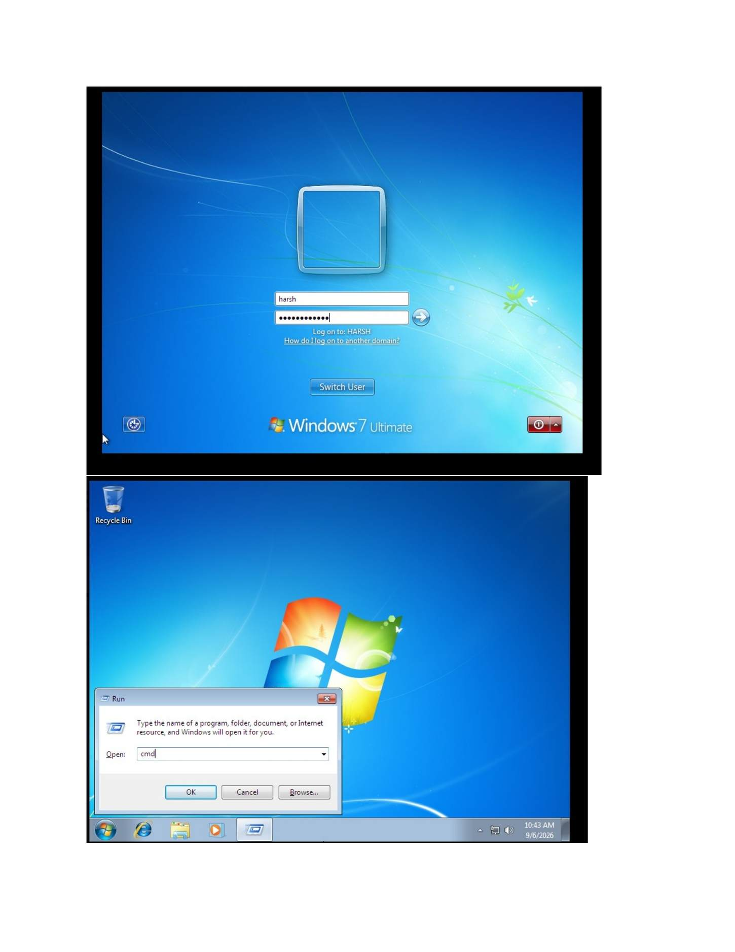
What I did: Applied the policy and then checked the Windows 7 client to verify the GPO effect.

PAGE 82 — DNS (DOMAIN NAME SYSTEM)
Topic: DNS (Domain Name System)
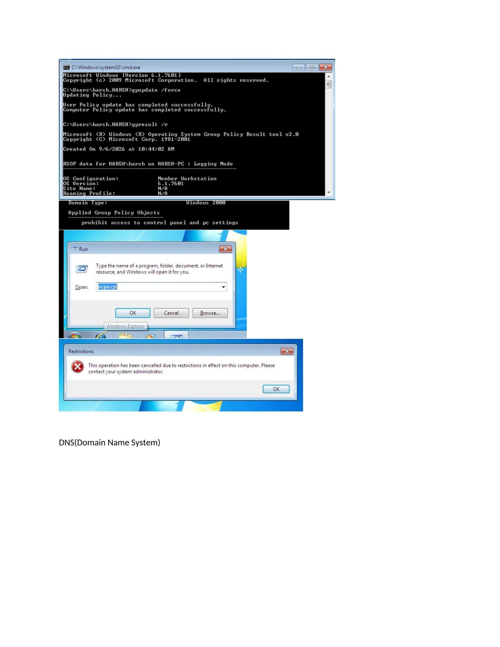
What I did: Opened a Command Prompt and prepared to test the DNS configuration.

PAGE 83 — DNS (DOMAIN NAME SYSTEM)
Topic: DNS (Domain Name System)
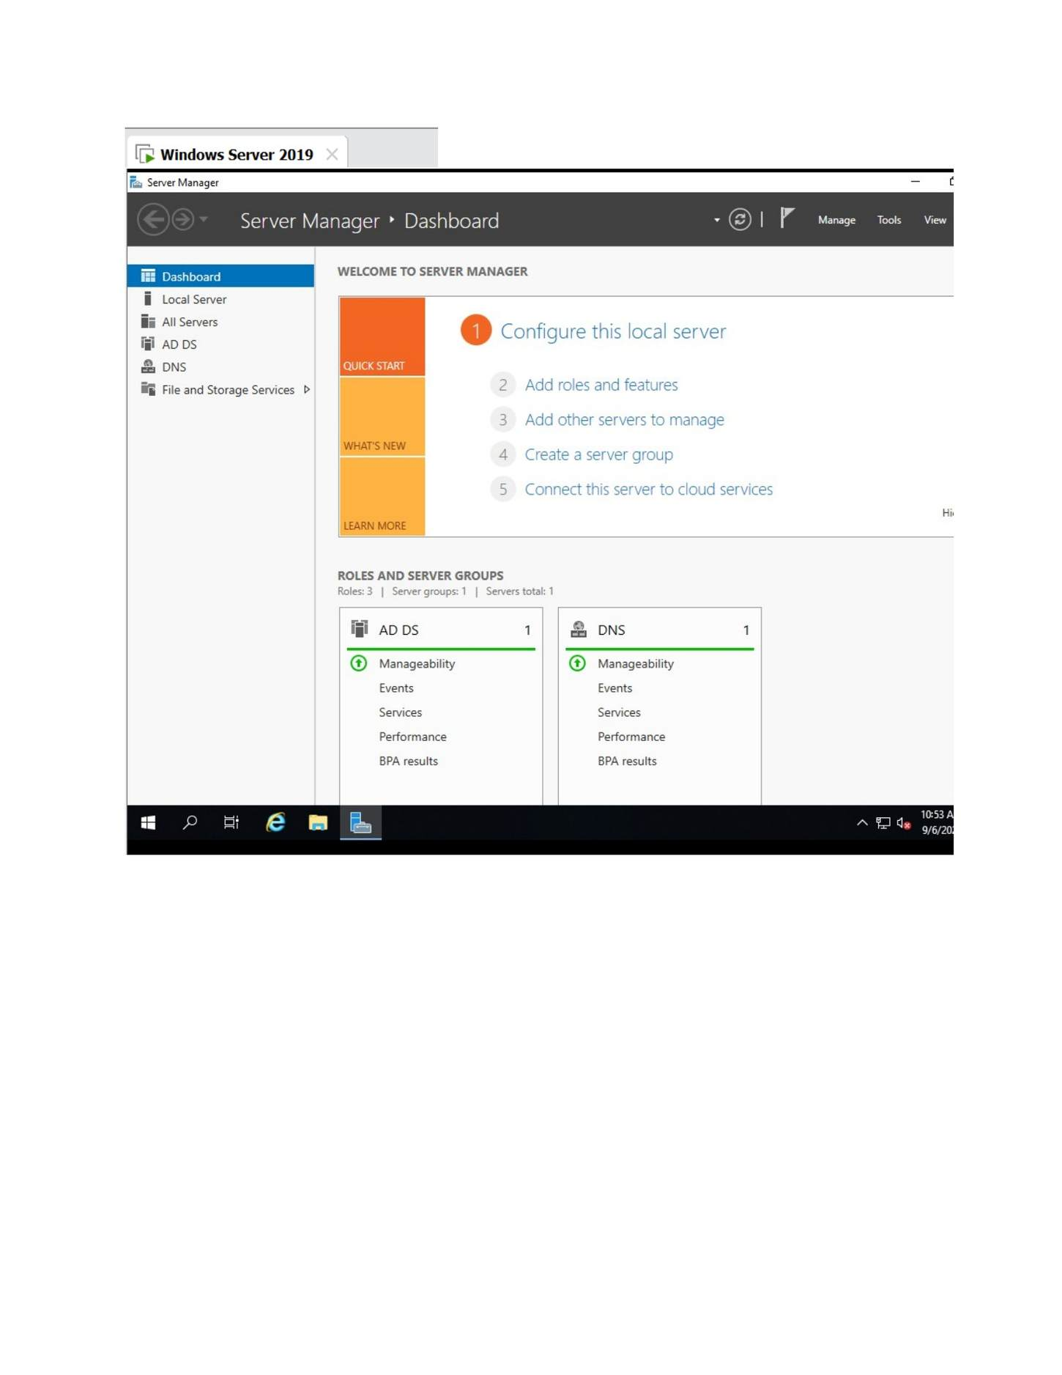
What I did: Used the Windows administrative tools to open DNS-related management.

PAGE 84 — DNS (DOMAIN NAME SYSTEM)
Topic: DNS (Domain Name System)
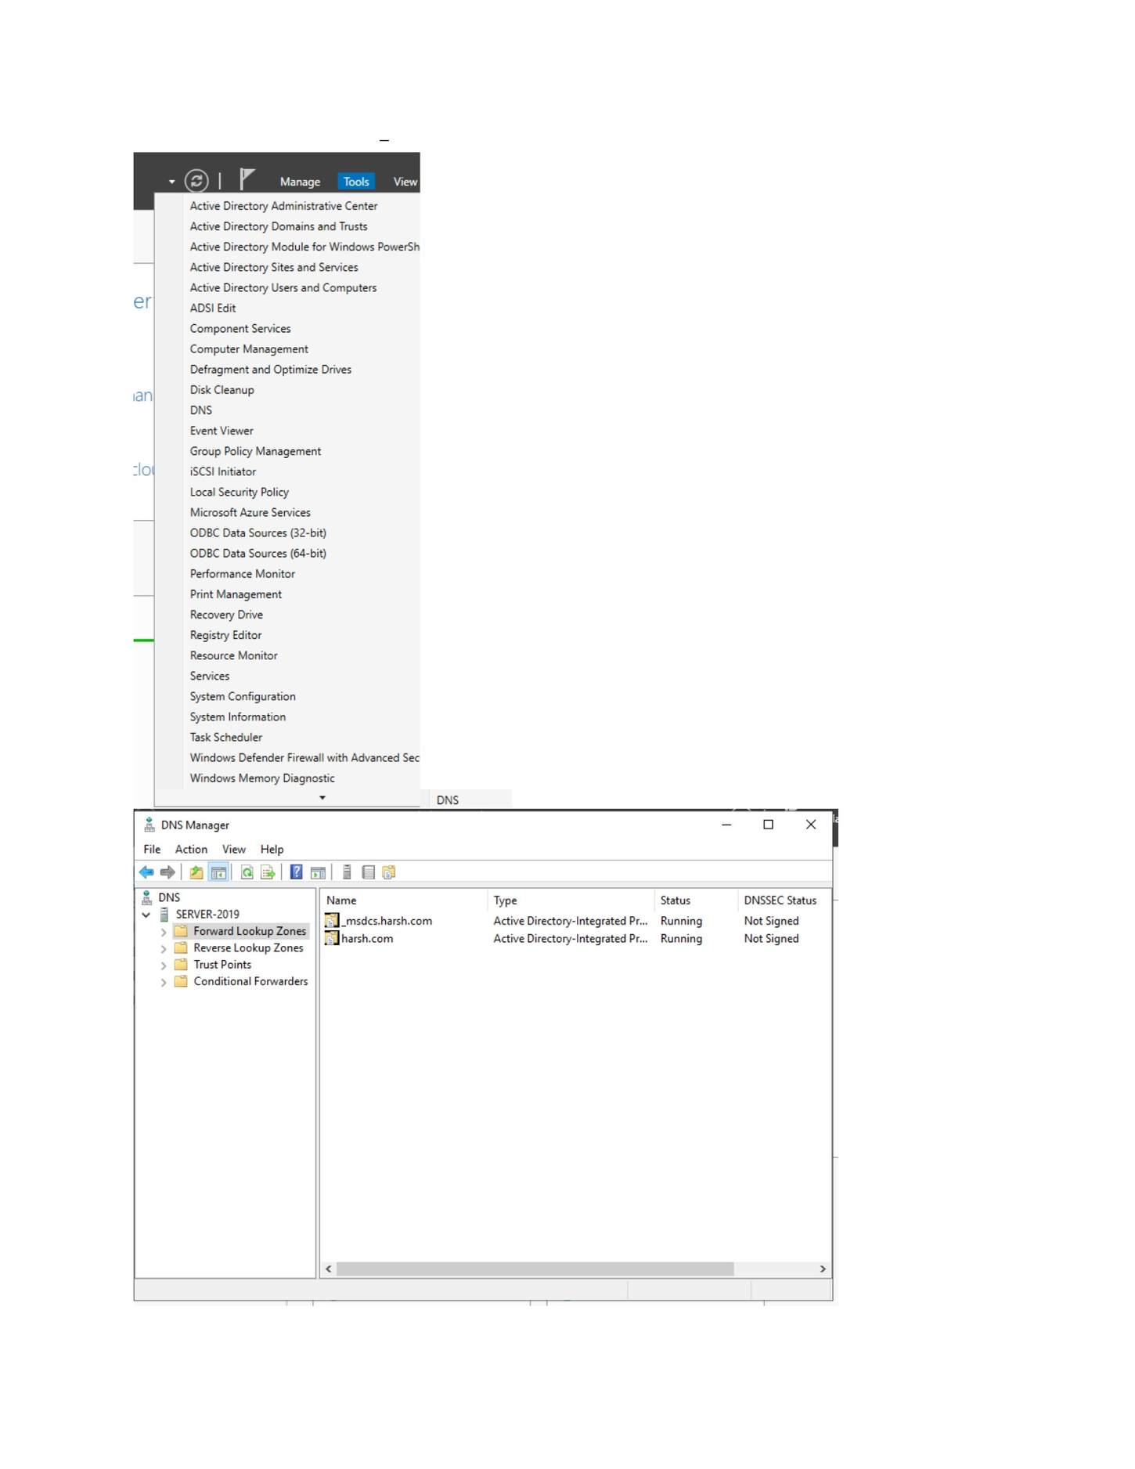
What I did: Opened the DNS management tools from Server Manager.

PAGE 85 — DNS (DOMAIN NAME SYSTEM)
Topic: DNS (Domain Name System)
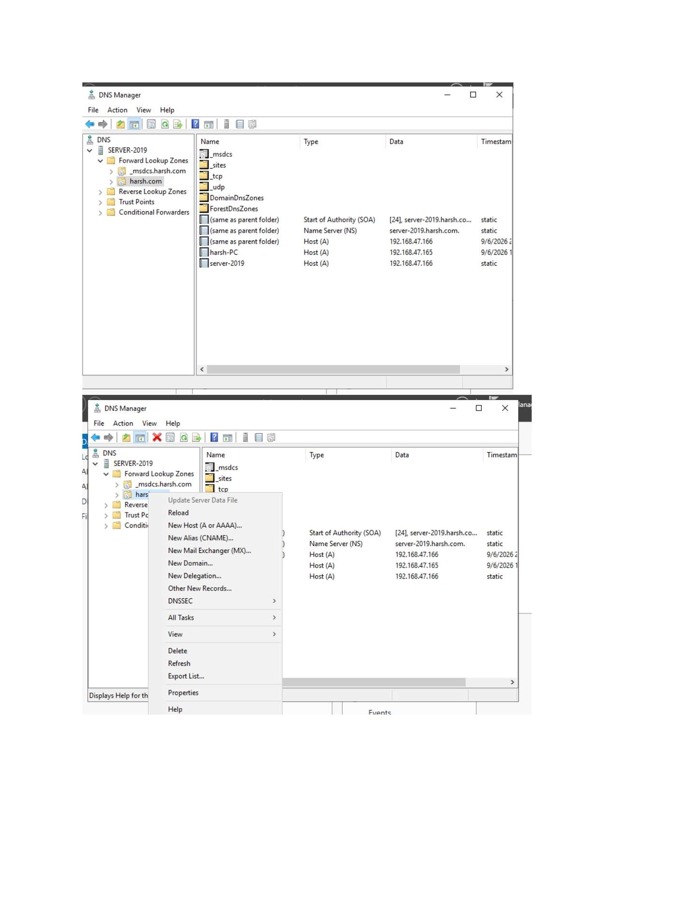
What I did: Reviewed the available DNS administrative tools and selected DNS Manager.

PAGE 86 — DNS (DOMAIN NAME SYSTEM)
Topic: DNS (Domain Name System)
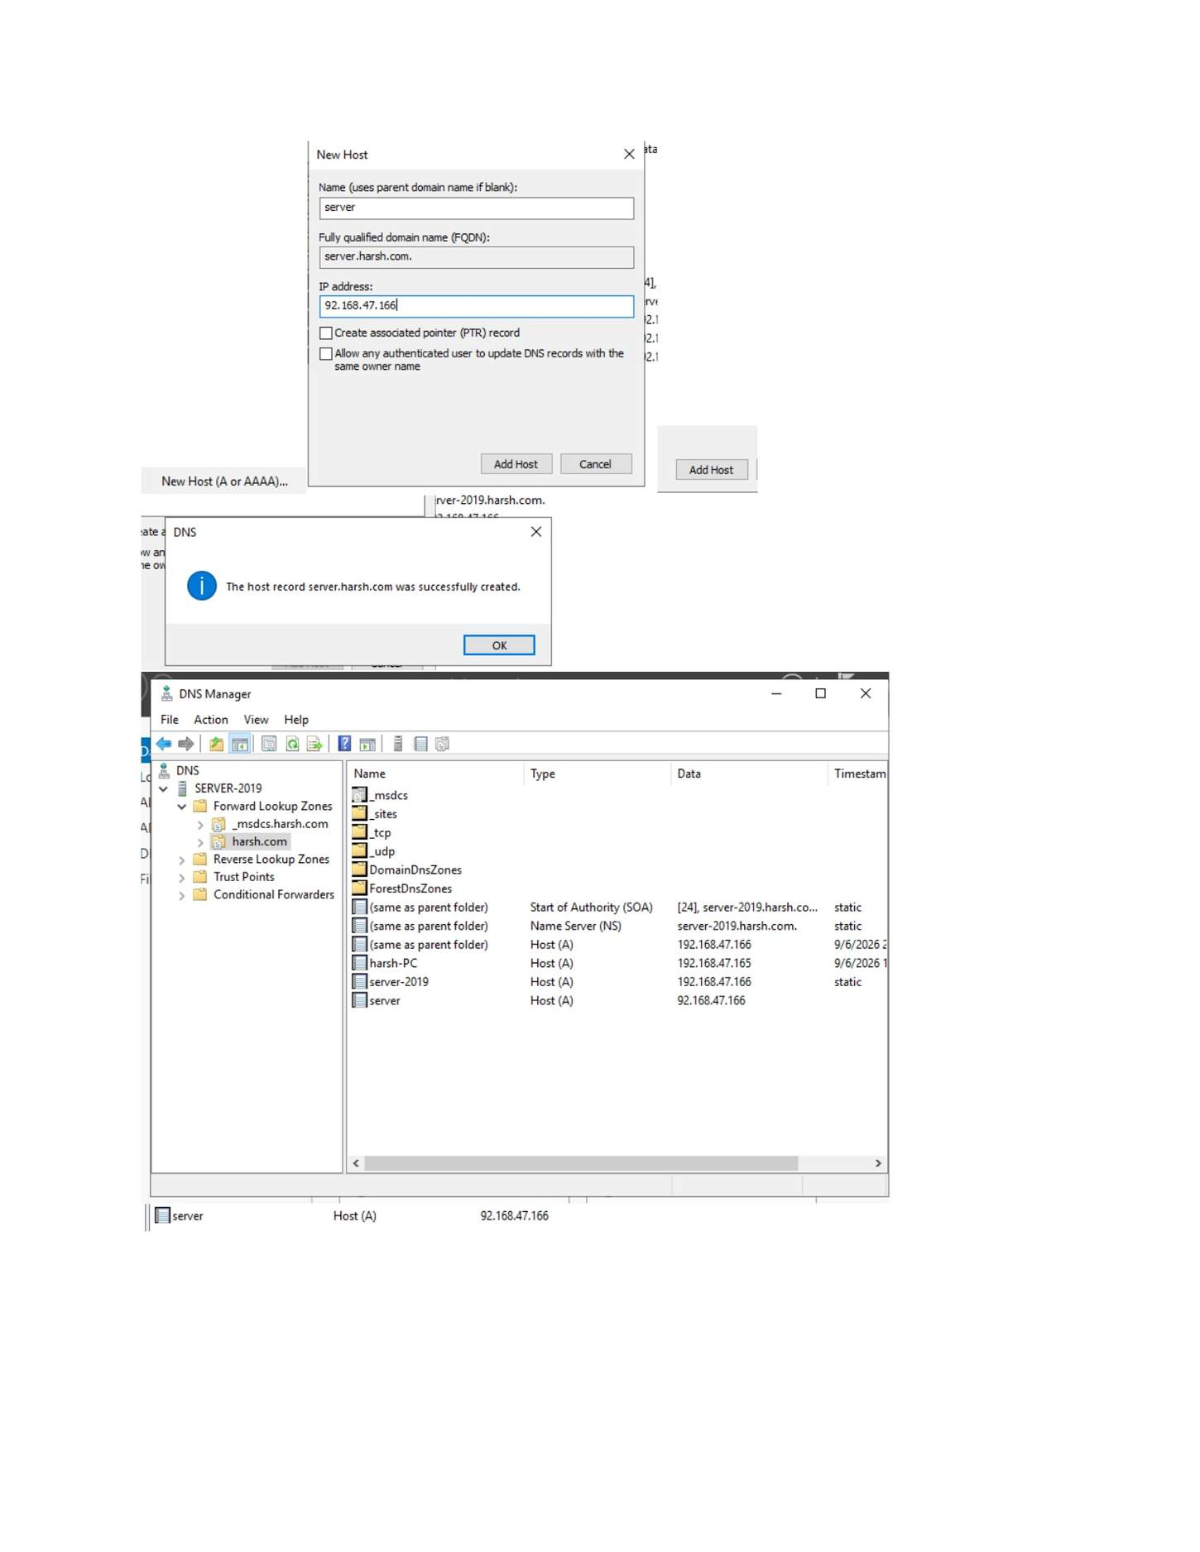
What I did: Opened DNS Manager and expanded the server/Forward Lookup Zones.

PAGE 87 — DNS (DOMAIN NAME SYSTEM)
Topic: DNS (Domain Name System)
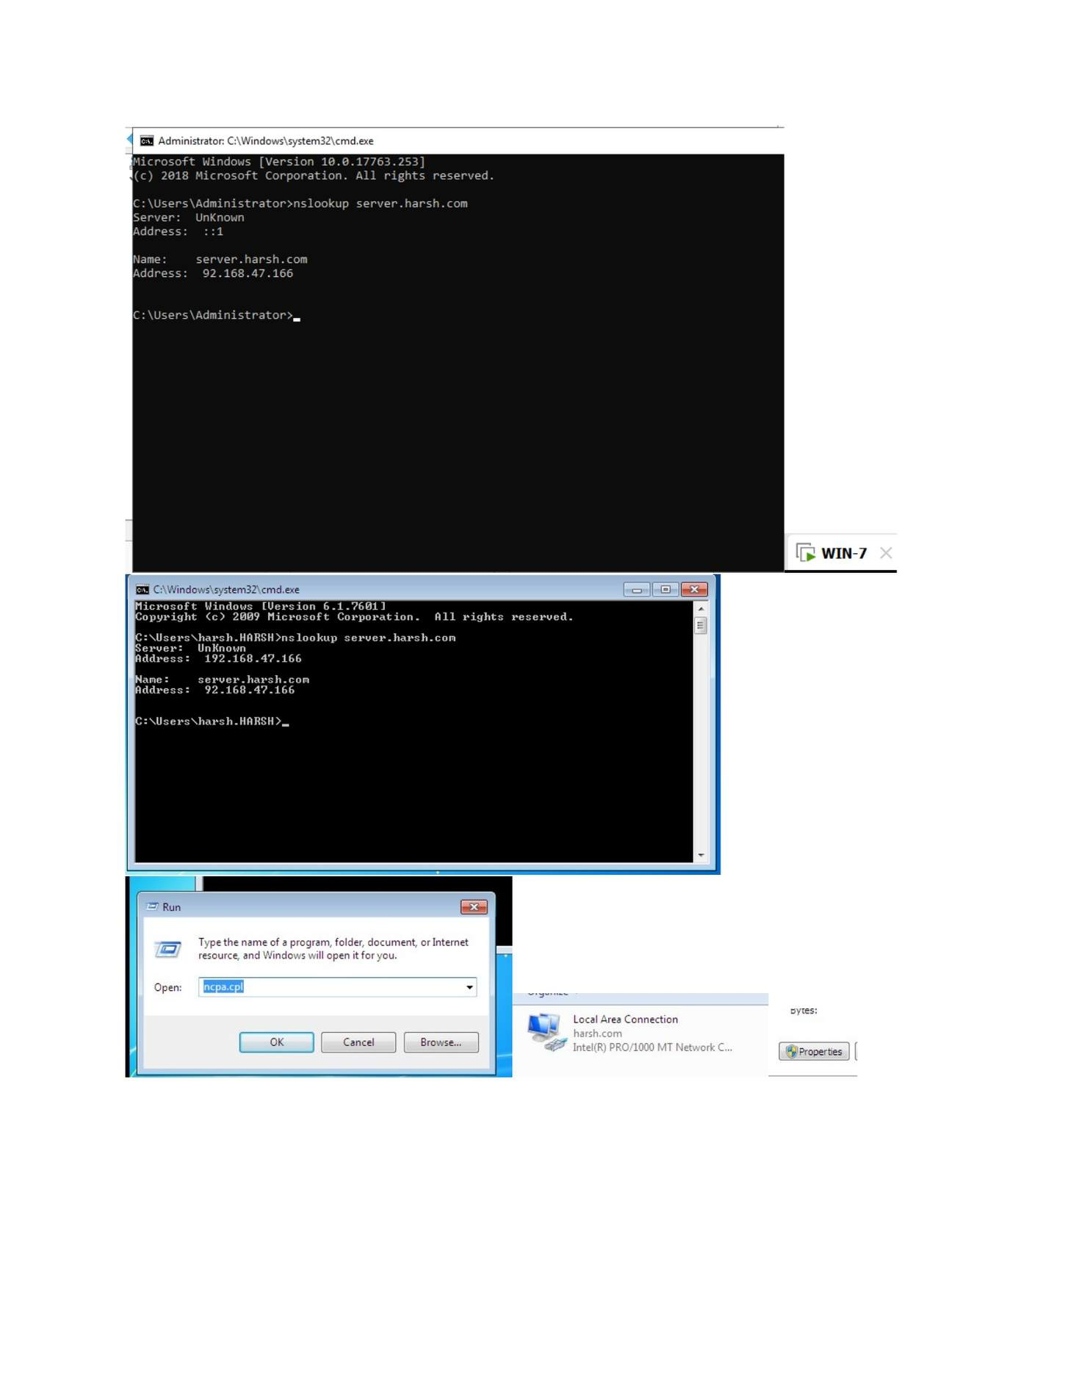
What I did: Started the New Zone Wizard for the DNS zone.

PAGE 88 — DNS (DOMAIN NAME SYSTEM)
Topic: DNS (Domain Name System)
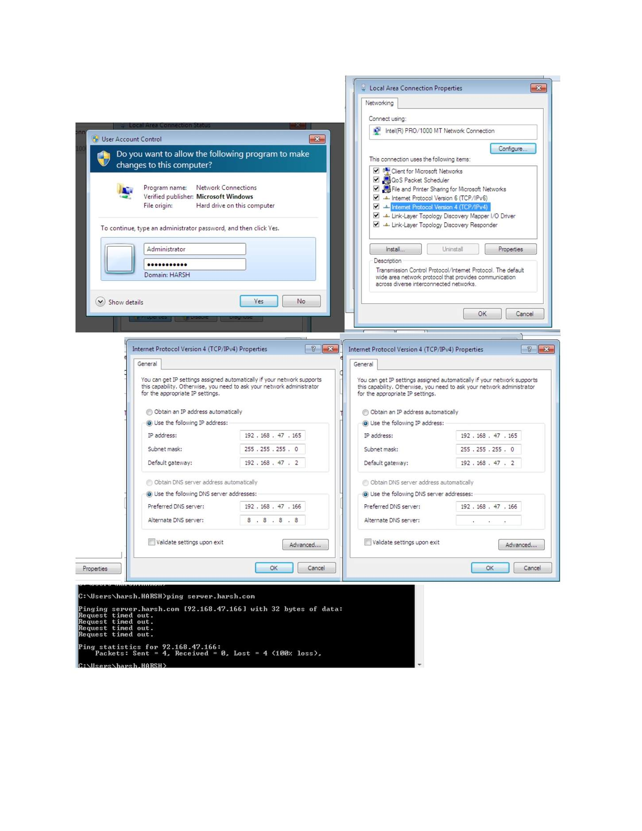
What I did: Selected the appropriate zone type/replication scope in the New Zone Wizard.

PAGE 89 — DNS (DOMAIN NAME SYSTEM)
Topic: DNS (Domain Name System)
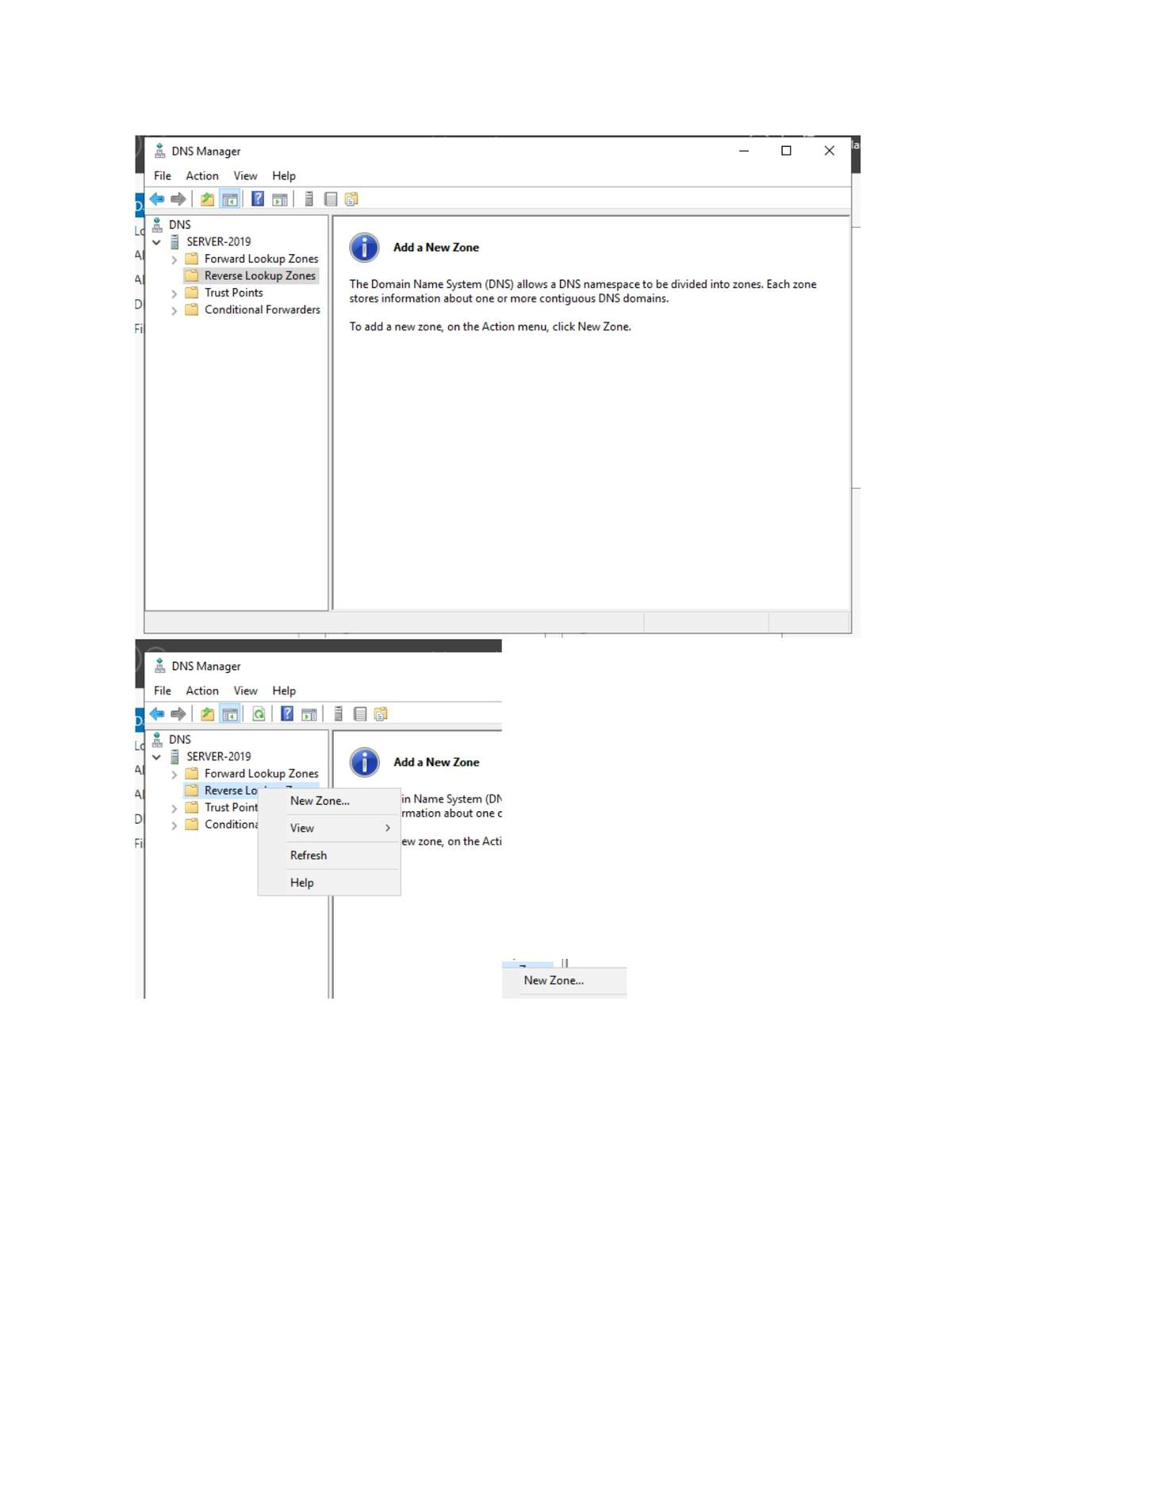
What I did: Configured the zone name and dynamic-update options shown in the wizard.

PAGE 90 — DNS (DOMAIN NAME SYSTEM)
Topic: DNS (Domain Name System)
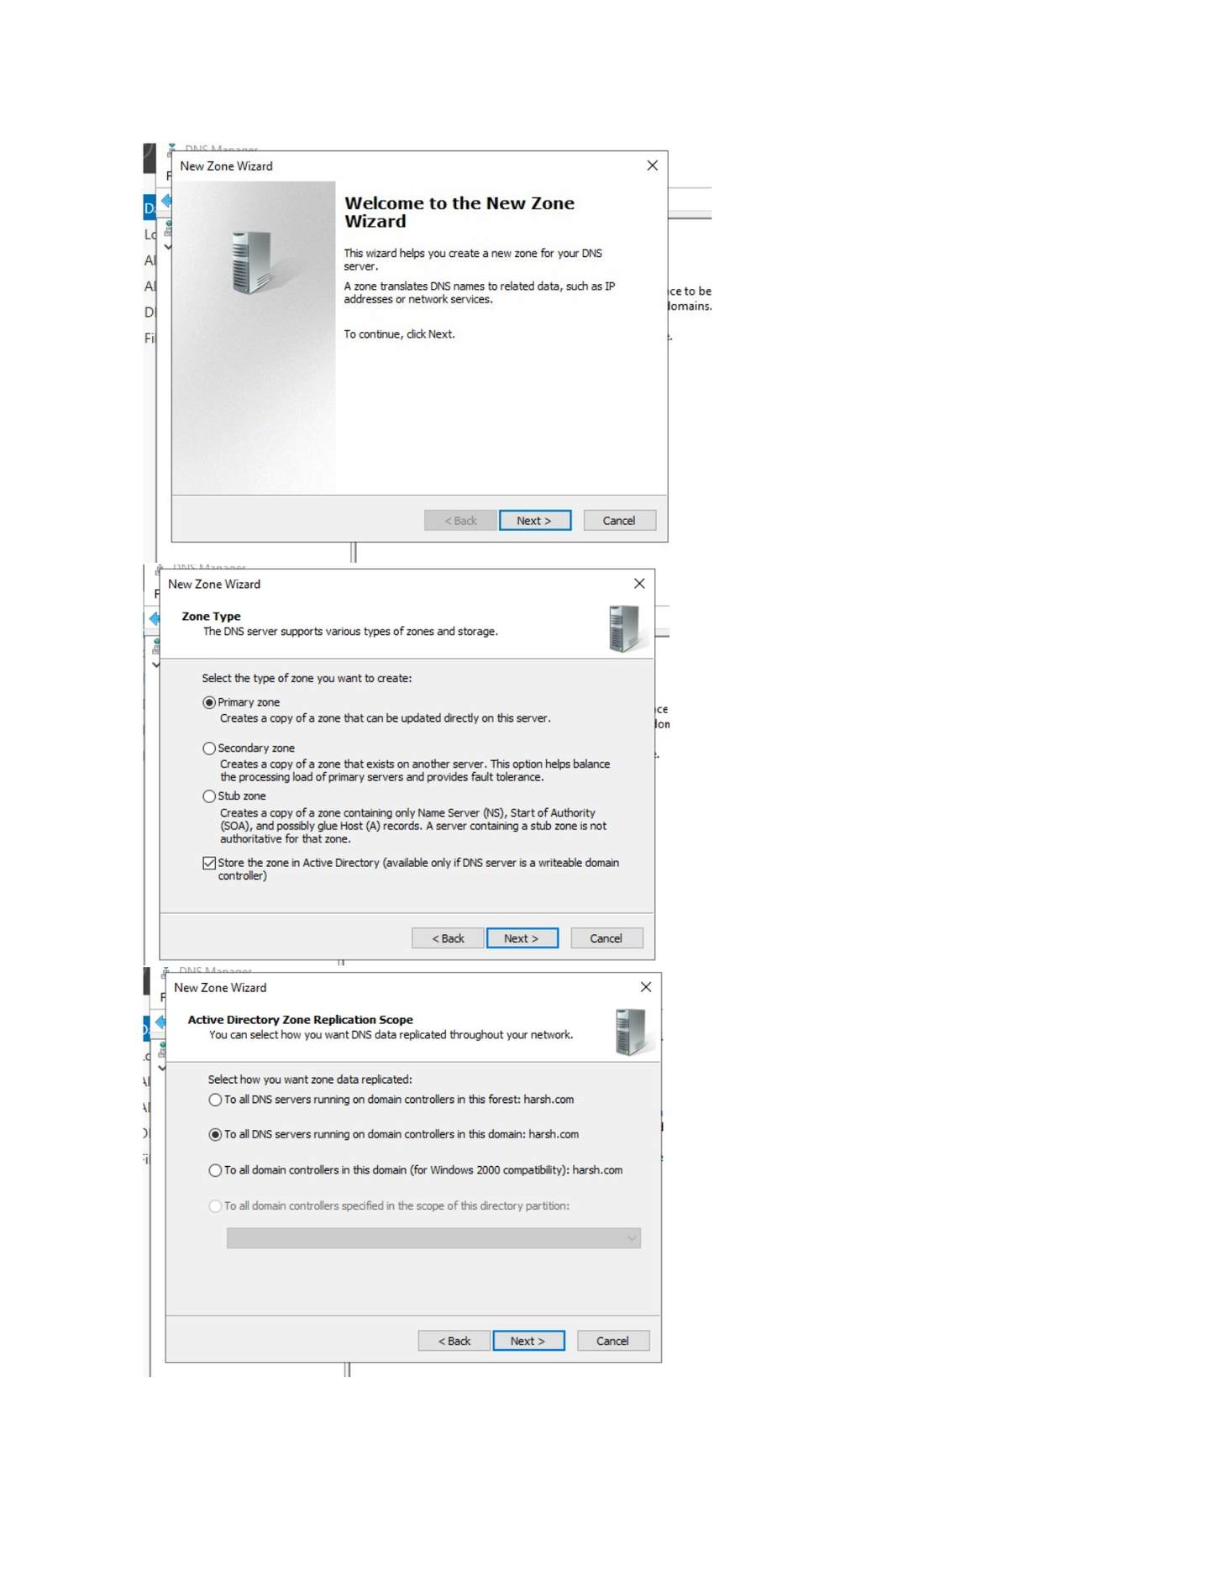
What I did: Completed the New Zone Wizard and returned to the DNS console.

PAGE 91 — DNS (DOMAIN NAME SYSTEM)
Topic: DNS (Domain Name System)
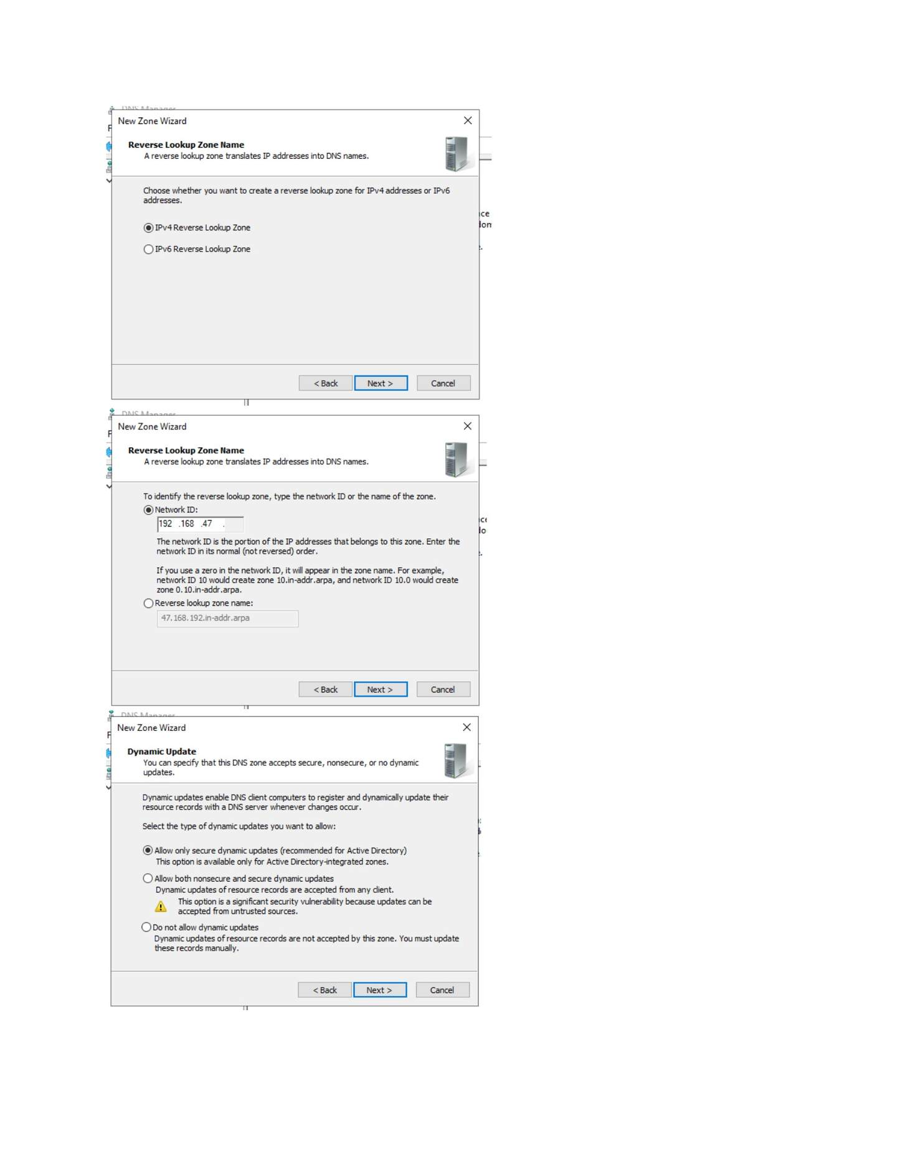
What I did: Verified the newly created DNS zone/records in DNS Manager.

PAGE 92 — DNS (DOMAIN NAME SYSTEM)
Topic: DNS (Domain Name System)
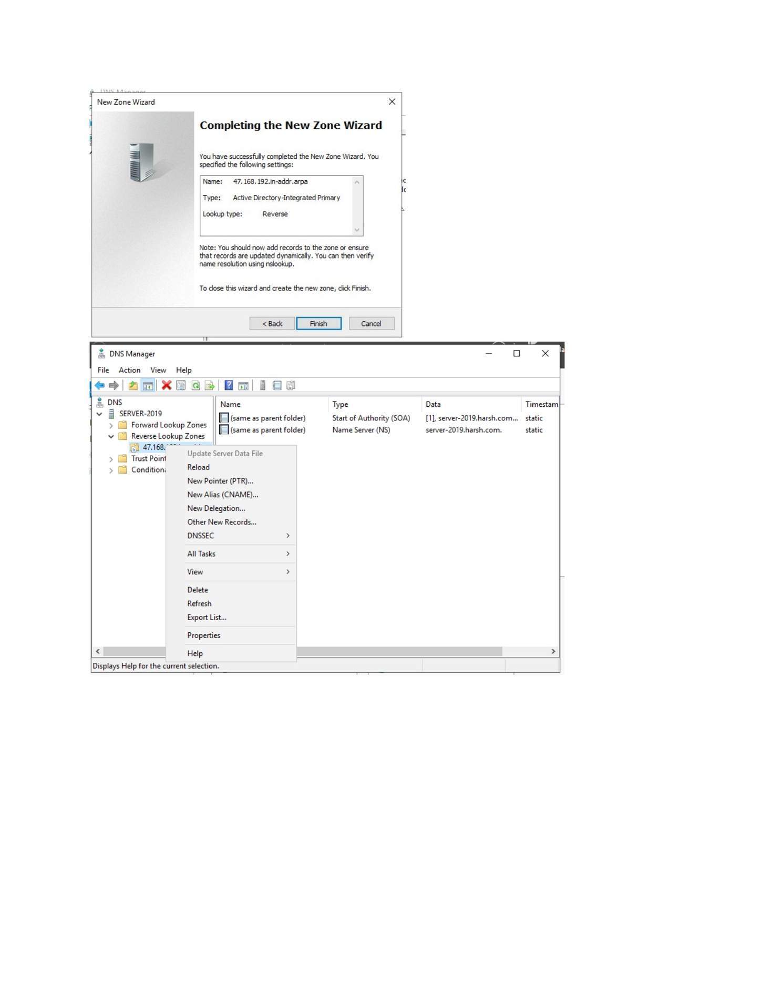
What I did: Used Command Prompt to test name resolution with the configured DNS server.

PAGE 93 — DNS (DOMAIN NAME SYSTEM)
Topic: DNS (Domain Name System)
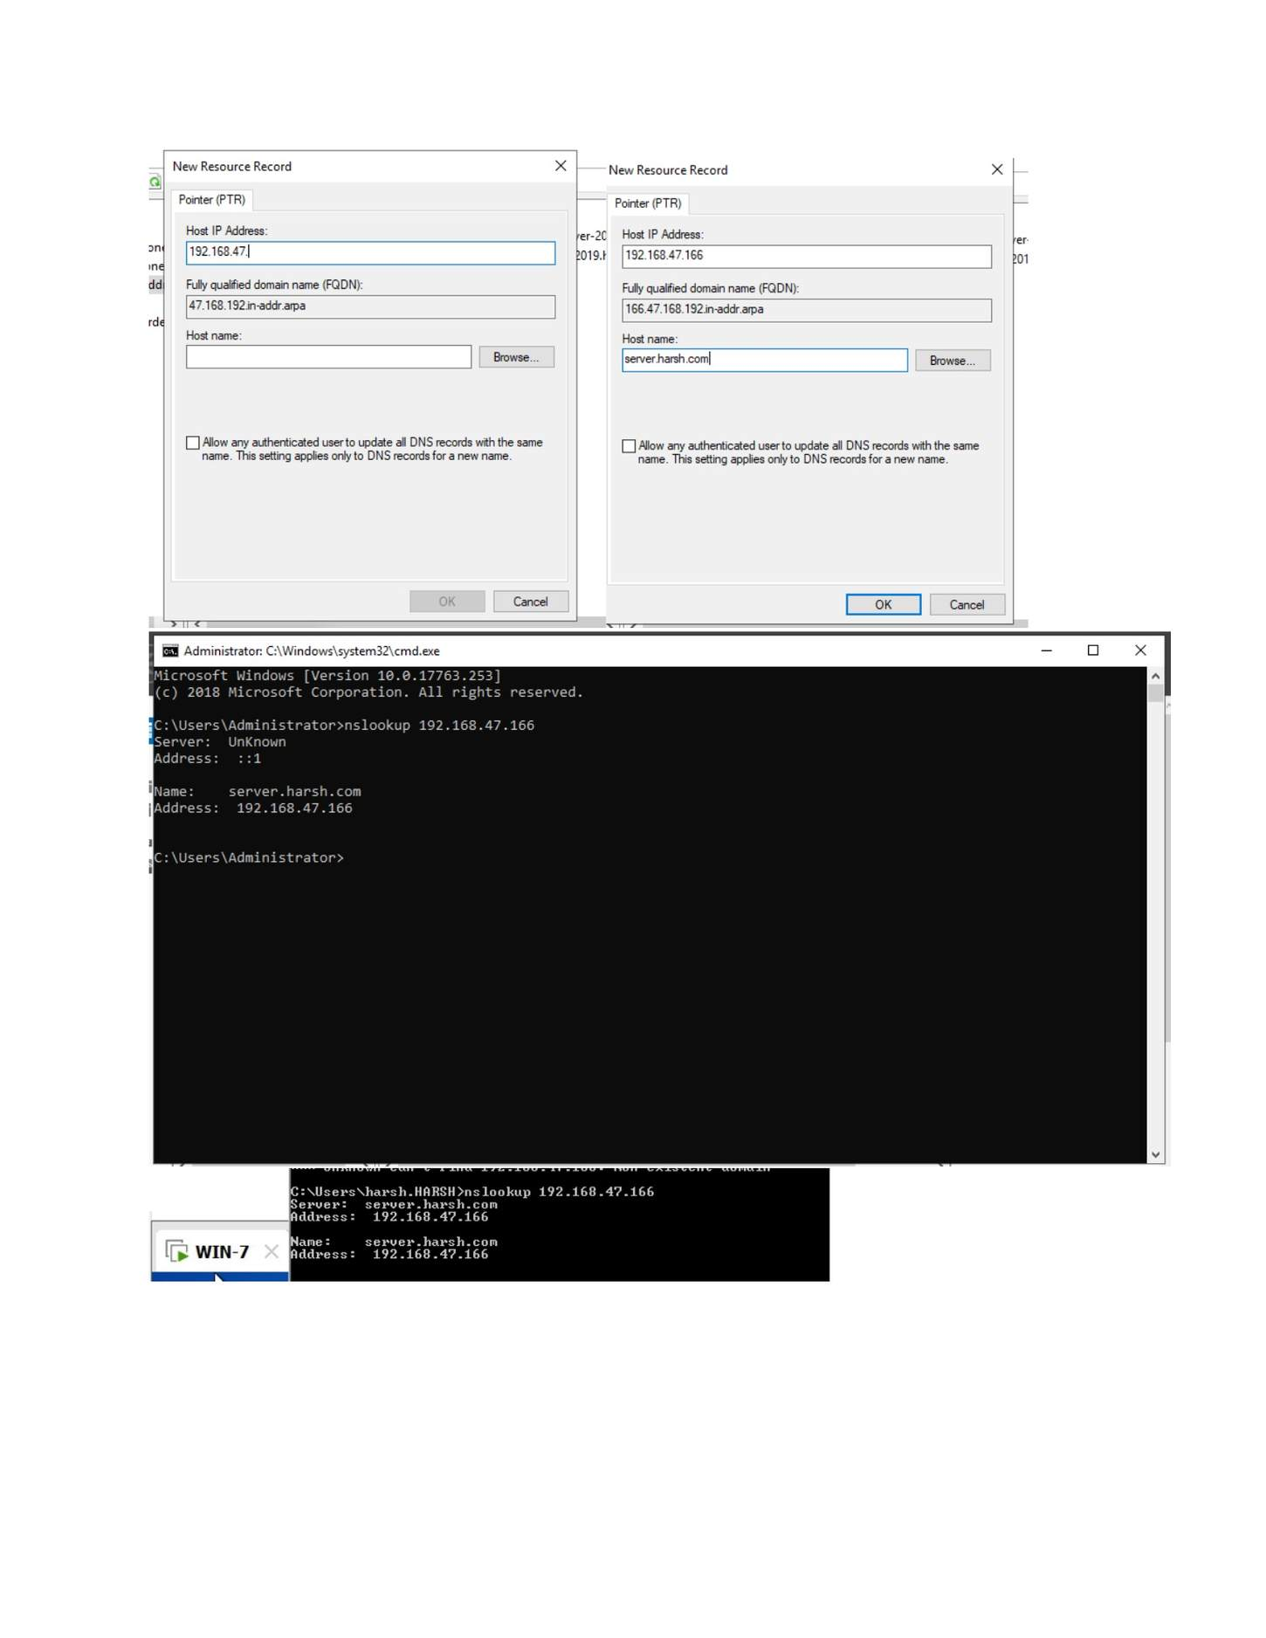
What I did: Confirmed the DNS lookup/result shown in the command window.

PAGE 94 — DHCP (DYNAMIC HOST CONFIGURATION PROTOCOL)
Topic: DHCP (Dynamic Host Configuration Protocol)
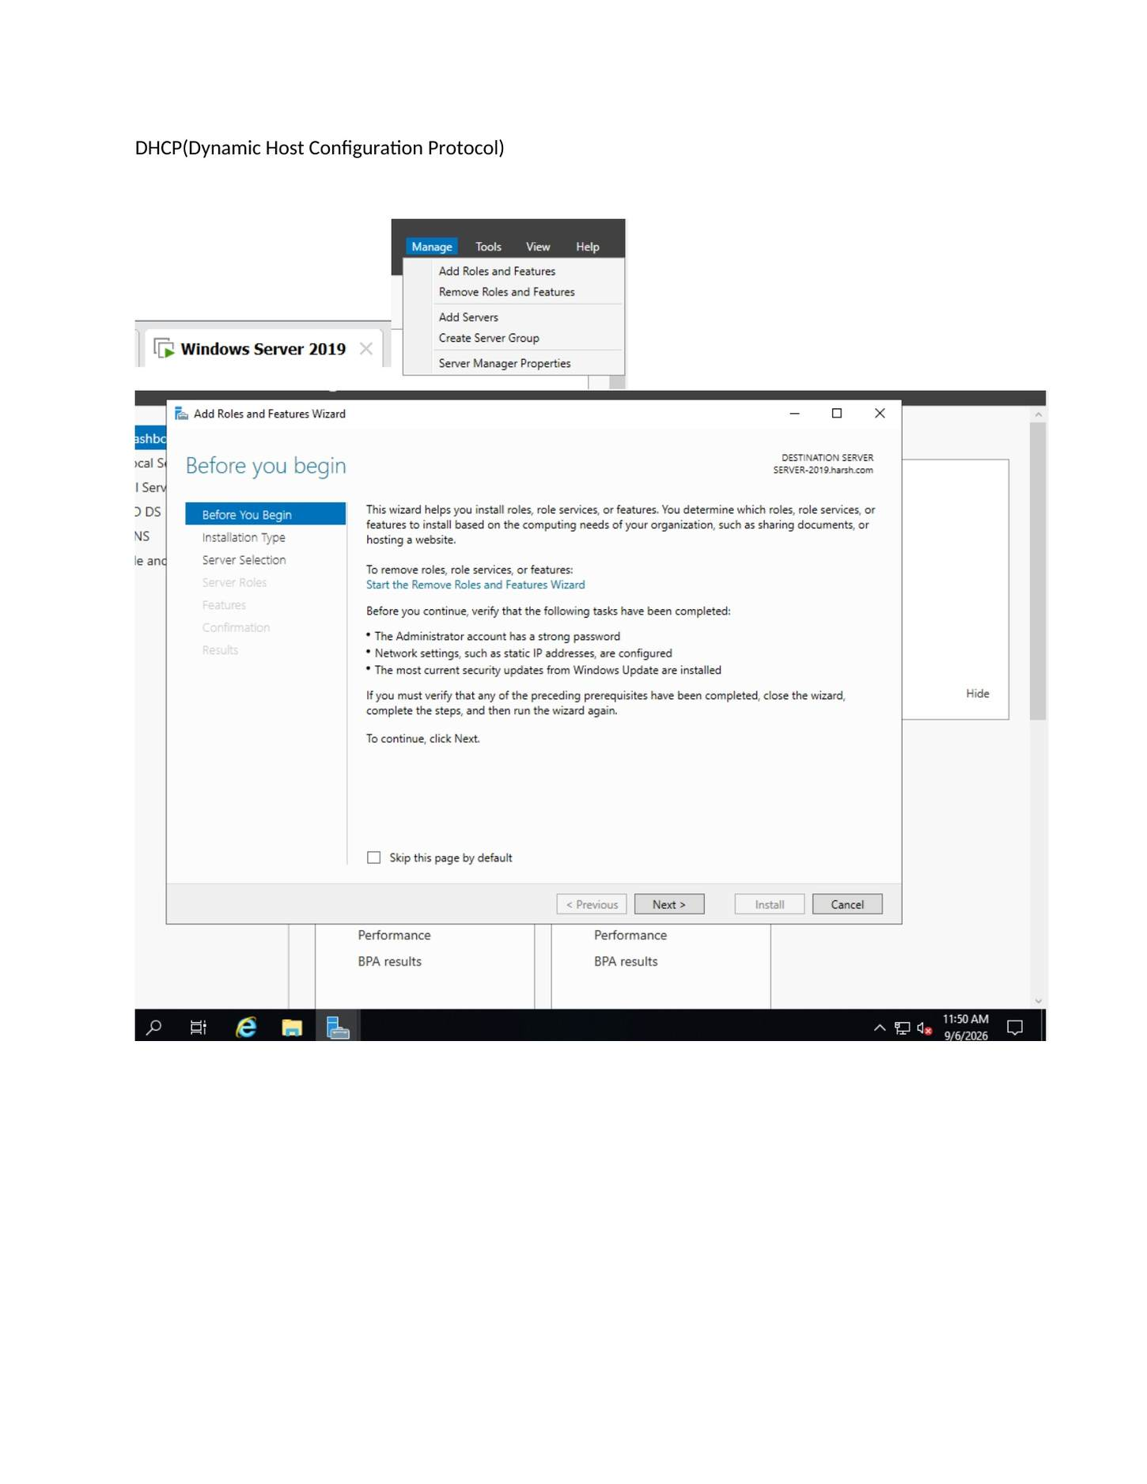
What I did: Opened Server Manager and started installing the DHCP Server role.

PAGE 95 — DHCP (DYNAMIC HOST CONFIGURATION PROTOCOL)
Topic: DHCP (Dynamic Host Configuration Protocol)
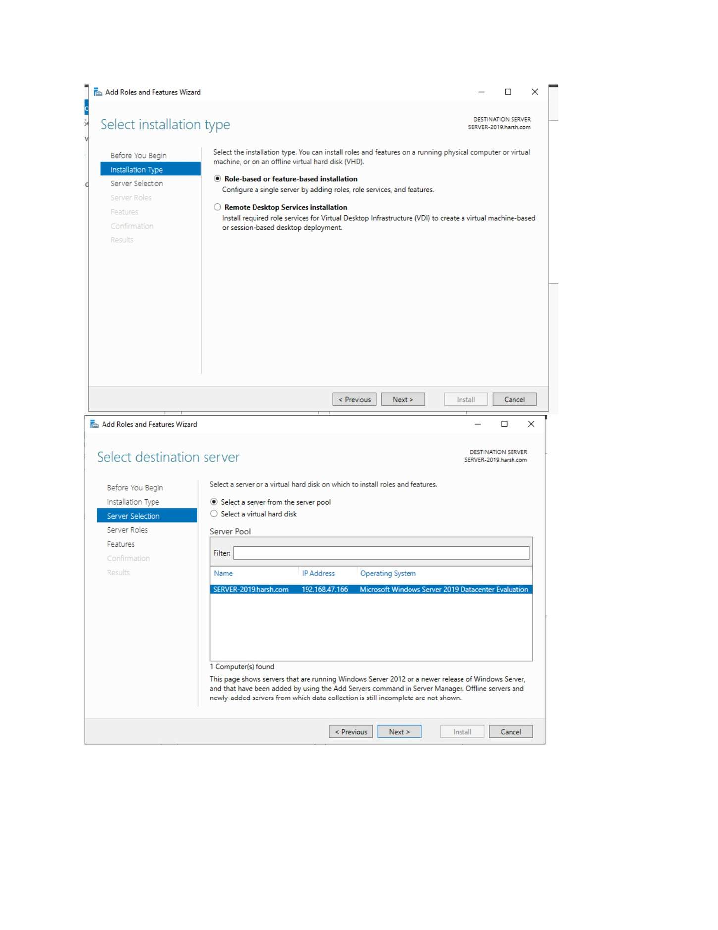
What I did: Selected the role-based installation option for DHCP.

PAGE 96 — DHCP (DYNAMIC HOST CONFIGURATION PROTOCOL)
Topic: DHCP (Dynamic Host Configuration Protocol)
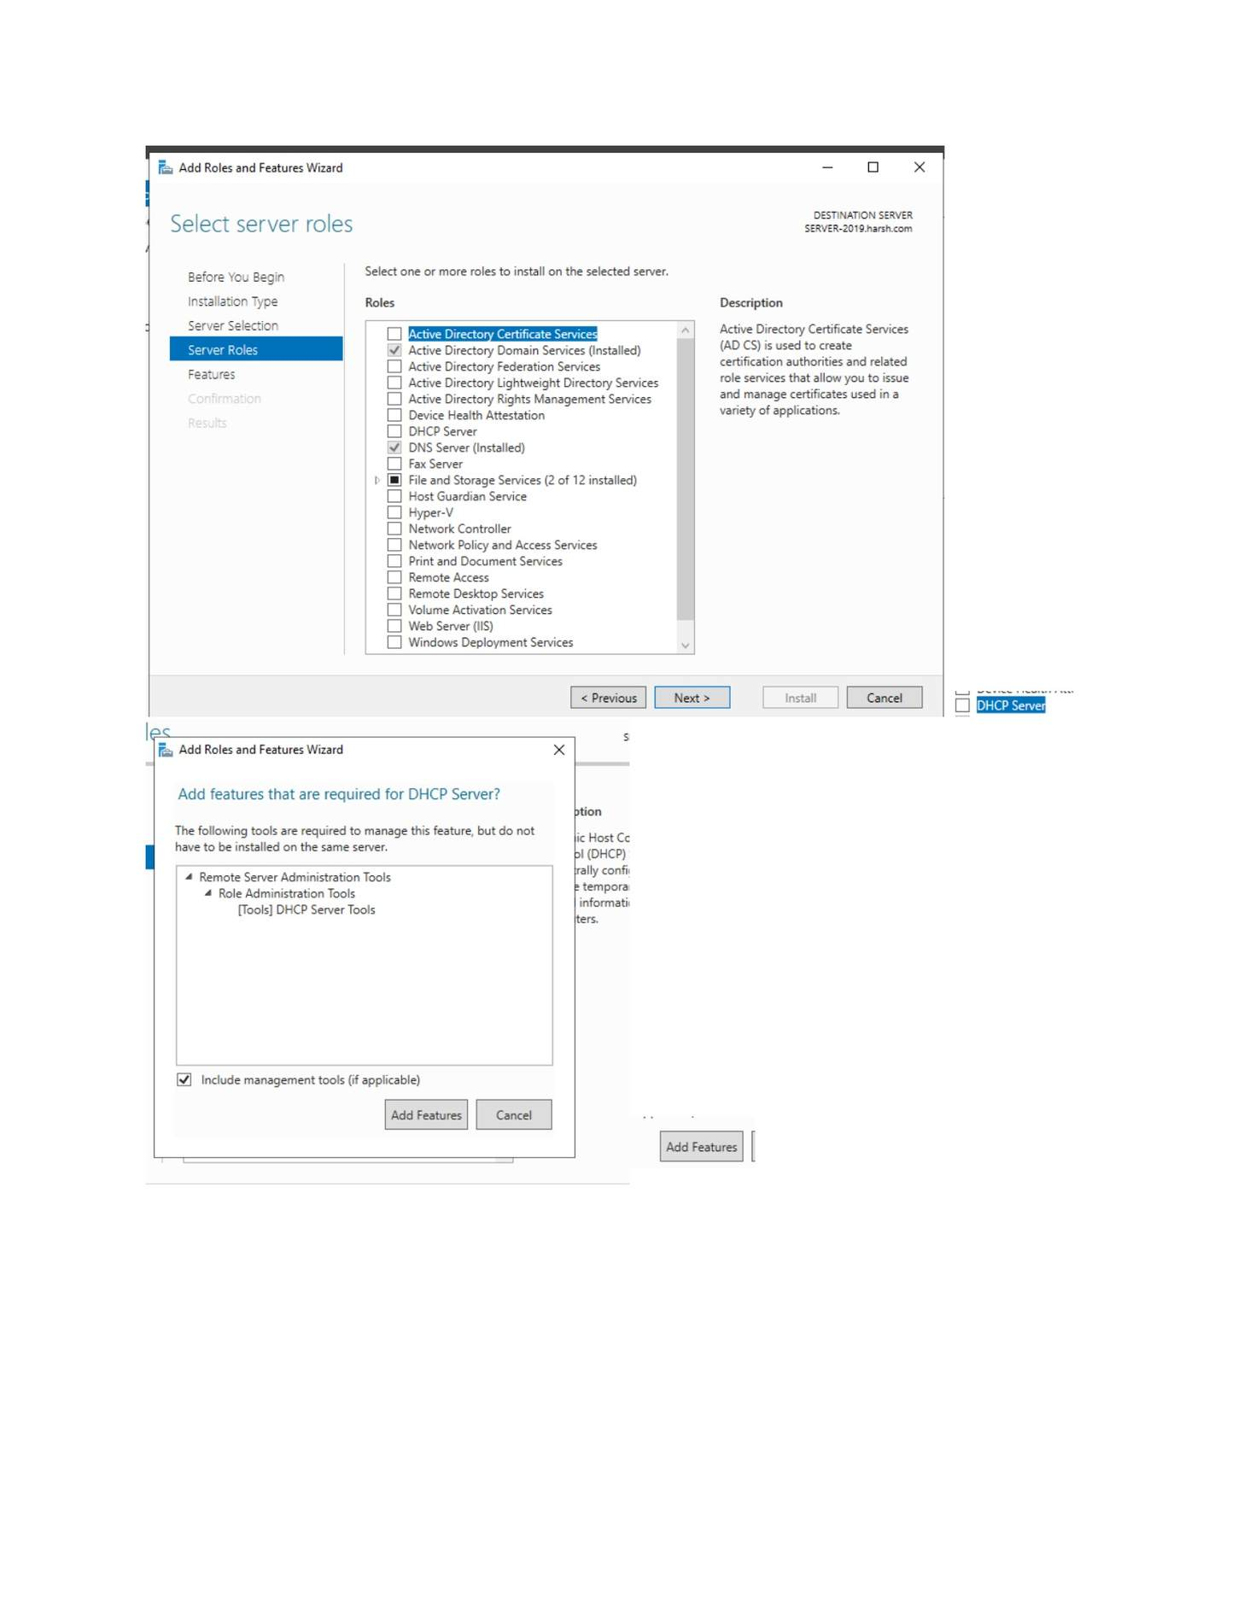
What I did: Selected the destination server for the DHCP role.

PAGE 97 — DHCP (DYNAMIC HOST CONFIGURATION PROTOCOL)
Topic: DHCP (Dynamic Host Configuration Protocol)
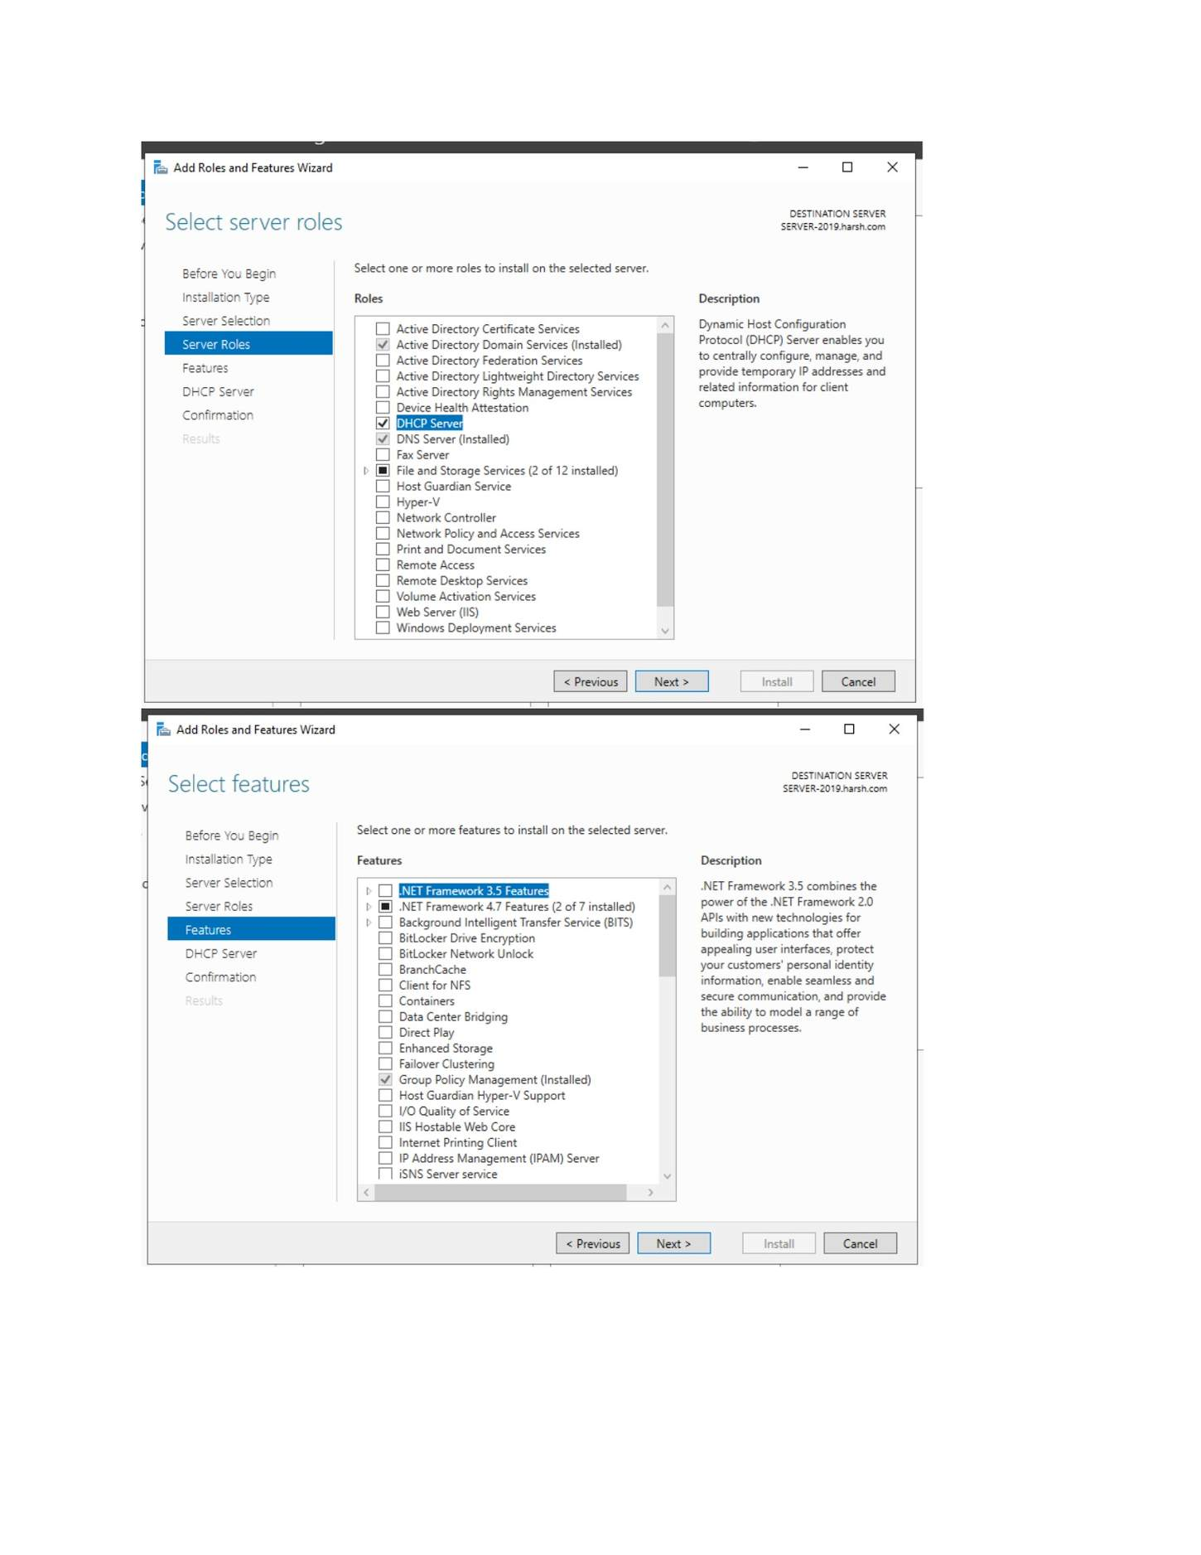
What I did: Selected Dynamic Host Configuration Protocol (DHCP) Server from the roles list.

PAGE 98 — DHCP (DYNAMIC HOST CONFIGURATION PROTOCOL)
Topic: DHCP (Dynamic Host Configuration Protocol)
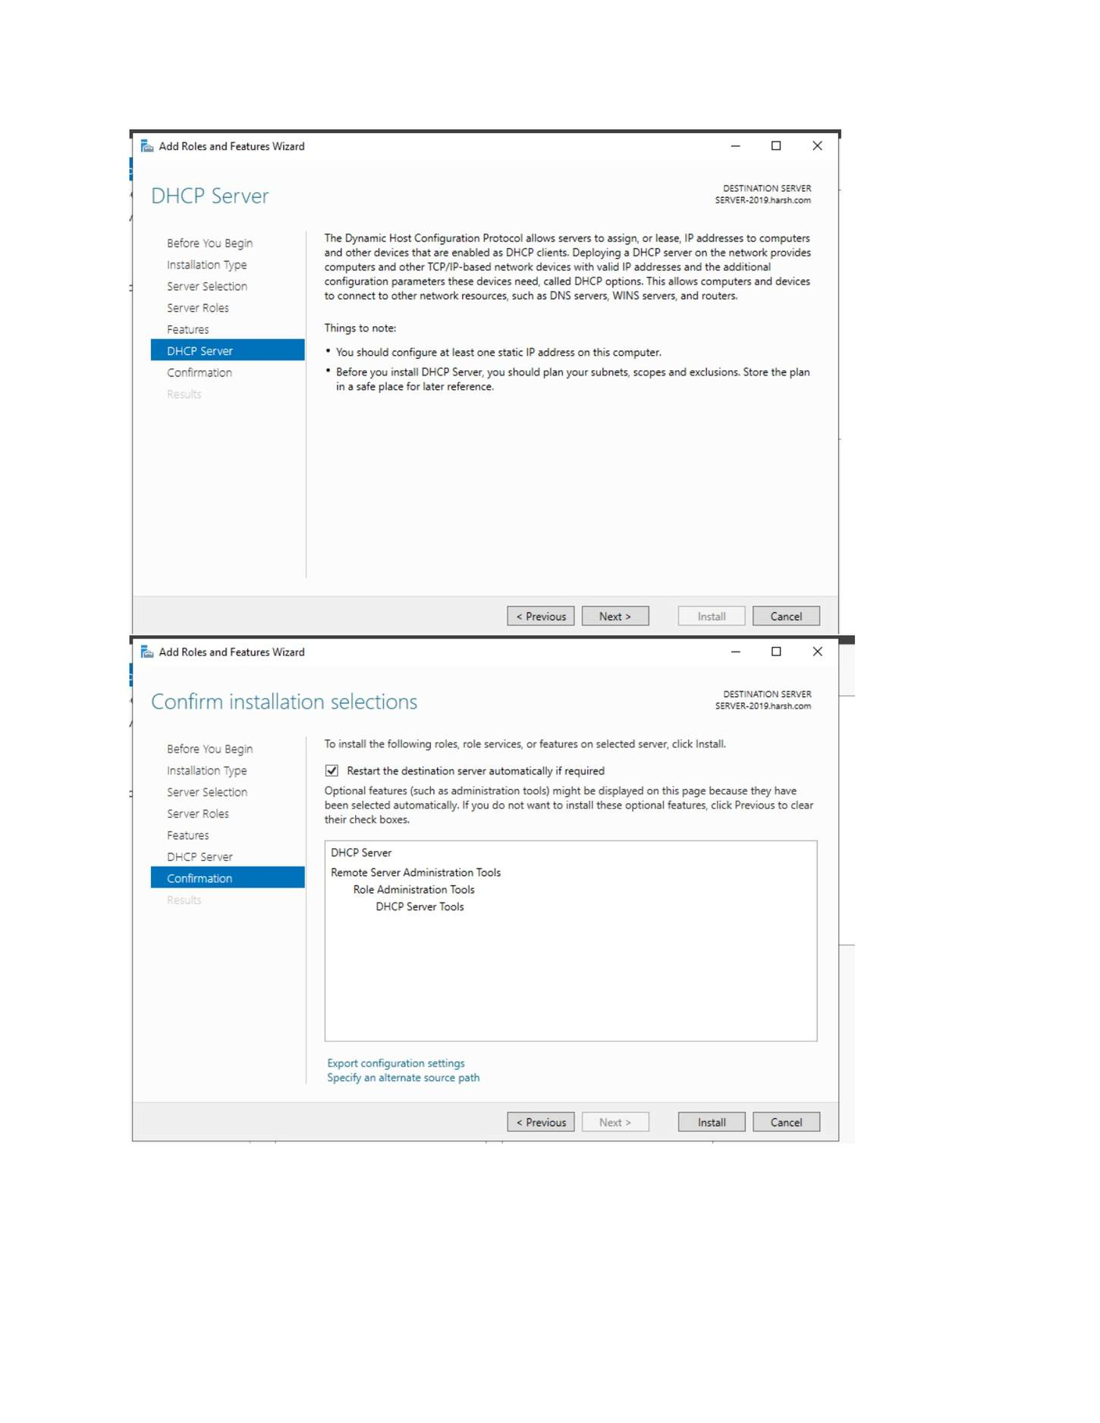
What I did: Reviewed the DHCP role information and continued.

PAGE 99 — DHCP (DYNAMIC HOST CONFIGURATION PROTOCOL)
Topic: DHCP (Dynamic Host Configuration Protocol)
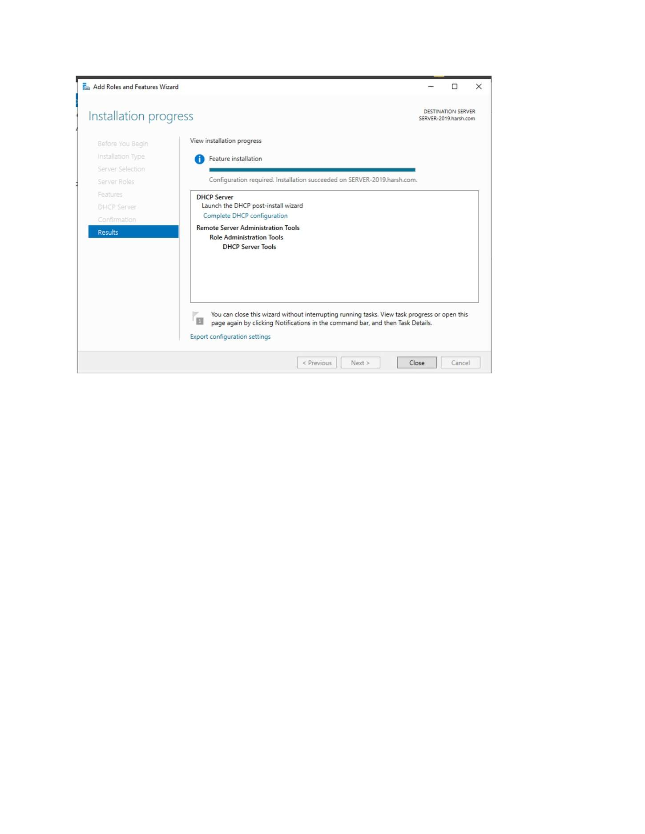
What I did: Confirmed the DHCP role installation selections.

PAGE 100 — DHCP (DYNAMIC HOST CONFIGURATION PROTOCOL)
Topic: DHCP (Dynamic Host Configuration Protocol)
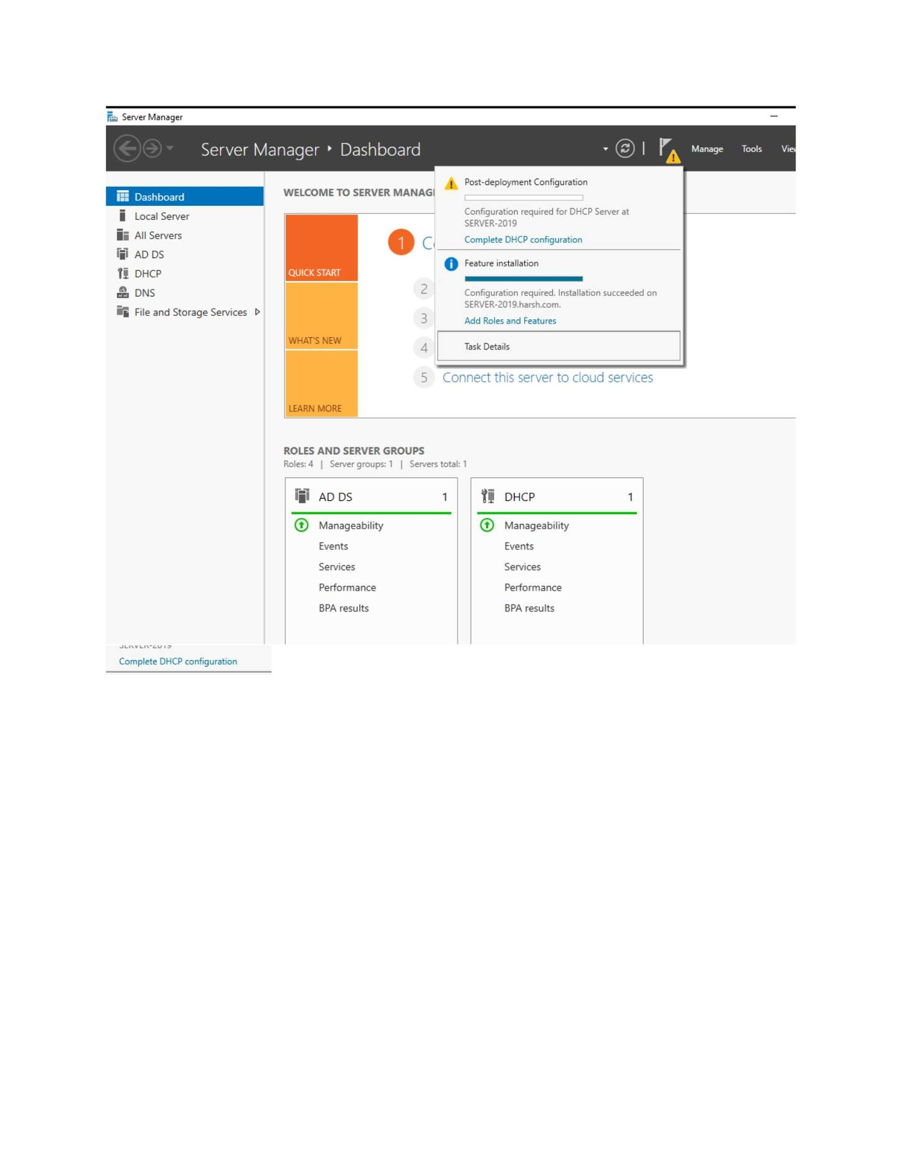
What I did: Started the DHCP Server role installation.

PAGE 101 — DHCP (DYNAMIC HOST CONFIGURATION PROTOCOL)
Topic: DHCP (Dynamic Host Configuration Protocol)
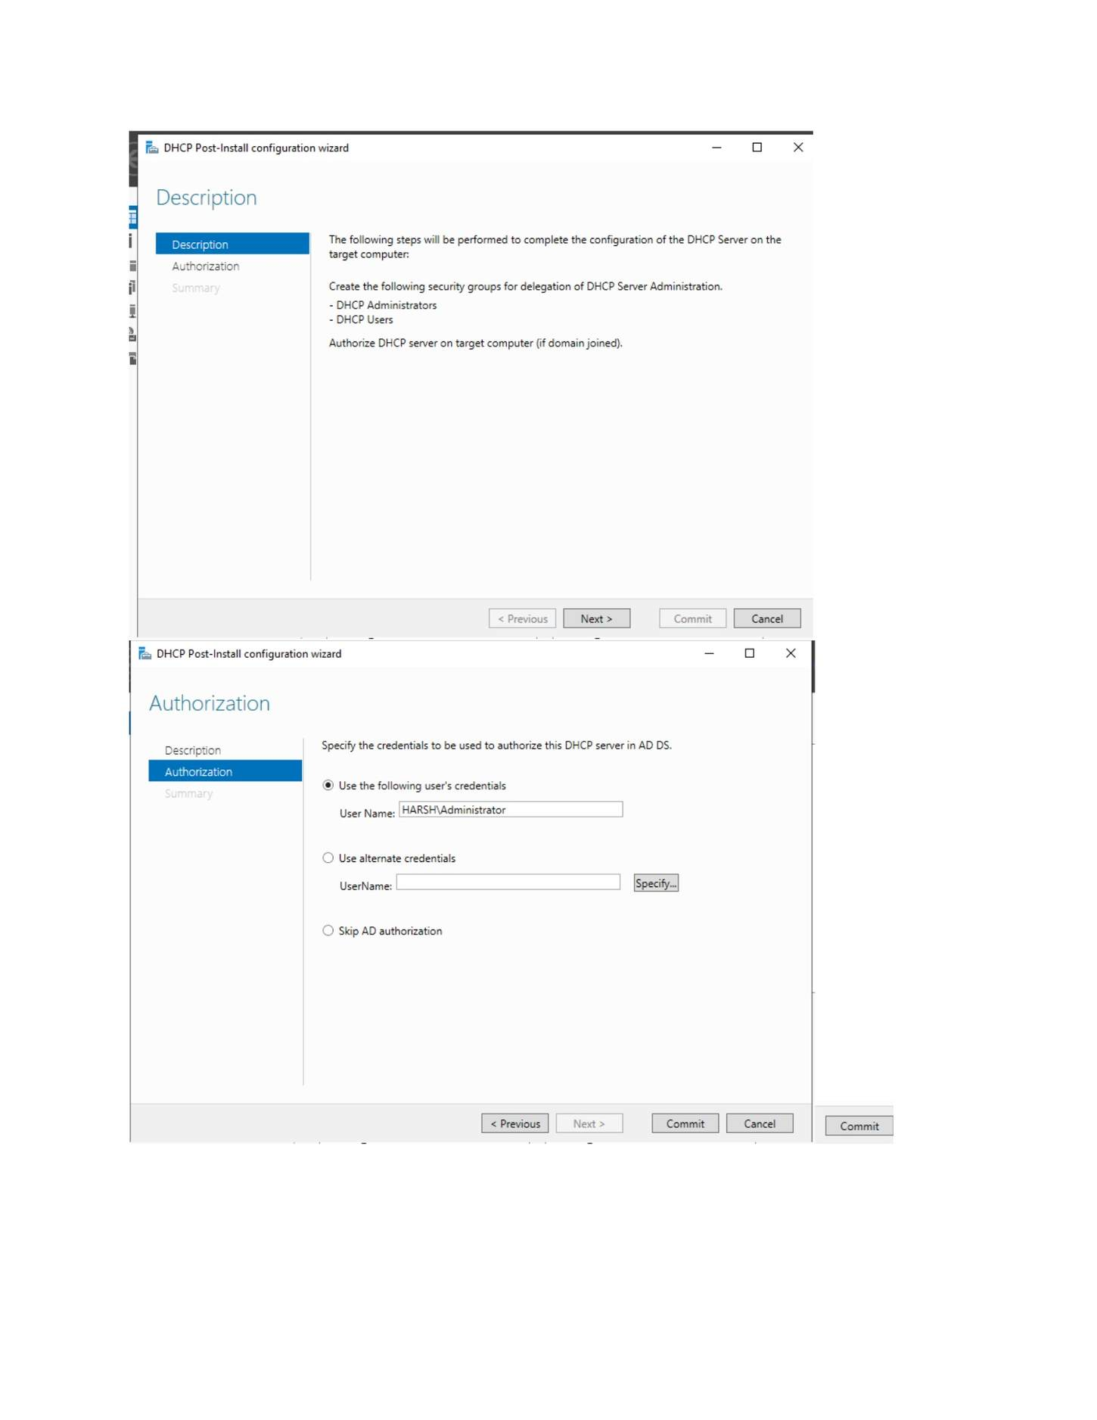
What I did: Waited for the DHCP role installation to complete.

PAGE 102 — DHCP (DYNAMIC HOST CONFIGURATION PROTOCOL)
Topic: DHCP (Dynamic Host Configuration Protocol)
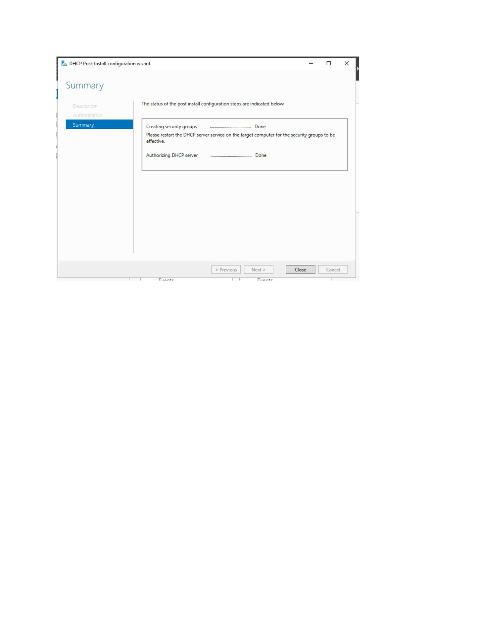
What I did: Opened the DHCP post-installation configuration/authorization step.

PAGE 103 — DHCP (DYNAMIC HOST CONFIGURATION PROTOCOL)
Topic: DHCP (Dynamic Host Configuration Protocol)
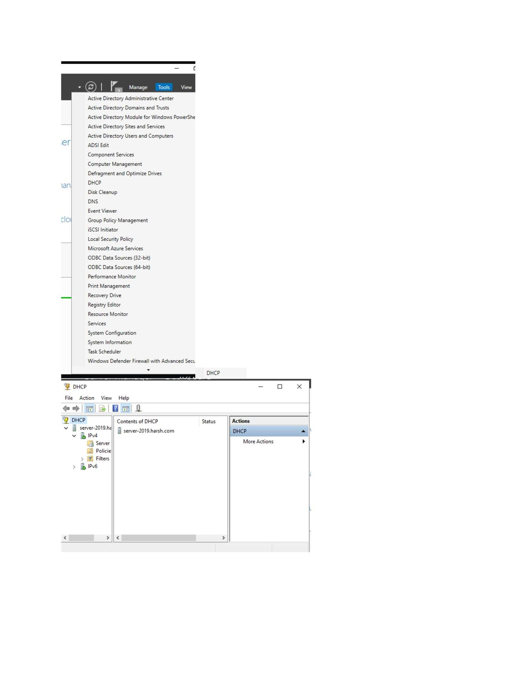
What I did: Authorized the DHCP server in Active Directory.

PAGE 104 — DHCP (DYNAMIC HOST CONFIGURATION PROTOCOL)
Topic: DHCP (Dynamic Host Configuration Protocol)
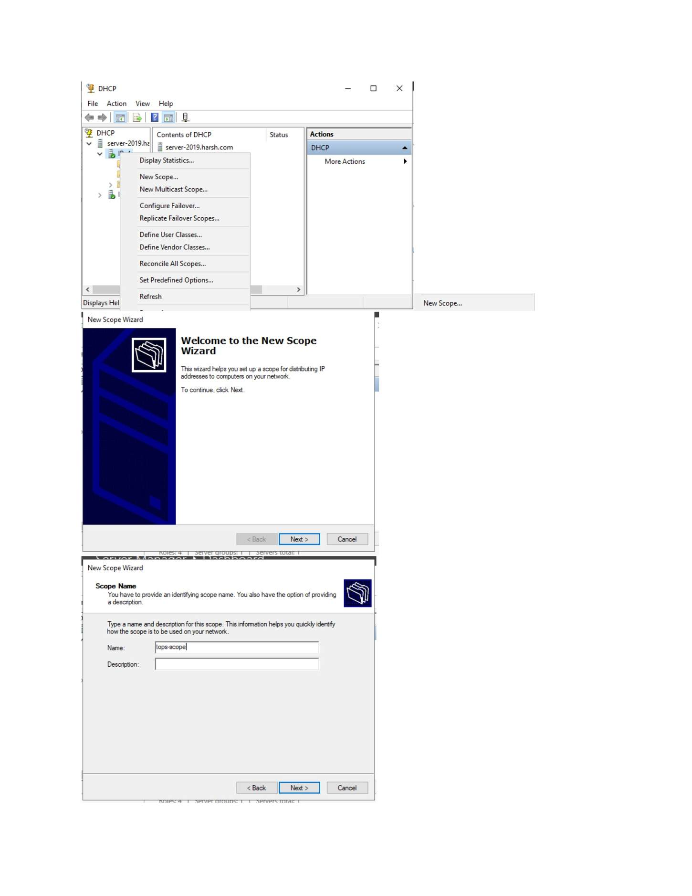
What I did: Reviewed the DHCP authorization/result shown after configuration.

PAGE 105 — DHCP (DYNAMIC HOST CONFIGURATION PROTOCOL)
Topic: DHCP (Dynamic Host Configuration Protocol)
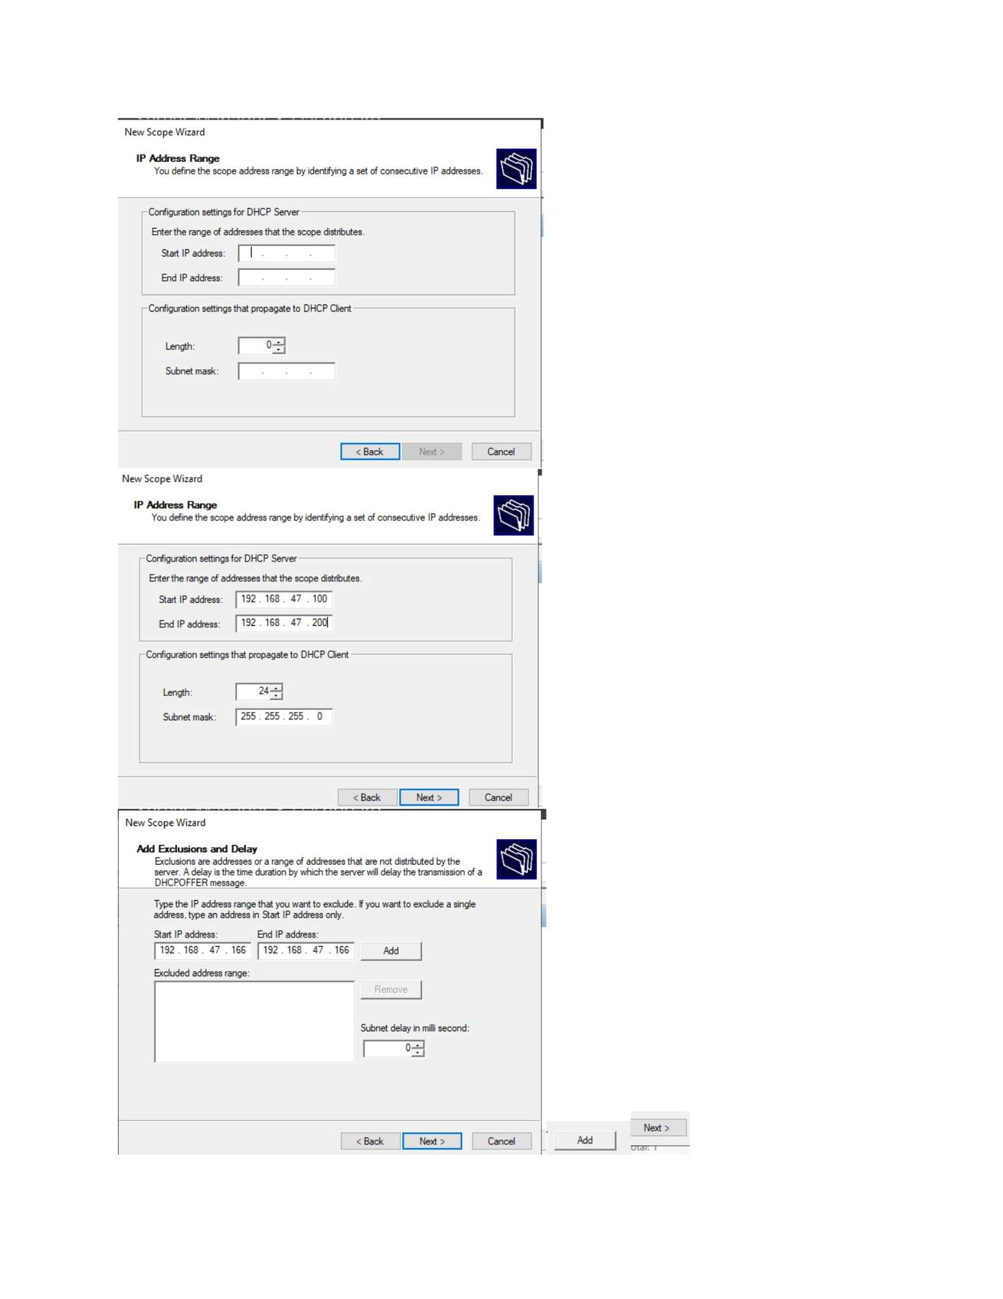
What I did: Opened the DHCP management console.

PAGE 106 — DHCP (DYNAMIC HOST CONFIGURATION PROTOCOL)
Topic: DHCP (Dynamic Host Configuration Protocol)
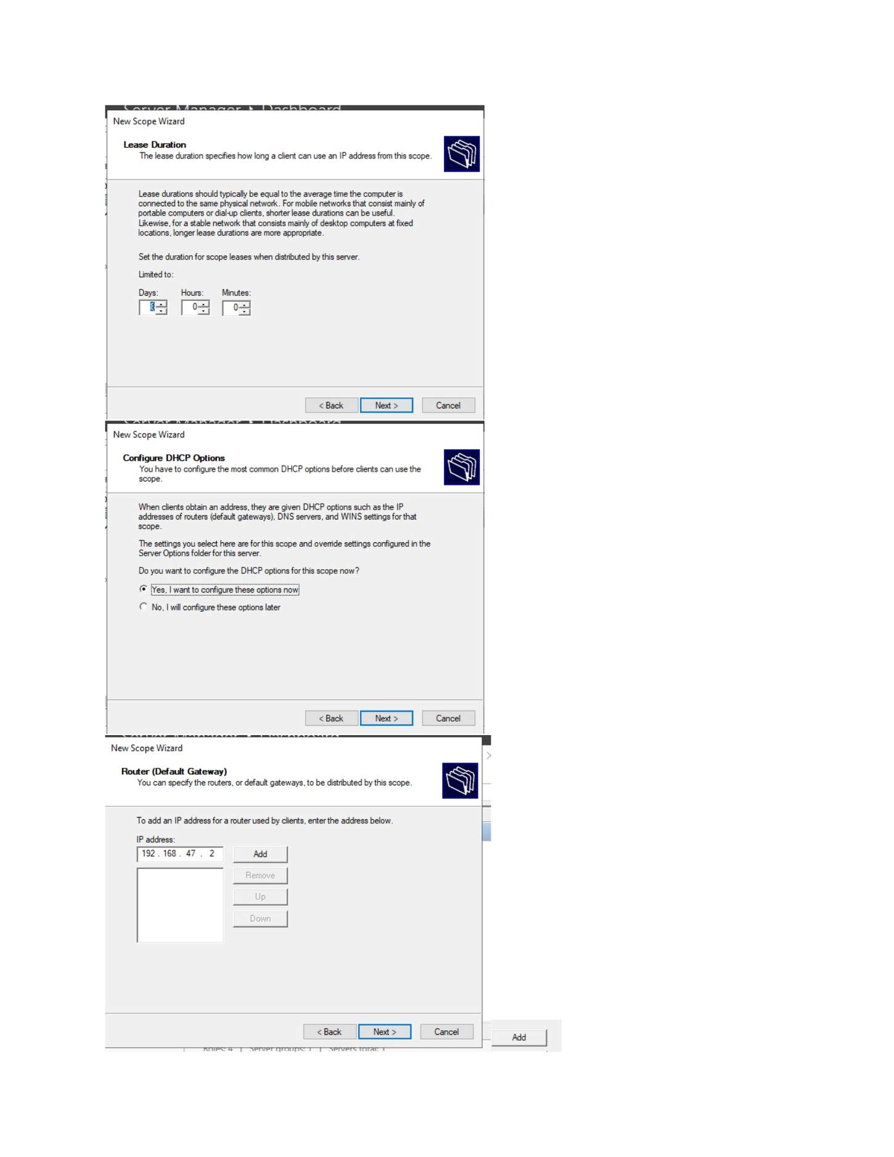
What I did: Started the New Scope Wizard to create a DHCP address scope.

PAGE 107 — DHCP (DYNAMIC HOST CONFIGURATION PROTOCOL)
Topic: DHCP (Dynamic Host Configuration Protocol)
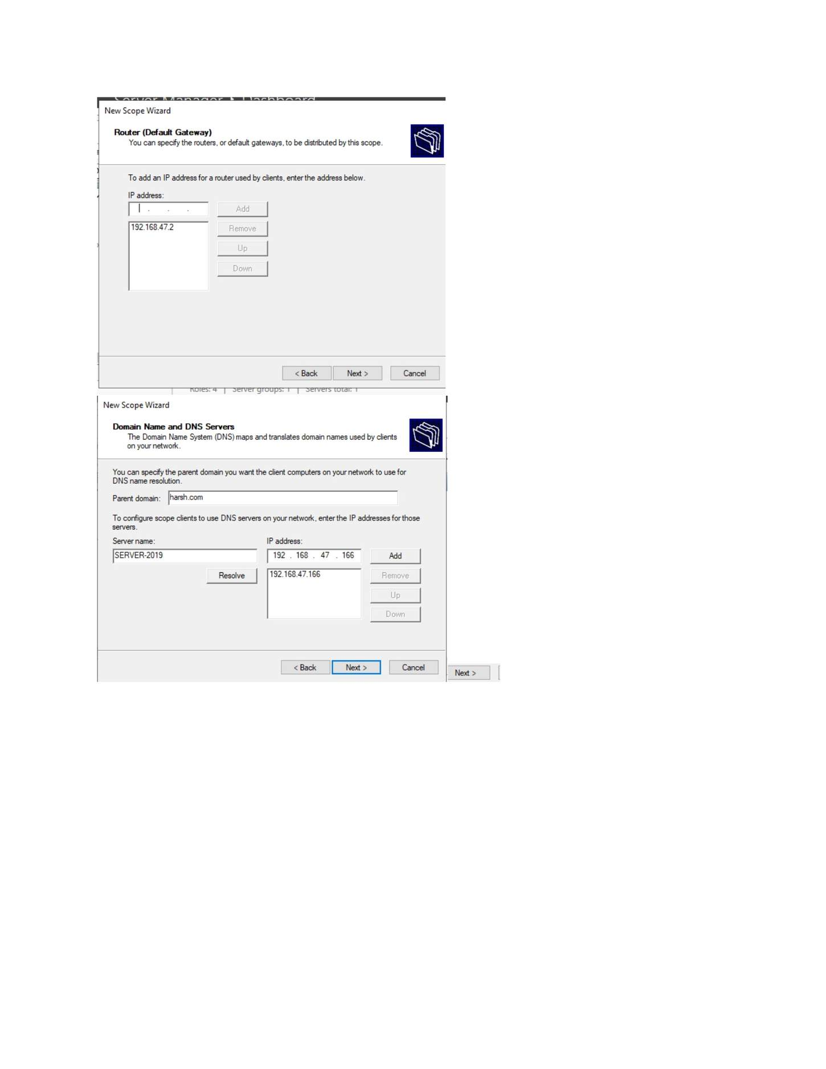
What I did: Entered the DHCP scope name/description.

PAGE 108 — DHCP (DYNAMIC HOST CONFIGURATION PROTOCOL)
Topic: DHCP (Dynamic Host Configuration Protocol)
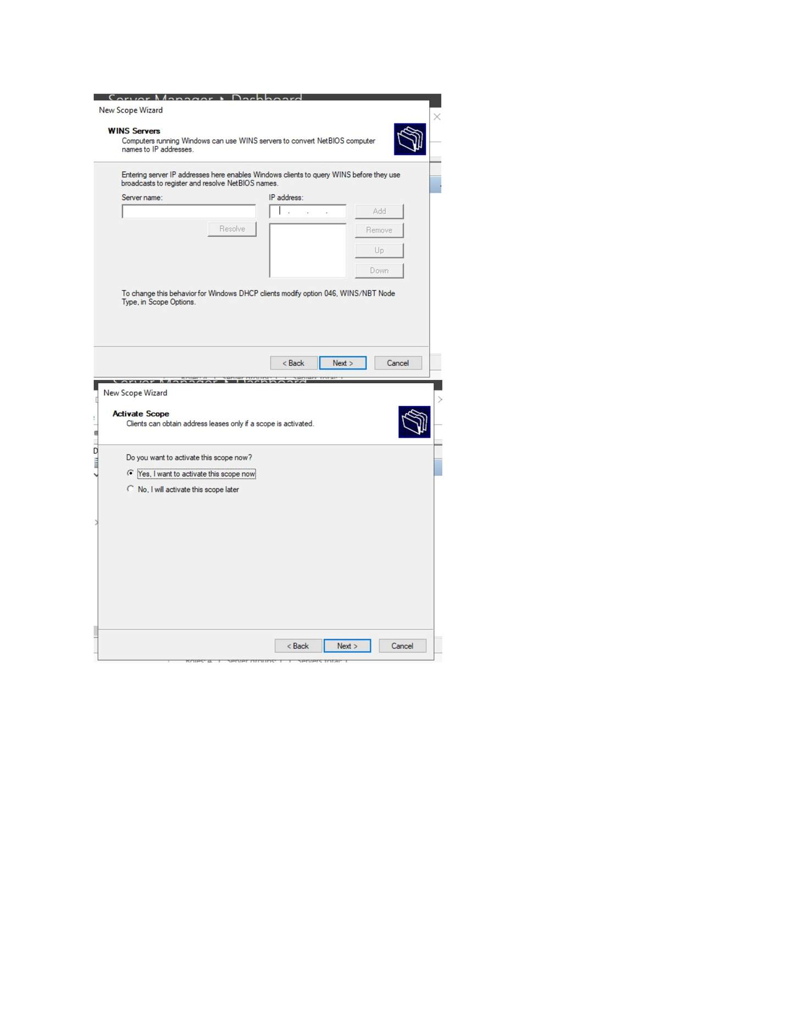
What I did: Specified the start and end IP addresses for the DHCP scope.

PAGE 109 — DHCP (DYNAMIC HOST CONFIGURATION PROTOCOL)
Topic: DHCP (Dynamic Host Configuration Protocol)
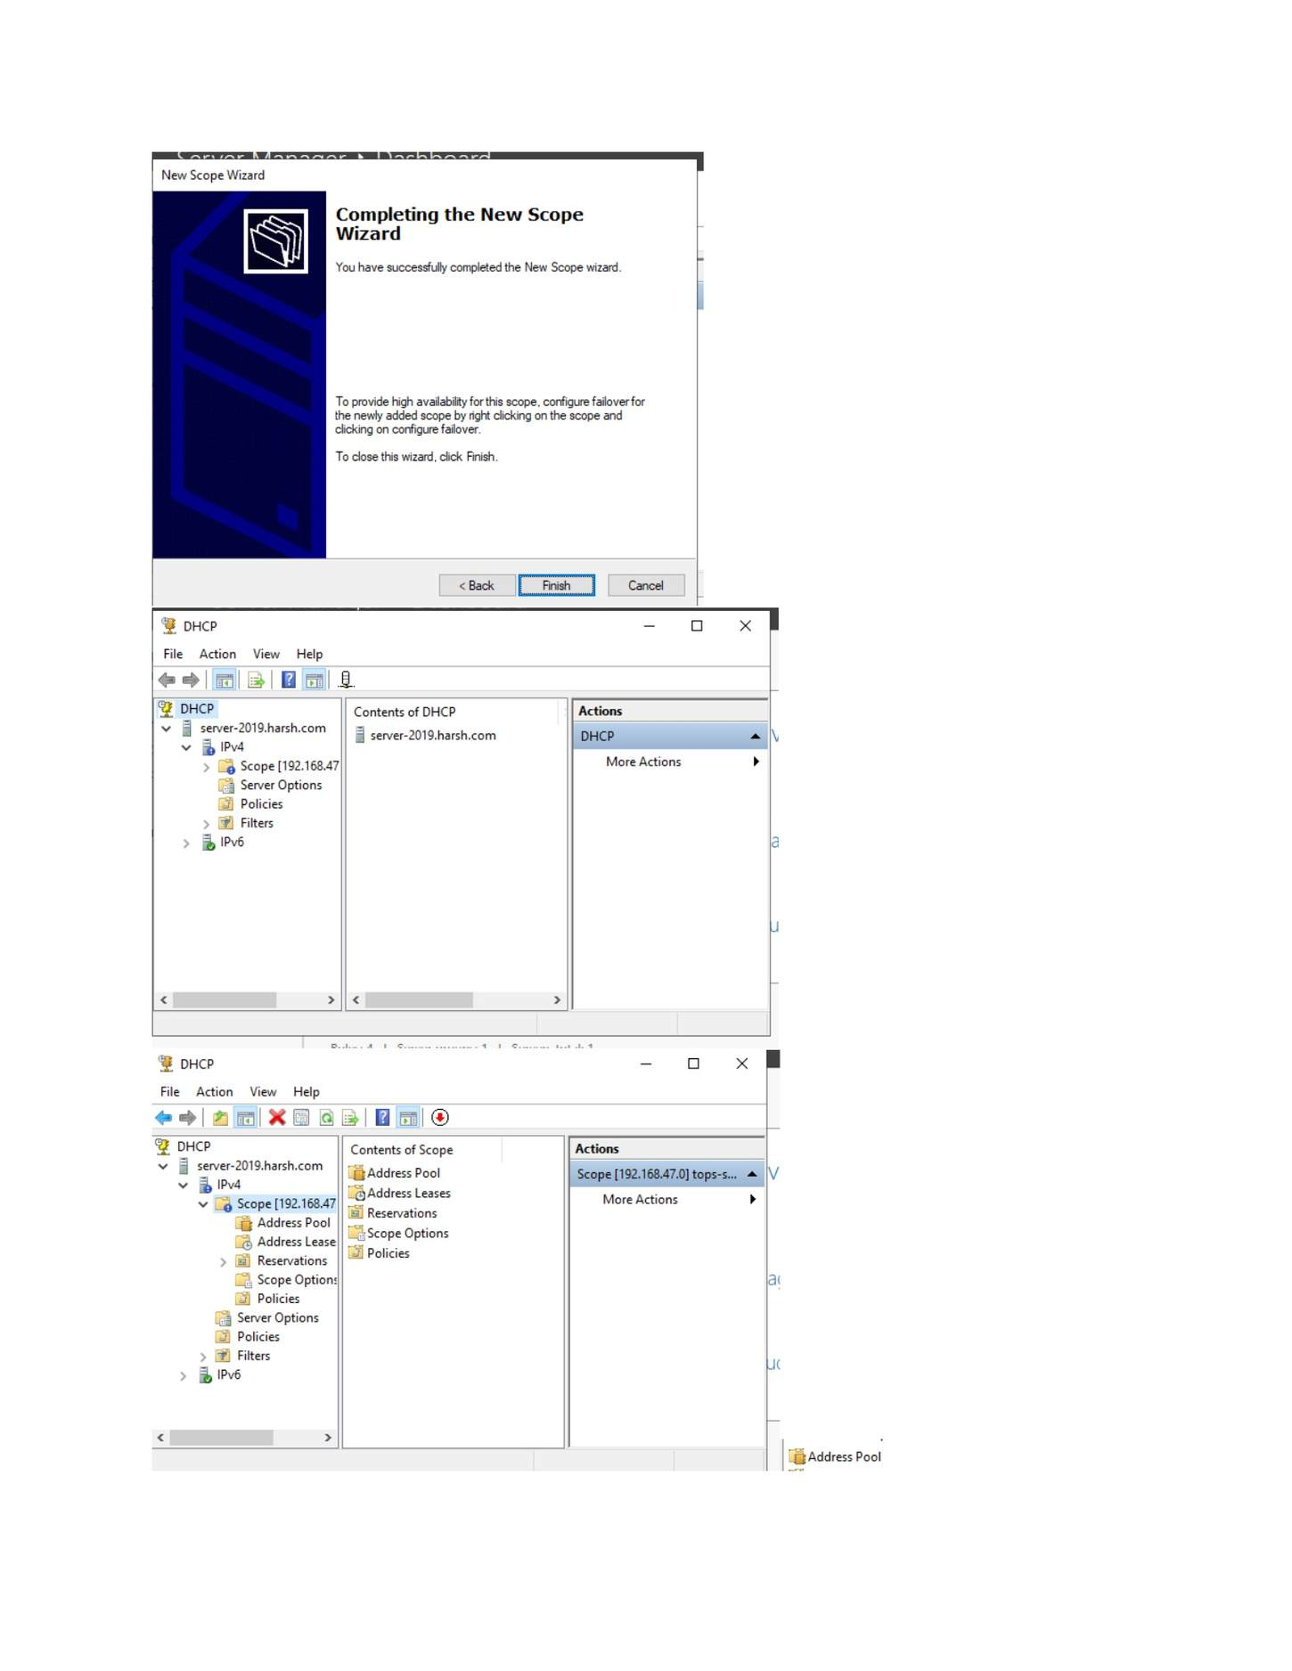
What I did: Configured the subnet mask/prefix for the scope.

PAGE 110 — DHCP (DYNAMIC HOST CONFIGURATION PROTOCOL)
Topic: DHCP (Dynamic Host Configuration Protocol)
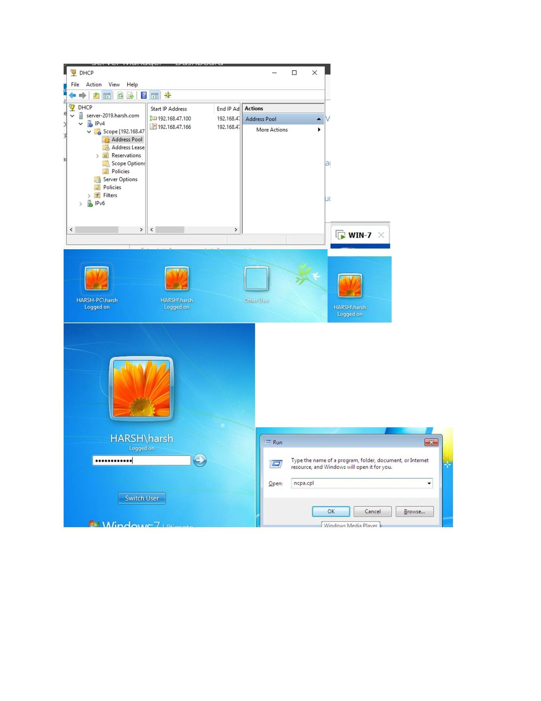
What I did: Specified the exclusion range so those addresses would not be leased.

PAGE 111 — DHCP (DYNAMIC HOST CONFIGURATION PROTOCOL)
Topic: DHCP (Dynamic Host Configuration Protocol)
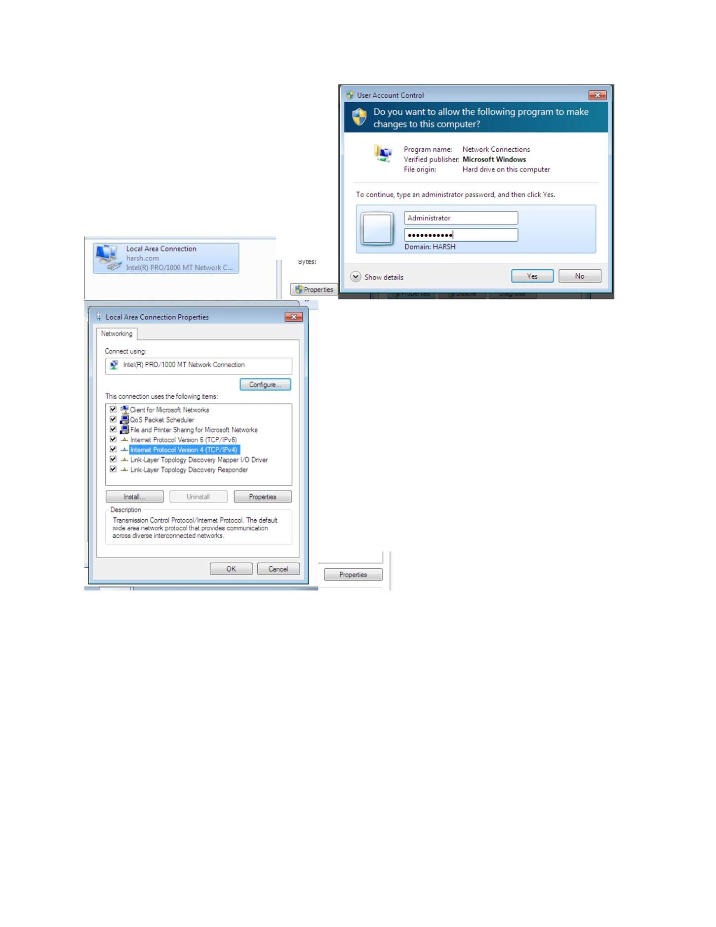
What I did: Configured the DHCP lease duration.

PAGE 112 — DHCP (DYNAMIC HOST CONFIGURATION PROTOCOL)
Topic: DHCP (Dynamic Host Configuration Protocol)
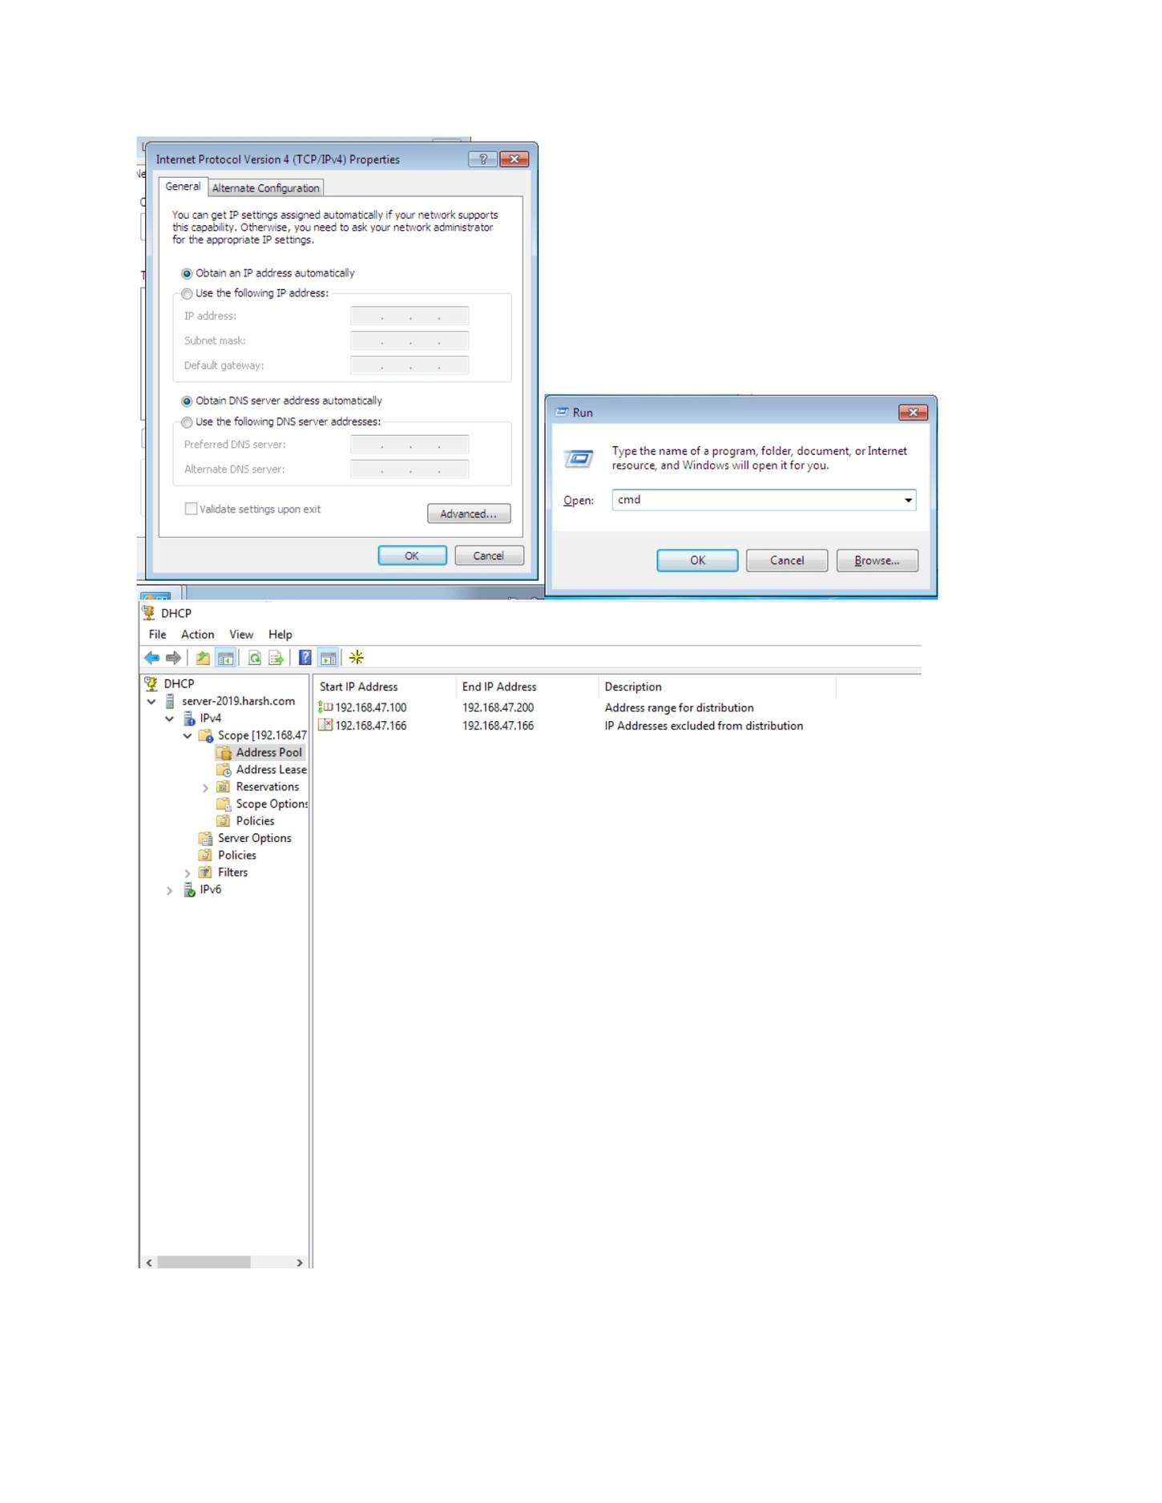
What I did: Configured the router/default-gateway option for DHCP clients.

PAGE 113 — DHCP (DYNAMIC HOST CONFIGURATION PROTOCOL)
Topic: DHCP (Dynamic Host Configuration Protocol)
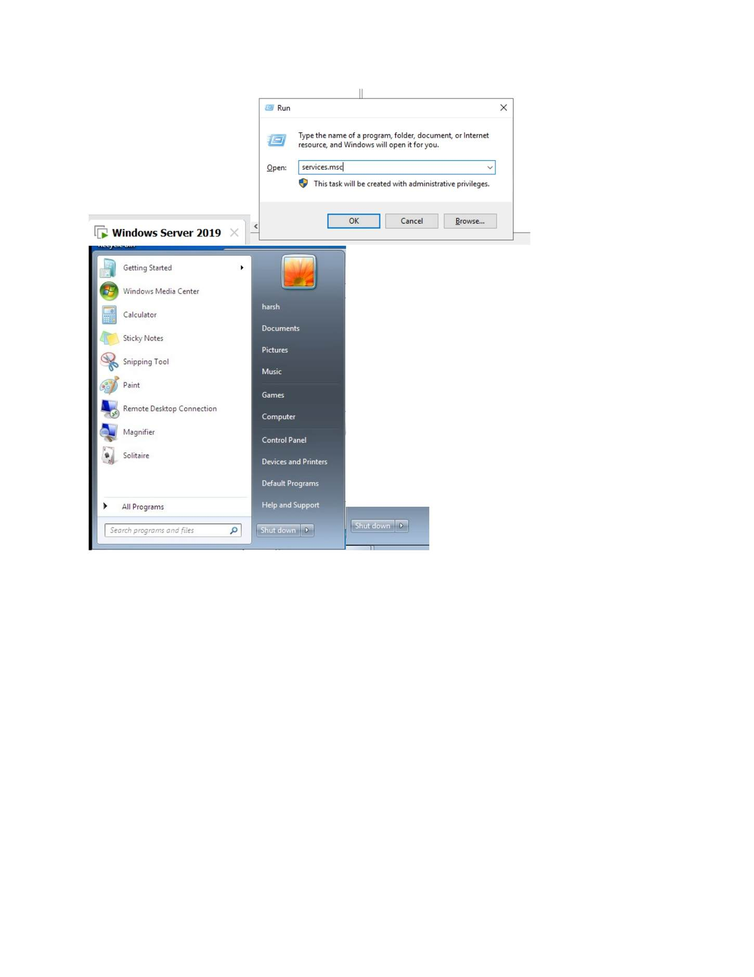
What I did: Configured the DNS/domain options supplied to DHCP clients.

PAGE 114 — DHCP (DYNAMIC HOST CONFIGURATION PROTOCOL)
Topic: DHCP (Dynamic Host Configuration Protocol)
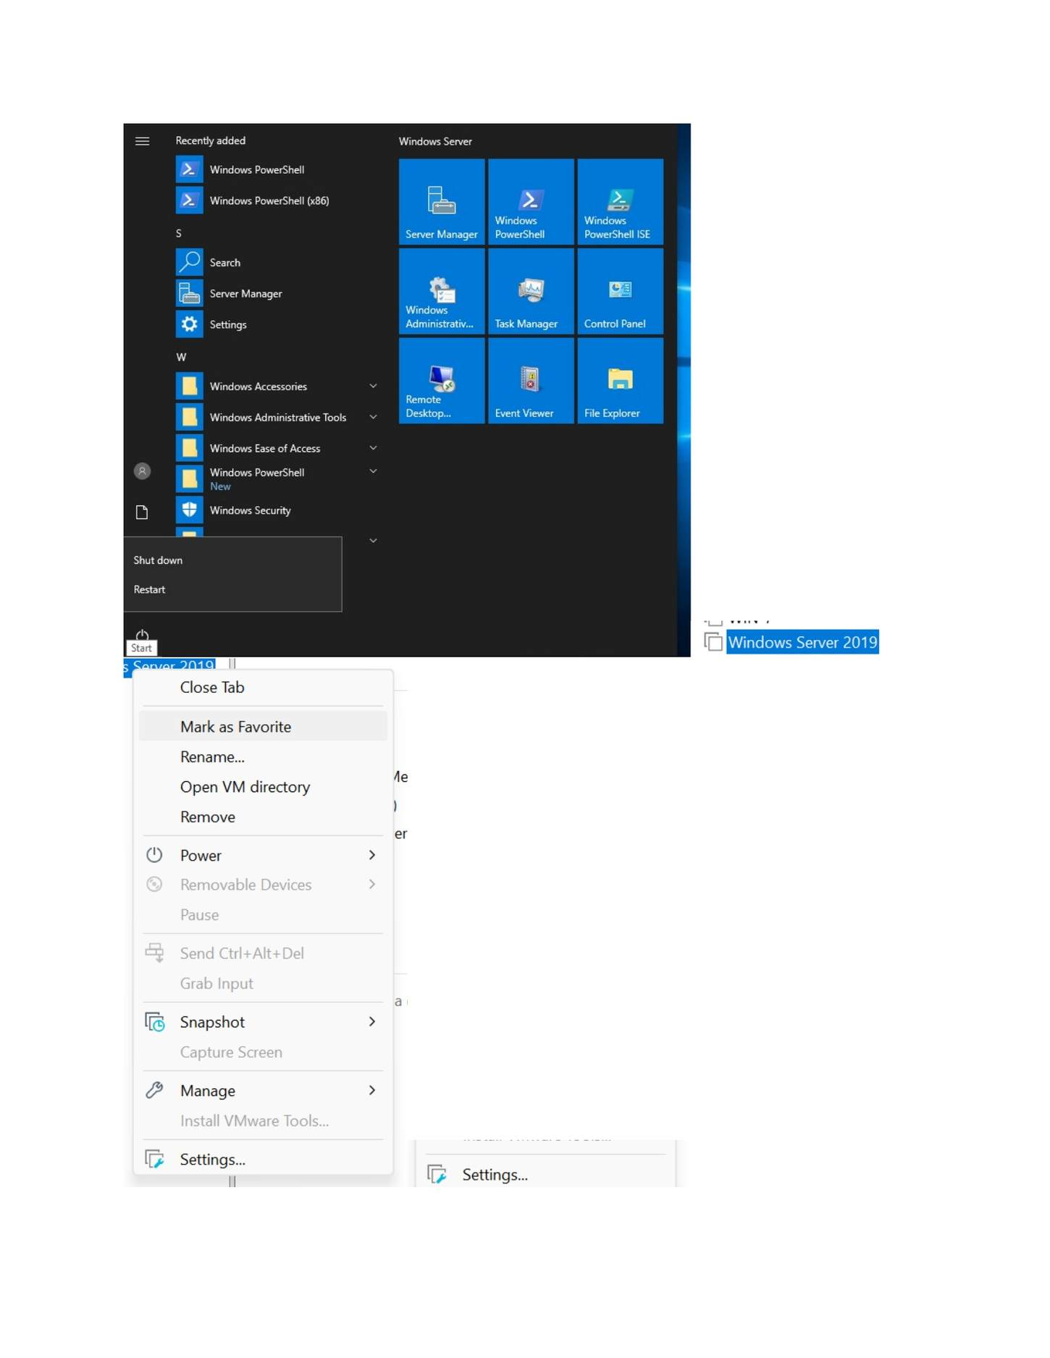
What I did: Reviewed the final DHCP scope settings before completion.

PAGE 115 — DHCP (DYNAMIC HOST CONFIGURATION PROTOCOL)
Topic: DHCP (Dynamic Host Configuration Protocol)
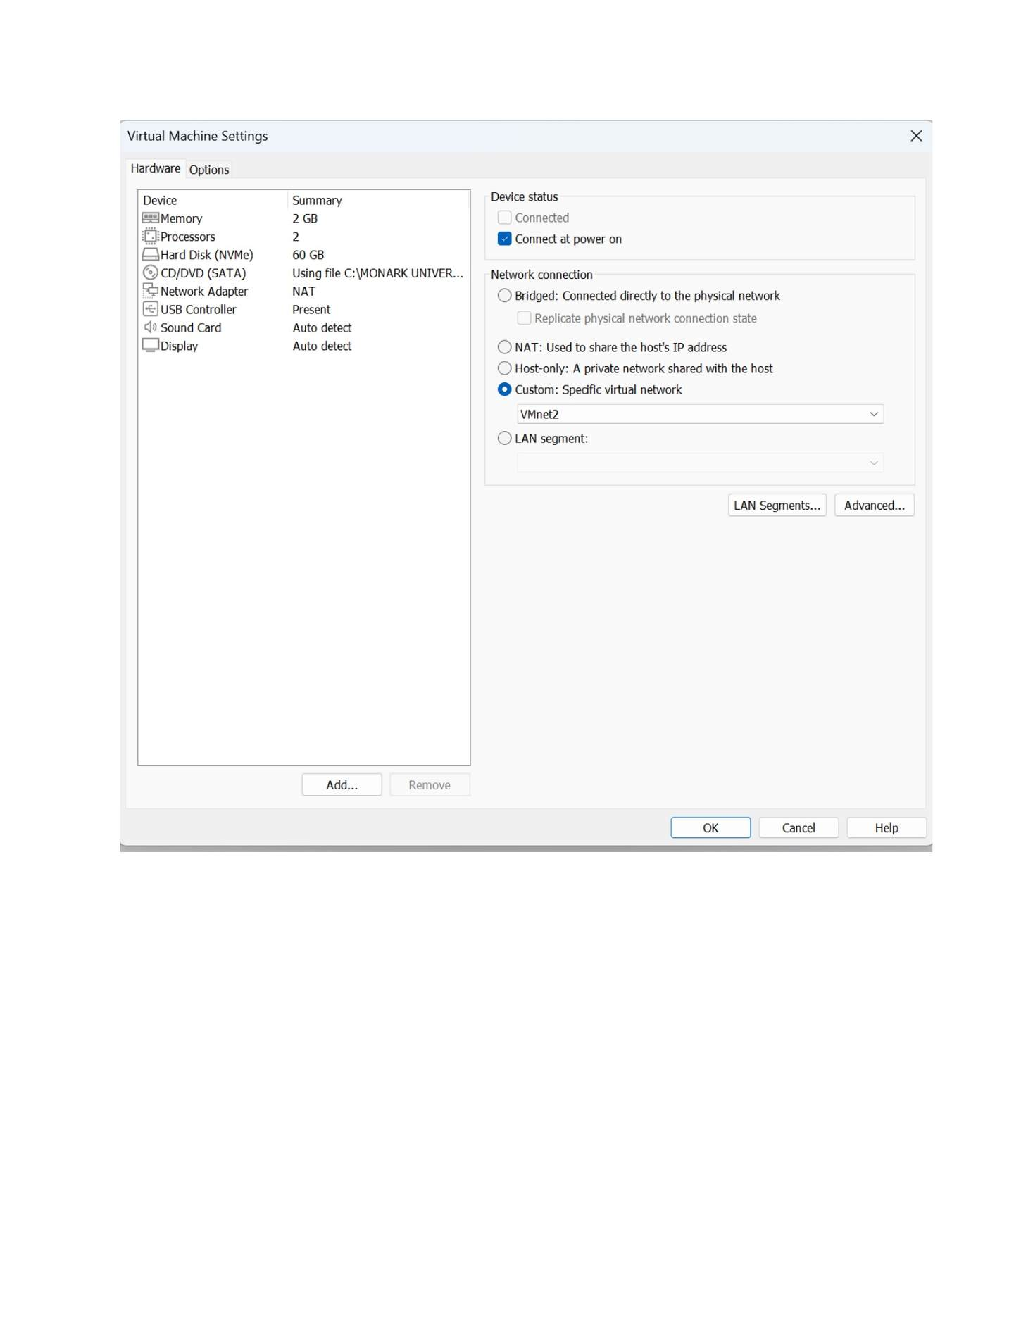
What I did: Completed the New Scope Wizard and activated the scope.

PAGE 116 — DHCP (DYNAMIC HOST CONFIGURATION PROTOCOL)
Topic: DHCP (Dynamic Host Configuration Protocol)
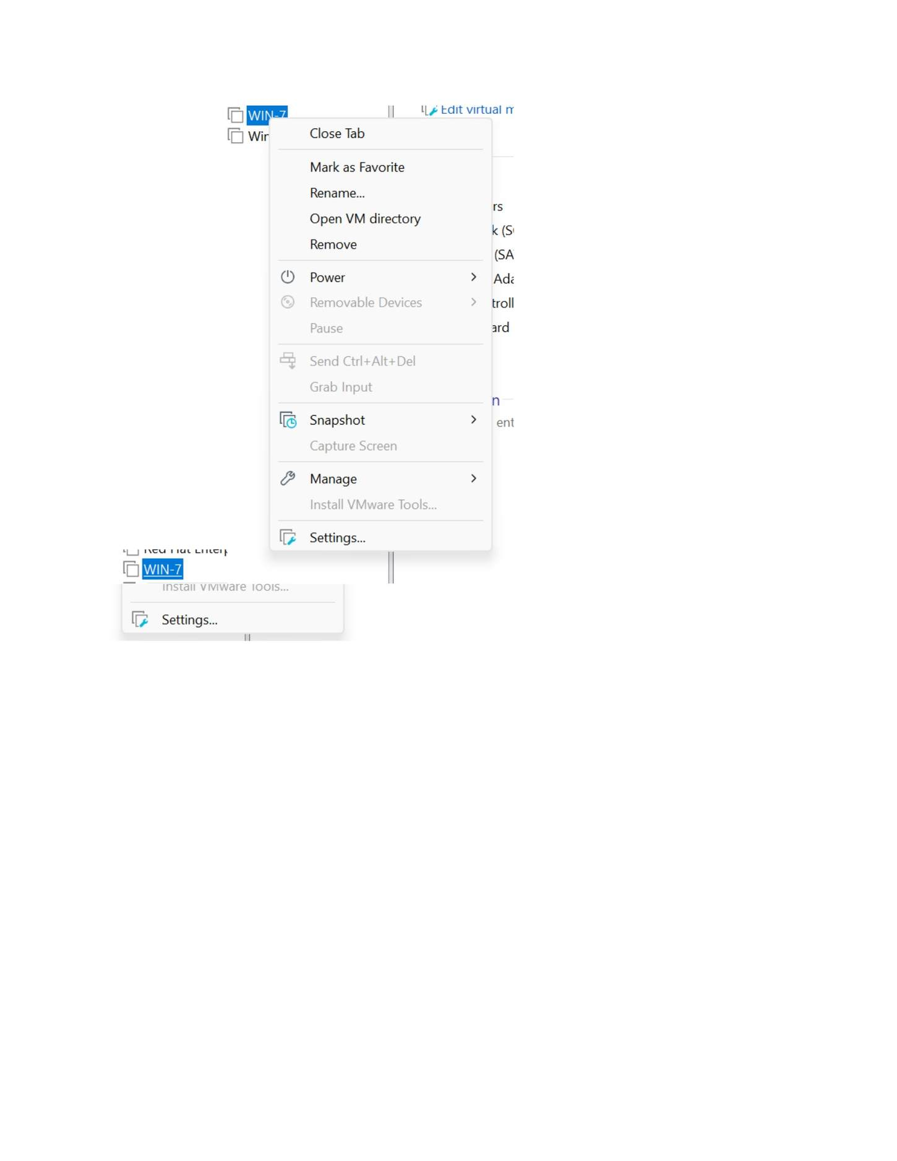
What I did: Opened the DHCP scope to verify the address range and active configuration.

PAGE 117 — DHCP (DYNAMIC HOST CONFIGURATION PROTOCOL)
Topic: DHCP (Dynamic Host Configuration Protocol)
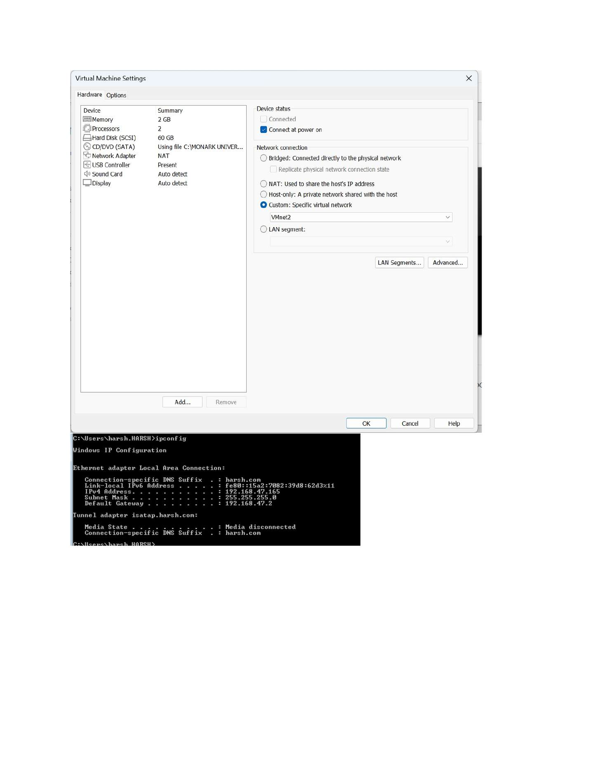
What I did: Reviewed the scope addresses/leases displayed by DHCP.

PAGE 118 — DHCP (DYNAMIC HOST CONFIGURATION PROTOCOL)
Topic: DHCP (Dynamic Host Configuration Protocol)
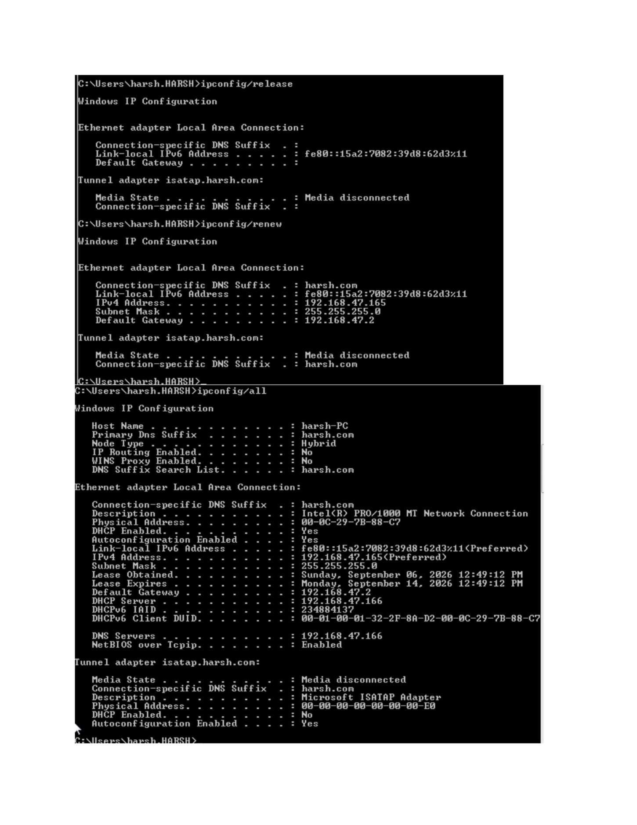
What I did: Checked the DHCP client/network configuration on the Windows client.

PAGE 119 — DHCP (DYNAMIC HOST CONFIGURATION PROTOCOL)
Topic: DHCP (Dynamic Host Configuration Protocol)
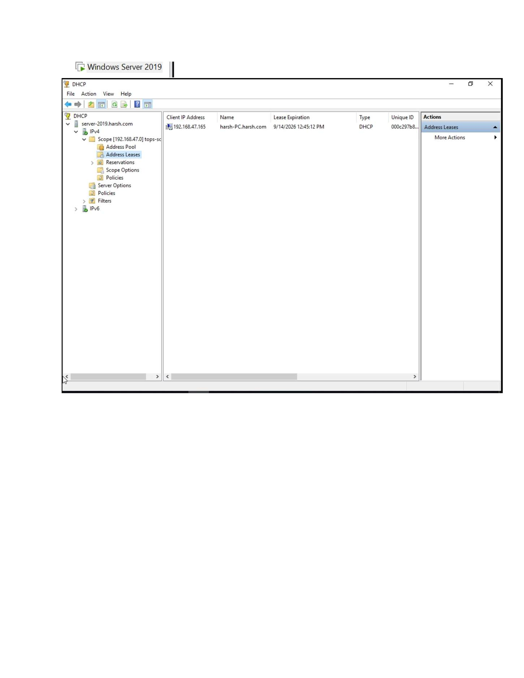
What I did: Opened the Windows network settings to review the adapter configuration.

PAGE 120 — FILE SERVER (SMB)
Topic: File Server (SMB)
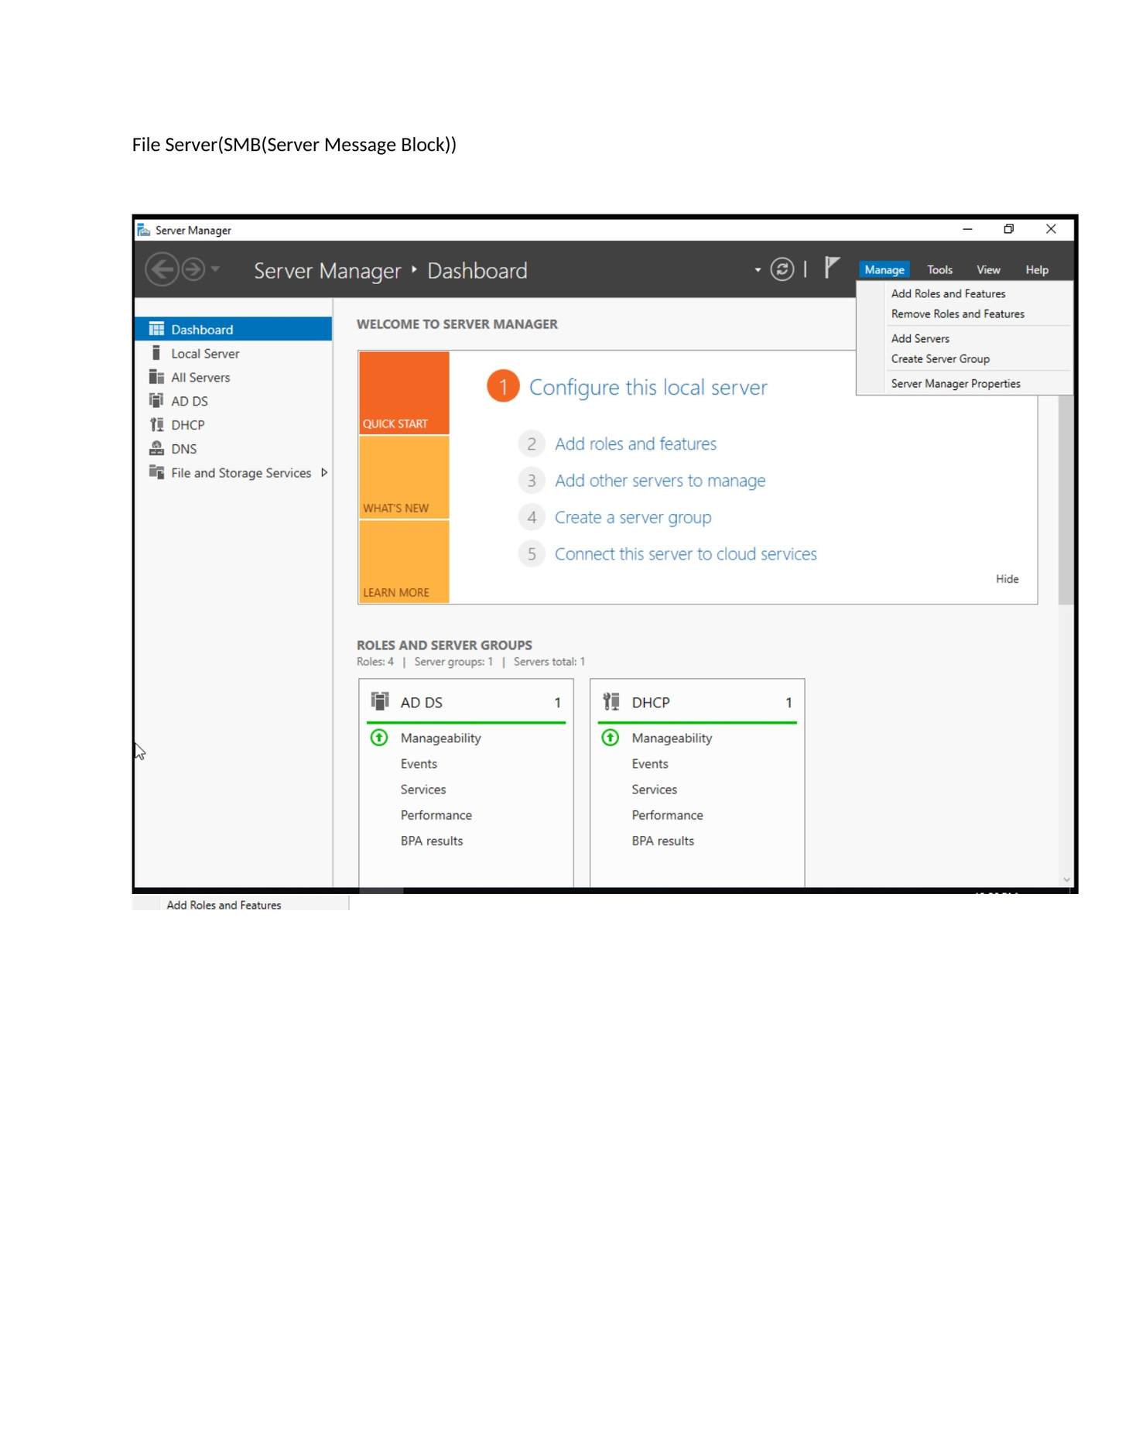
What I did: Opened Server Manager and started the File Server/SMB configuration.

PAGE 121 — FILE SERVER (SMB)
Topic: File Server (SMB)
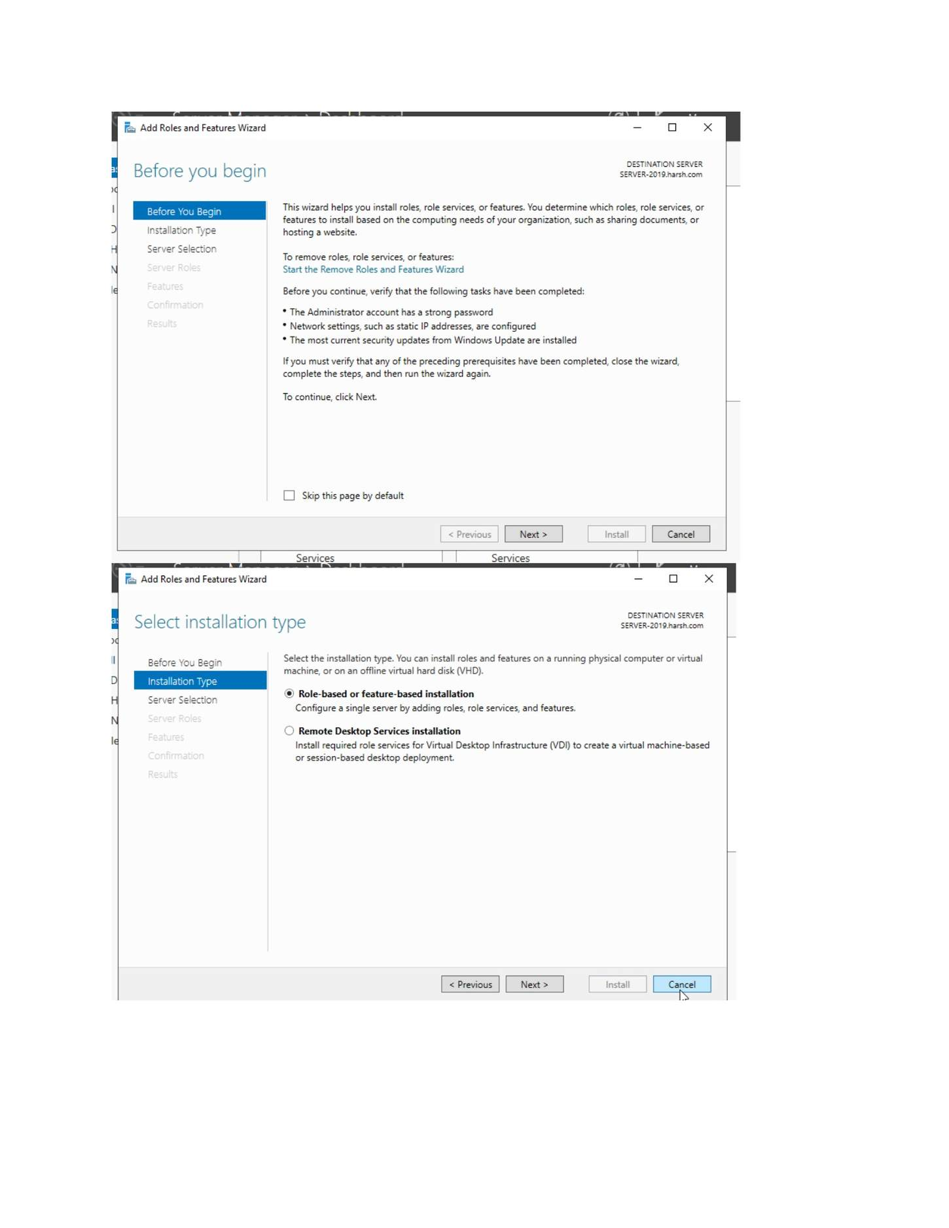
What I did: Started the Add Roles and Features wizard for the file-server role.

PAGE 122 — FILE SERVER (SMB)
Topic: File Server (SMB)
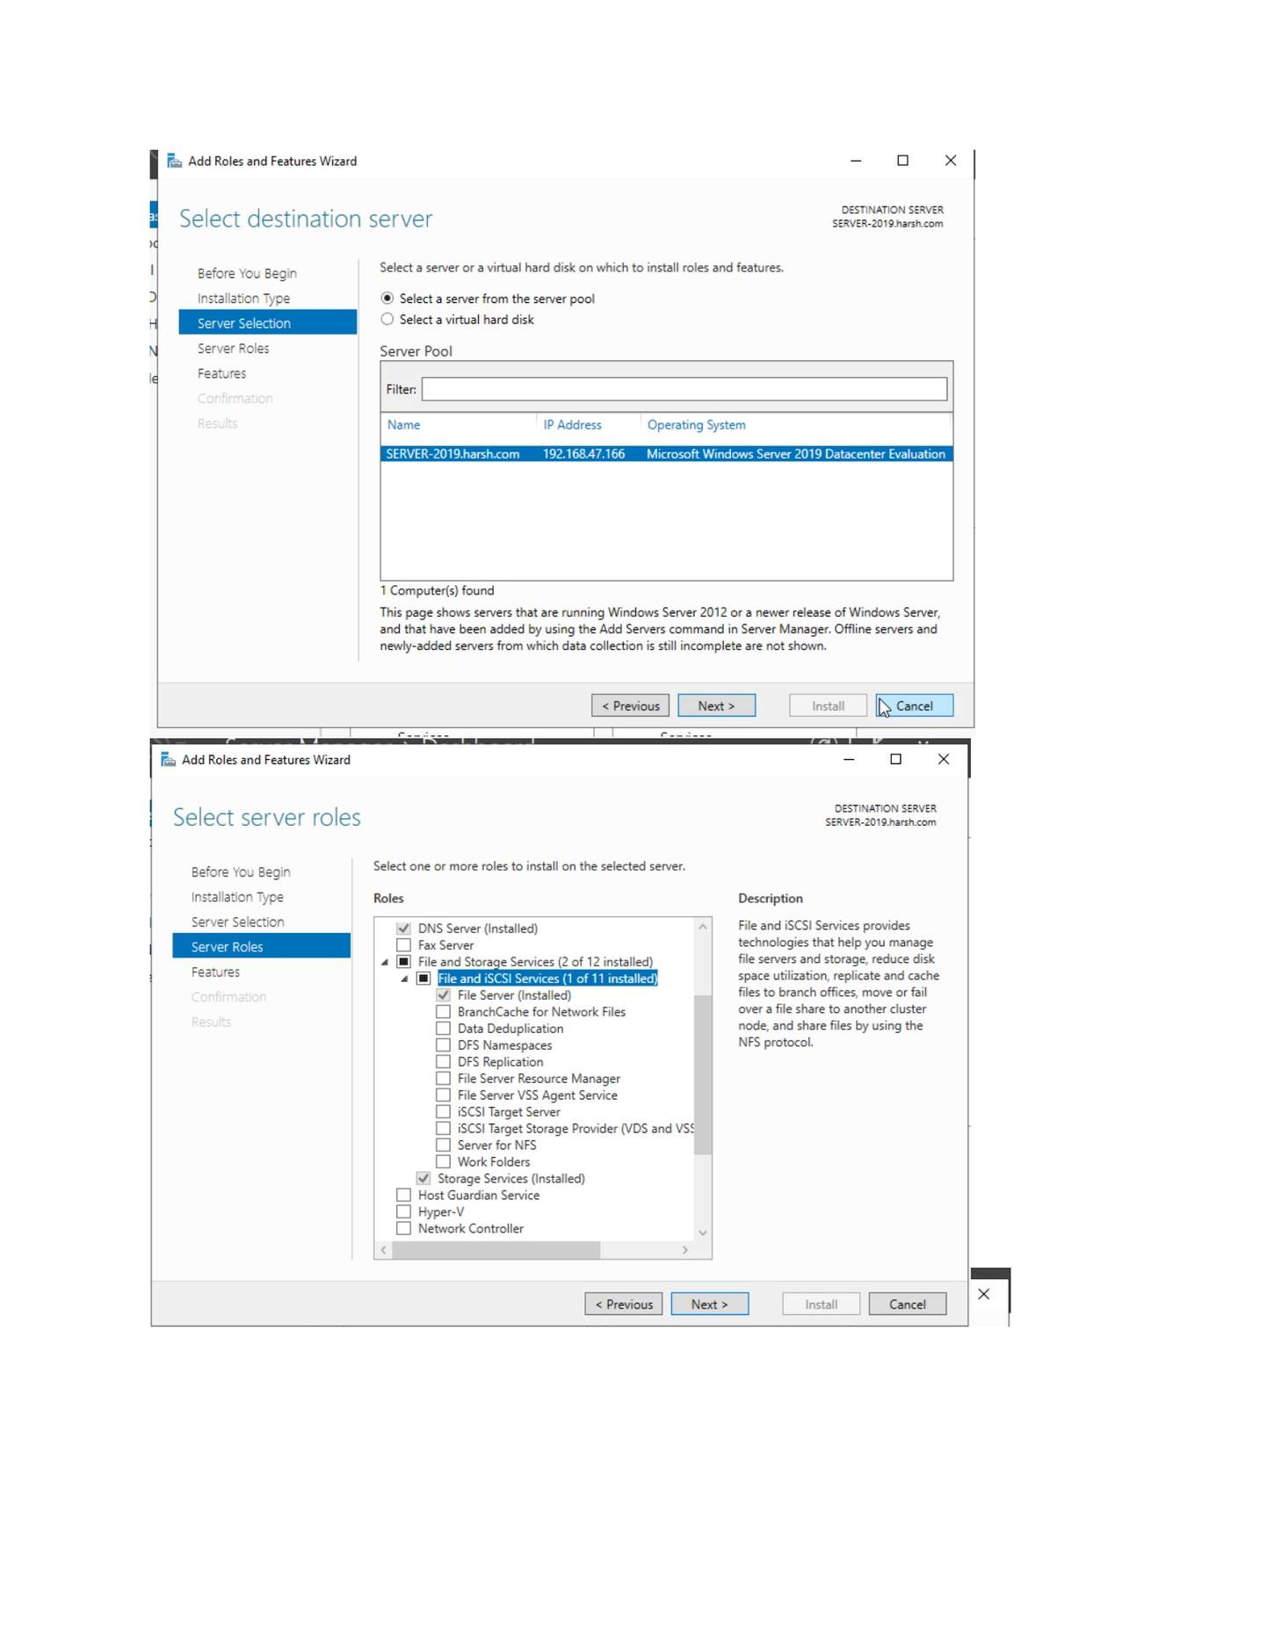
What I did: Selected the destination server and reviewed the available file-server components.

PAGE 123 — FILE SERVER (SMB)
Topic: File Server (SMB)
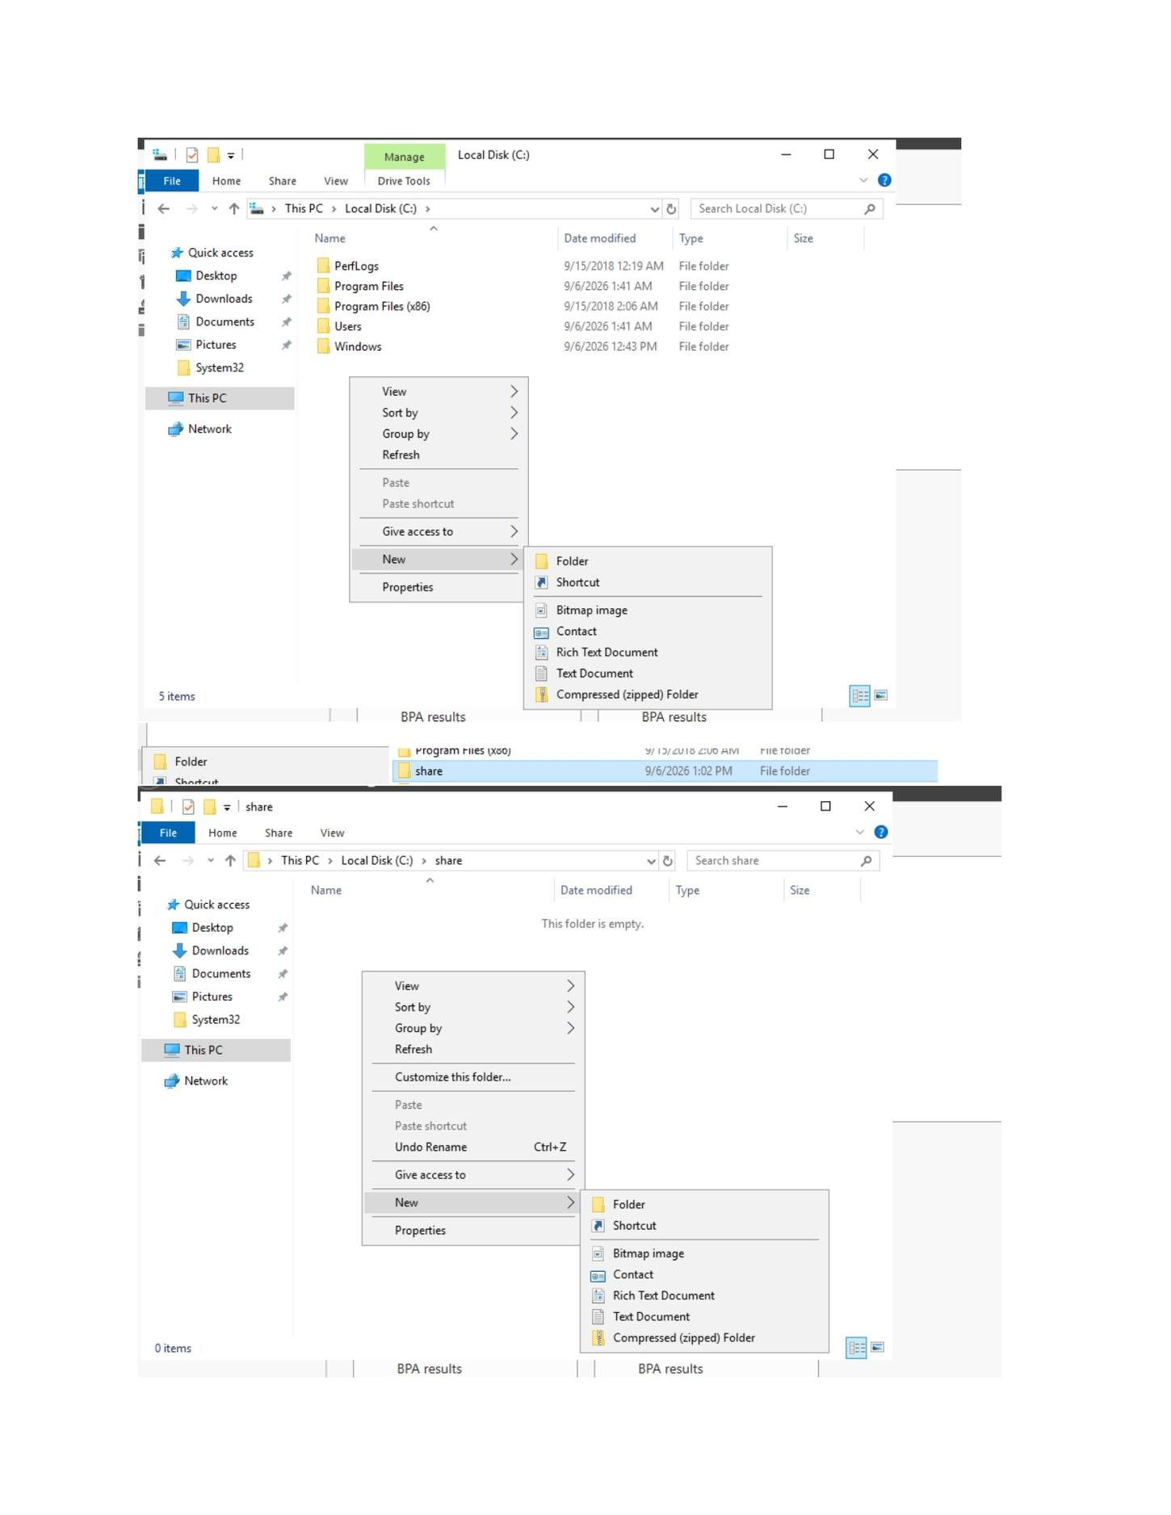
What I did: Created/opened the folder that would be used for the SMB share.

PAGE 124 — FILE SERVER (SMB)
Topic: File Server (SMB)
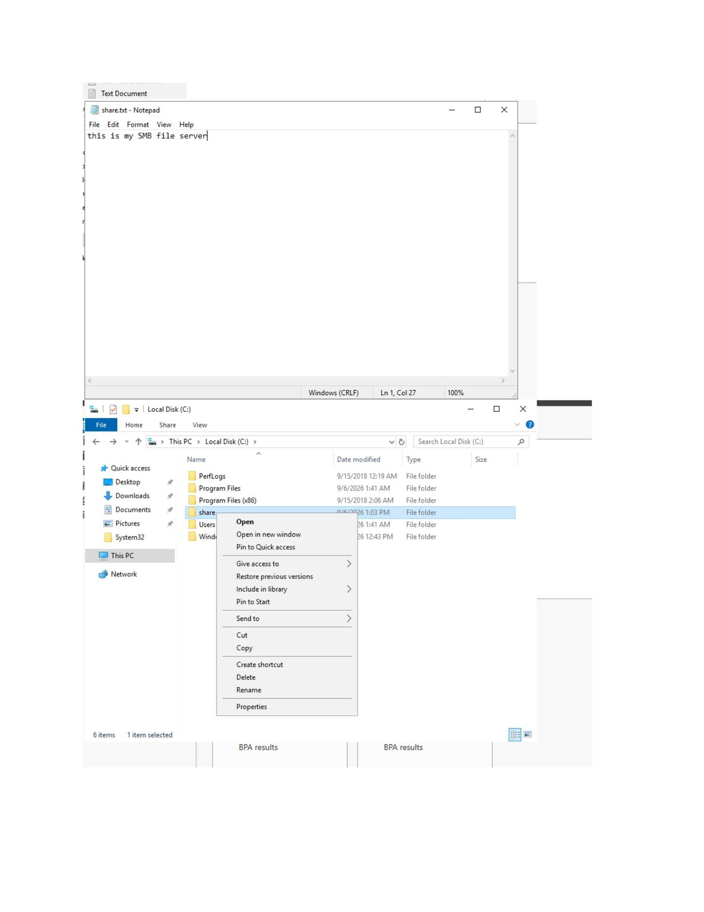
What I did: Opened the folder context menu/properties to configure sharing.

PAGE 125 — FILE SERVER (SMB)
Topic: File Server (SMB)
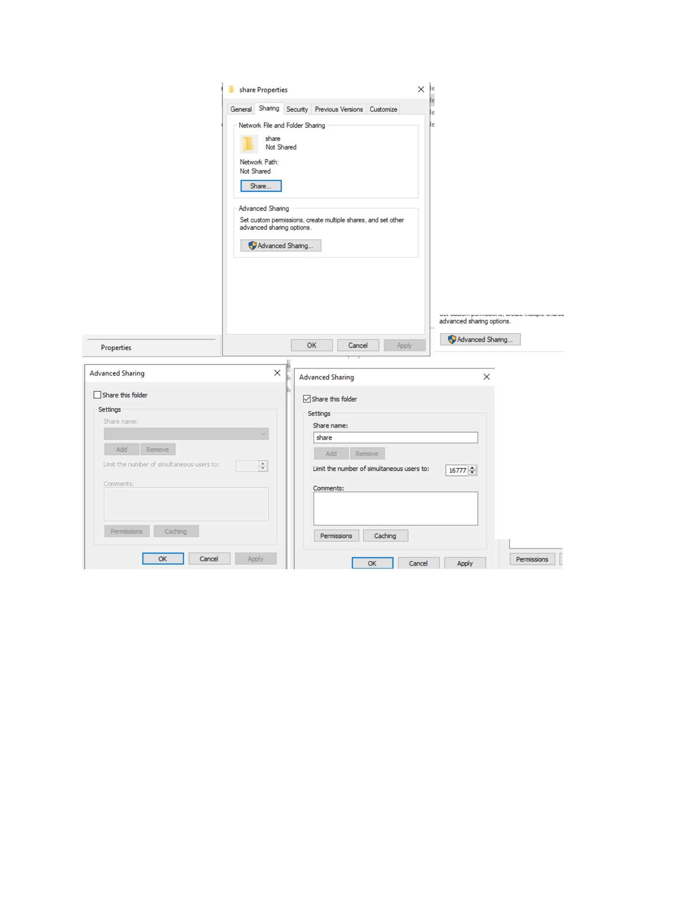
What I did: Opened the Sharing/Advanced Sharing settings for the selected folder.

PAGE 126 — FILE SERVER (SMB)
Topic: File Server (SMB)
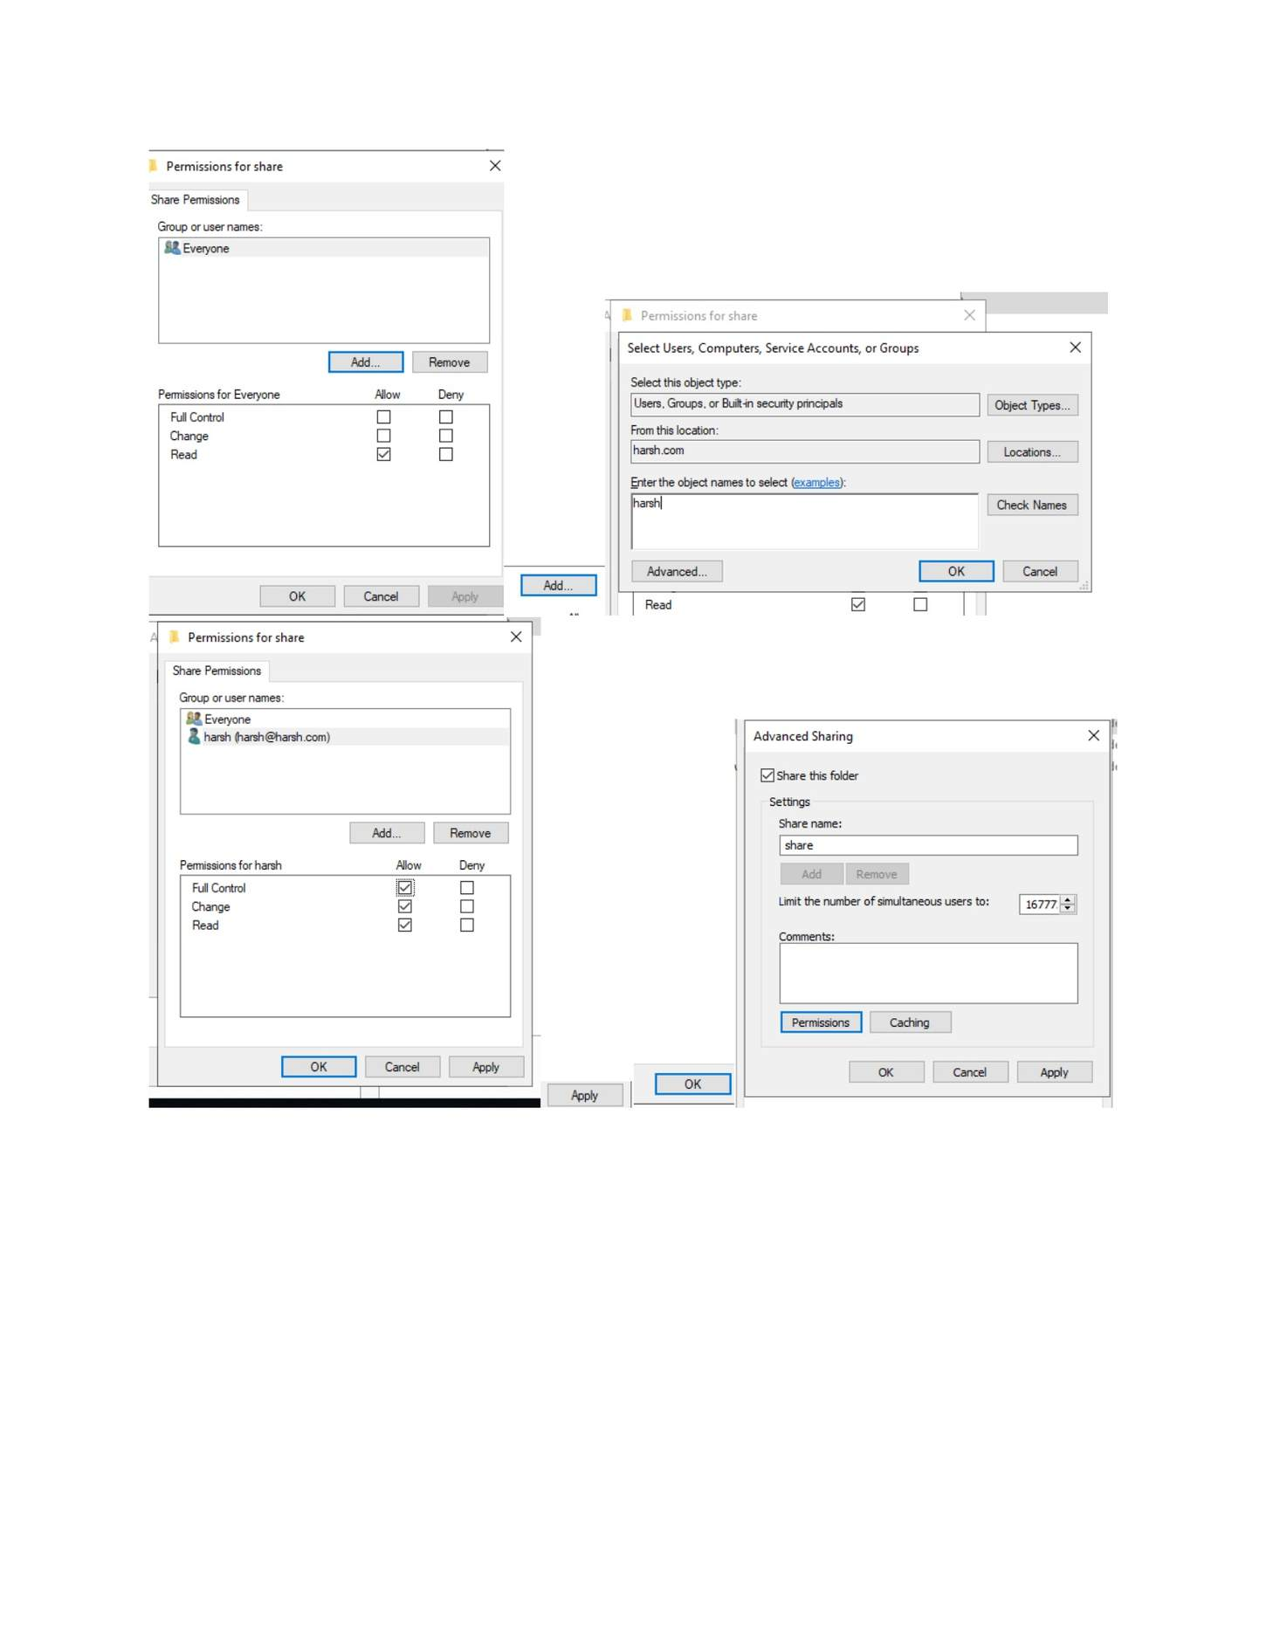
What I did: Entered/configured the SMB share name and sharing settings.

PAGE 127 — FILE SERVER (SMB)
Topic: File Server (SMB)
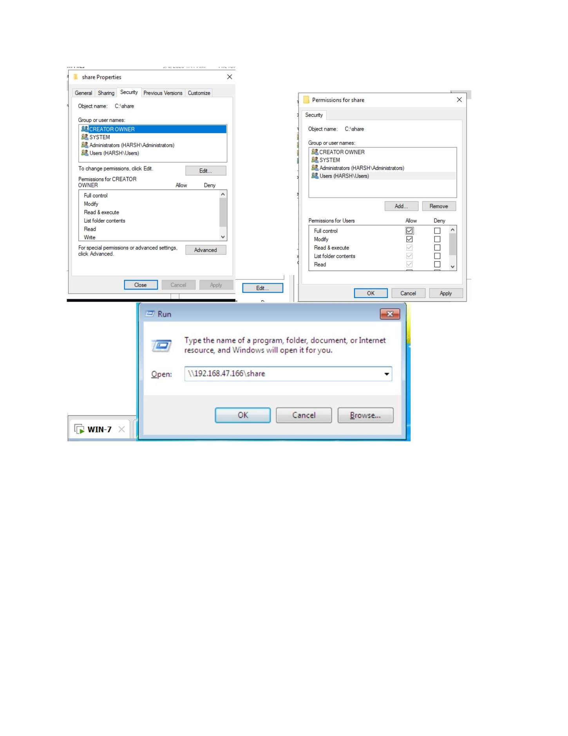
What I did: Configured the share permissions for the required users/groups.

PAGE 128 — FILE SERVER (SMB)
Topic: File Server (SMB)
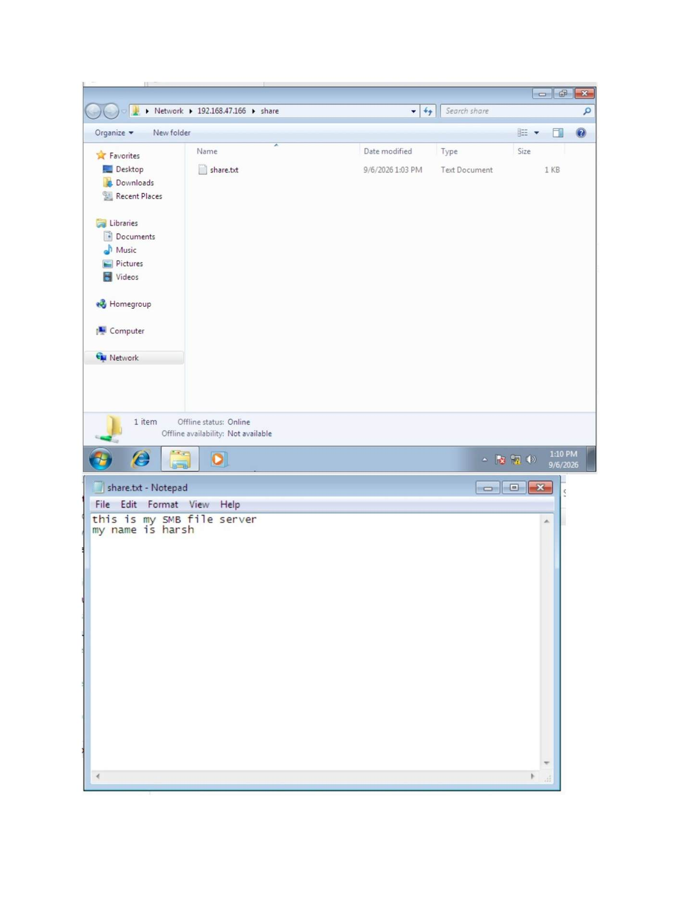
What I did: Reviewed the resulting share and permission configuration.

PAGE 129 — FILE SERVER (SMB)
Topic: File Server (SMB)
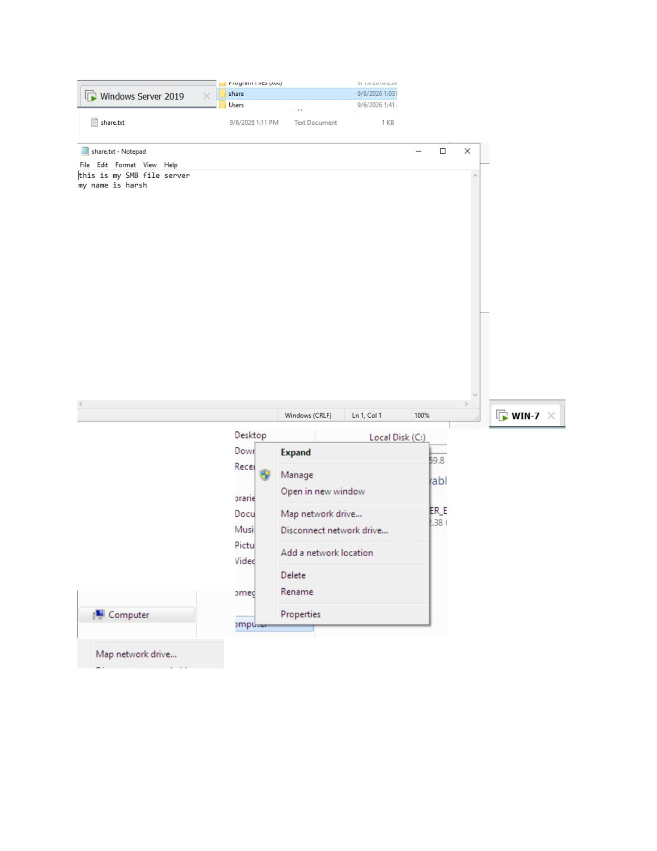
What I did: Opened the shared-folder location from the Windows client.

PAGE 130 — FILE SERVER (SMB)
Topic: File Server (SMB)
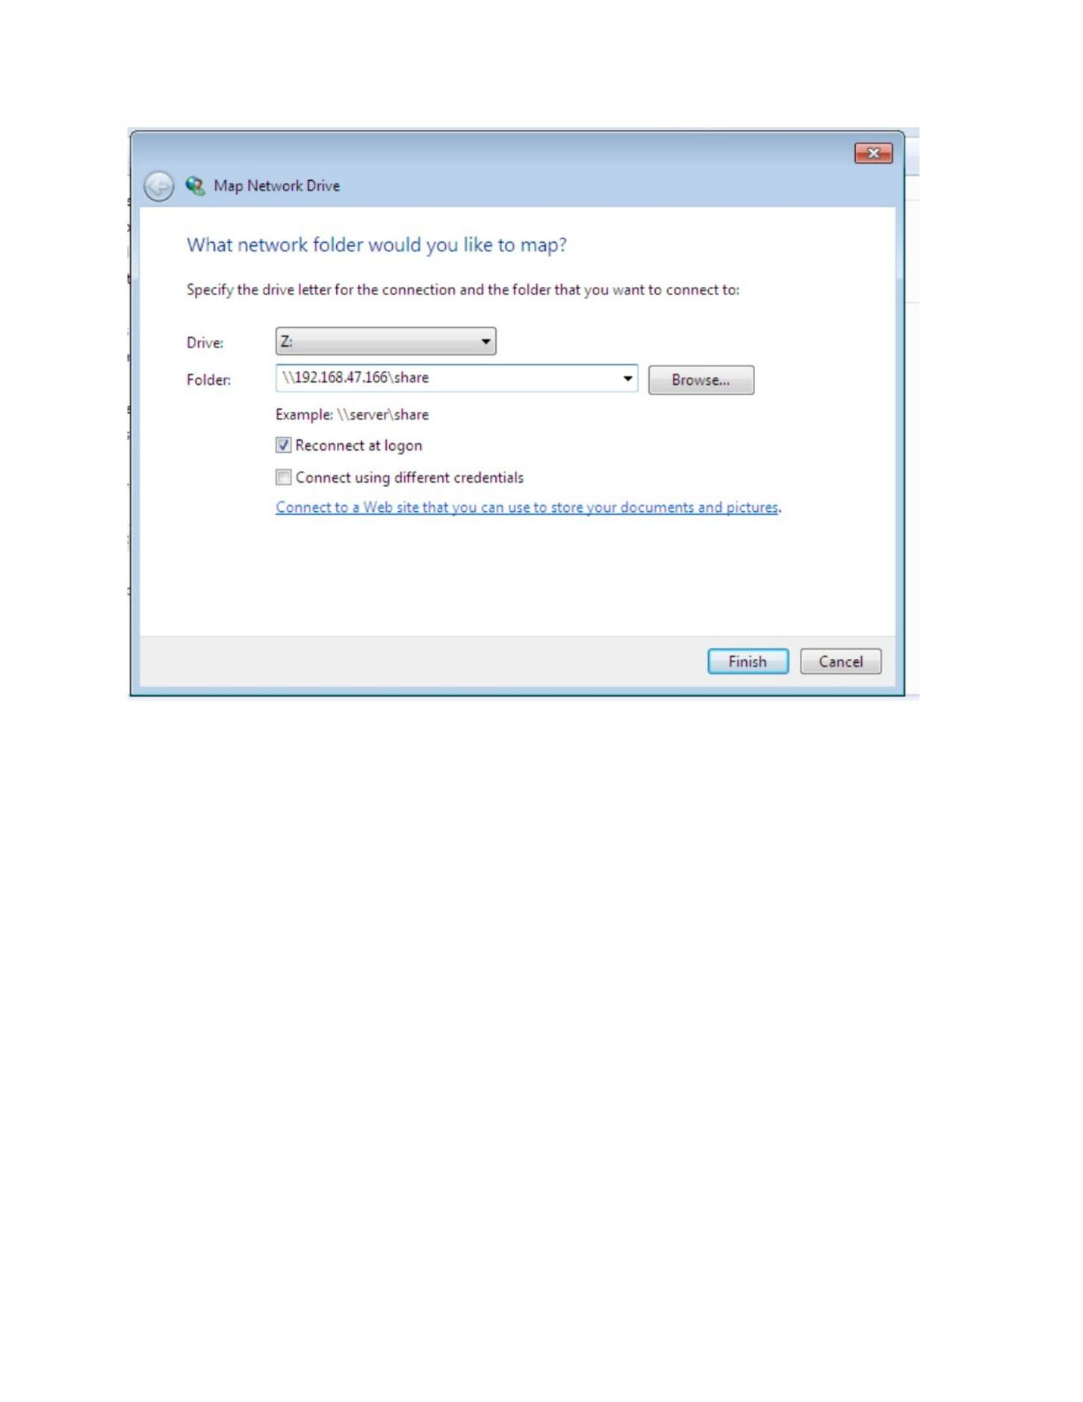
What I did: Started Map Network Drive and entered the network share path.

PAGE 131 — FILE SERVER (SMB)
Topic: File Server (SMB)
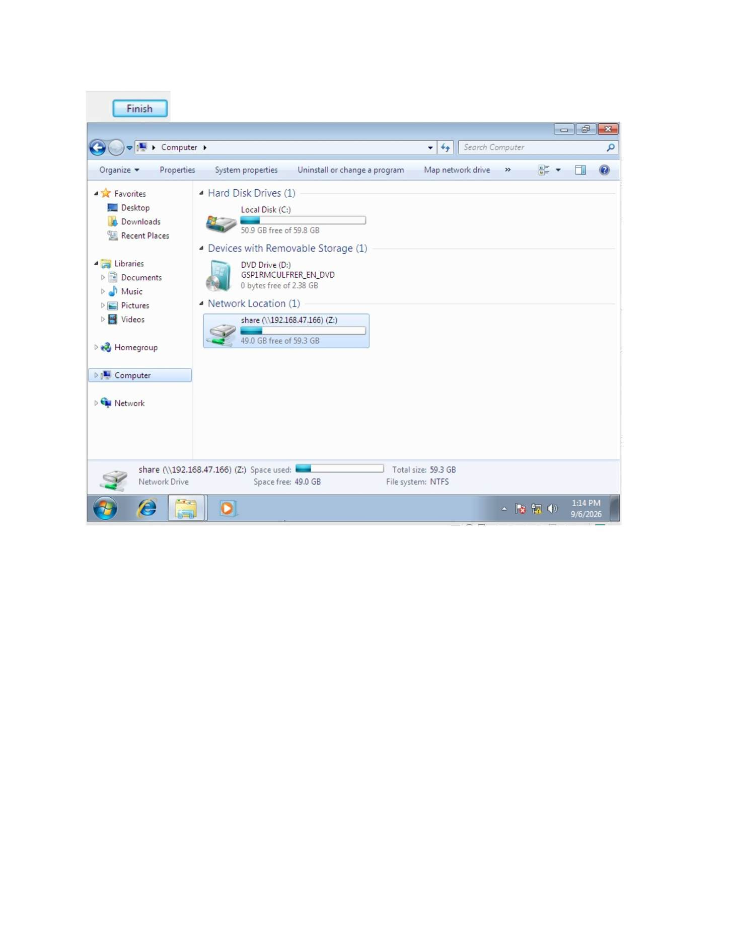
What I did: Mapped the SMB share to a drive letter and completed the connection.

PAGE 132 — FILE SERVER (ISCSI)
Topic: File Server (iSCSI)
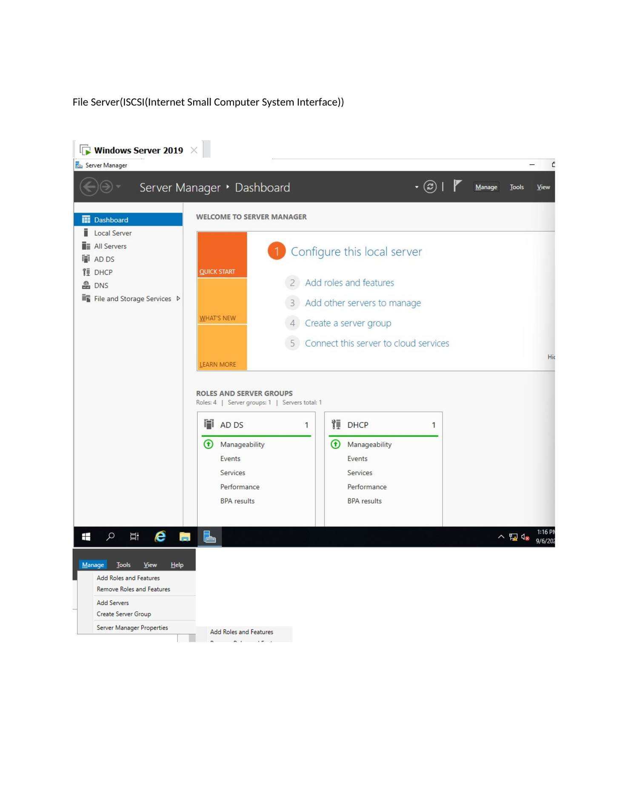
What I did: Opened Server Manager and started the iSCSI/file-storage role configuration.

PAGE 133 — FILE SERVER (ISCSI)
Topic: File Server (iSCSI)
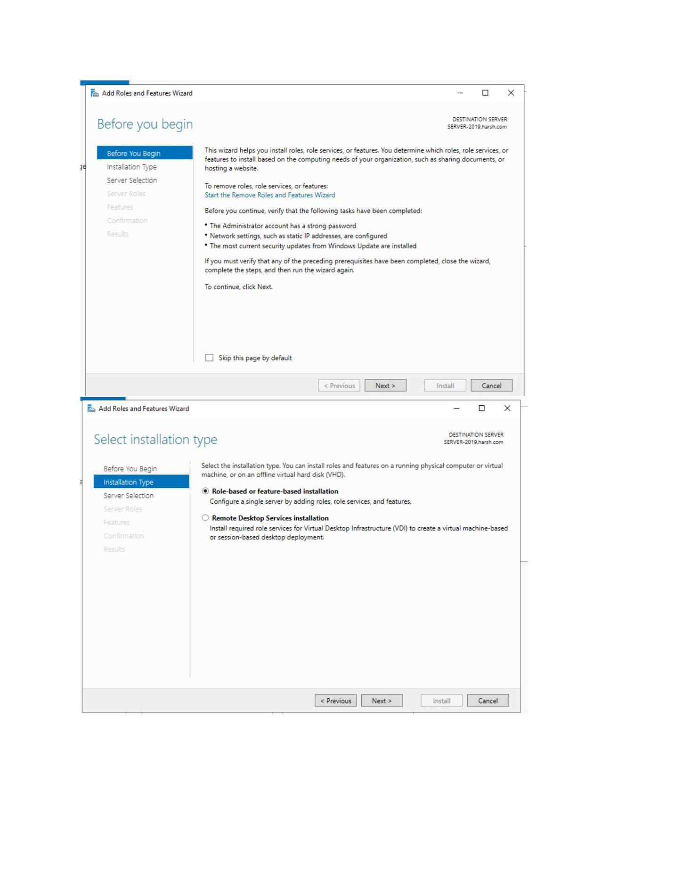
What I did: Selected the required File and Storage Services components for iSCSI.

PAGE 134 — FILE SERVER (ISCSI)
Topic: File Server (iSCSI)
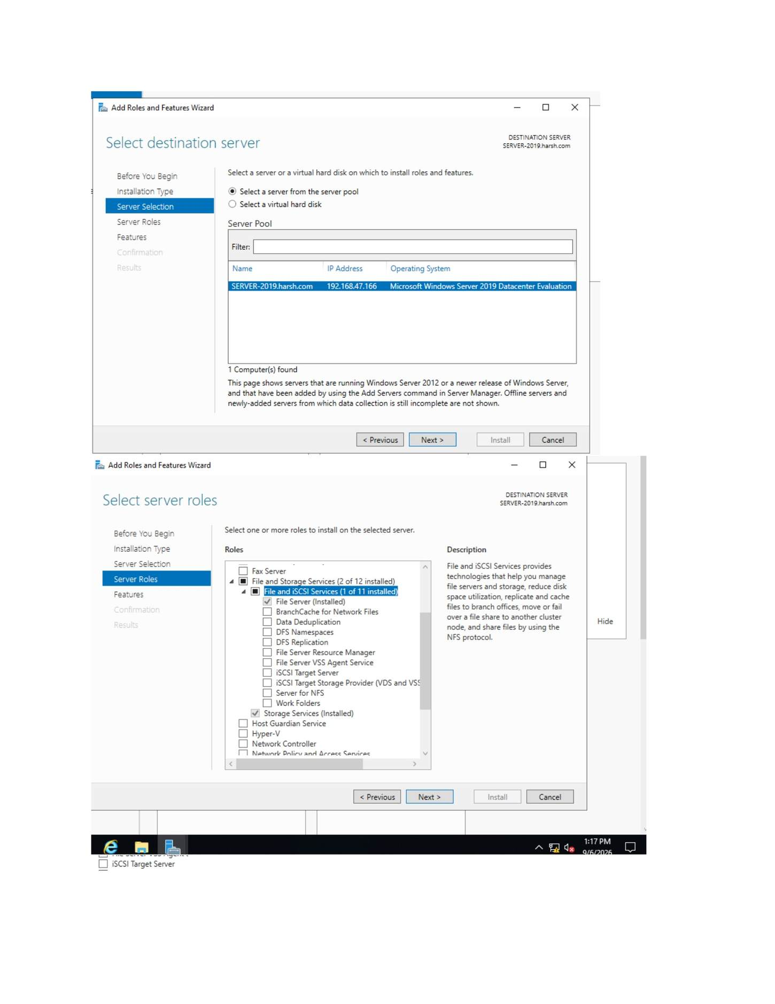
What I did: Confirmed the installation selections for the iSCSI target service.

PAGE 135 — FILE SERVER (ISCSI)
Topic: File Server (iSCSI)
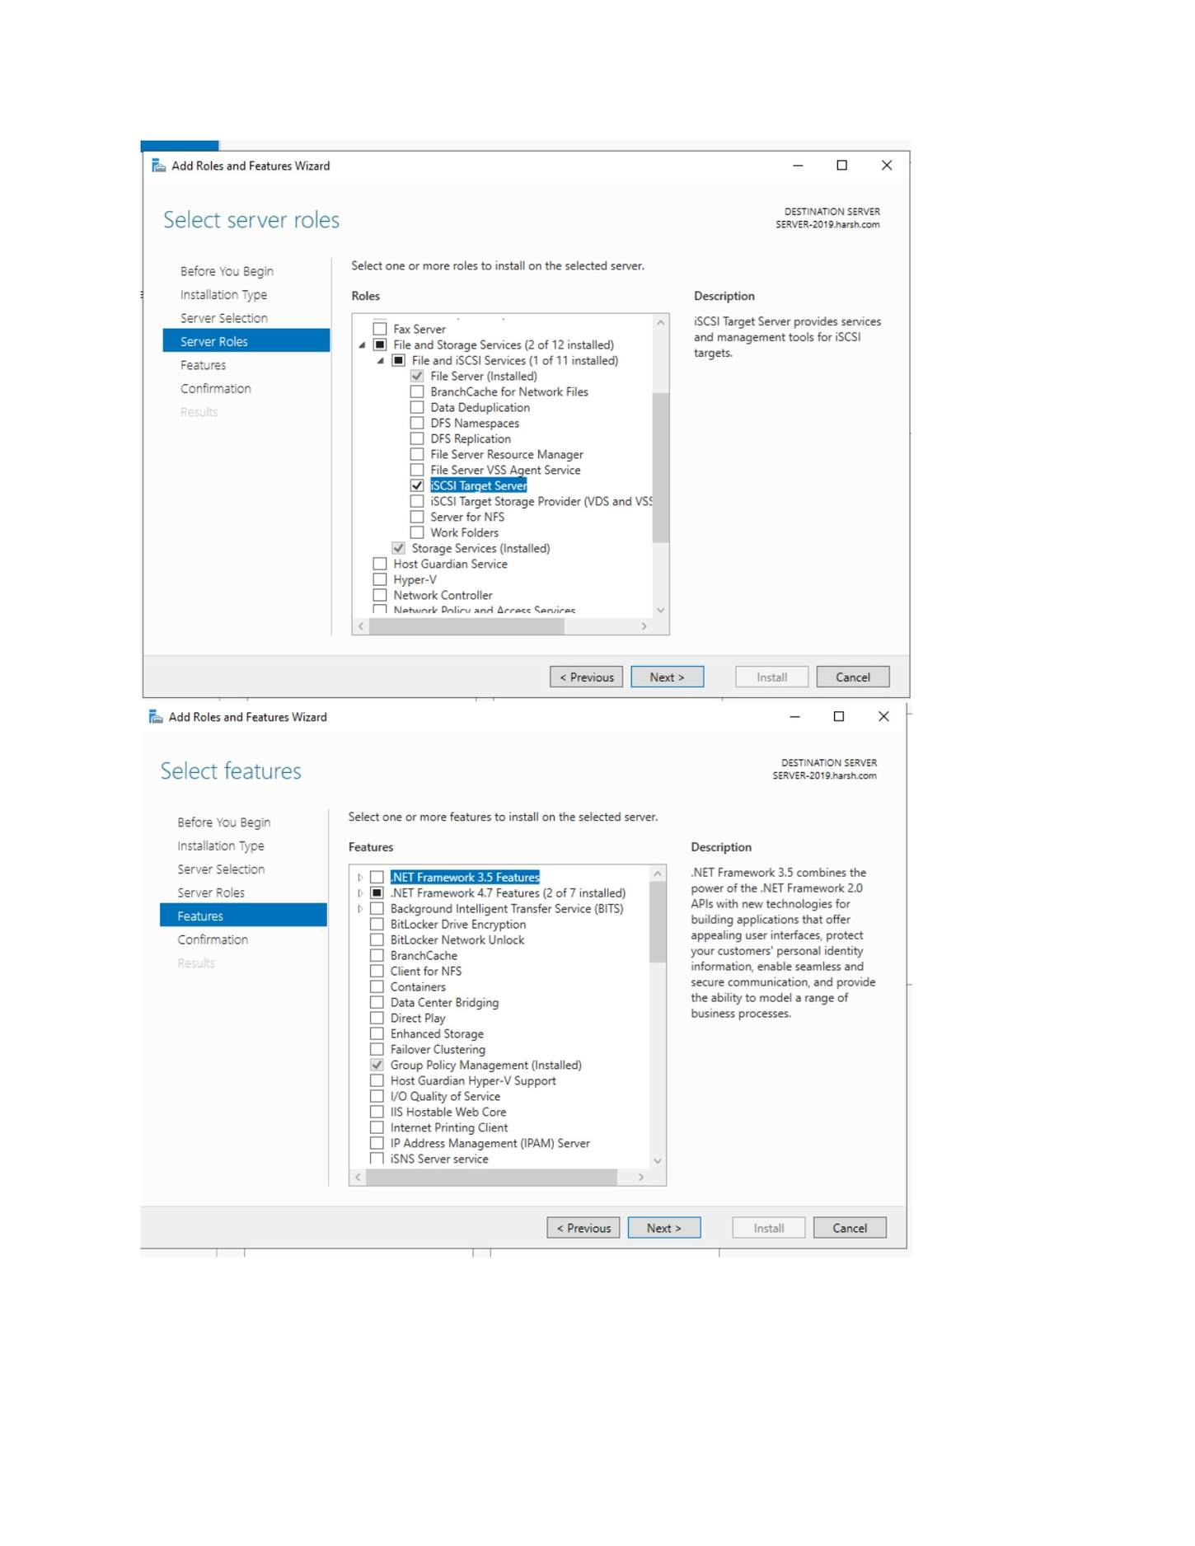
What I did: Reviewed Server Manager after the iSCSI components were installed.

PAGE 136 — FILE SERVER (ISCSI)
Topic: File Server (iSCSI)
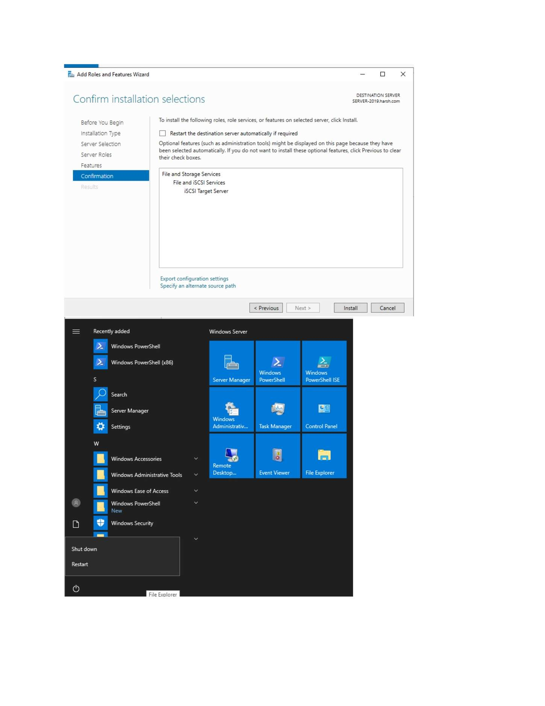
What I did: Opened File and Storage Services > Volumes/Disks to prepare iSCSI storage.

PAGE 137 — FILE SERVER (ISCSI)
Topic: File Server (iSCSI)
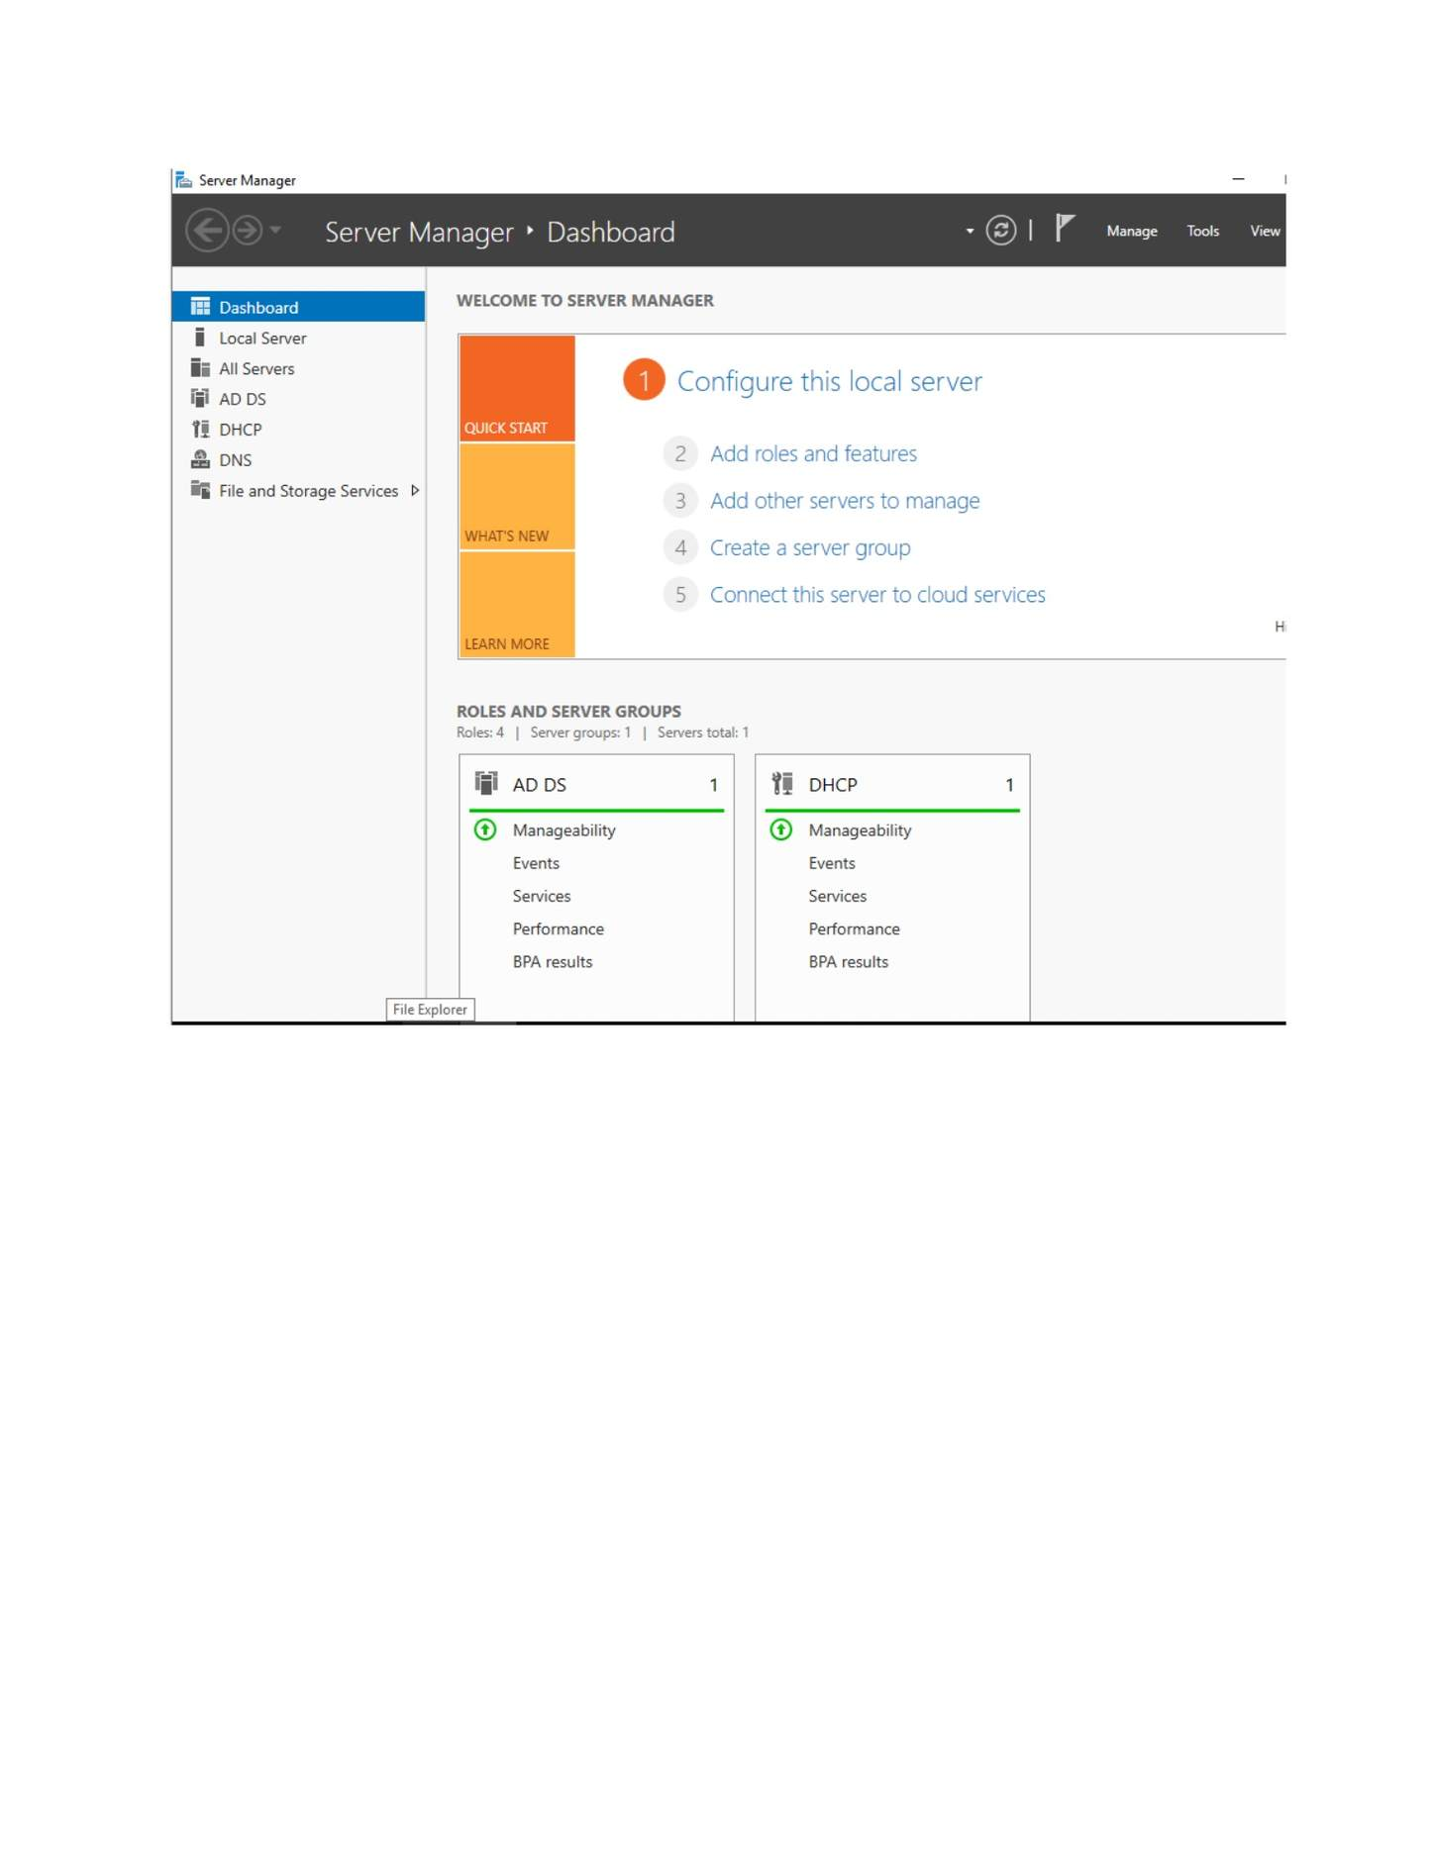
What I did: Opened the storage location used for the iSCSI virtual disk.

PAGE 138 — FILE SERVER (ISCSI)
Topic: File Server (iSCSI)
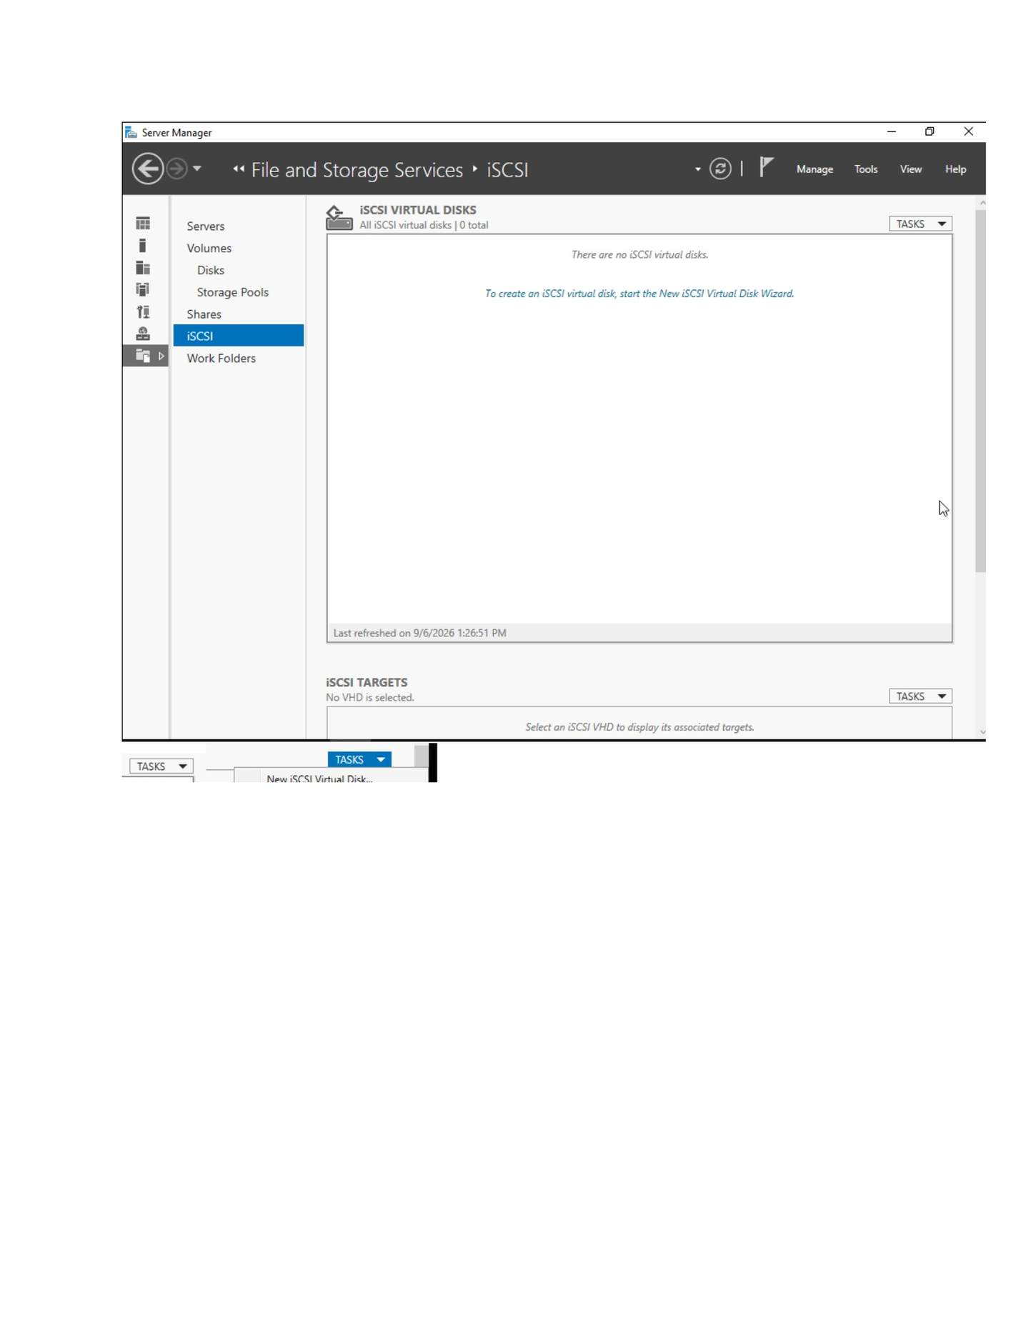
What I did: Selected the volume/location where the iSCSI virtual disk would be stored.

PAGE 139 — FILE SERVER (ISCSI)
Topic: File Server (iSCSI)
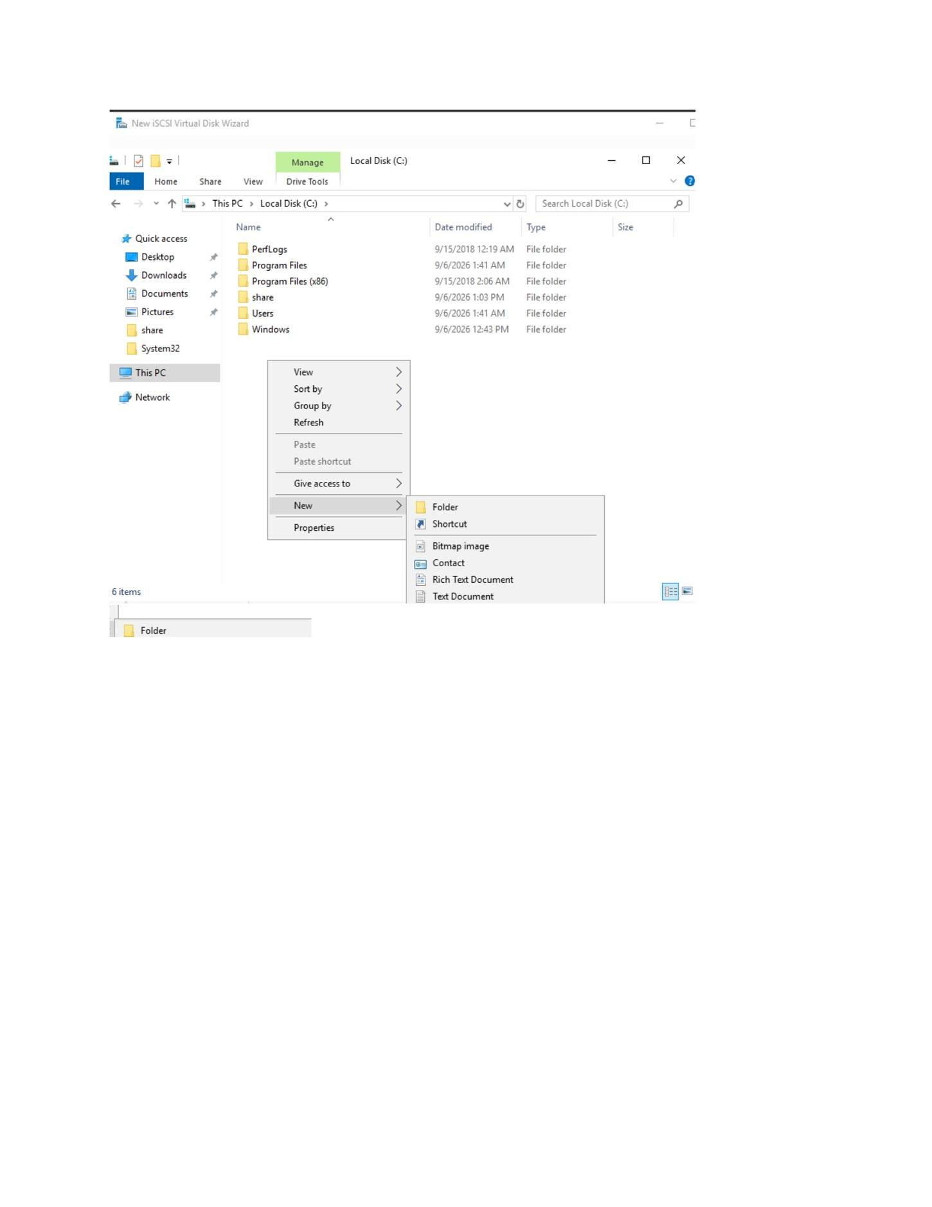
What I did: Entered the iSCSI virtual disk name.

PAGE 140 — FILE SERVER (ISCSI)
Topic: File Server (iSCSI)
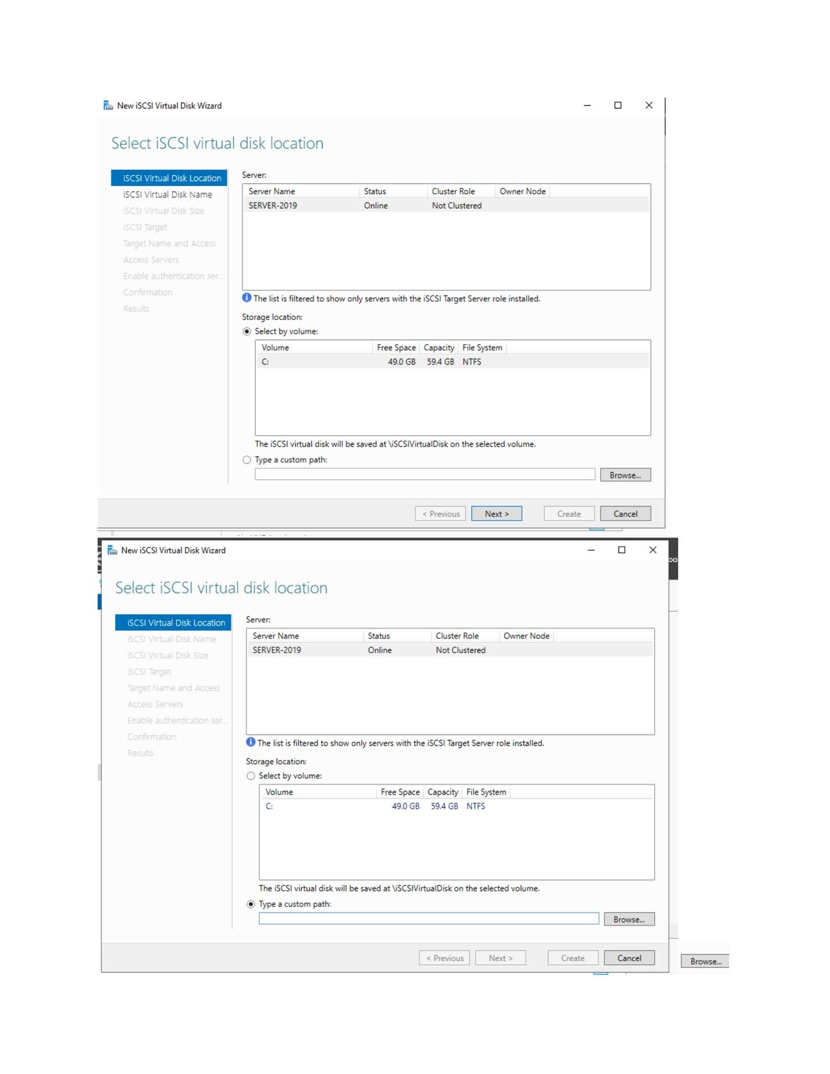
What I did: Specified the size and allocation settings for the iSCSI virtual disk.

PAGE 141 — FILE SERVER (ISCSI)
Topic: File Server (iSCSI)
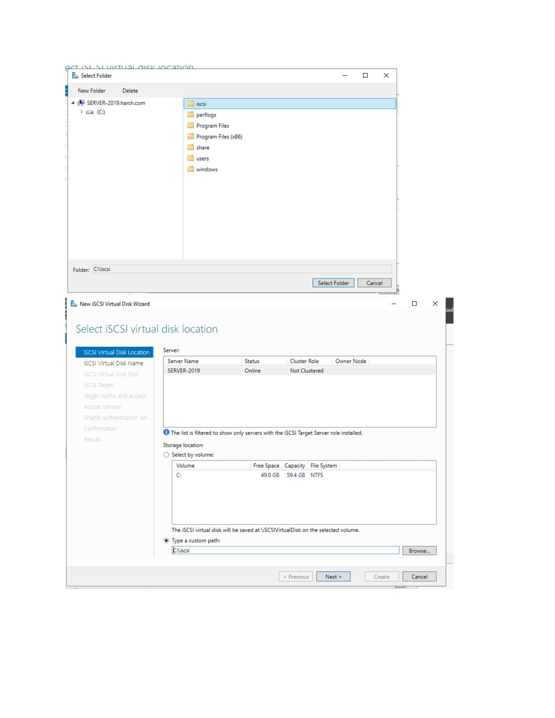
What I did: Entered the iSCSI target name.

PAGE 142 — FILE SERVER (ISCSI)
Topic: File Server (iSCSI)
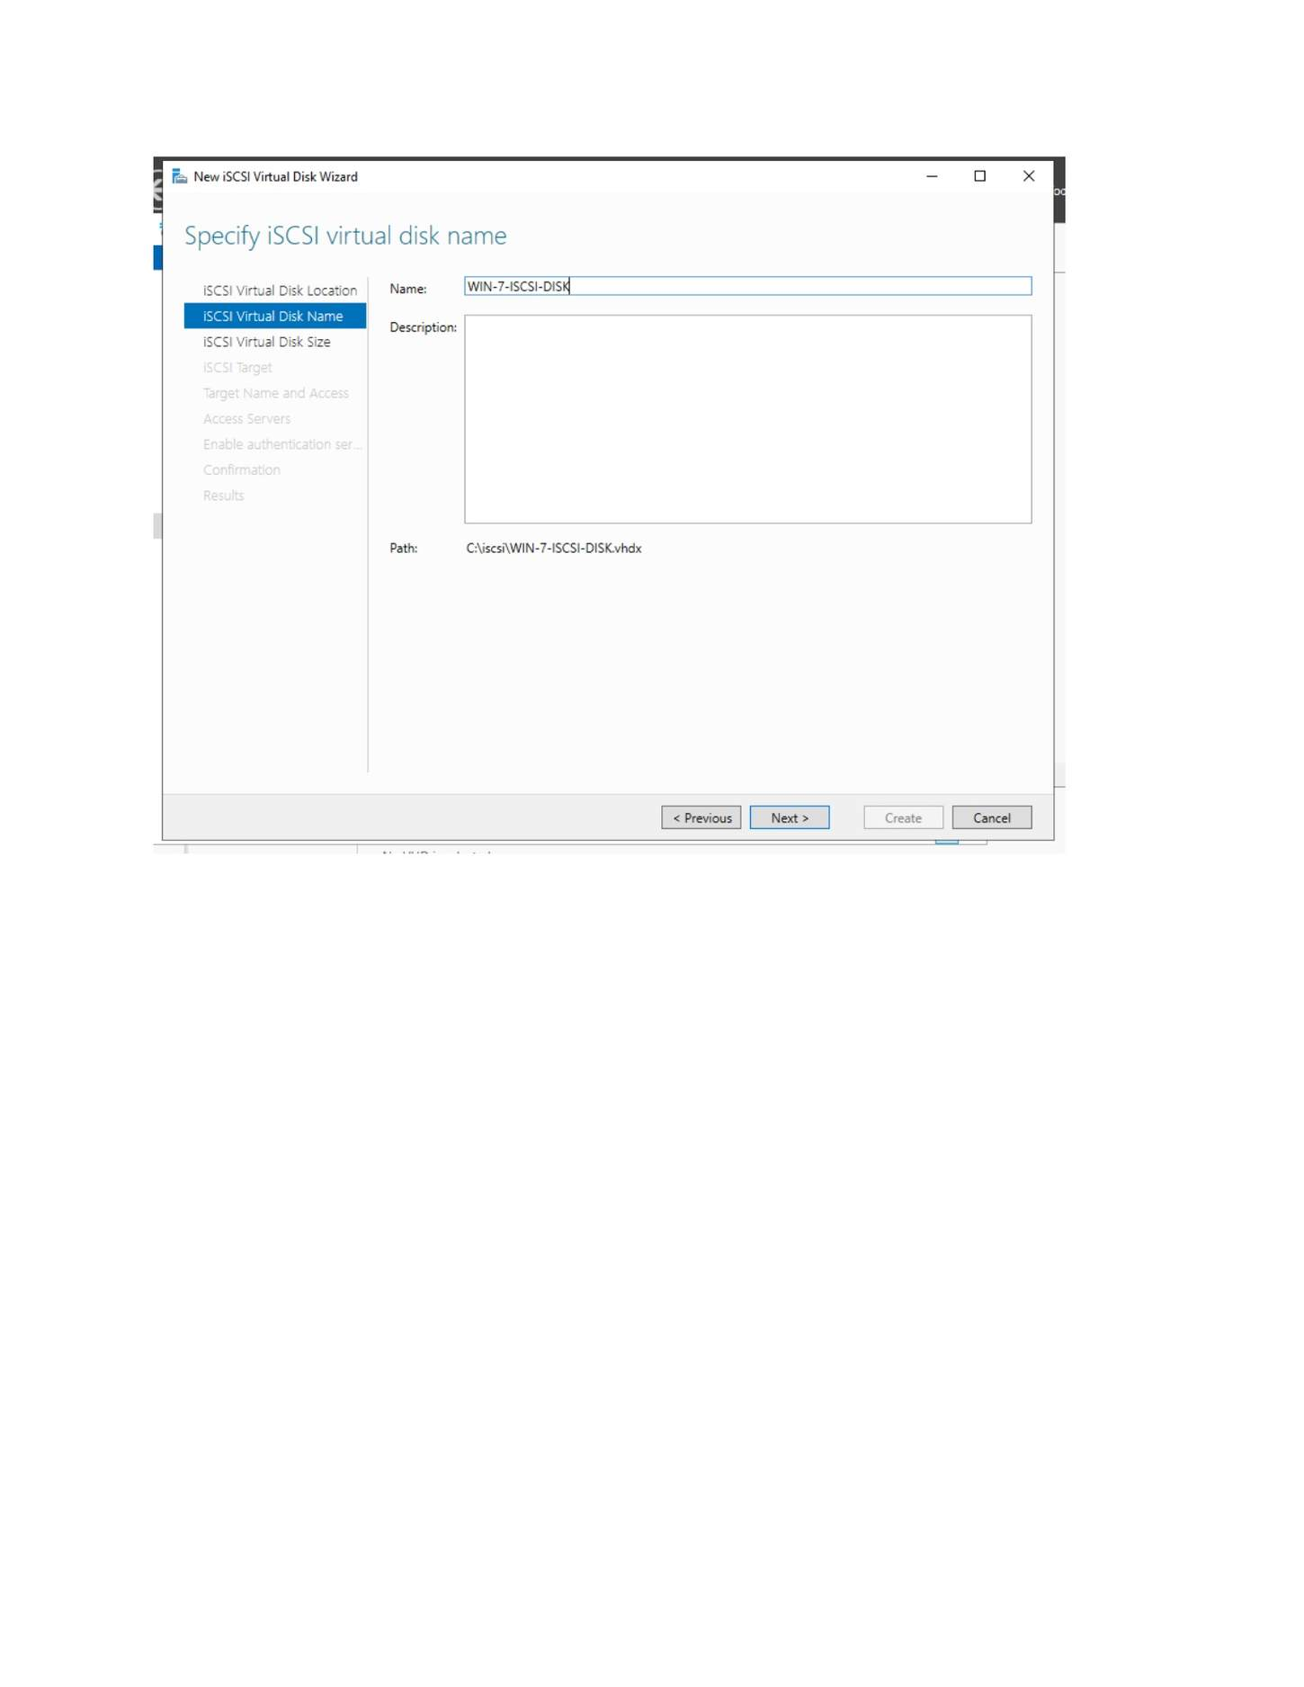
What I did: Opened the Specify Access Servers step for the target.

PAGE 143 — FILE SERVER (ISCSI)
Topic: File Server (iSCSI)
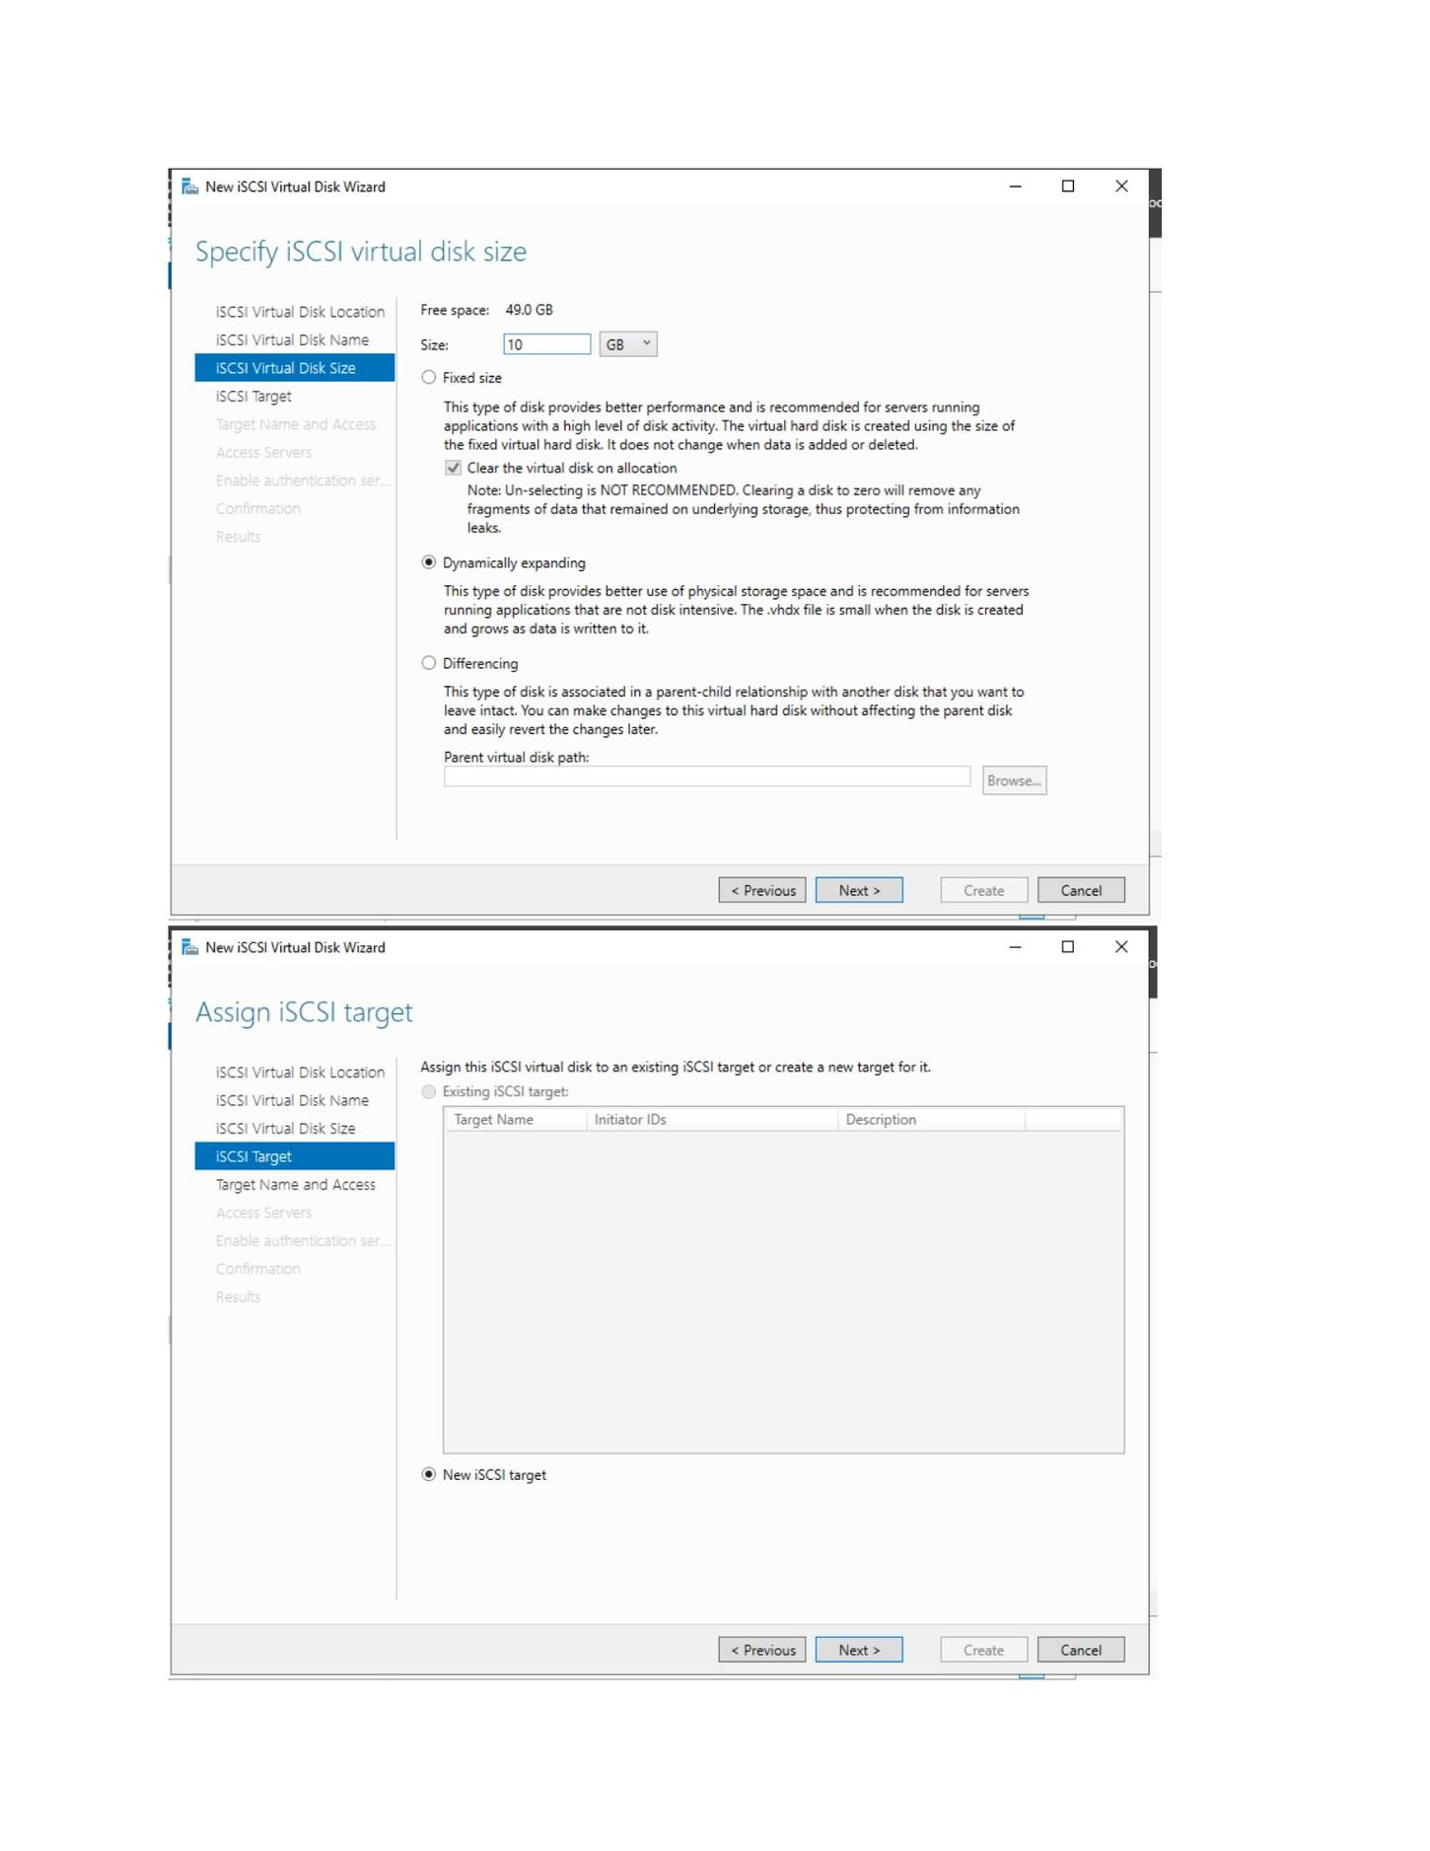
What I did: Checked the Windows client initiator information used to identify the iSCSI initiator.

PAGE 144 — FILE SERVER (ISCSI)
Topic: File Server (iSCSI)
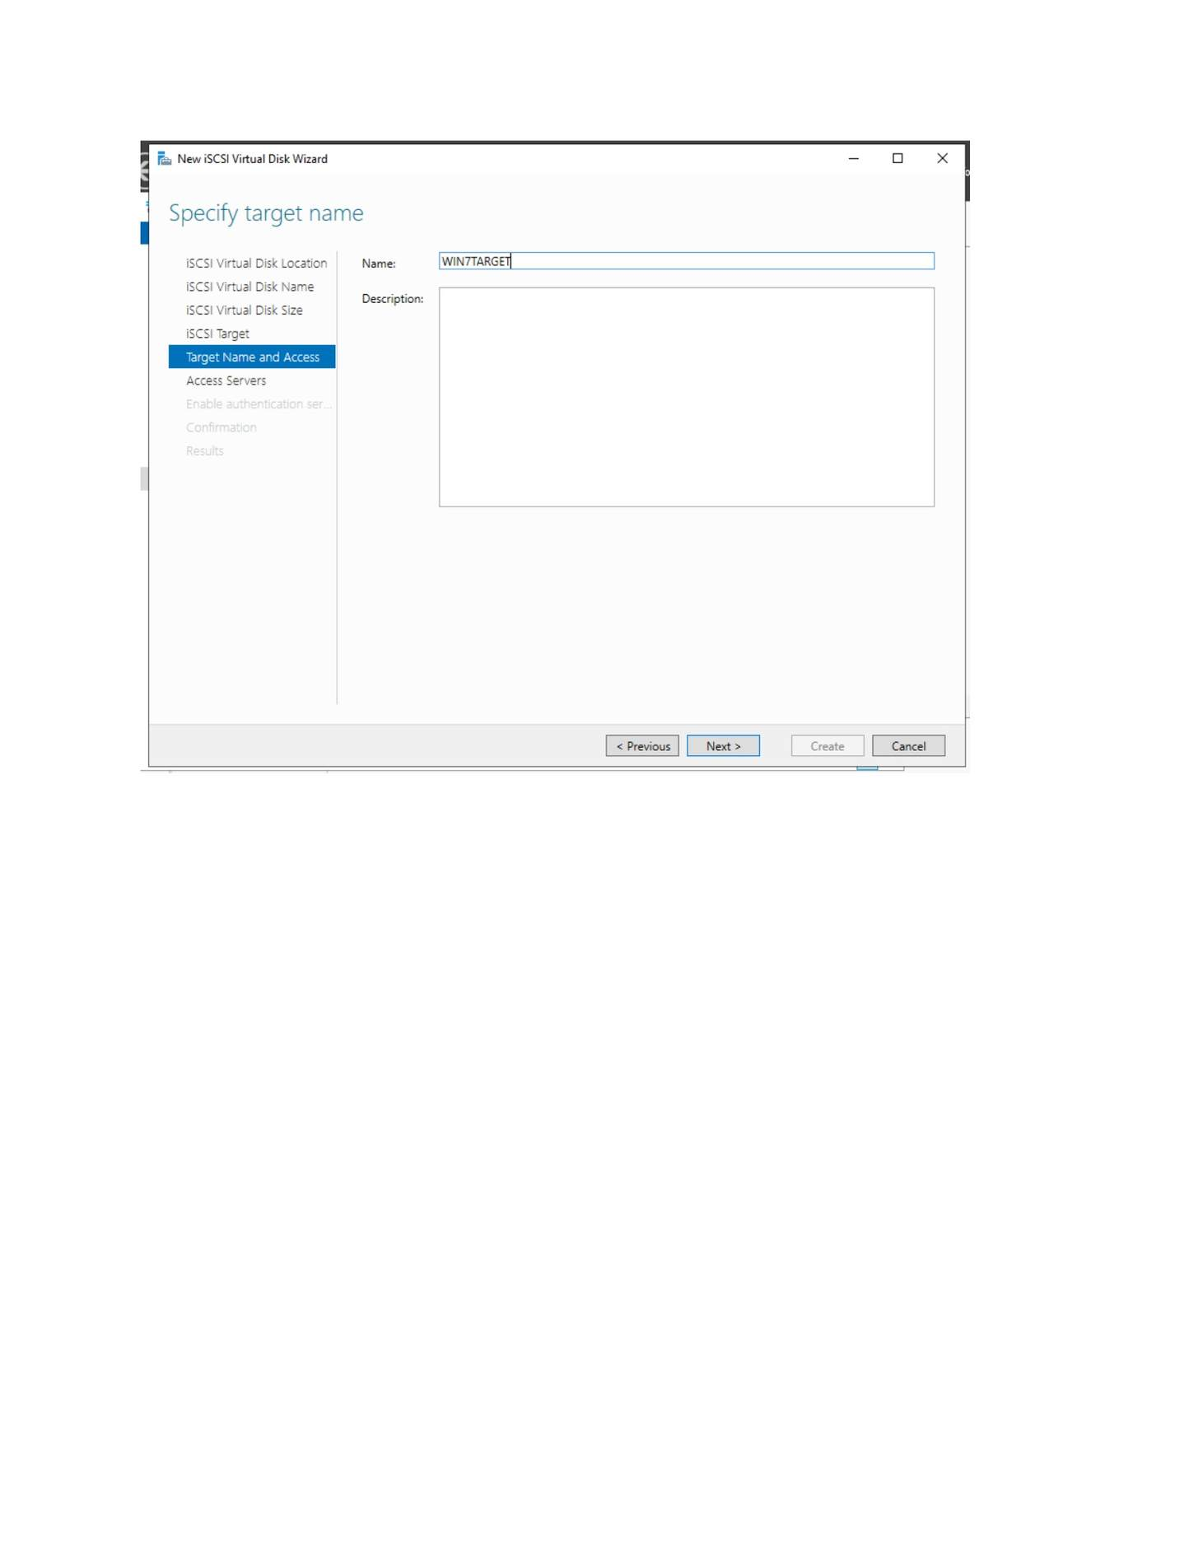
What I did: Selected the initiator-identification method and added the client initiator.

PAGE 145 — FILE SERVER (ISCSI)
Topic: File Server (iSCSI)
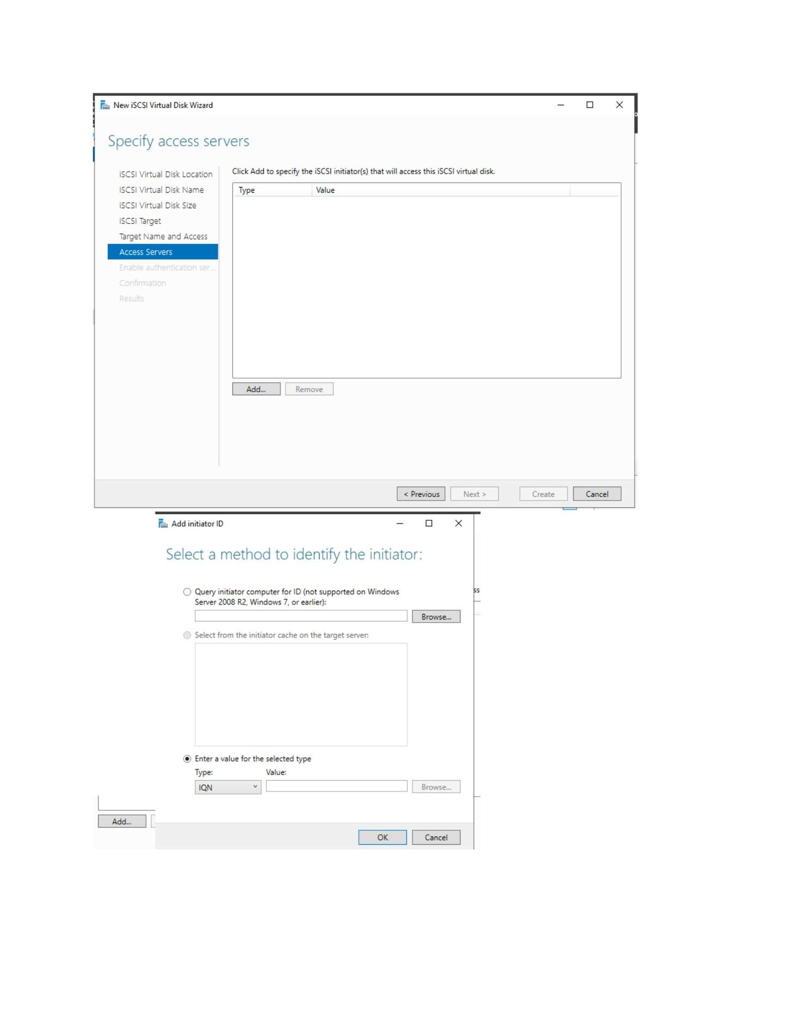
What I did: Reviewed the initiator/access-server entry for the iSCSI target.

PAGE 146 — FILE SERVER (ISCSI)
Topic: File Server (iSCSI)
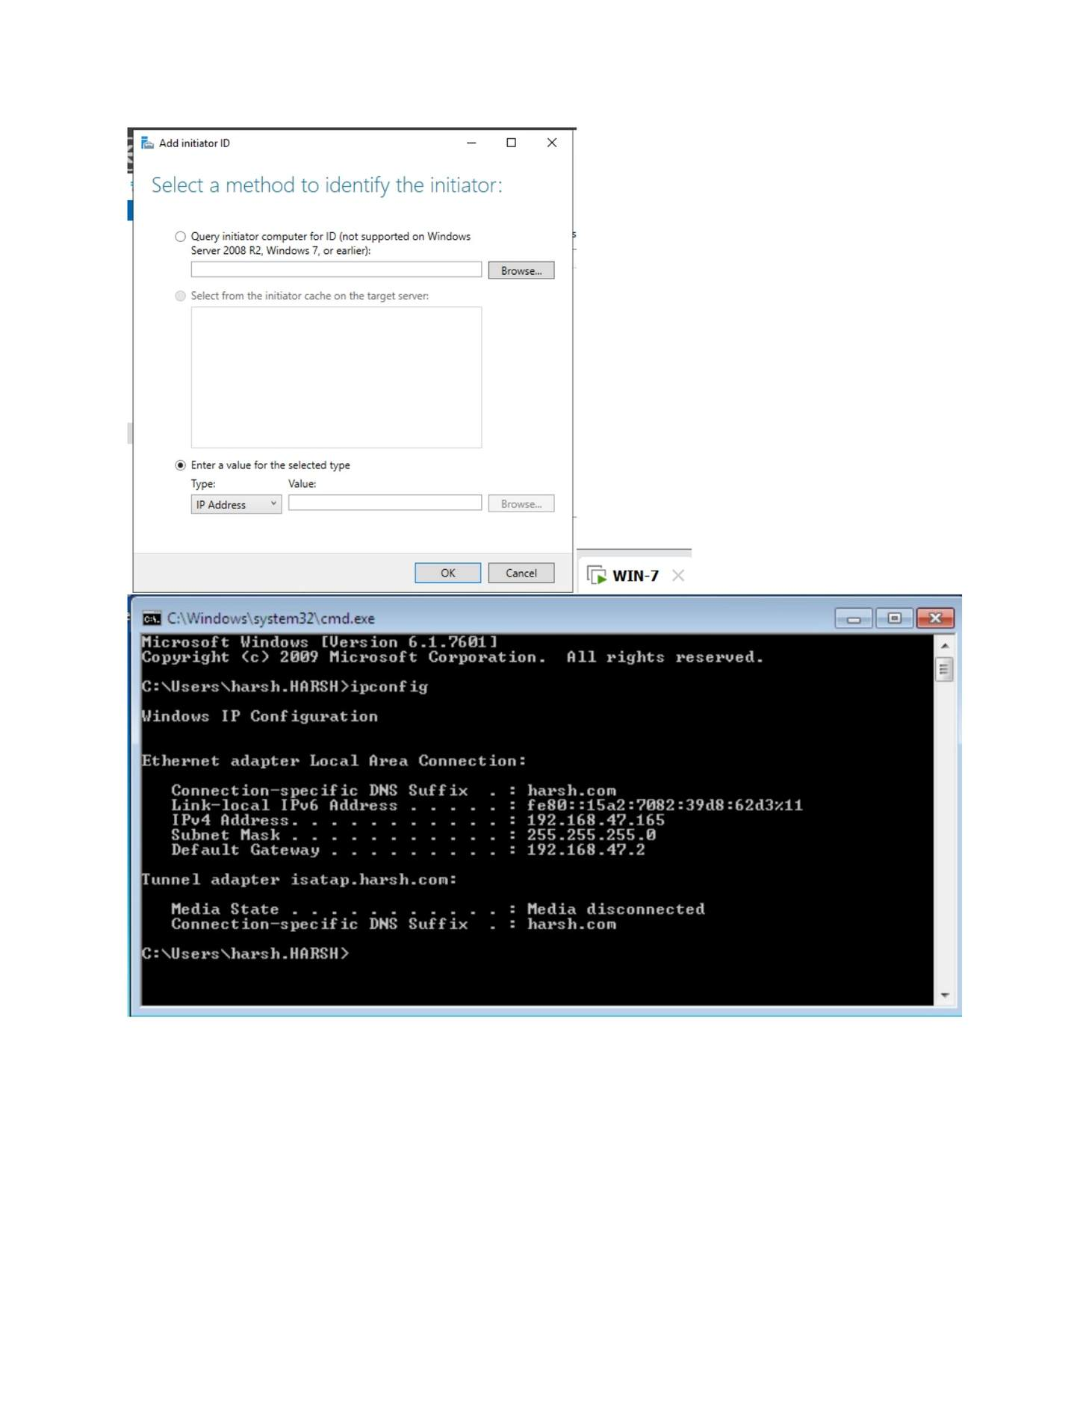
What I did: Configured/continued the optional CHAP authentication settings.

PAGE 147 — FILE SERVER (ISCSI)
Topic: File Server (iSCSI)
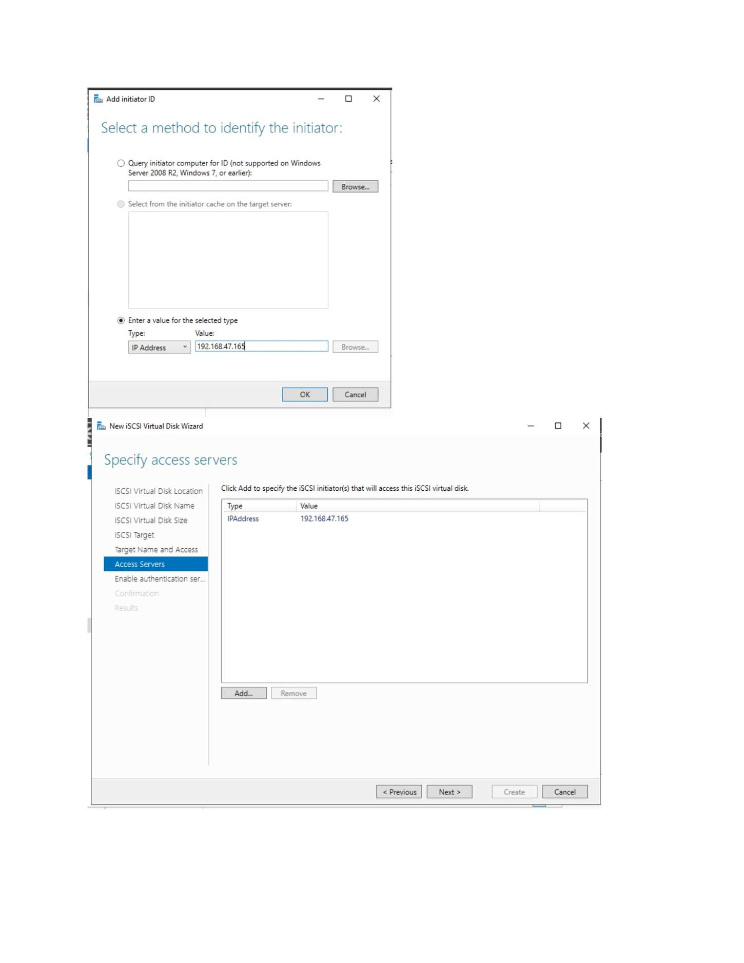
What I did: Reviewed the complete iSCSI virtual-disk/target selections.

PAGE 148 — FILE SERVER (ISCSI)
Topic: File Server (iSCSI)
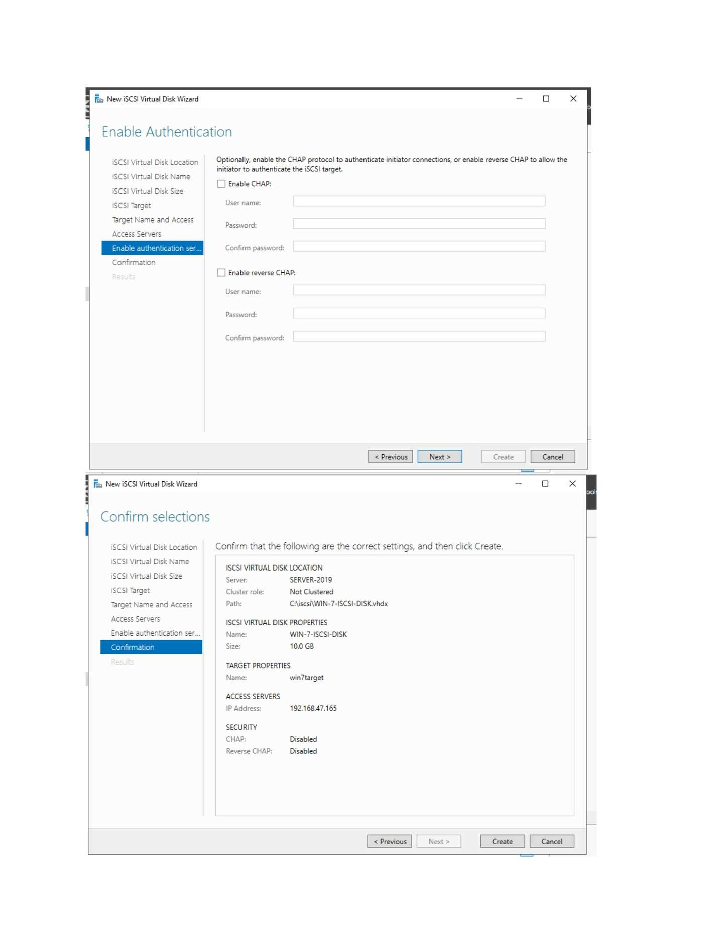
What I did: Opened the iSCSI Initiator on the Windows client.

PAGE 149 — FILE SERVER (ISCSI)
Topic: File Server (iSCSI)
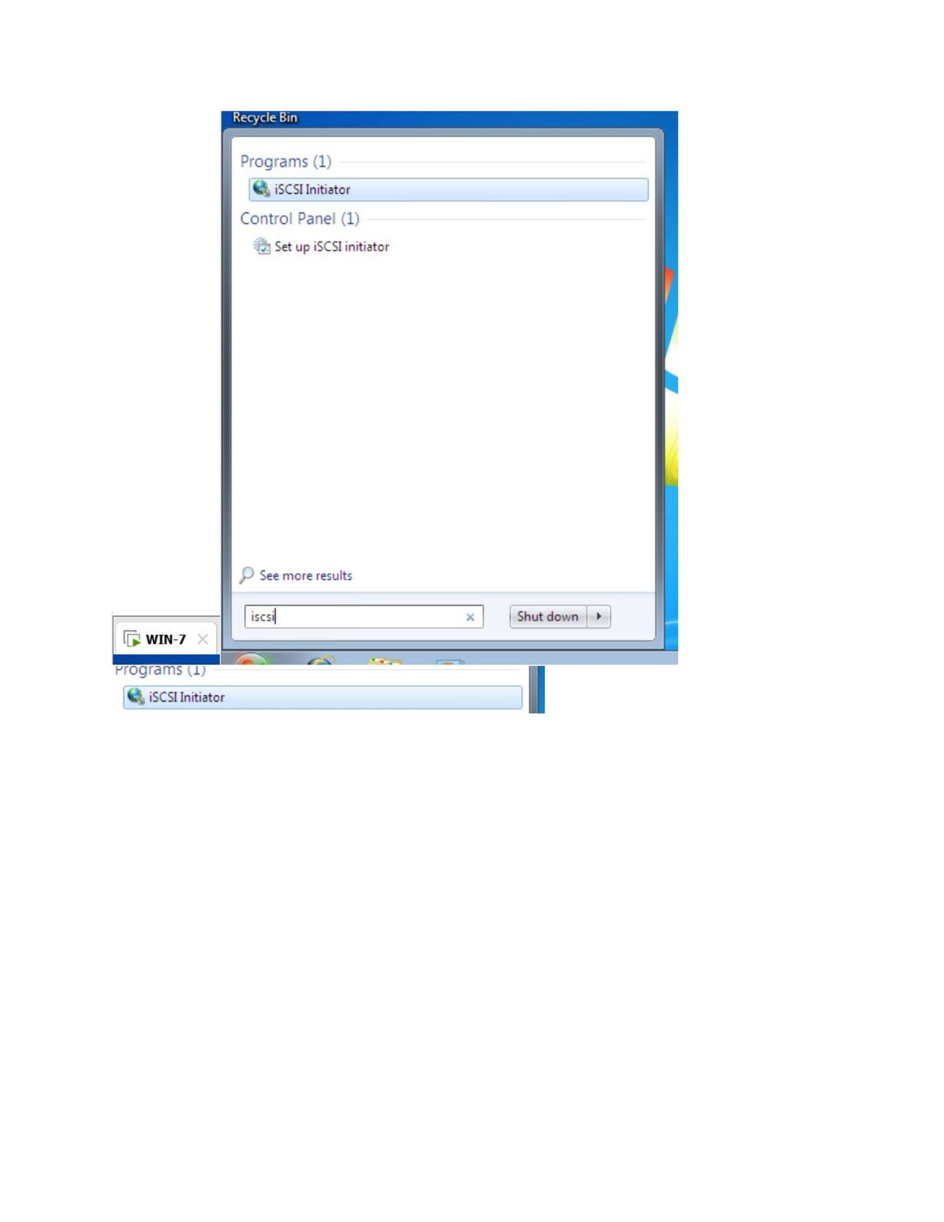
What I did: Approved the User Account Control prompt to open iSCSI Initiator.

PAGE 150 — FILE SERVER (ISCSI)
Topic: File Server (iSCSI)
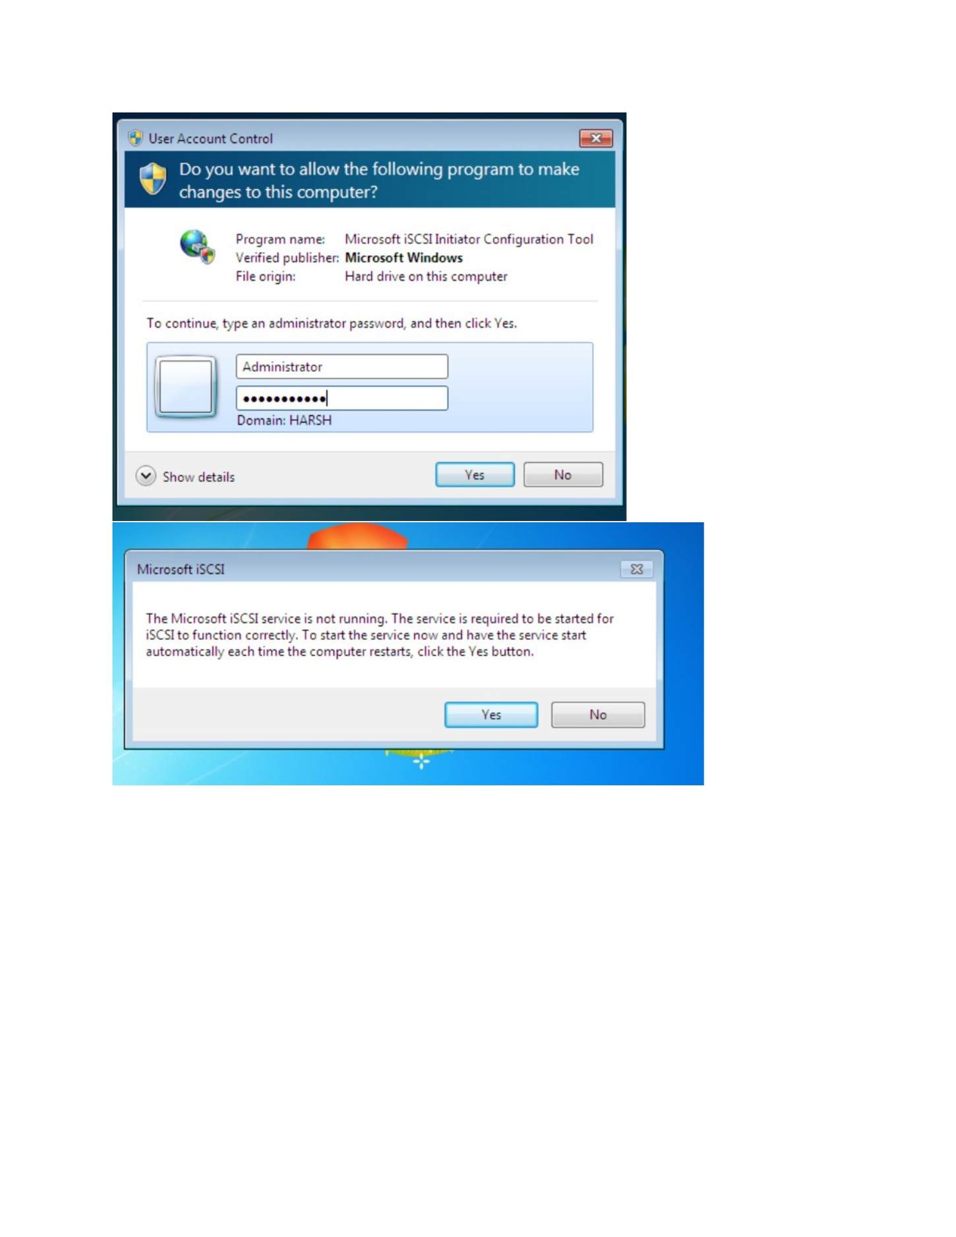
What I did: Opened the iSCSI Initiator Targets/Discovery area.

PAGE 151 — FILE SERVER (ISCSI)
Topic: File Server (iSCSI)
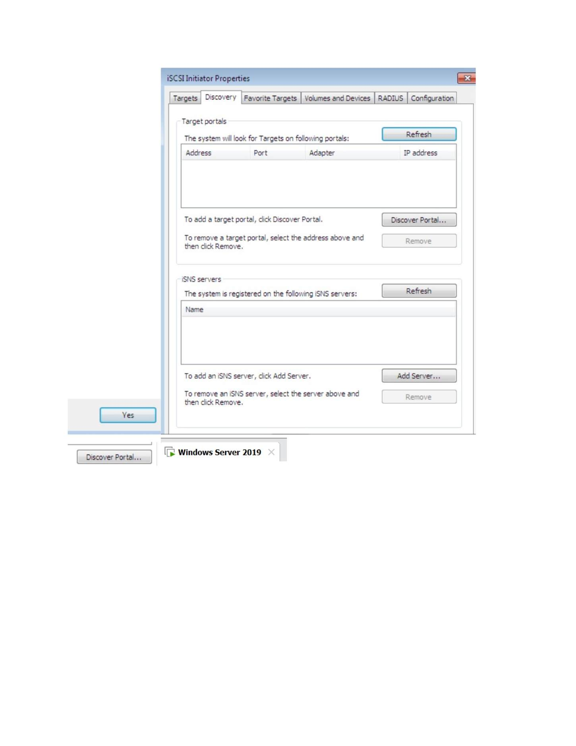
What I did: Opened Discover Portal and entered the iSCSI target portal IP address and port 3260.

PAGE 152 — FILE SERVER (ISCSI)
Topic: File Server (iSCSI)
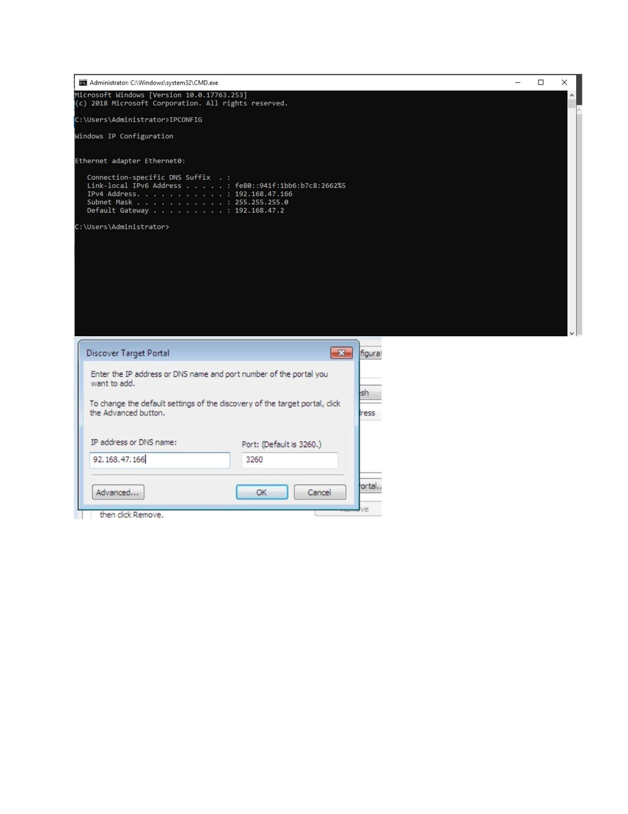
What I did: Verified the discovered target portal in the iSCSI Initiator.

PAGE 153 — FILE SERVER (ISCSI)
Topic: File Server (iSCSI)
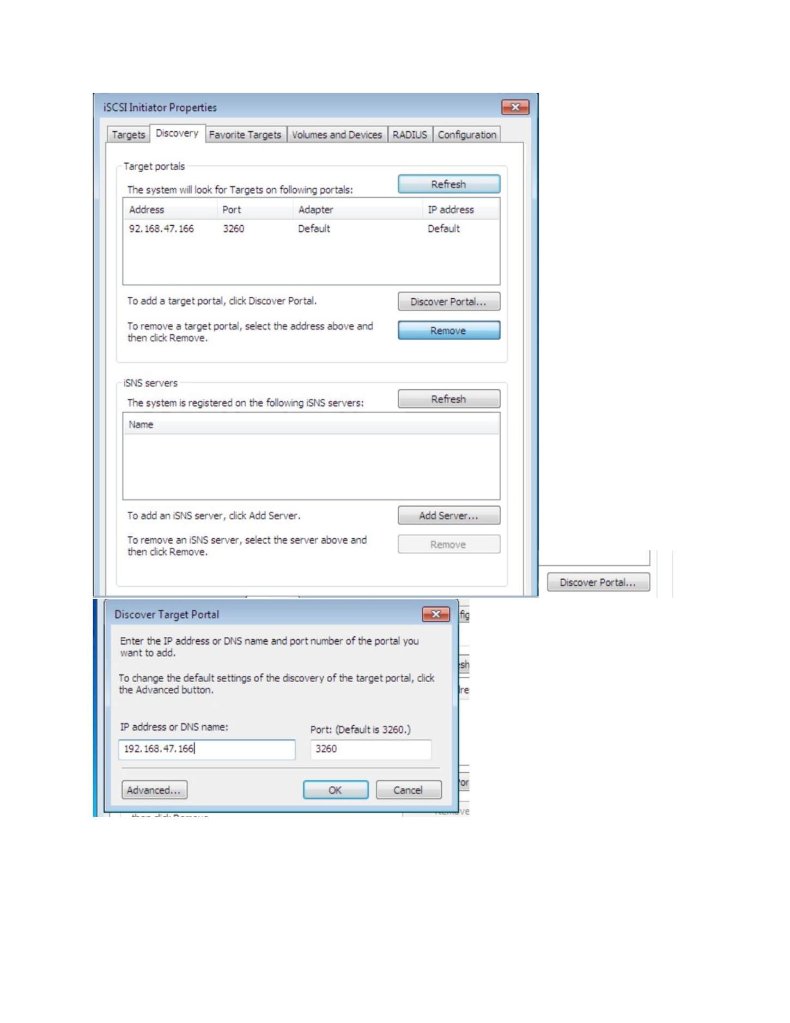
What I did: Reviewed the discovered iSCSI target and connection options.

PAGE 154 — FILE SERVER (ISCSI)
Topic: File Server (iSCSI)
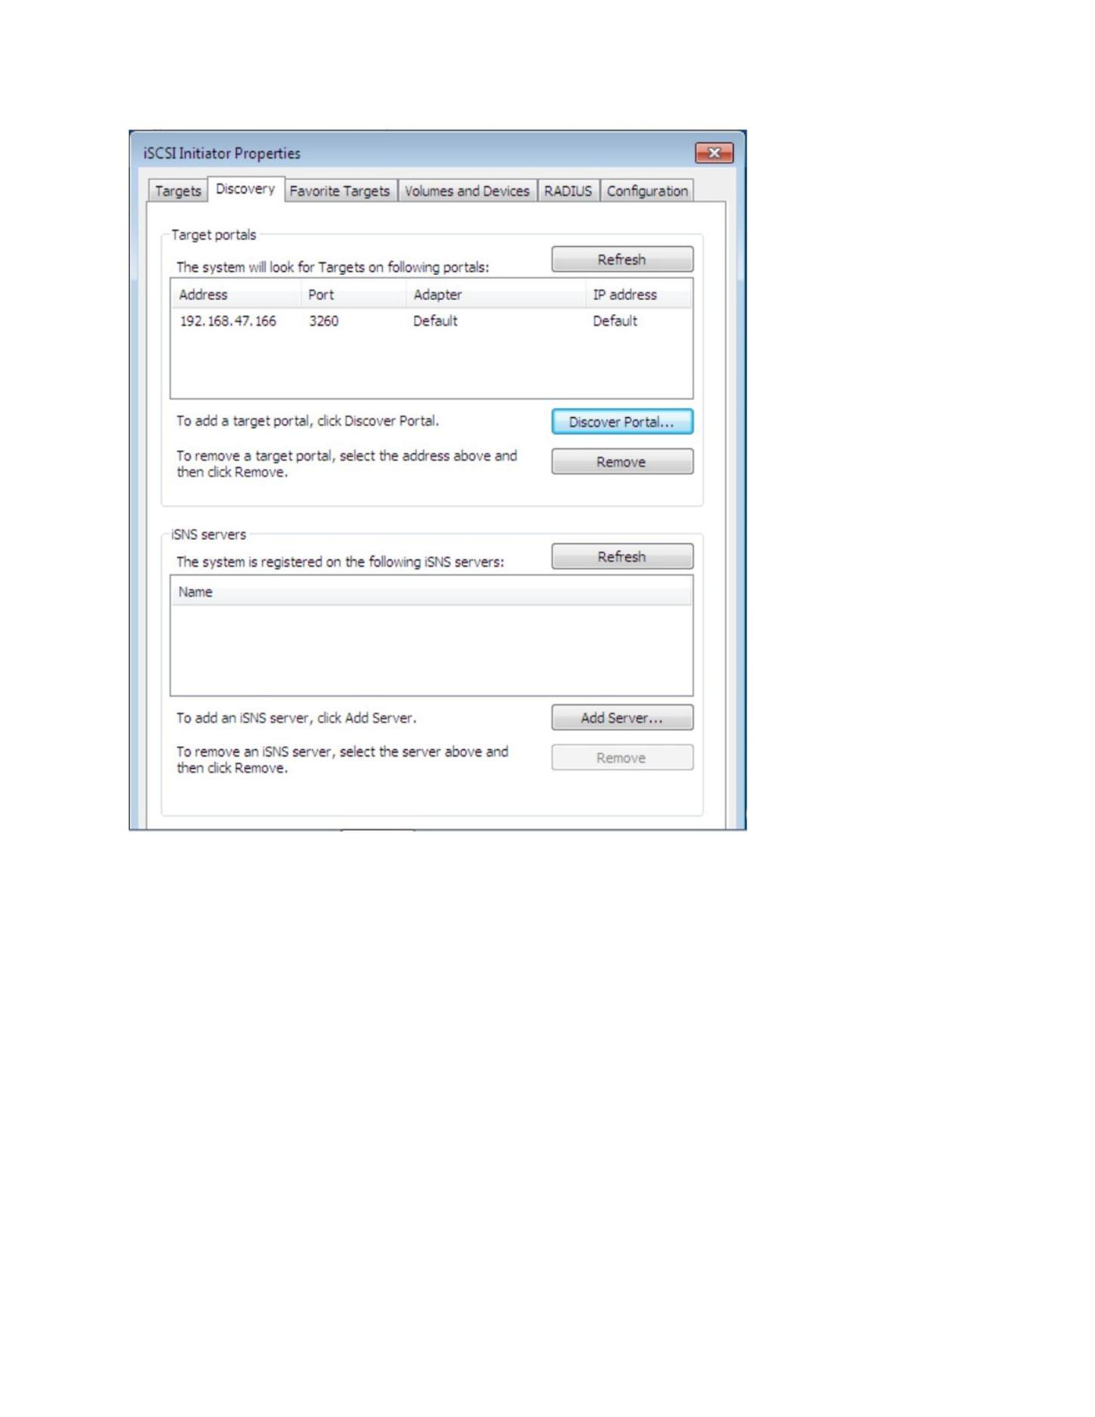
What I did: Used Quick Connect to connect the Windows client to the iSCSI target.

PAGE 155 — FILE SERVER (ISCSI)
Topic: File Server (iSCSI)
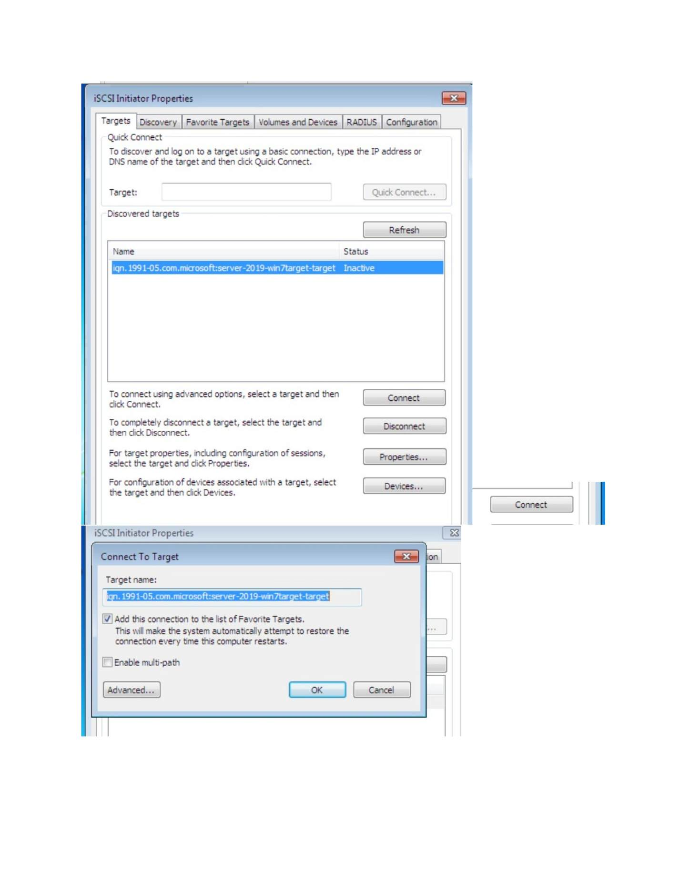
What I did: Confirmed the iSCSI target/session connection.

PAGE 156 — FILE SERVER (ISCSI)
Topic: File Server (iSCSI)
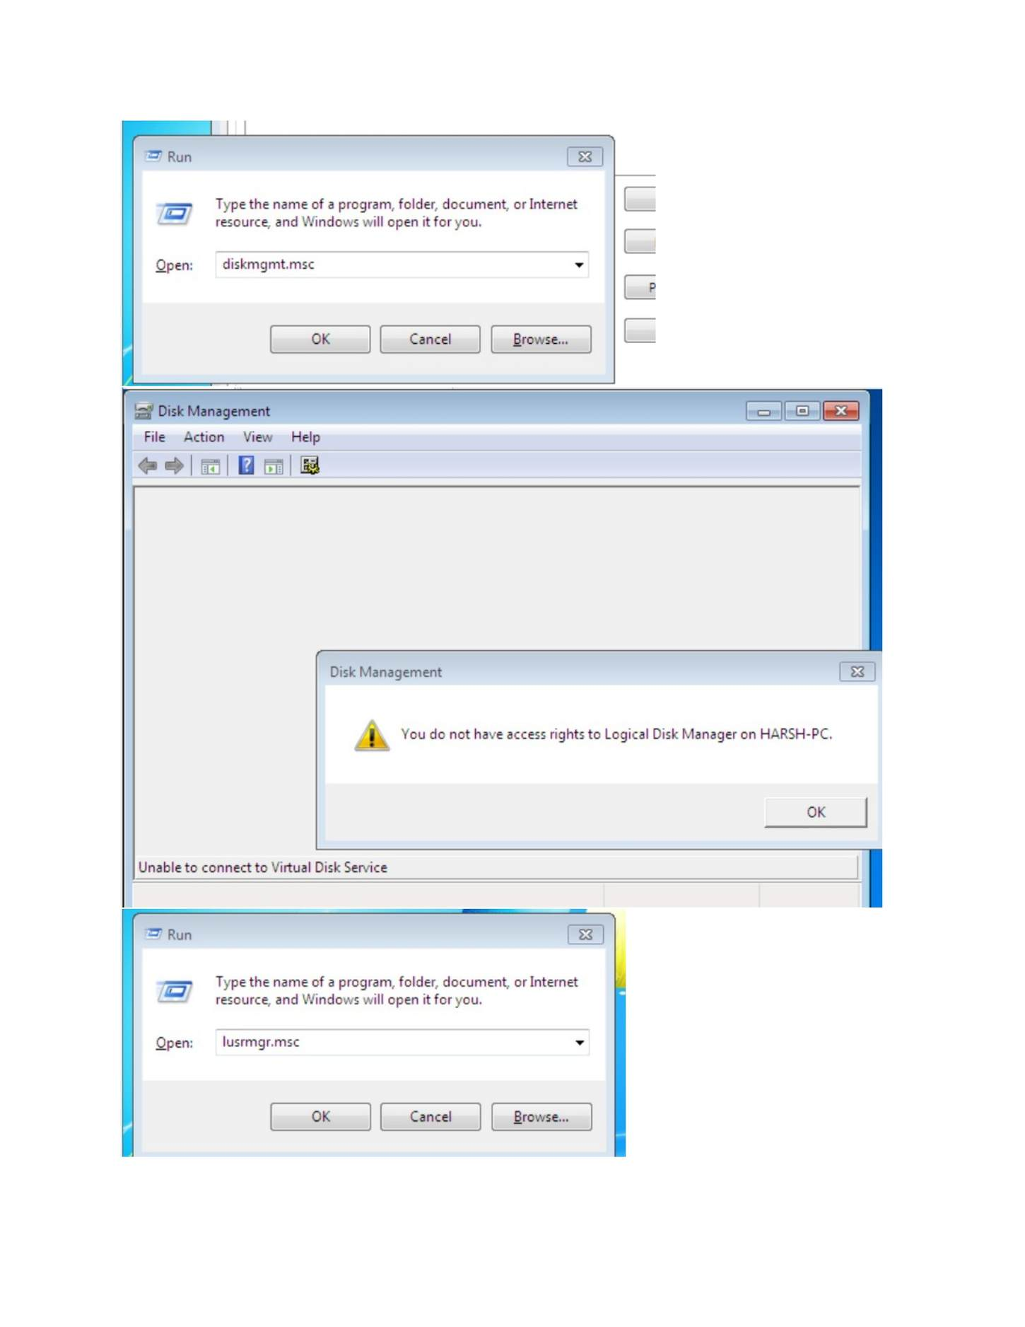
What I did: Reviewed the connected iSCSI target and available disk.

PAGE 157 — FILE SERVER (ISCSI)
Topic: File Server (iSCSI)
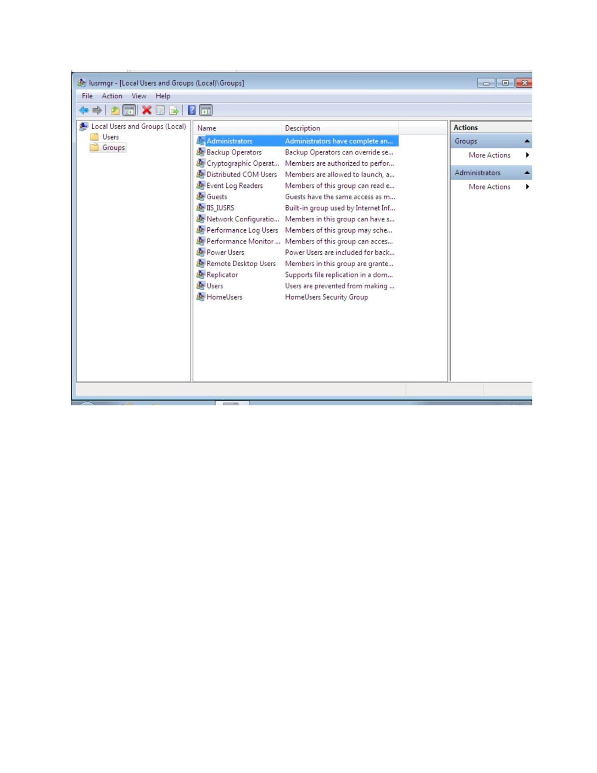
What I did: Opened the disk/storage management tools to locate the newly attached iSCSI disk.

PAGE 158 — FILE SERVER (ISCSI)
Topic: File Server (iSCSI)
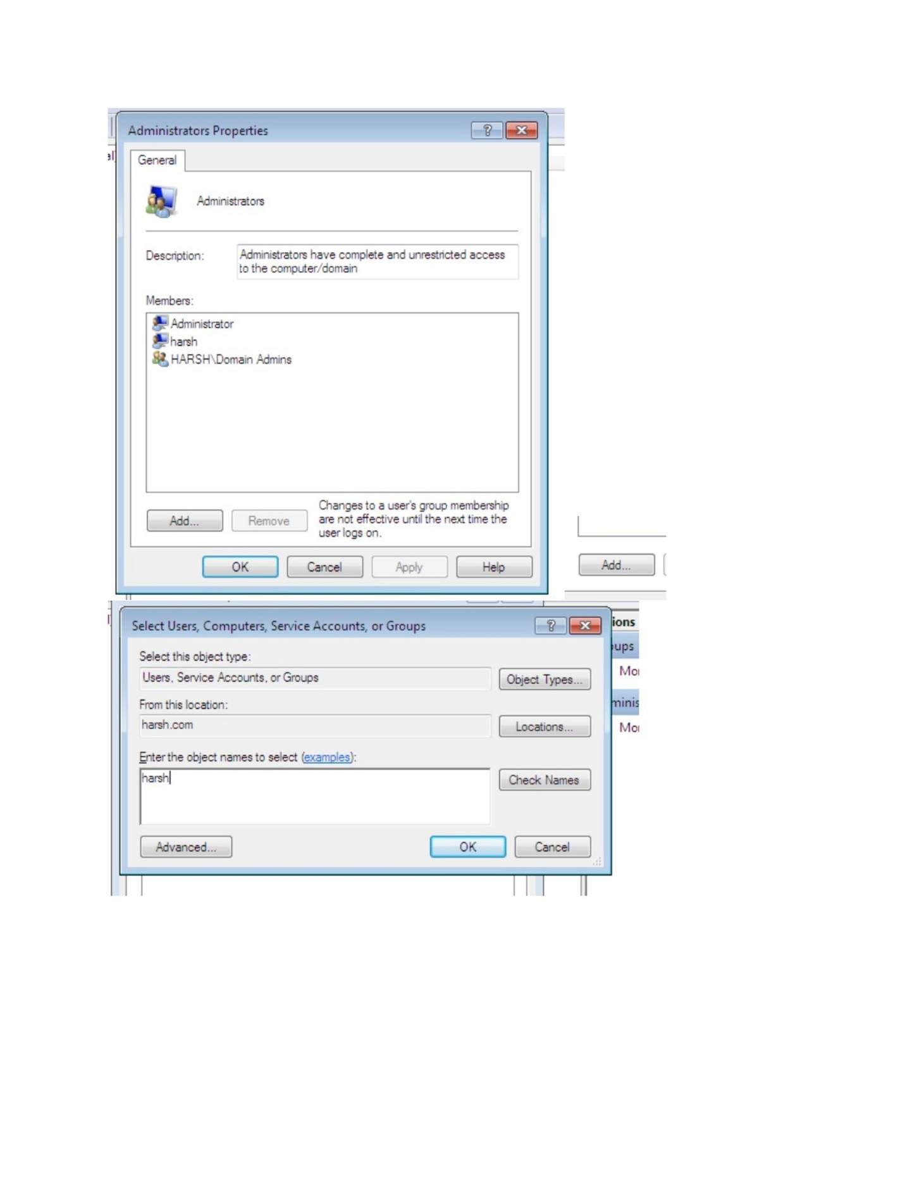
What I did: Opened Disk Management and selected the new disk for initialization/partitioning.

PAGE 159 — FILE SERVER (ISCSI)
Topic: File Server (iSCSI)
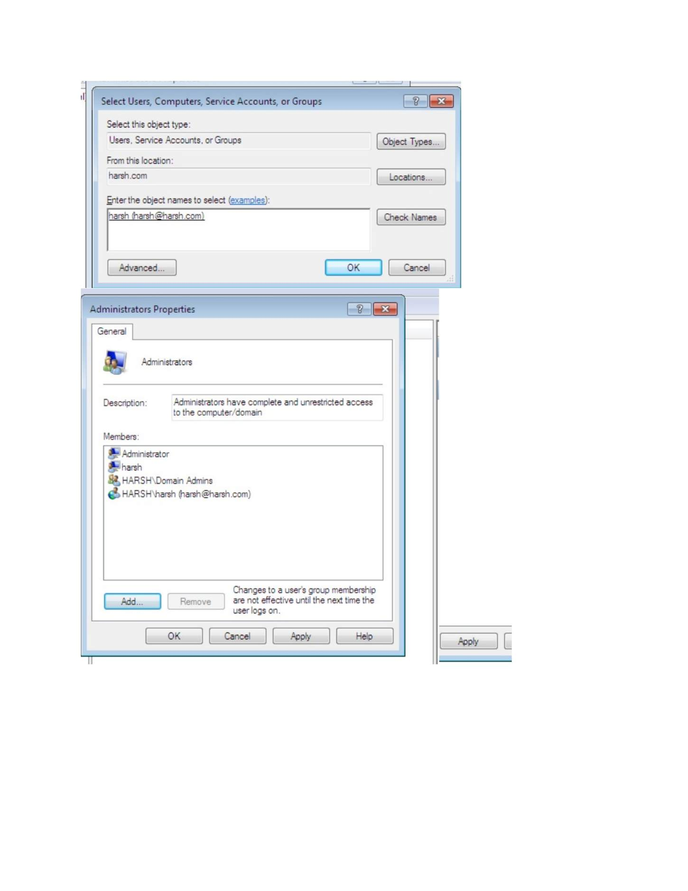
What I did: Started the New Simple Volume Wizard for the iSCSI disk.

PAGE 160 — FILE SERVER (ISCSI)
Topic: File Server (iSCSI)
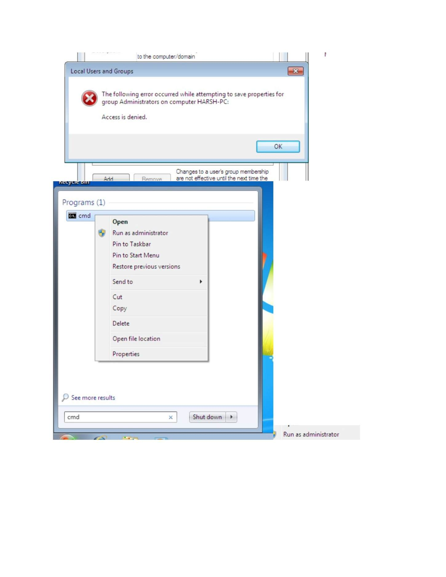
What I did: Specified the volume size/drive-letter settings in the New Simple Volume Wizard.

PAGE 161 — FILE SERVER (ISCSI)
Topic: File Server (iSCSI)
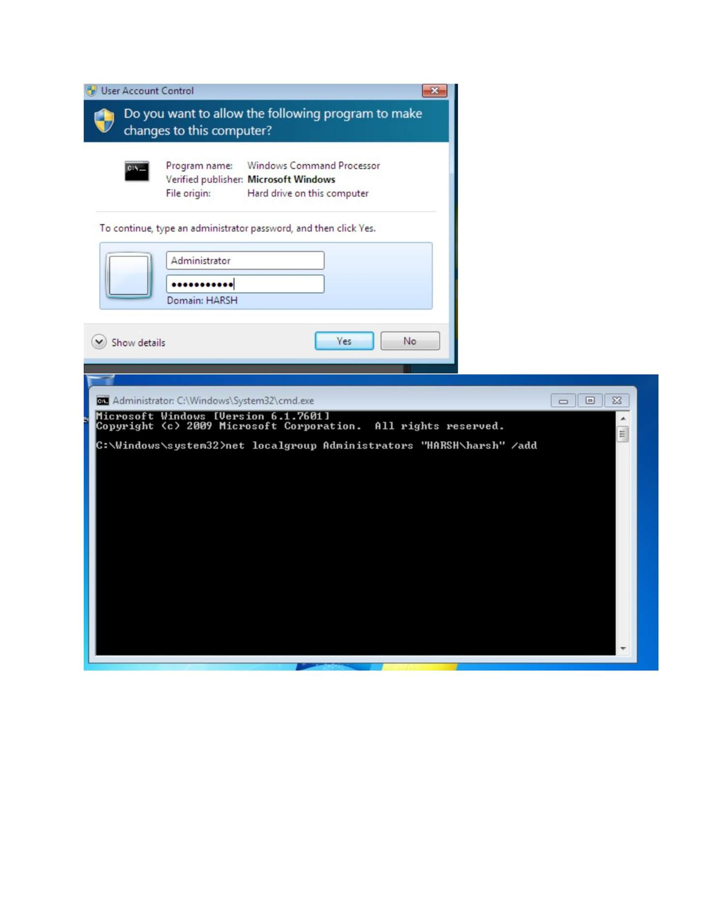
What I did: Selected the required formatting/file-system settings for the new volume.

PAGE 162 — FILE SERVER (ISCSI)
Topic: File Server (iSCSI)
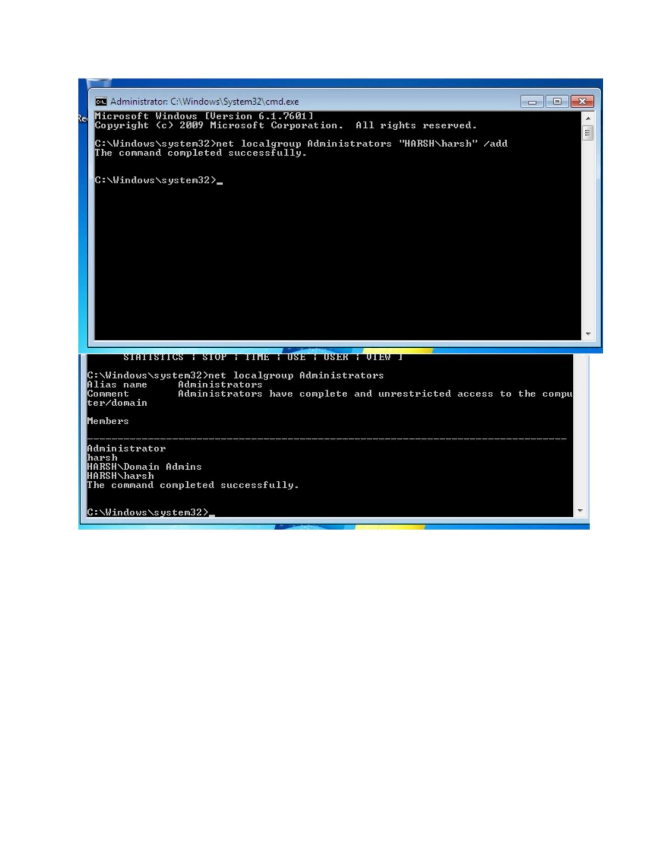
What I did: Completed the New Simple Volume Wizard.

PAGE 163 — FILE SERVER (ISCSI)
Topic: File Server (iSCSI)
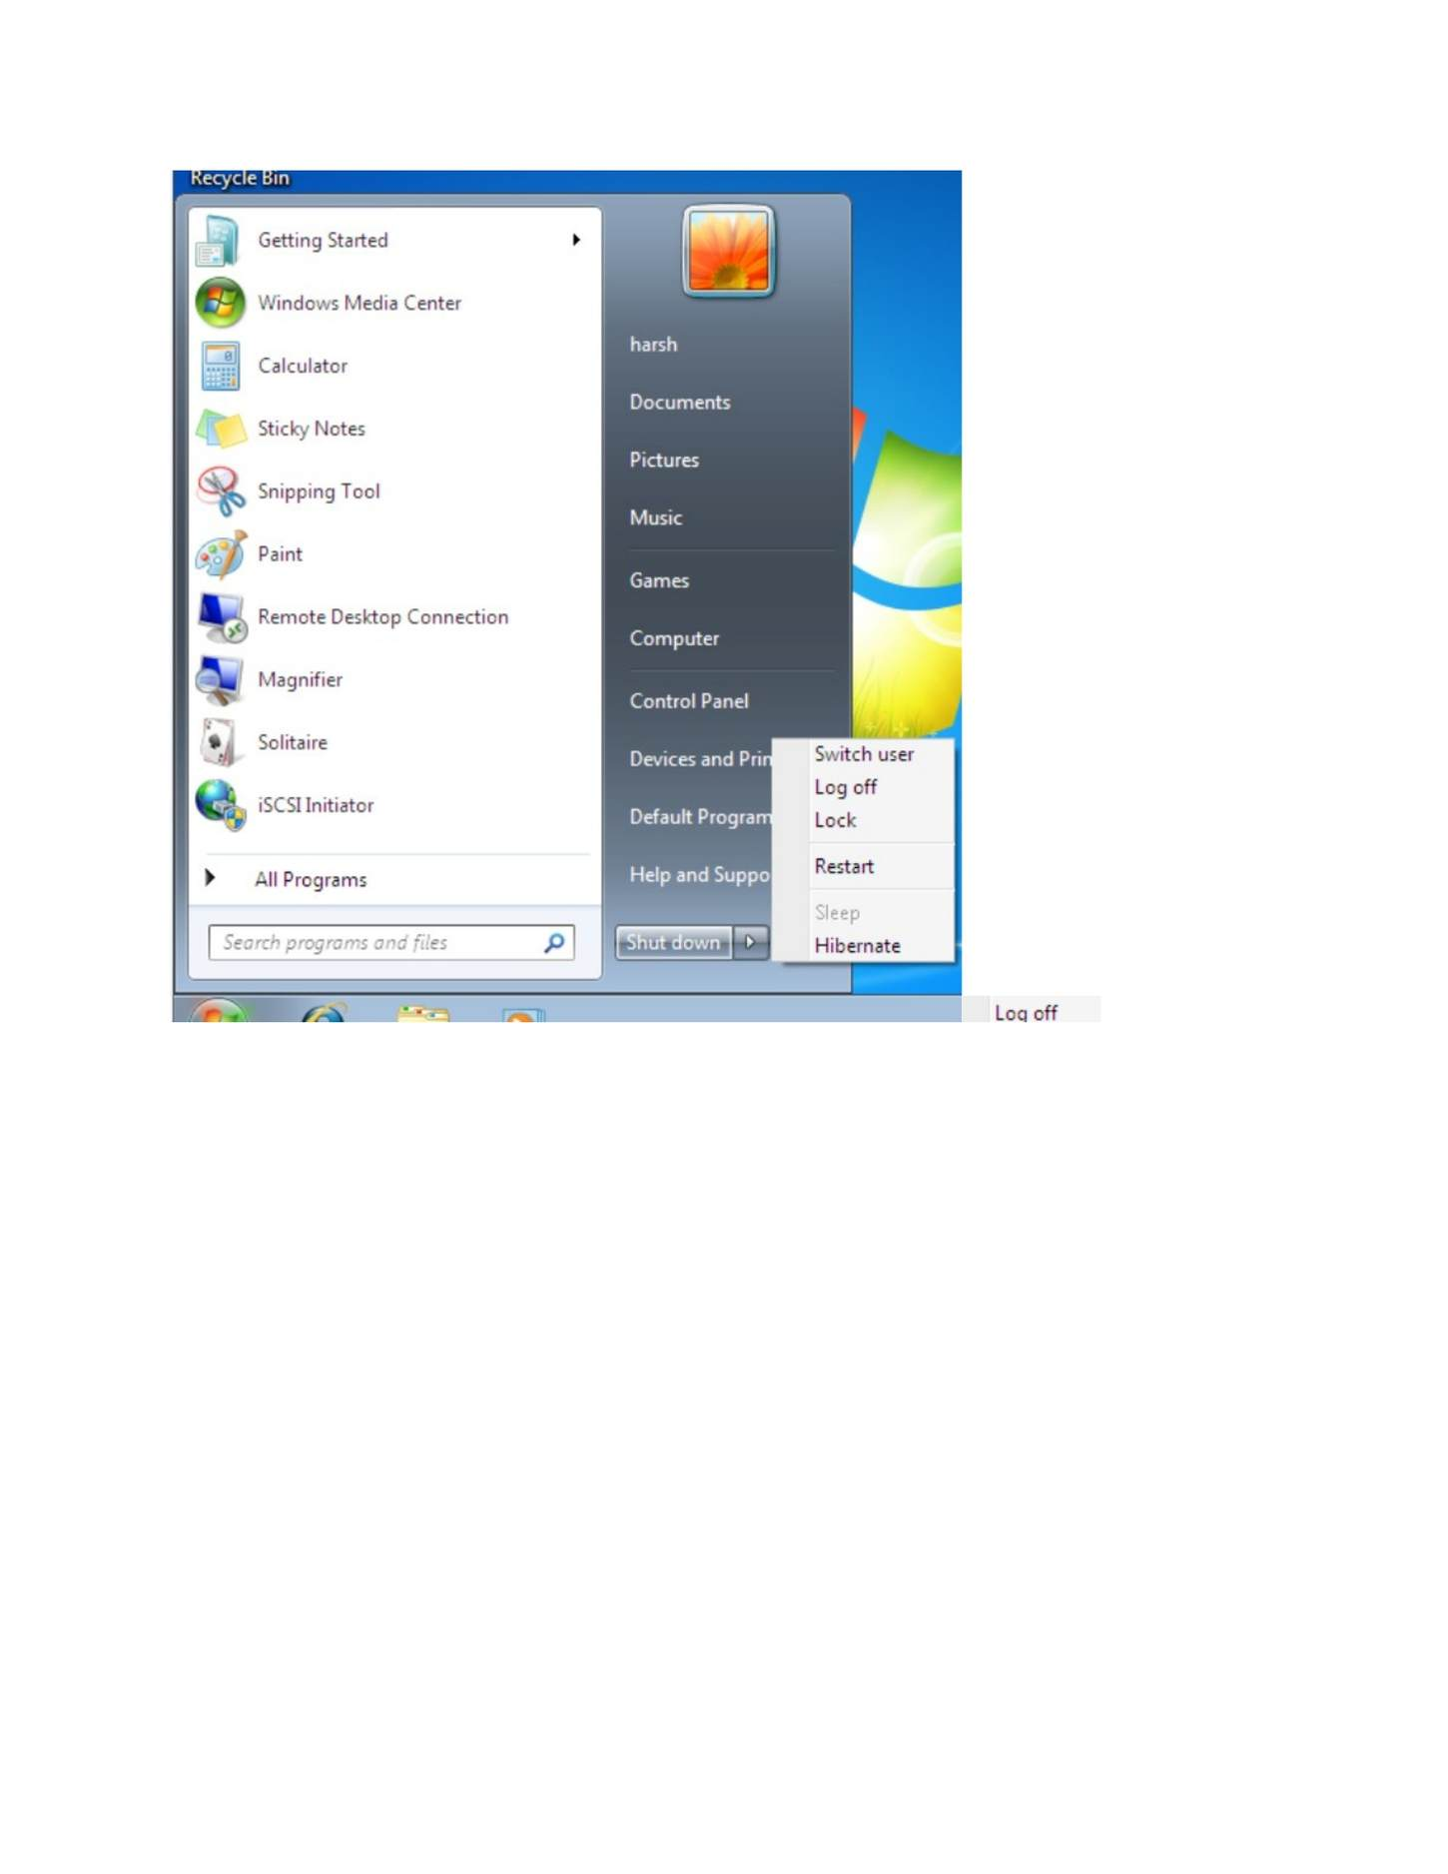
What I did: Verified the newly created volume and its file-system/drive information.

PAGE 164 — FILE SERVER (ISCSI)
Topic: File Server (iSCSI)
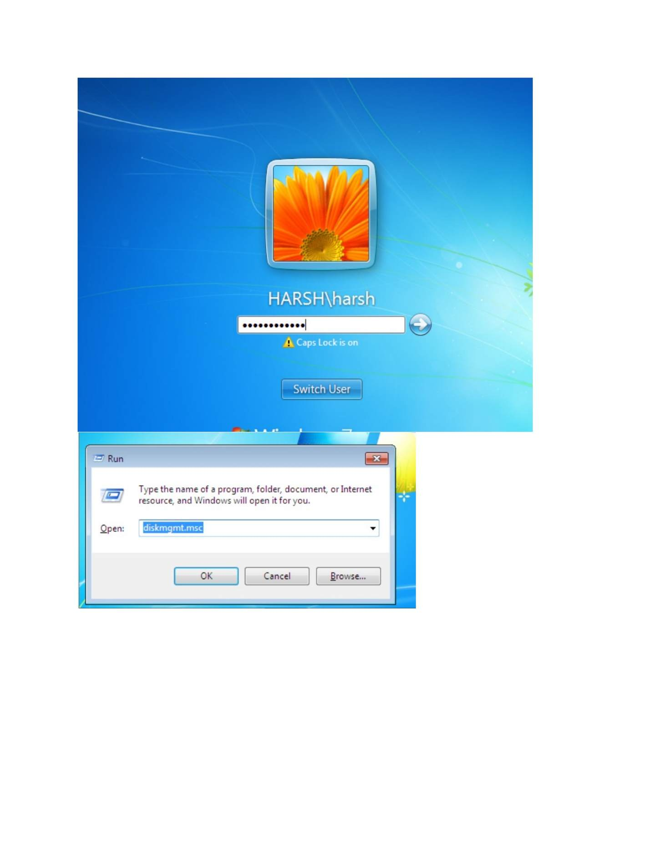
What I did: Confirmed the iSCSI storage was available to the Windows client.

PAGE 165 — FILE SERVER (ISCSI)
Topic: File Server (iSCSI)
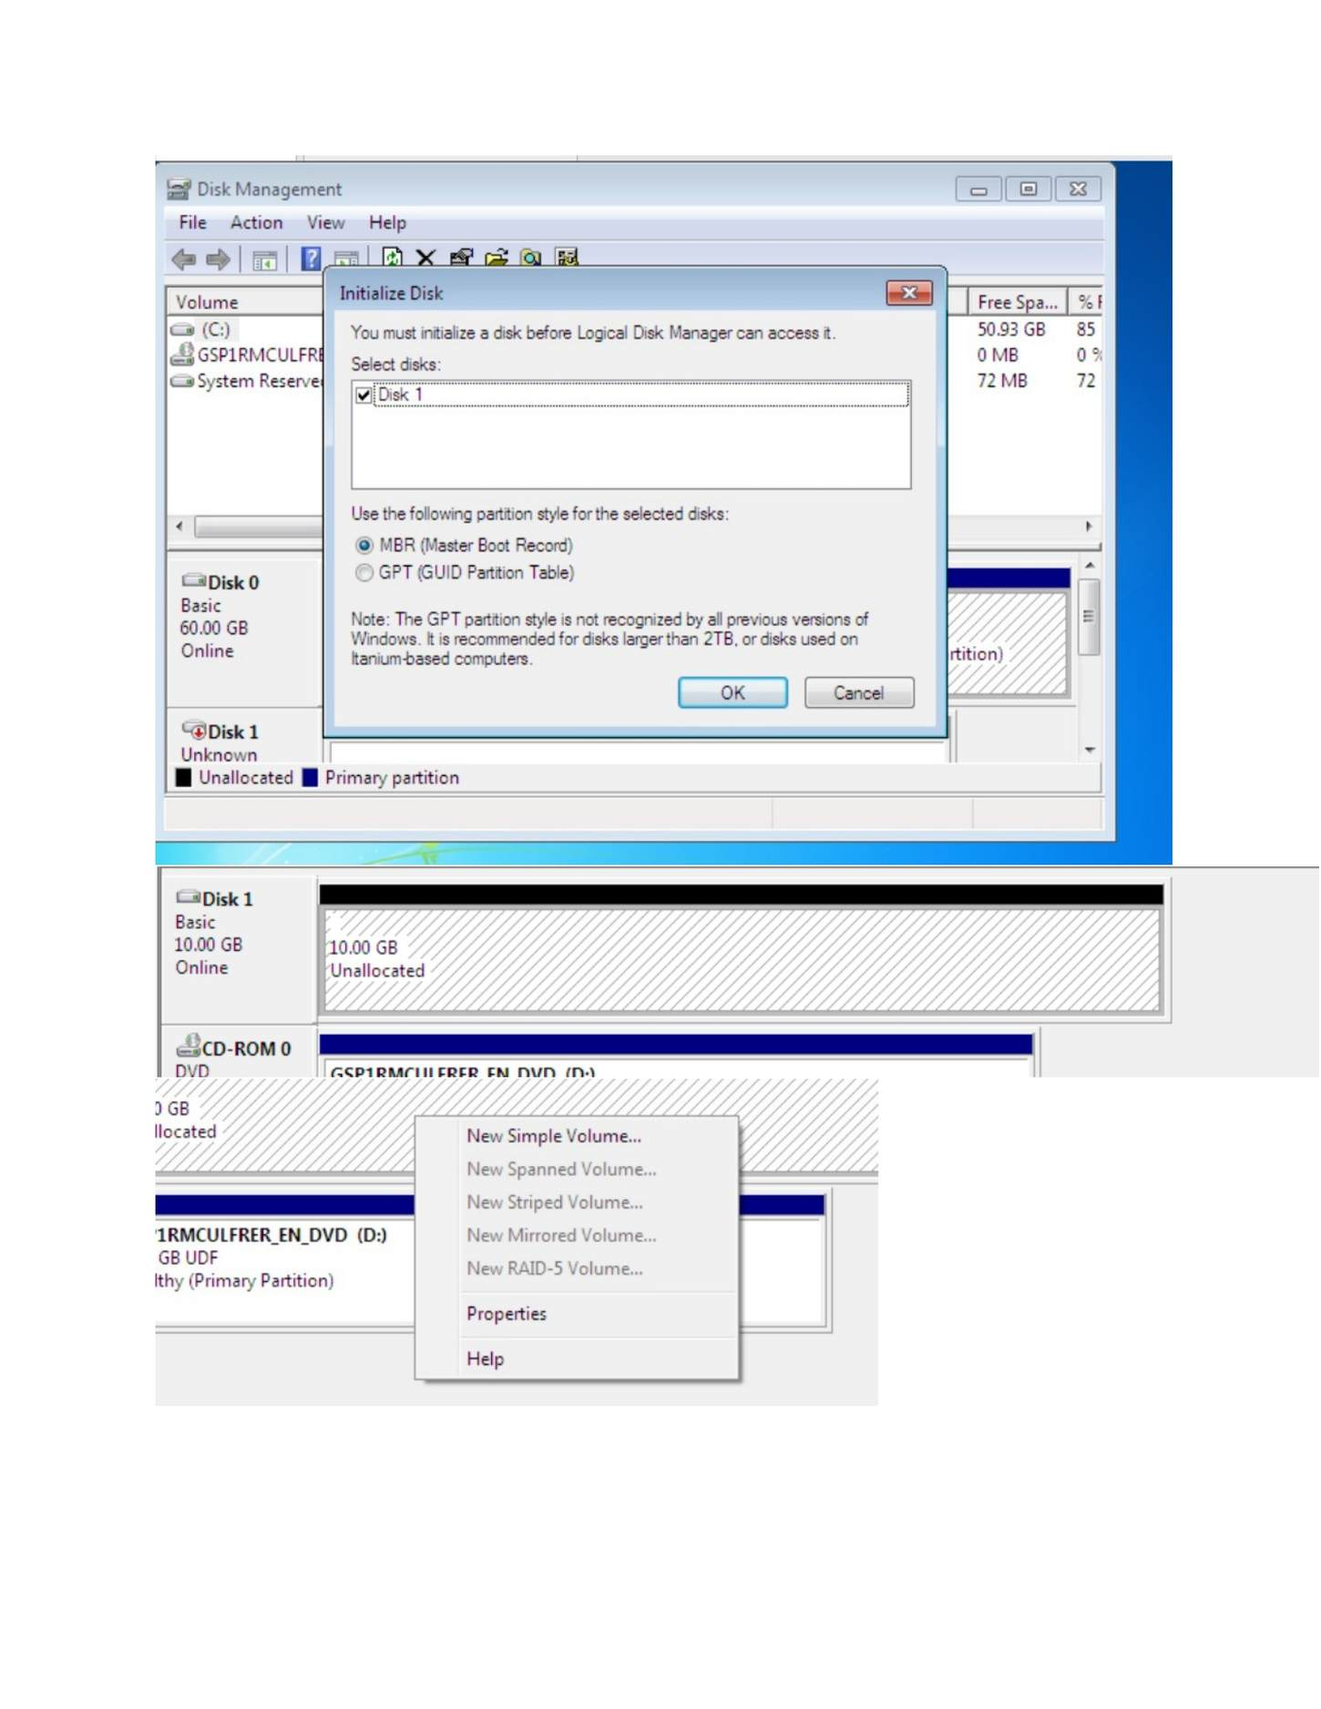
What I did: Reviewed the final disk/volume layout after formatting.

PAGE 166 — FILE SERVER (ISCSI)
Topic: File Server (iSCSI)
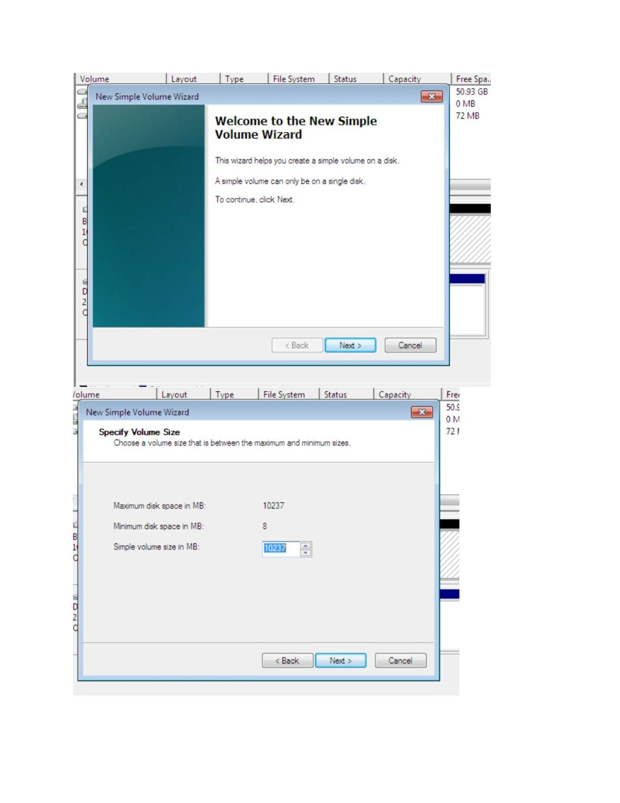
What I did: Checked the Windows client storage view for the new iSCSI volume.

PAGE 167 — FILE SERVER (ISCSI)
Topic: File Server (iSCSI)
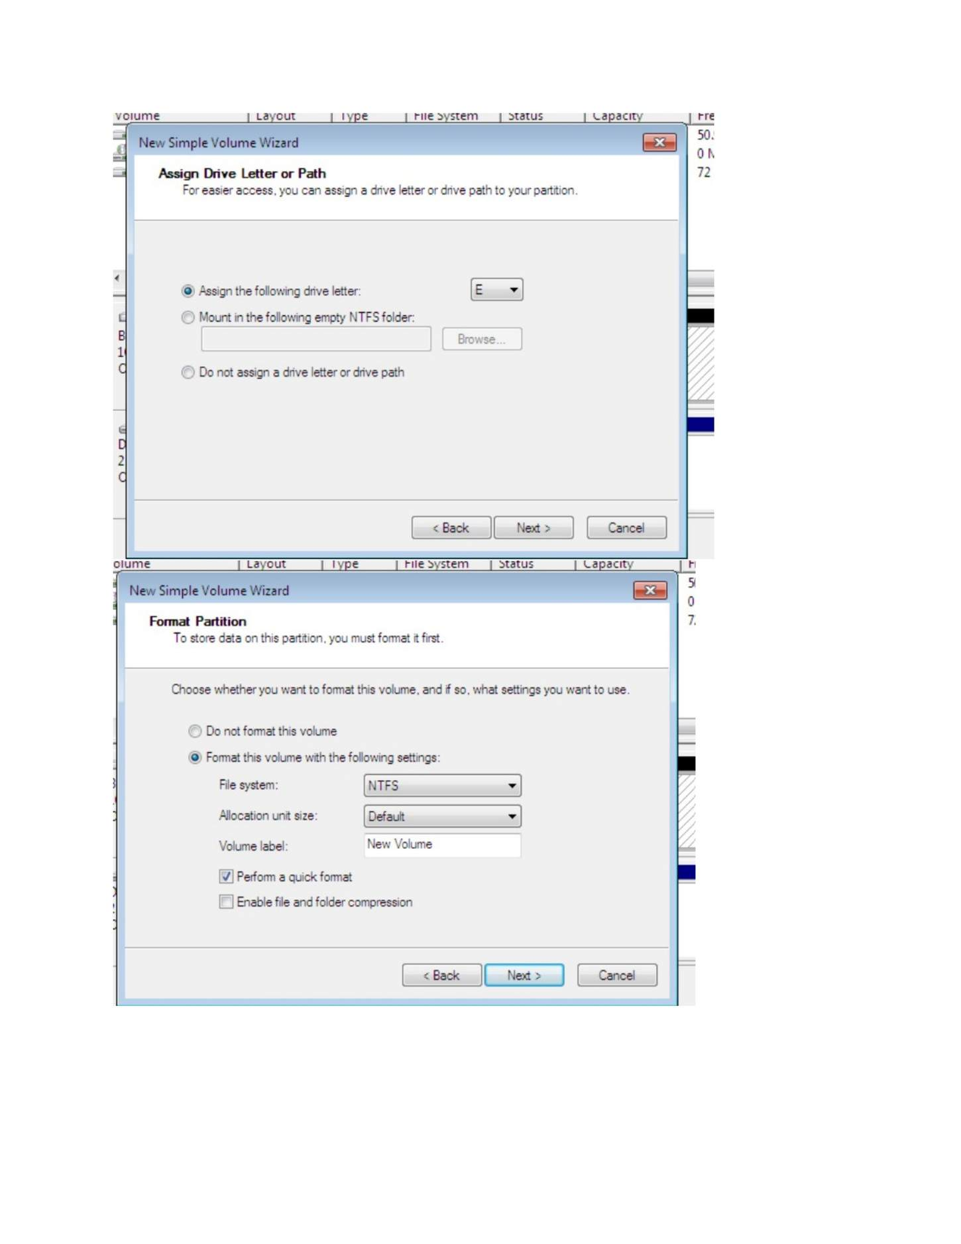
What I did: Confirmed the completed iSCSI storage setup.

PAGE 168 — FILE SERVER (ISCSI)
Topic: File Server (iSCSI)
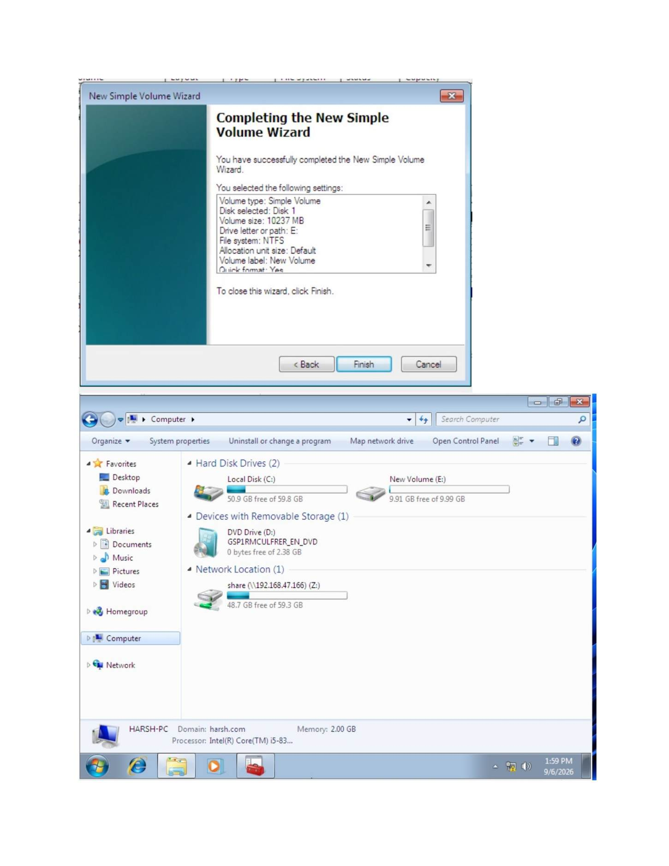
What I did: The screenshot shows the current configuration screen for this task; I reviewed the displayed settings and continued to the next step.

PAGE 169 — WEB SERVER (IIS)
Topic: Web Server (IIS)
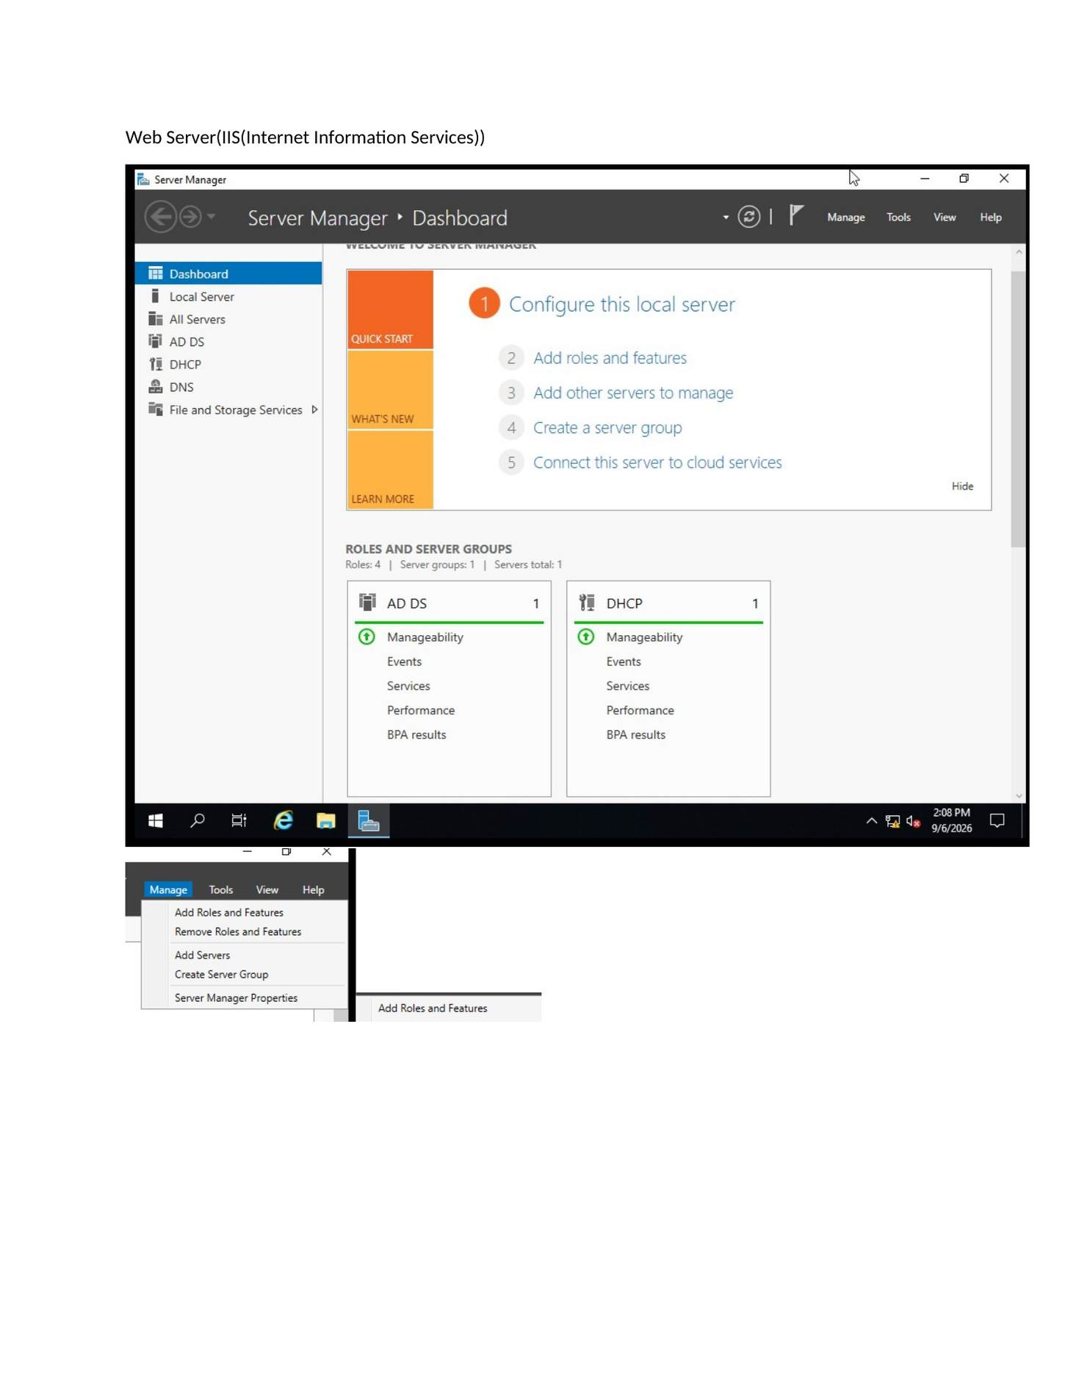
What I did: Opened Server Manager and started installing the Web Server (IIS) role.

PAGE 170 — WEB SERVER (IIS)
Topic: Web Server (IIS)
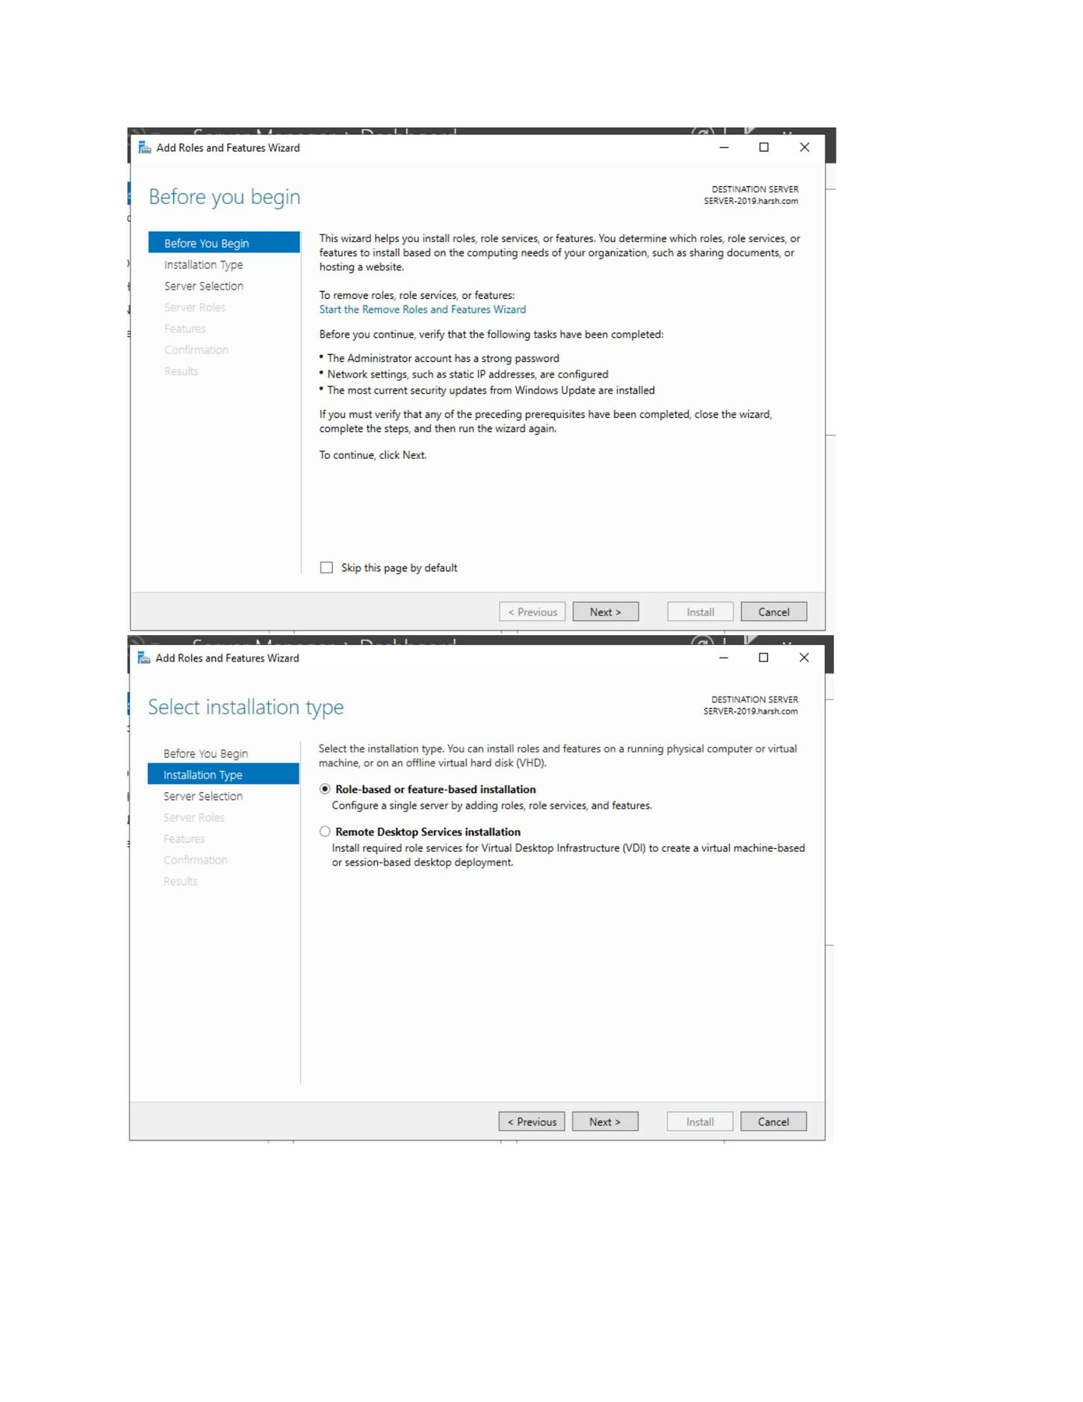
What I did: Started the Add Roles and Features wizard and reviewed the IIS prerequisites.

PAGE 171 — WEB SERVER (IIS)
Topic: Web Server (IIS)
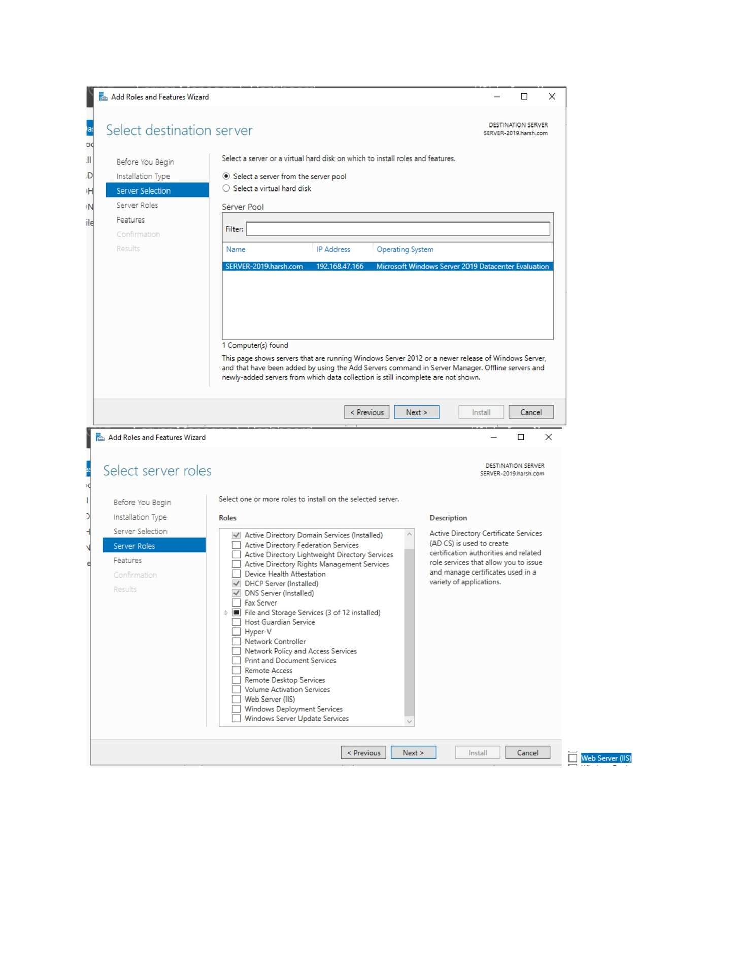
What I did: Selected the destination server for the IIS installation.

PAGE 172 — WEB SERVER (IIS)
Topic: Web Server (IIS)
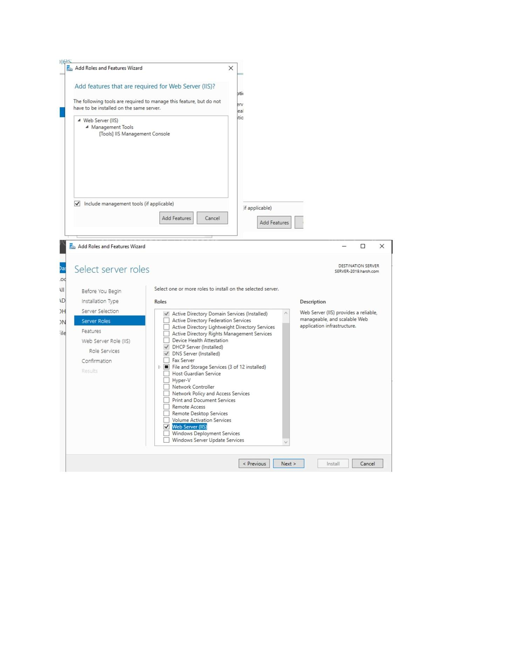
What I did: Selected Web Server (IIS) from the server roles.

PAGE 173 — WEB SERVER (IIS)
Topic: Web Server (IIS)
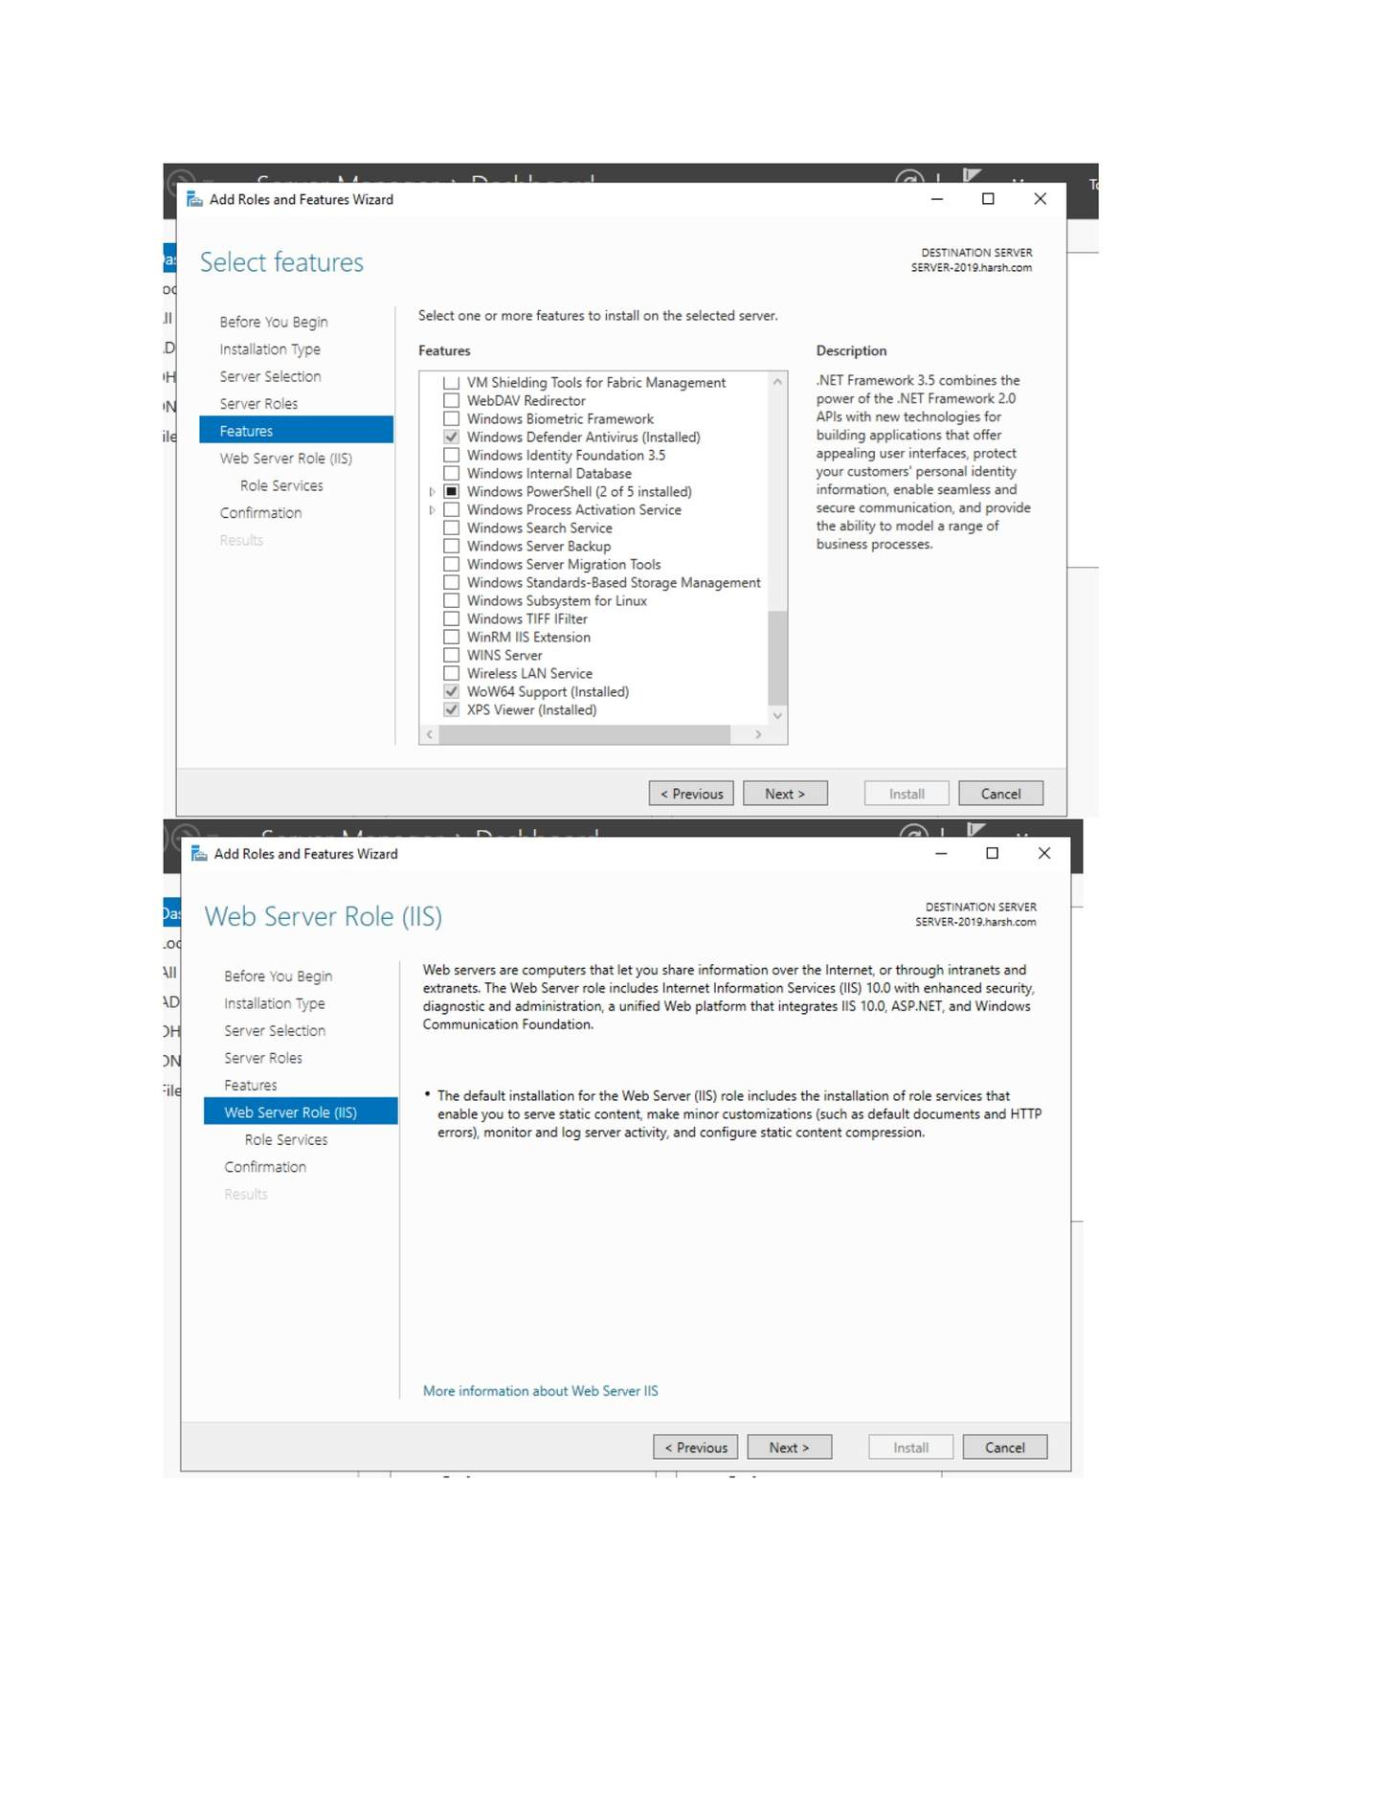
What I did: Reviewed the IIS role information and continued.

PAGE 174 — WEB SERVER (IIS)
Topic: Web Server (IIS)
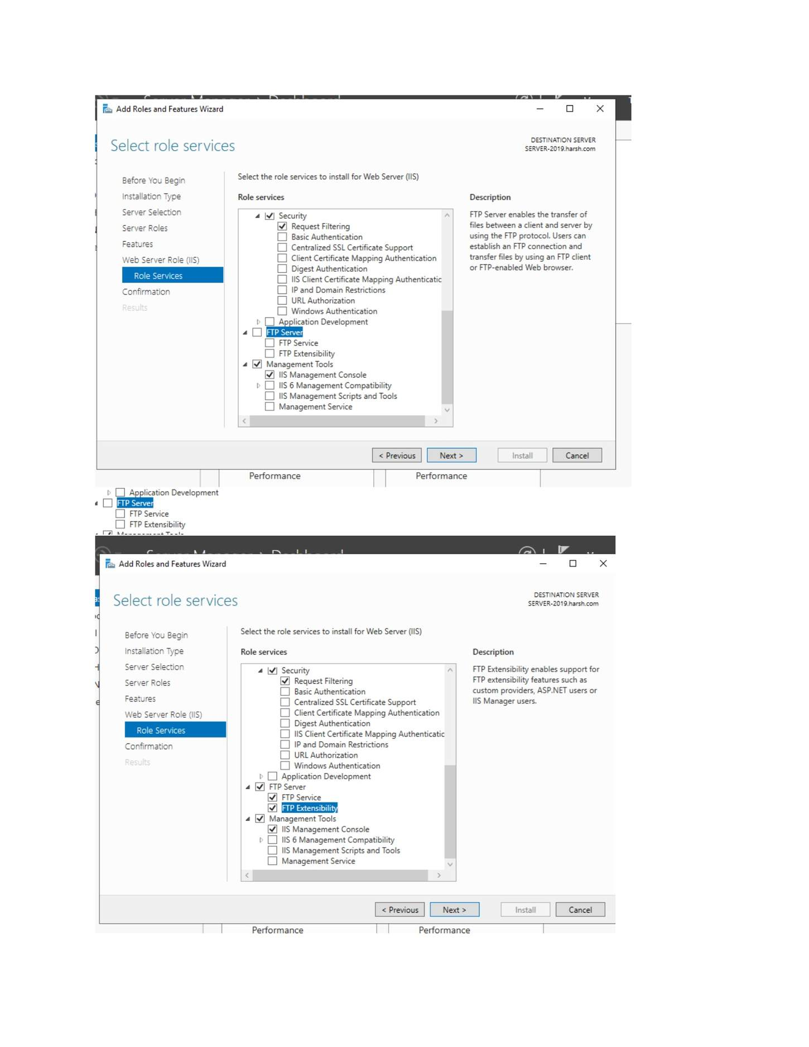
What I did: Selected the required IIS role services/features.

PAGE 175 — WEB SERVER (IIS)
Topic: Web Server (IIS)
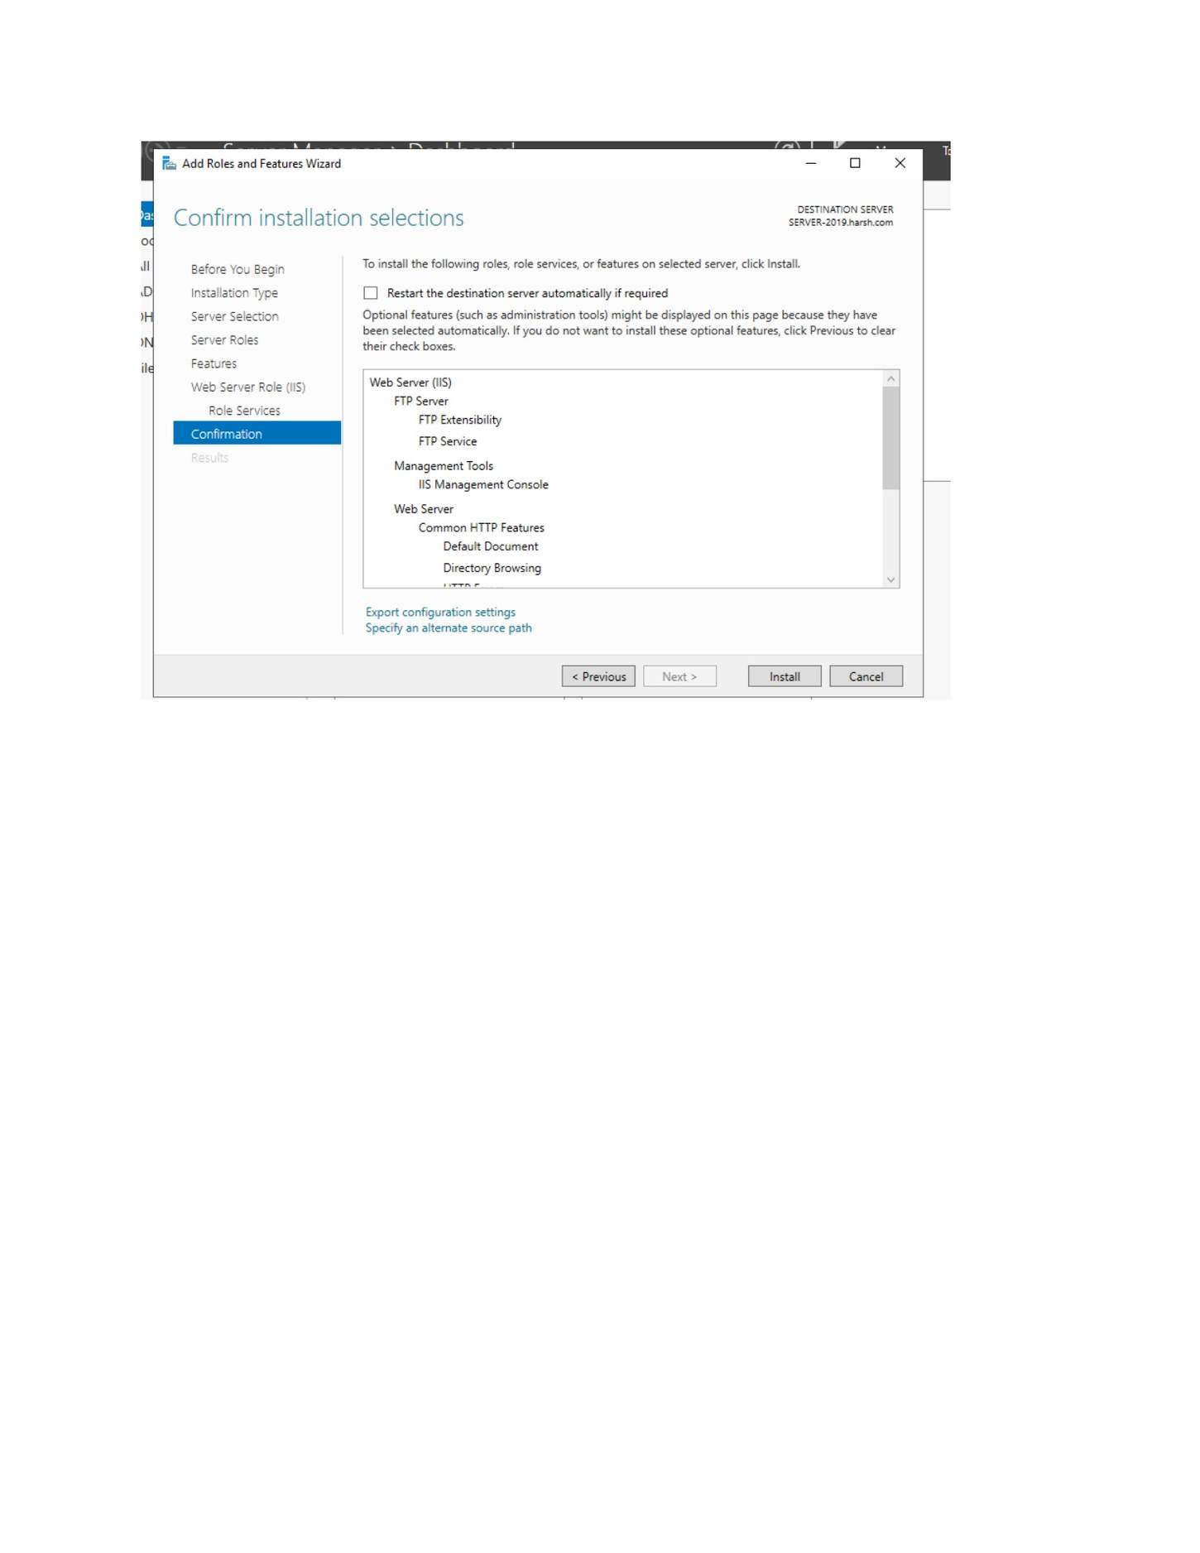
What I did: Reviewed the IIS role-service selections.

PAGE 176 — WEB SERVER (IIS)
Topic: Web Server (IIS)
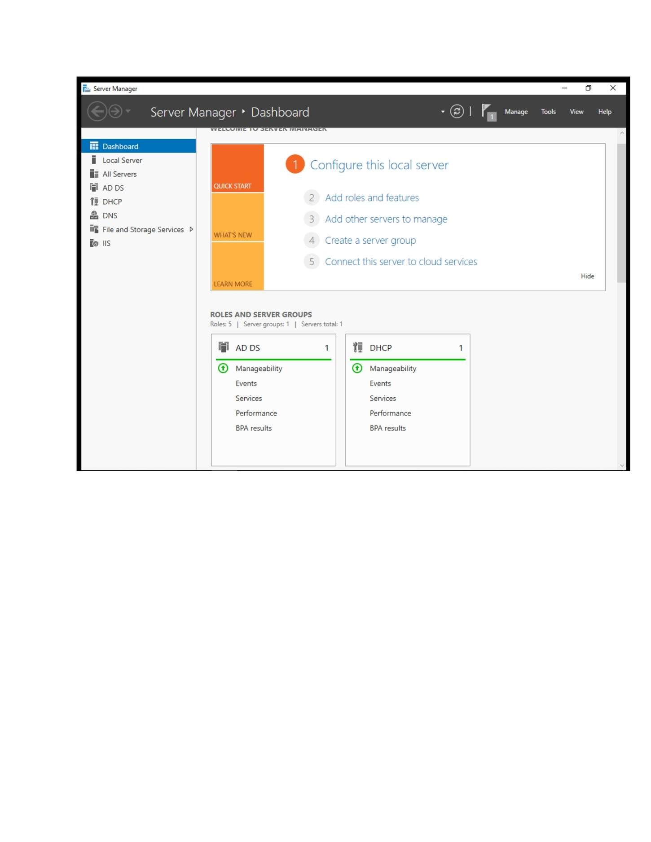
What I did: Confirmed the IIS installation selections.

PAGE 177 — WEB SERVER (IIS)
Topic: Web Server (IIS)
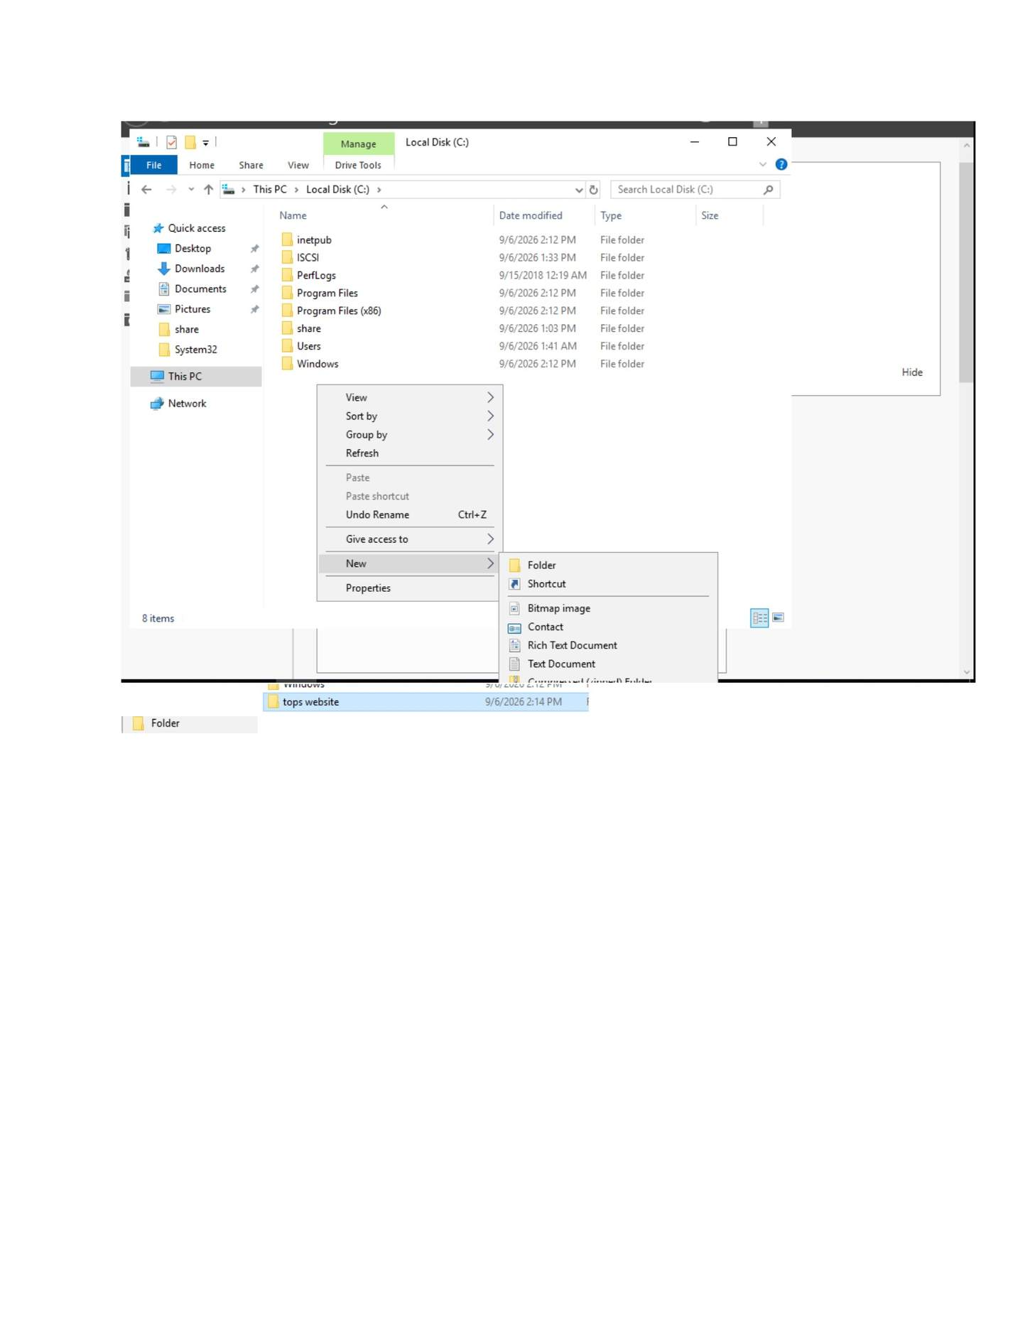
What I did: Completed the IIS role installation and returned to Server Manager.

PAGE 178 — WEB SERVER (IIS)
Topic: Web Server (IIS)
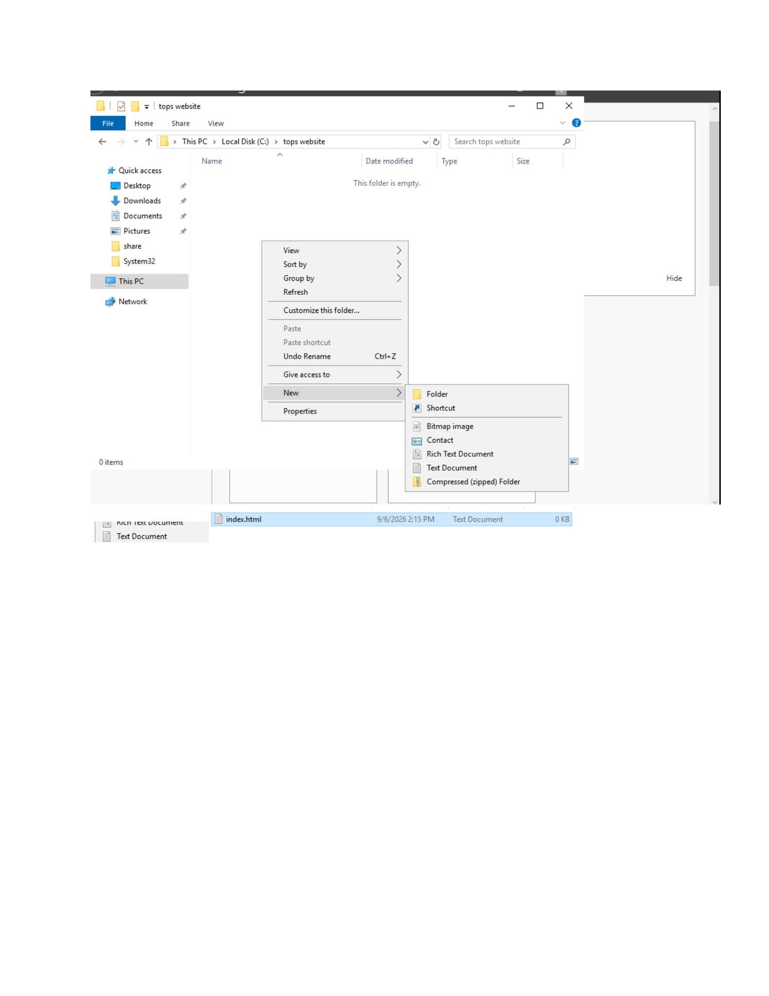
What I did: Created/opened the folder used for the website content.

PAGE 179 — WEB SERVER (IIS)
Topic: Web Server (IIS)
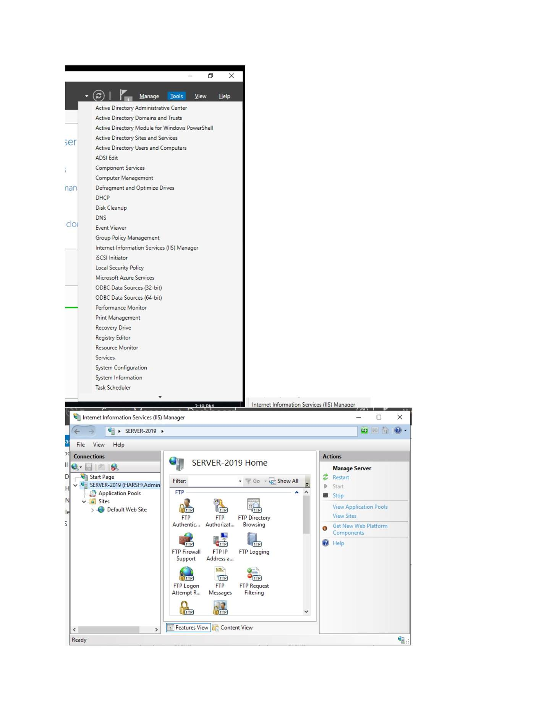
What I did: Configured the website/content folder and its files.

PAGE 180 — WEB SERVER (IIS)
Topic: Web Server (IIS)
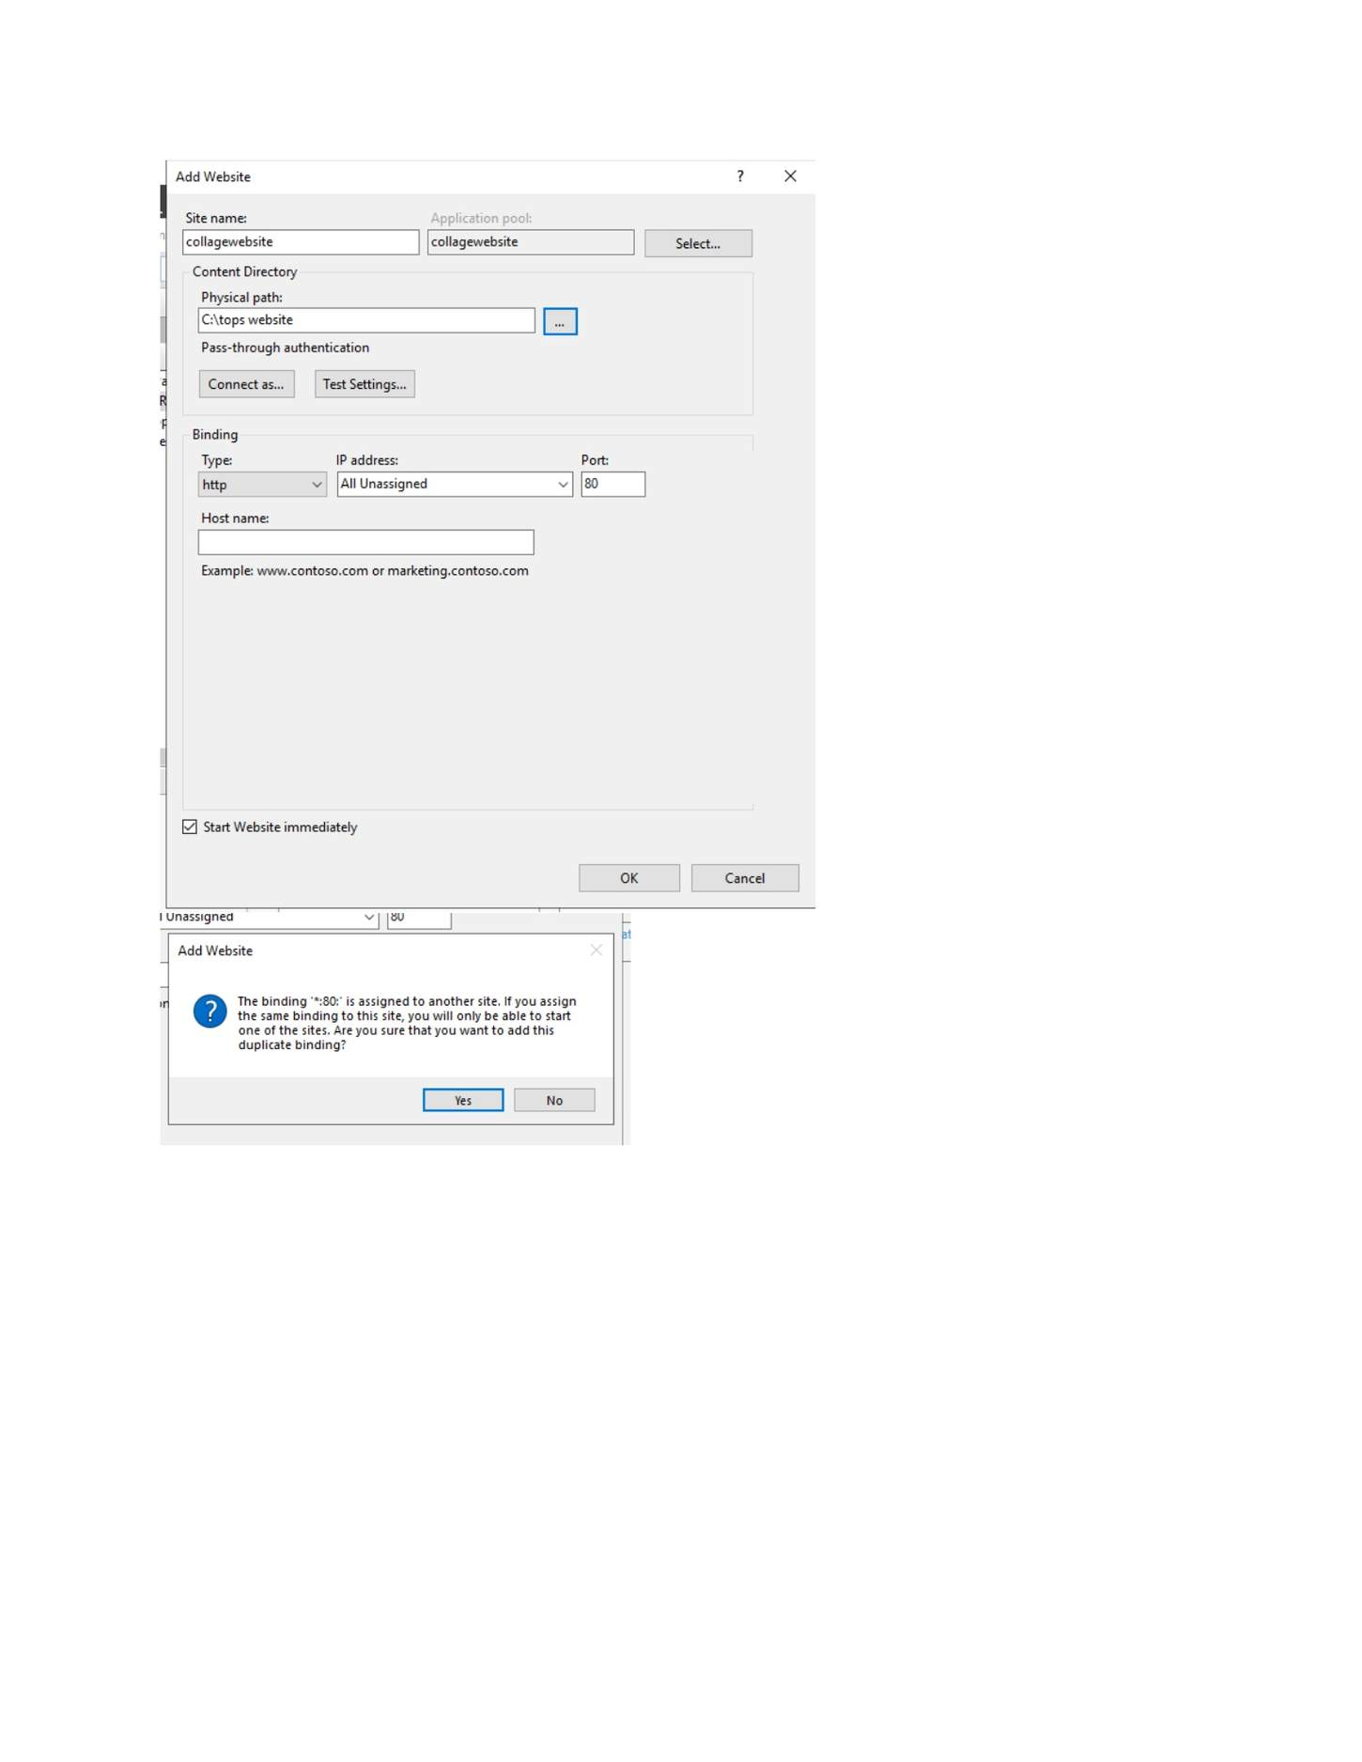
What I did: Opened IIS Manager/website management on the server.

PAGE 181 — WEB SERVER (IIS)
Topic: Web Server (IIS)
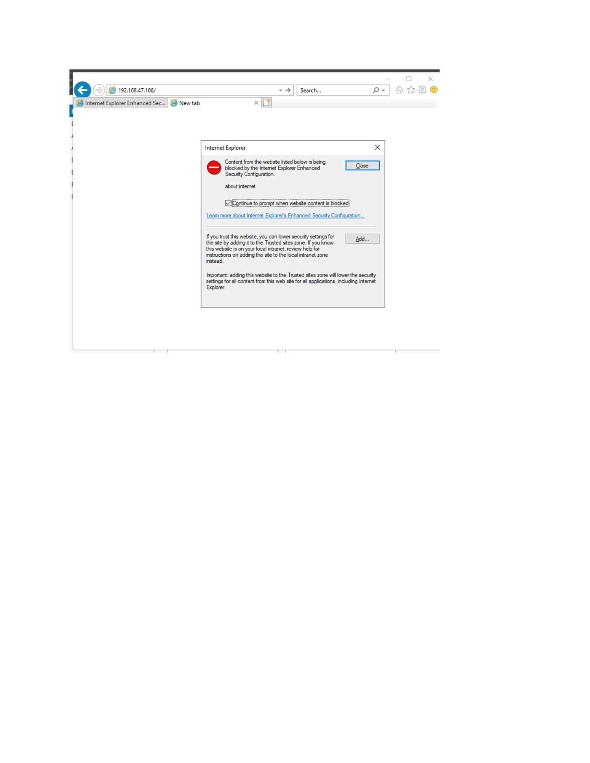
What I did: Reviewed the IIS site configuration/bindings.

PAGE 182 — WEB SERVER (IIS)
Topic: Web Server (IIS)
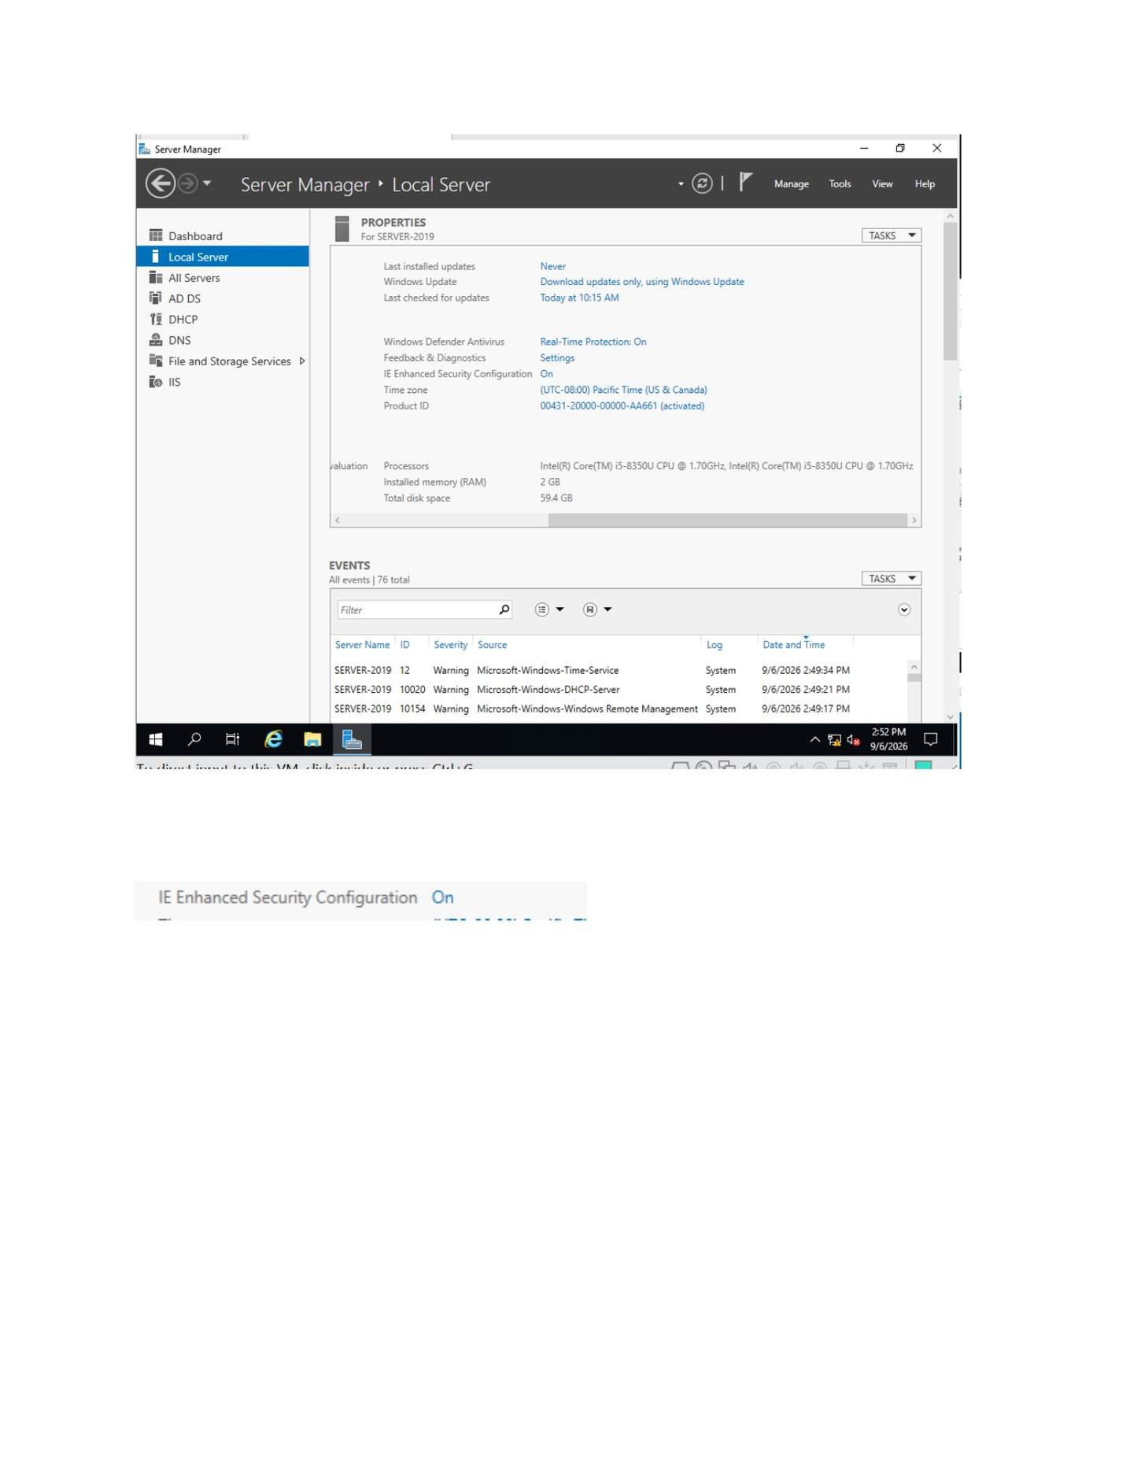
What I did: Configured the website binding/site settings shown.

PAGE 183 — WEB SERVER (IIS)
Topic: Web Server (IIS)
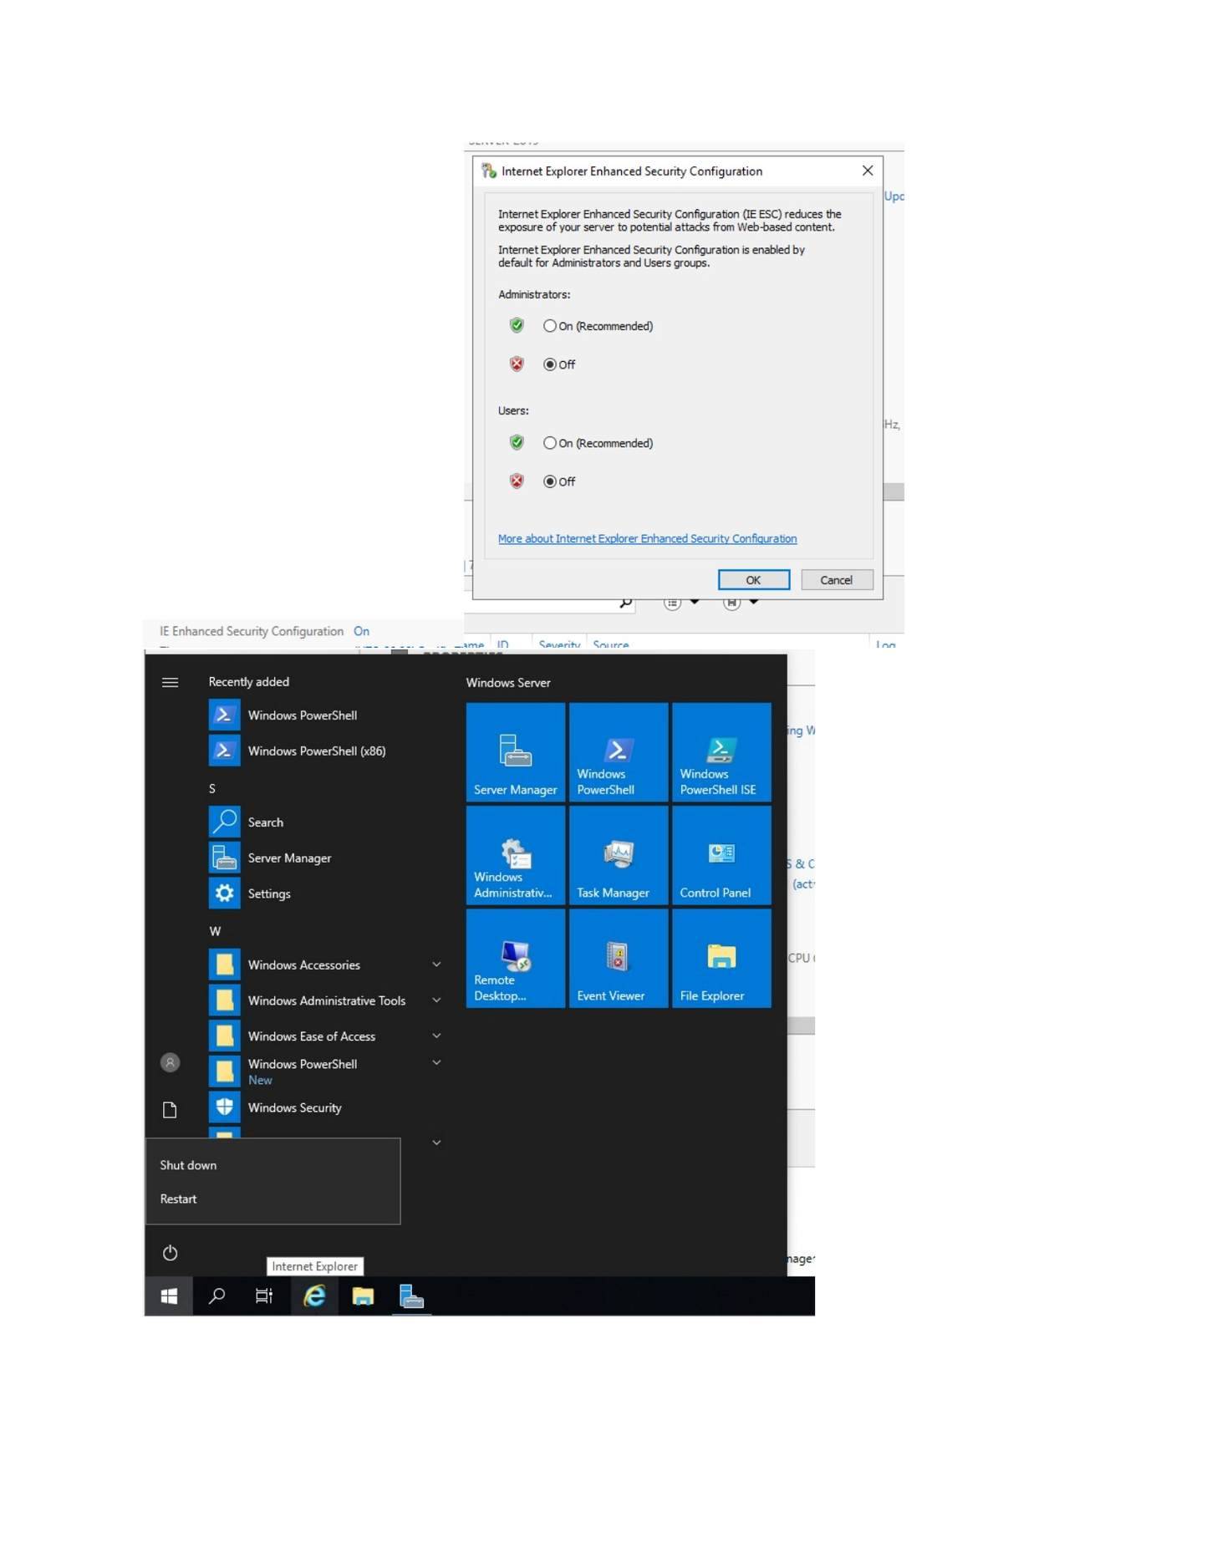
What I did: Checked the IIS service/site status after configuration.

PAGE 184 — WEB SERVER (IIS)
Topic: Web Server (IIS)
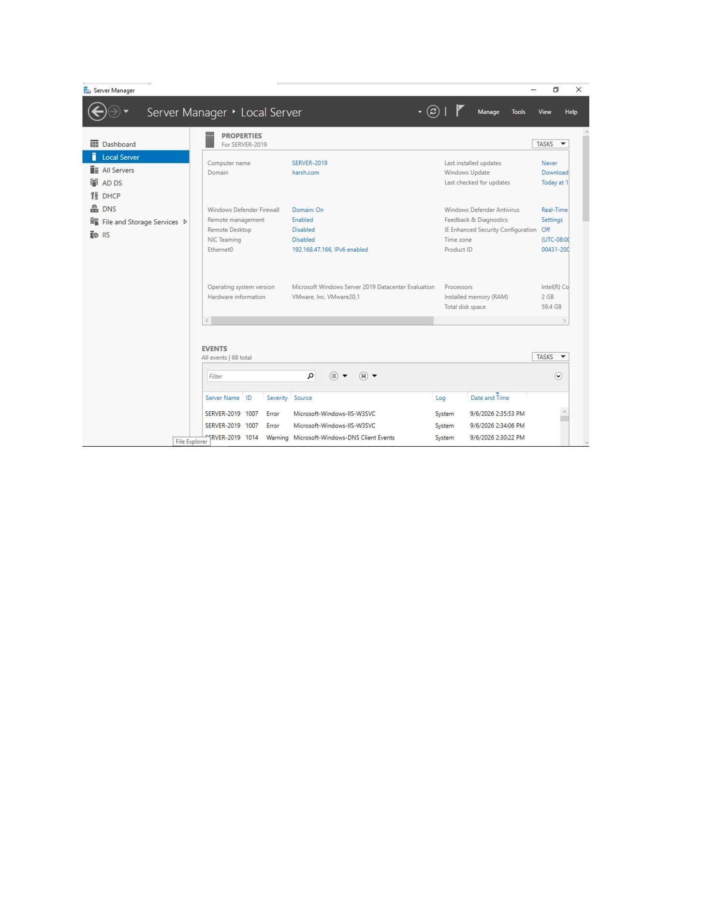
What I did: Opened the website from the browser to test the IIS site.

PAGE 185 — WEB SERVER (IIS)
Topic: Web Server (IIS)
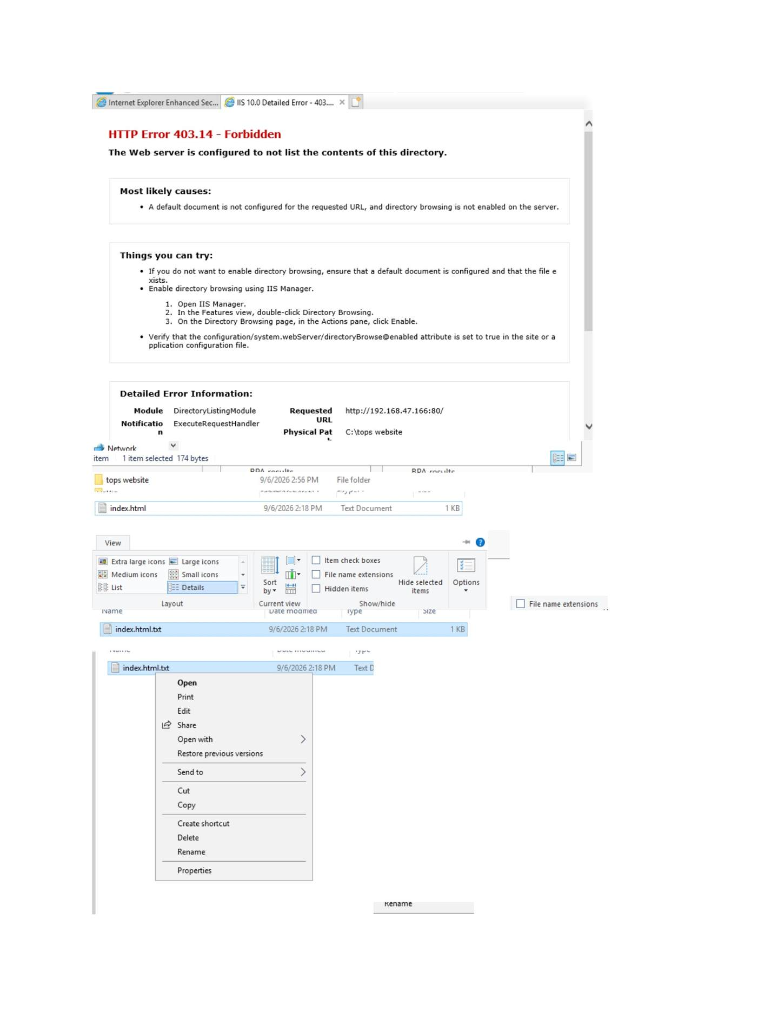
What I did: Observed the IIS 403.14 result while testing the site configuration.

PAGE 186 — WEB SERVER (IIS)
Topic: Web Server (IIS)
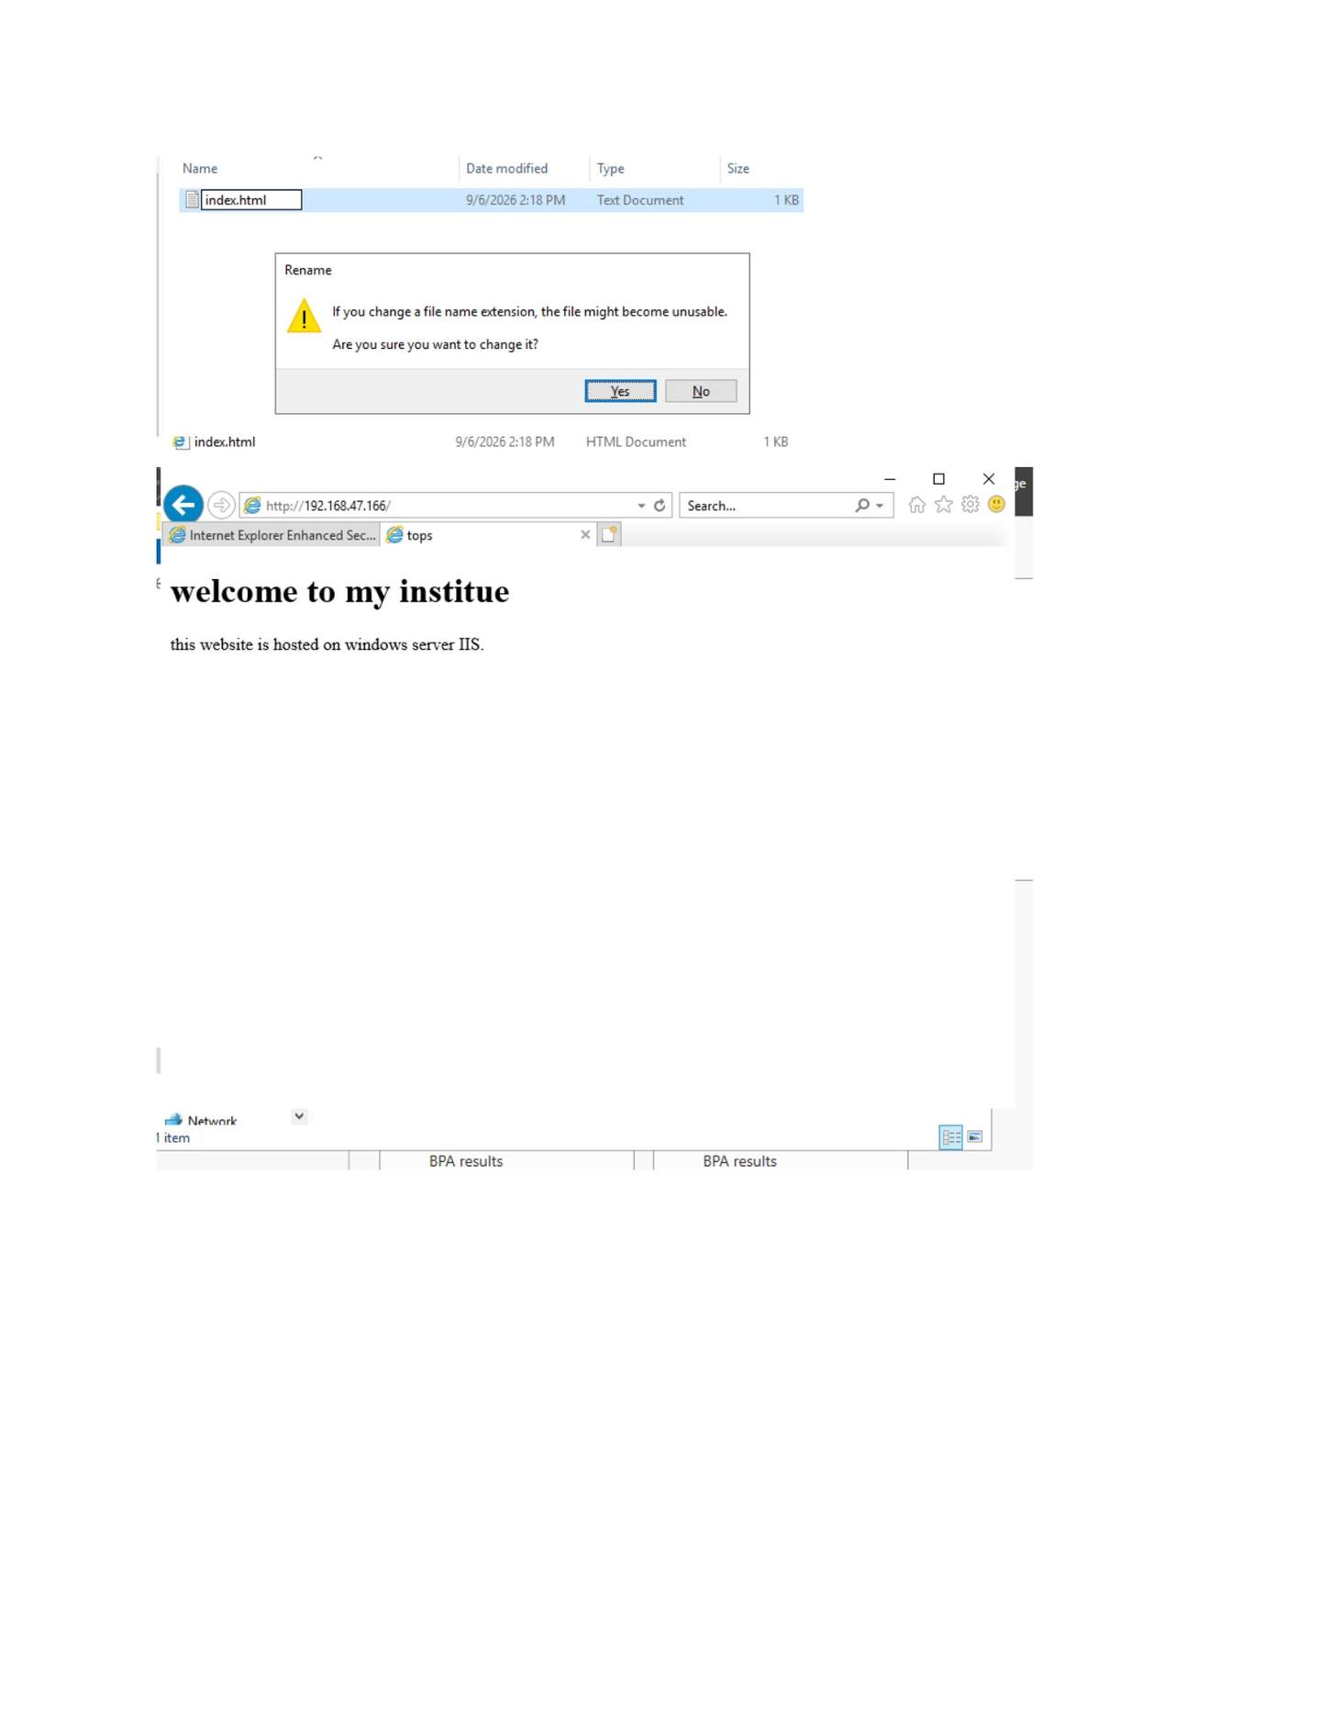
What I did: Adjusted/completed the IIS website content/configuration and verified the custom web page was displayed.

PAGE 187 — WEB SERVER (IIS / FTP)
Topic: Web Server (IIS / FTP)
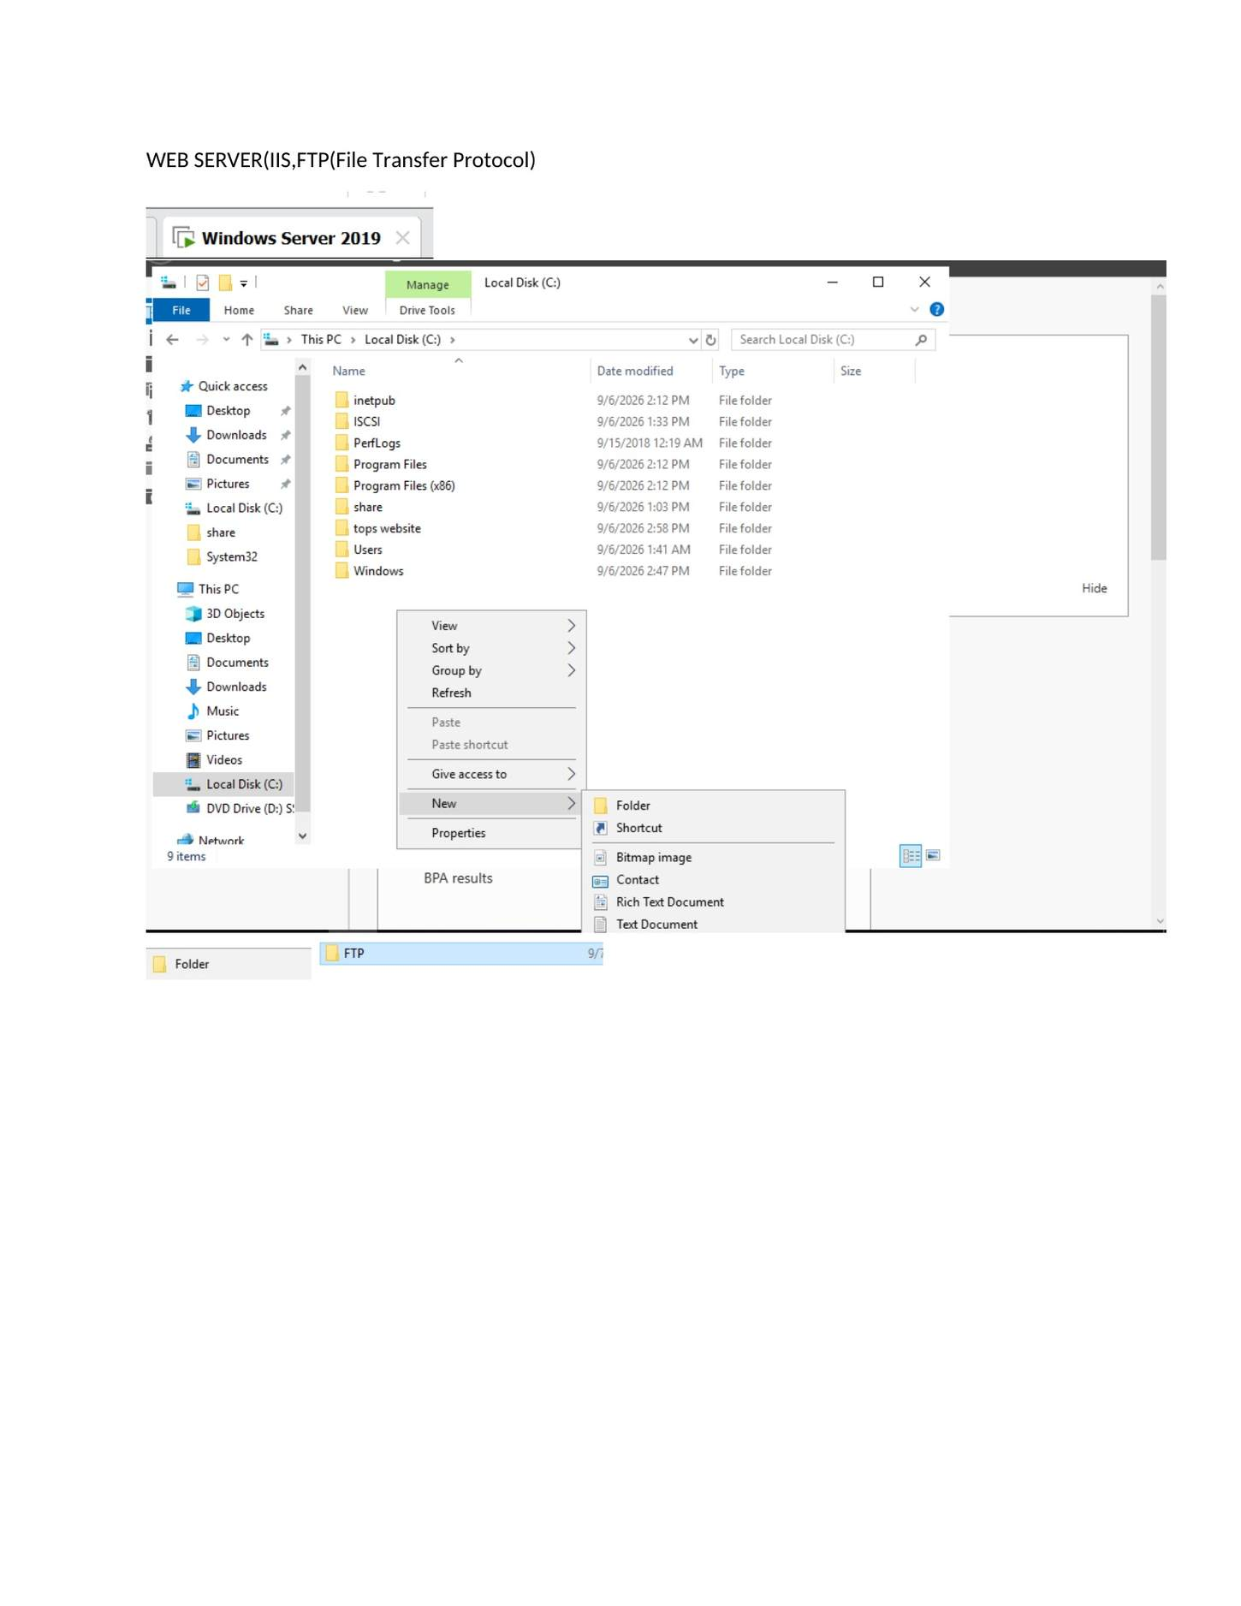
What I did: Opened the FTP section of the IIS/FTP practical and prepared the FTP root folder.

PAGE 188 — WEB SERVER (IIS / FTP)
Topic: Web Server (IIS / FTP)
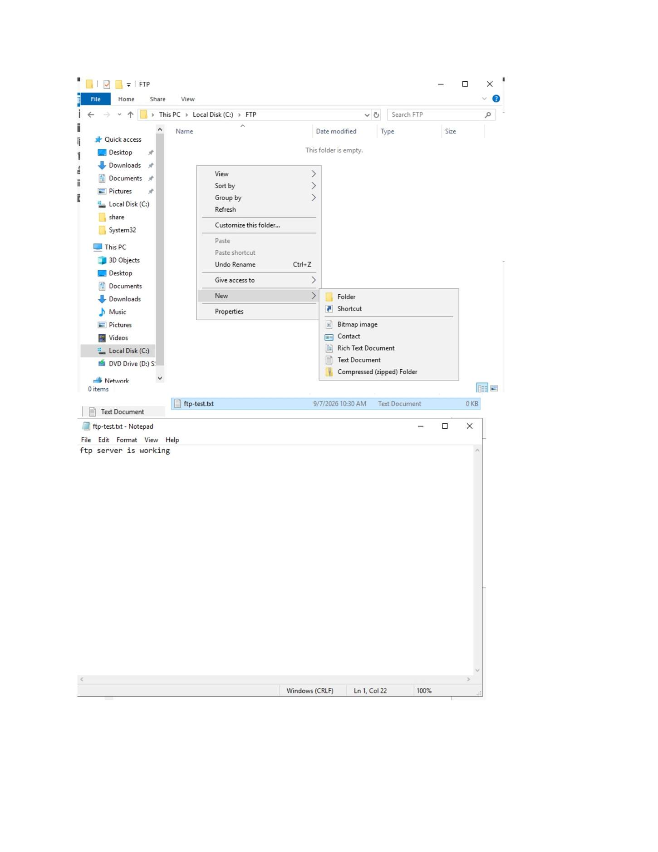
What I did: Created/opened the folder that would be used as the FTP root.

PAGE 189 — WEB SERVER (IIS / FTP)
Topic: Web Server (IIS / FTP)
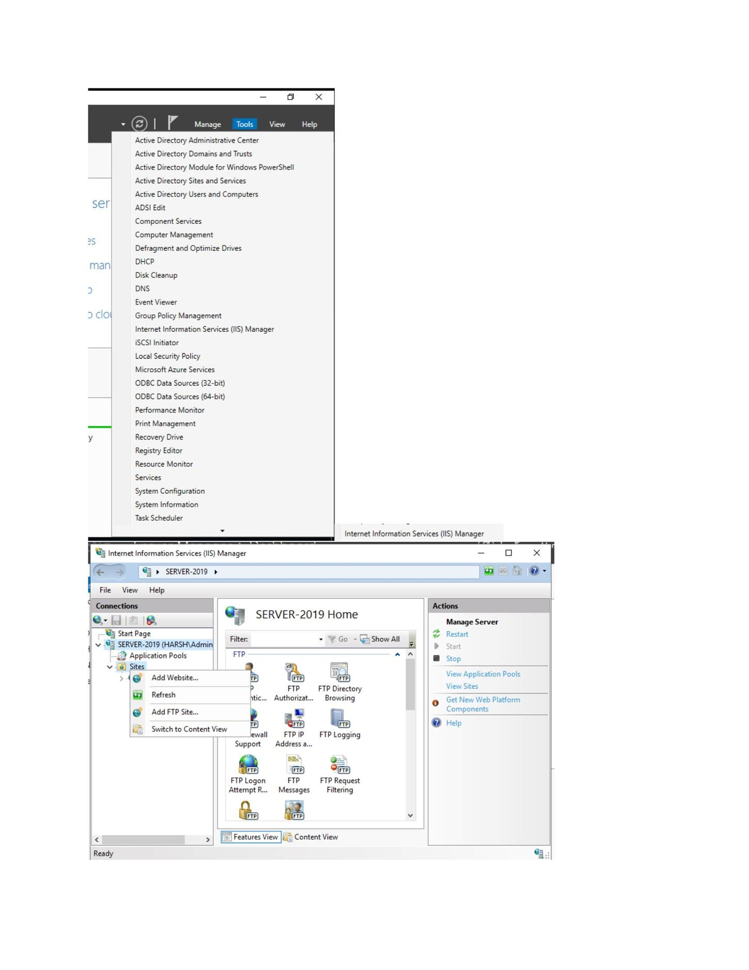
What I did: Opened IIS/administrative tools to configure the FTP service.

PAGE 190 — WEB SERVER (IIS / FTP)
Topic: Web Server (IIS / FTP)
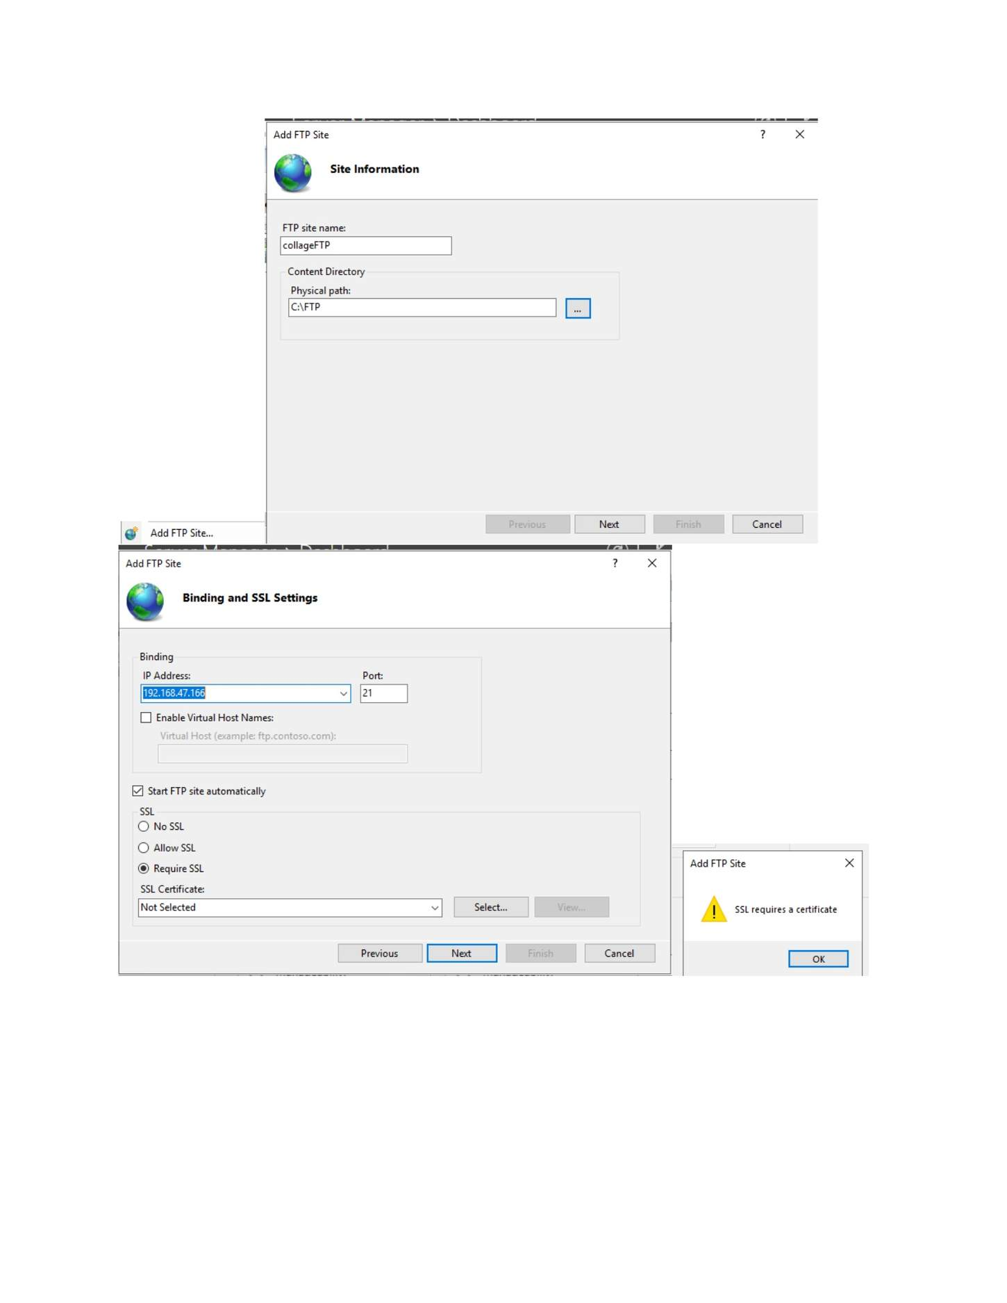
What I did: Started configuring the FTP site and its basic settings.

PAGE 191 — WEB SERVER (IIS / FTP)
Topic: Web Server (IIS / FTP)
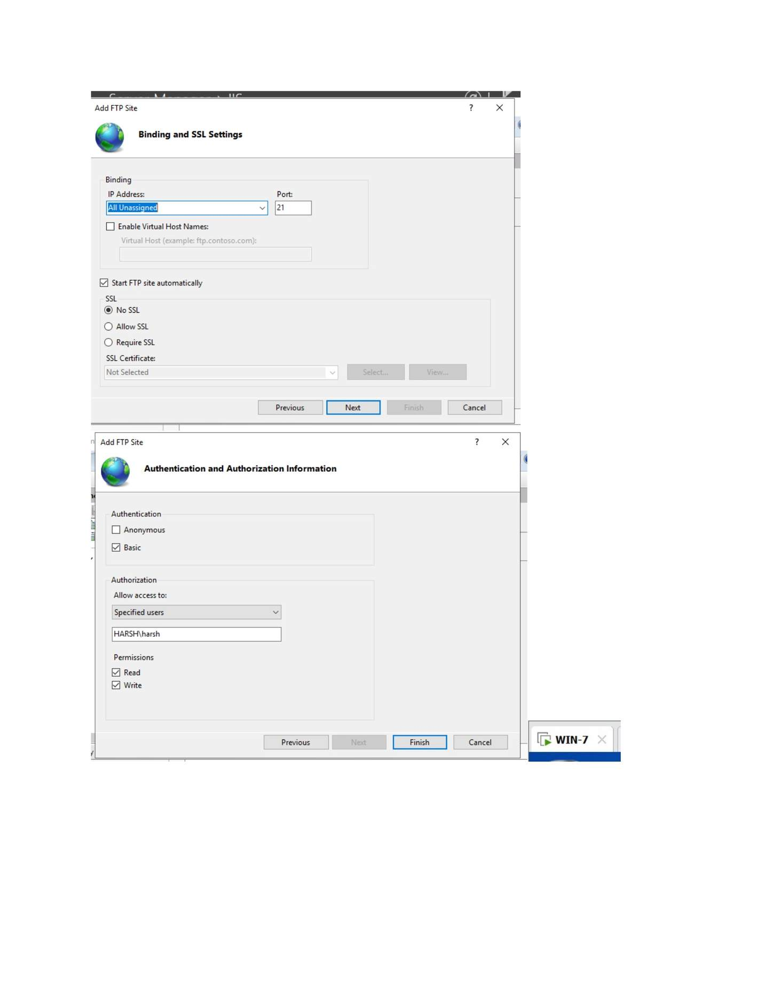
What I did: Configured the FTP site binding and authentication settings.

PAGE 192 — WEB SERVER (IIS / FTP)
Topic: Web Server (IIS / FTP)
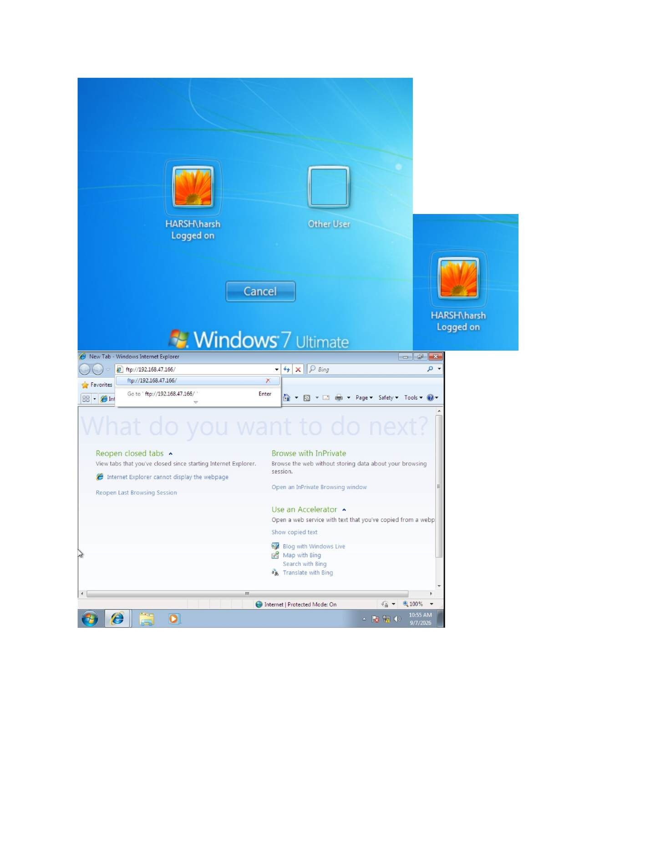
What I did: Configured FTP authorization rules for the required access.

PAGE 193 — WEB SERVER (IIS / FTP)
Topic: Web Server (IIS / FTP)
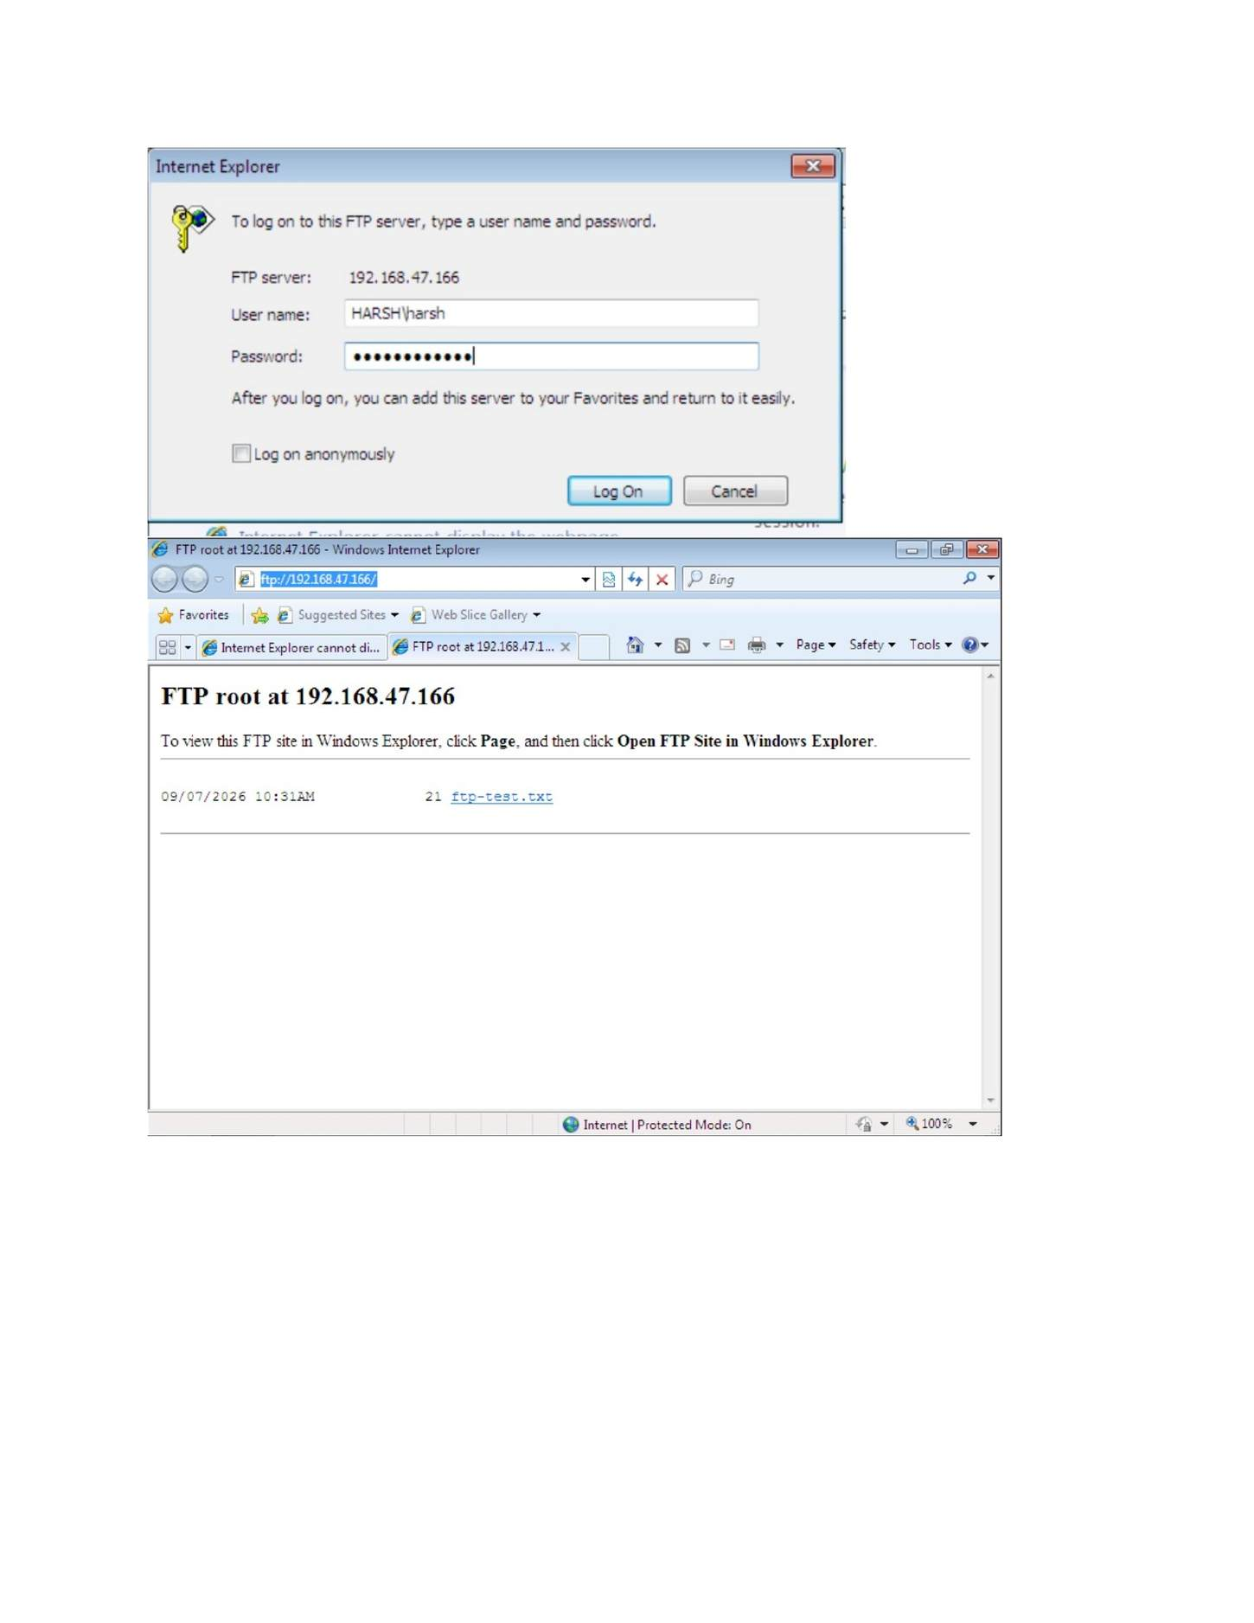
What I did: Tested the FTP service from the Windows client/browser.

PAGE 194 — WEB SERVER (IIS / FTP)
Topic: Web Server (IIS / FTP)
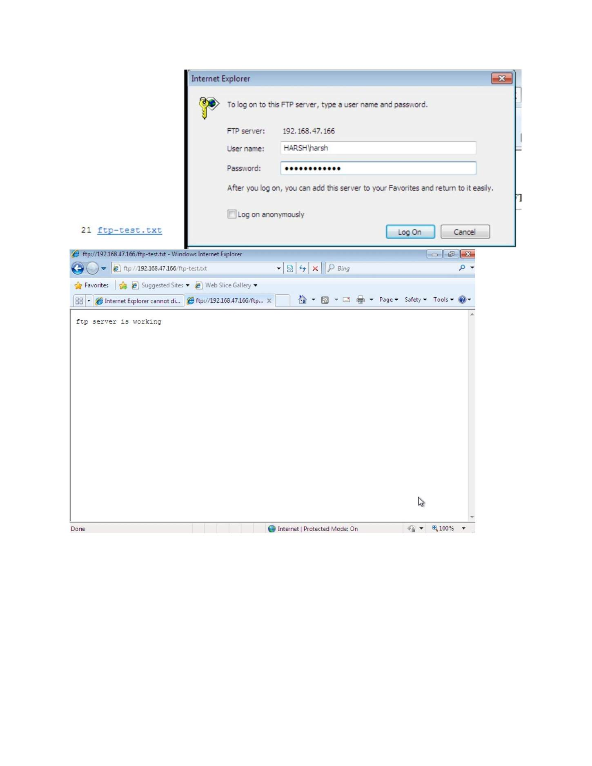
What I did: Entered the FTP server address and credentials to log in to the FTP server.

PAGE 195 — WDS (WINDOWS DEPLOYMENT SERVICES)
Topic: WDS (Windows Deployment Services)
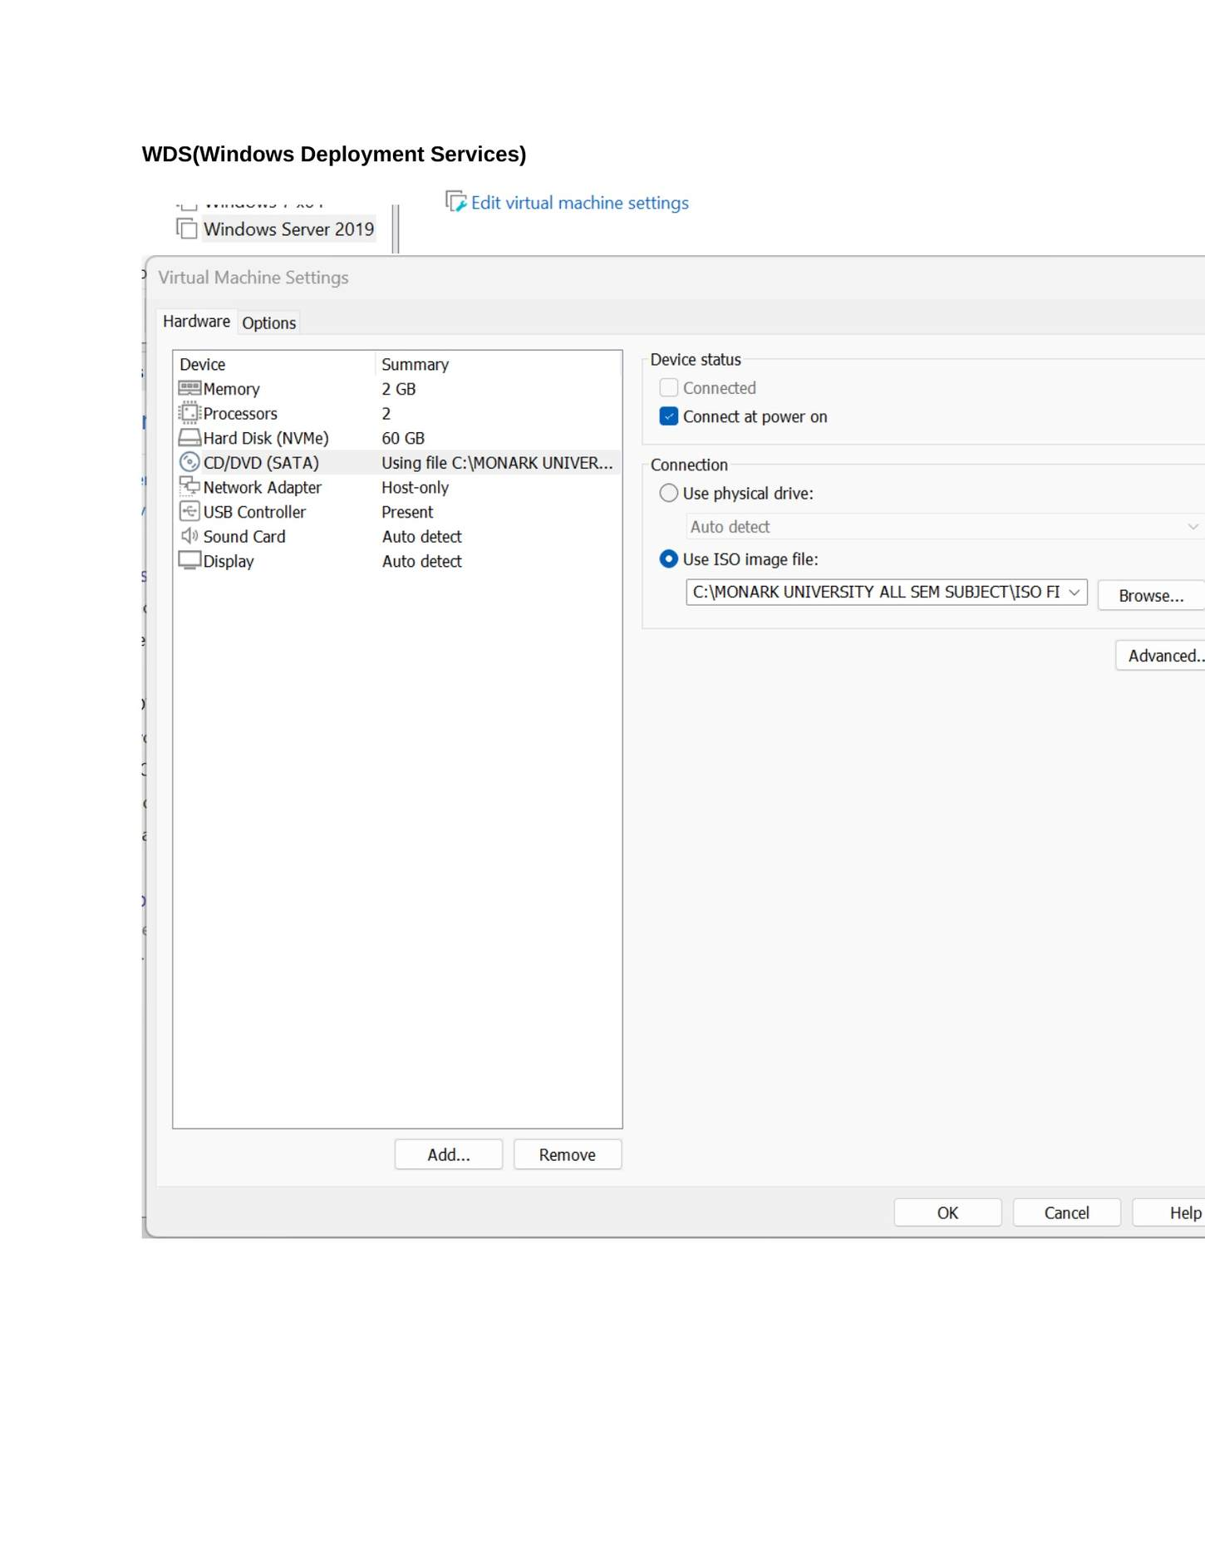
What I did: Opened the Windows Server VM settings and reviewed the WDS server hardware configuration.

PAGE 196 — WDS (WINDOWS DEPLOYMENT SERVICES)
Topic: WDS (Windows Deployment Services)
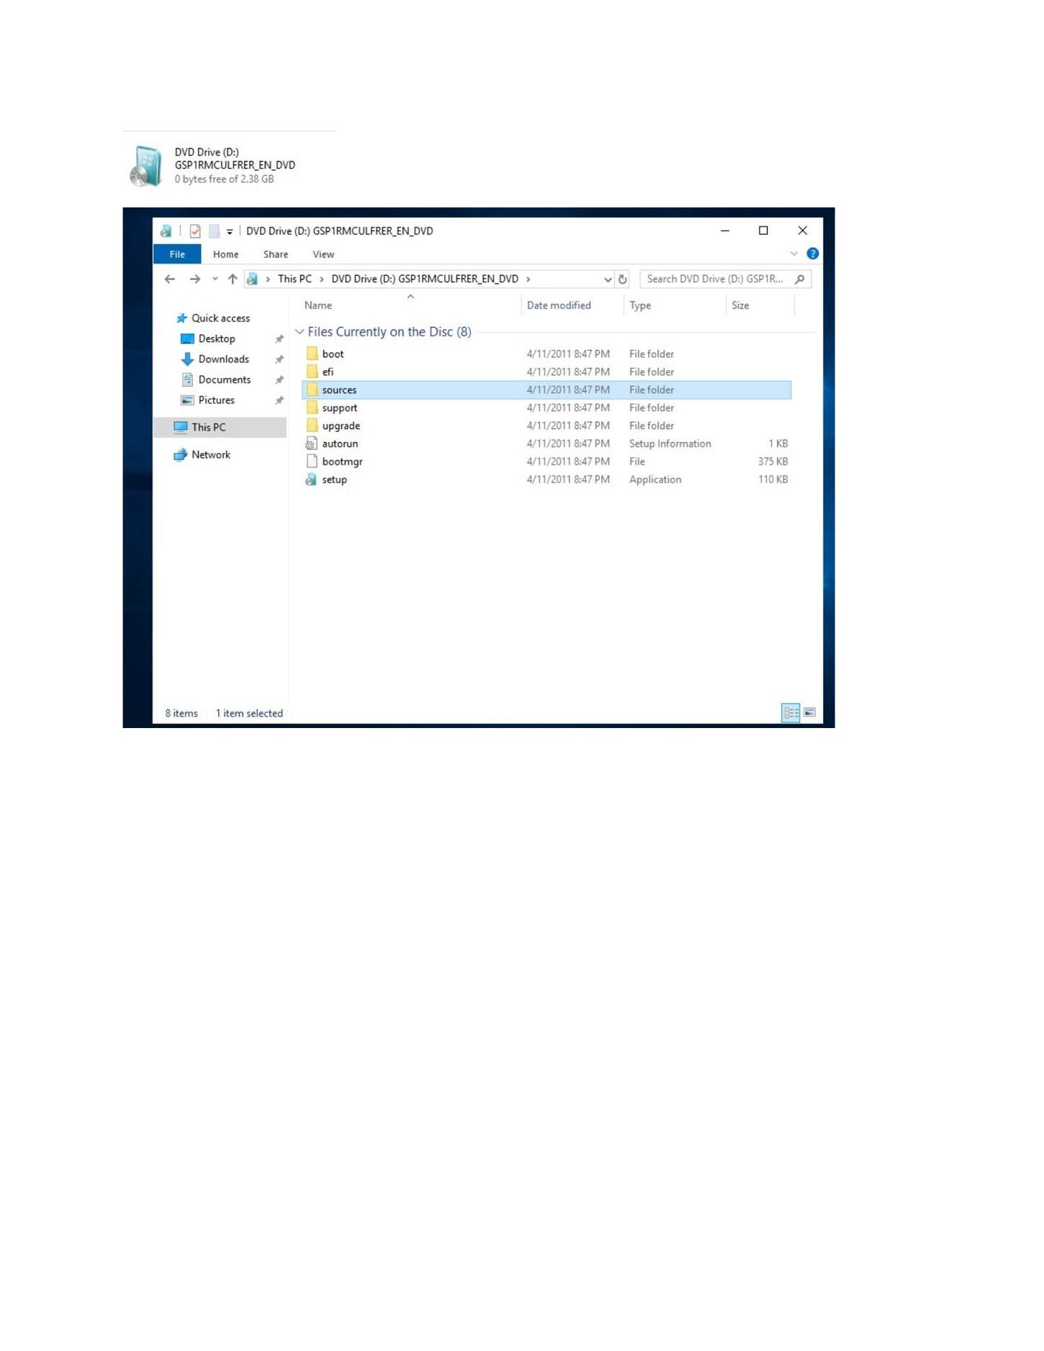
What I did: Opened the Windows installation DVD/media folder that would be used by WDS.

PAGE 197 — WDS (WINDOWS DEPLOYMENT SERVICES)
Topic: WDS (Windows Deployment Services)
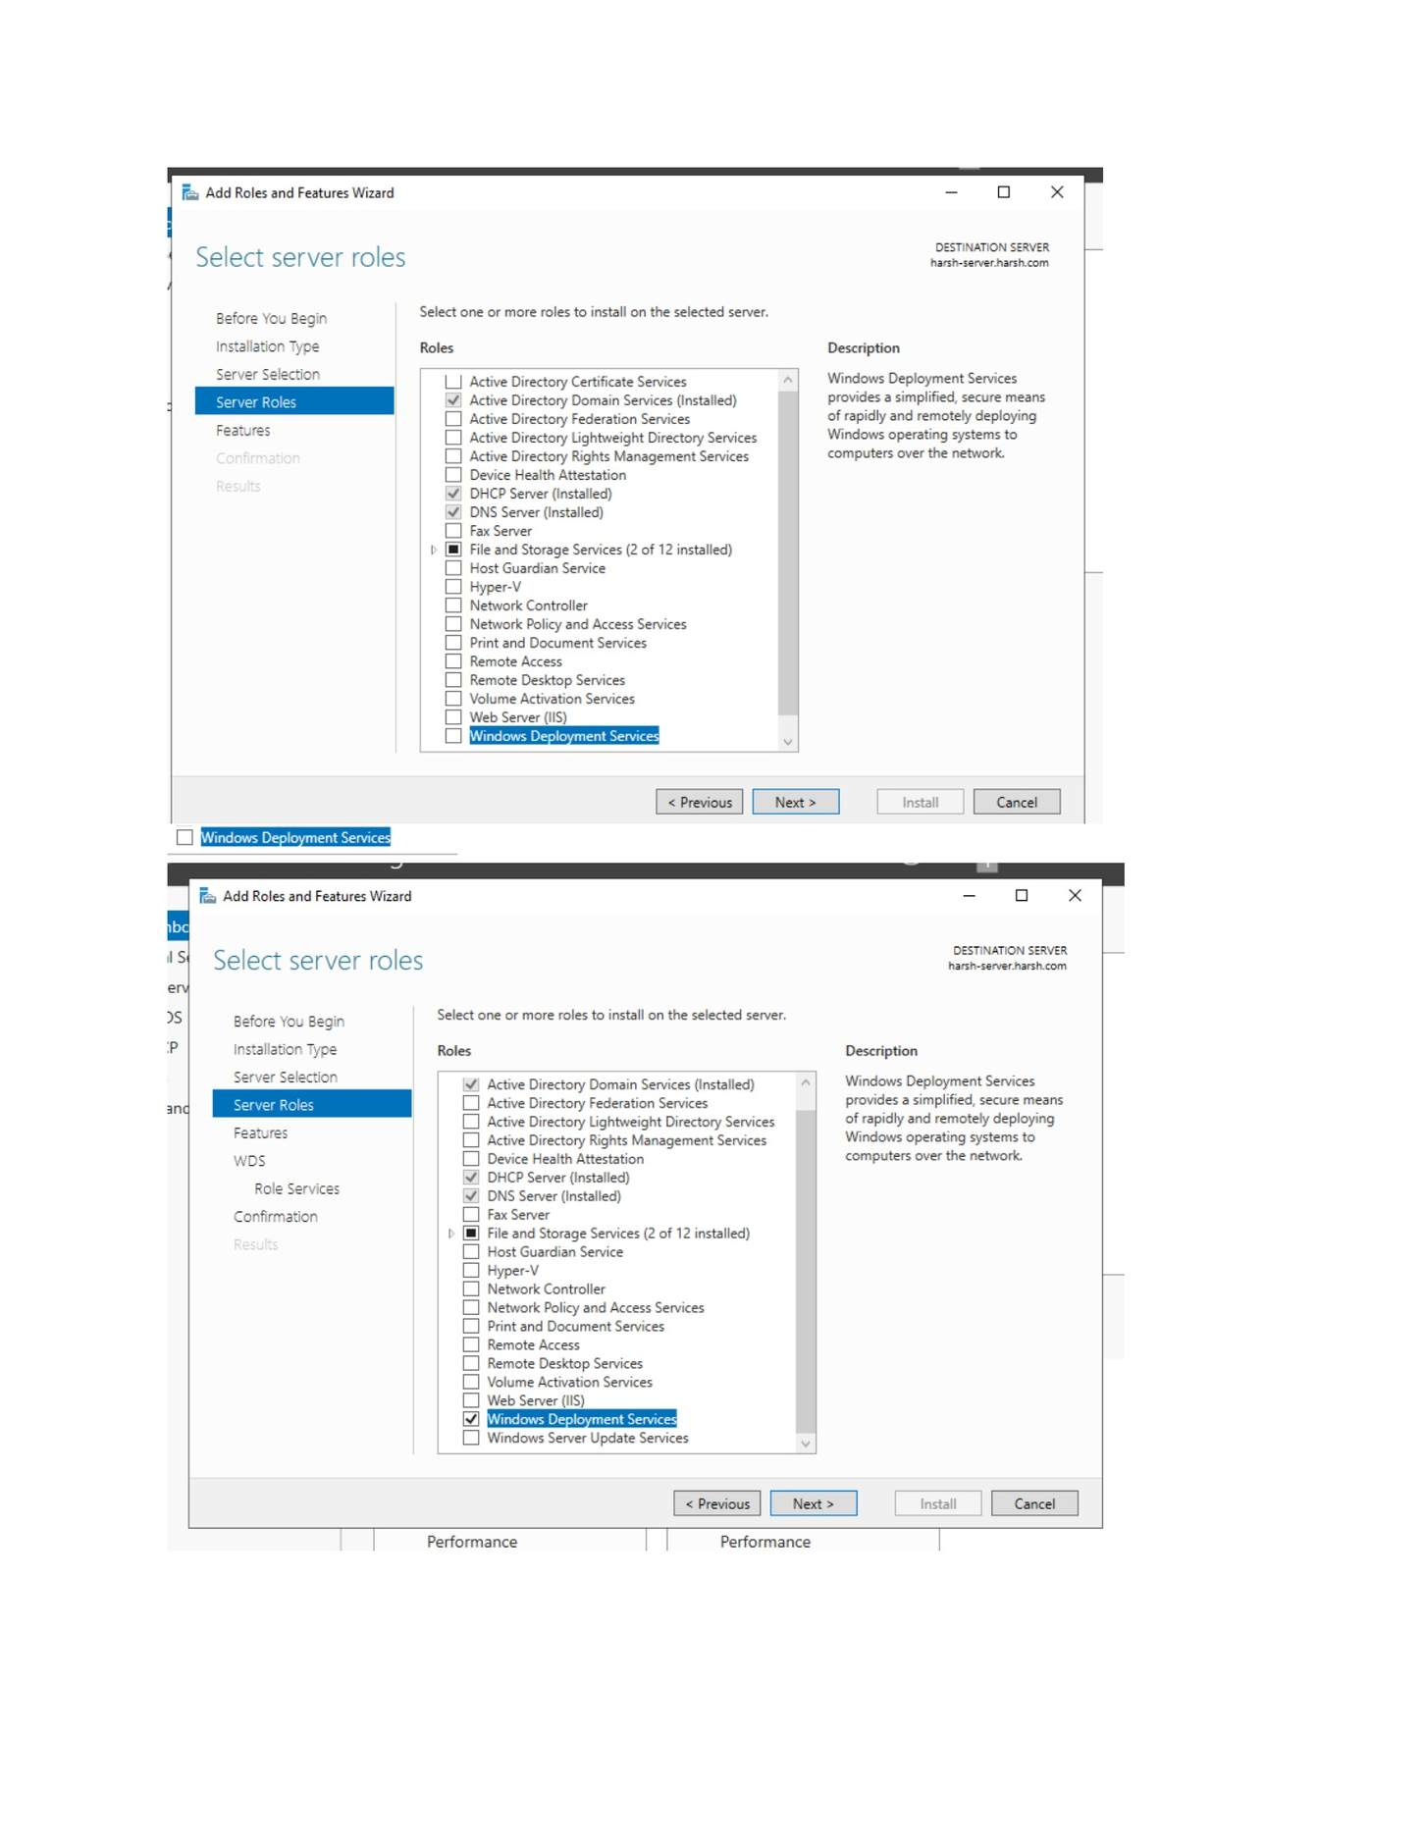
What I did: Started the Add Roles and Features wizard and selected Windows Deployment Services.

PAGE 198 — WDS (WINDOWS DEPLOYMENT SERVICES)
Topic: WDS (Windows Deployment Services)
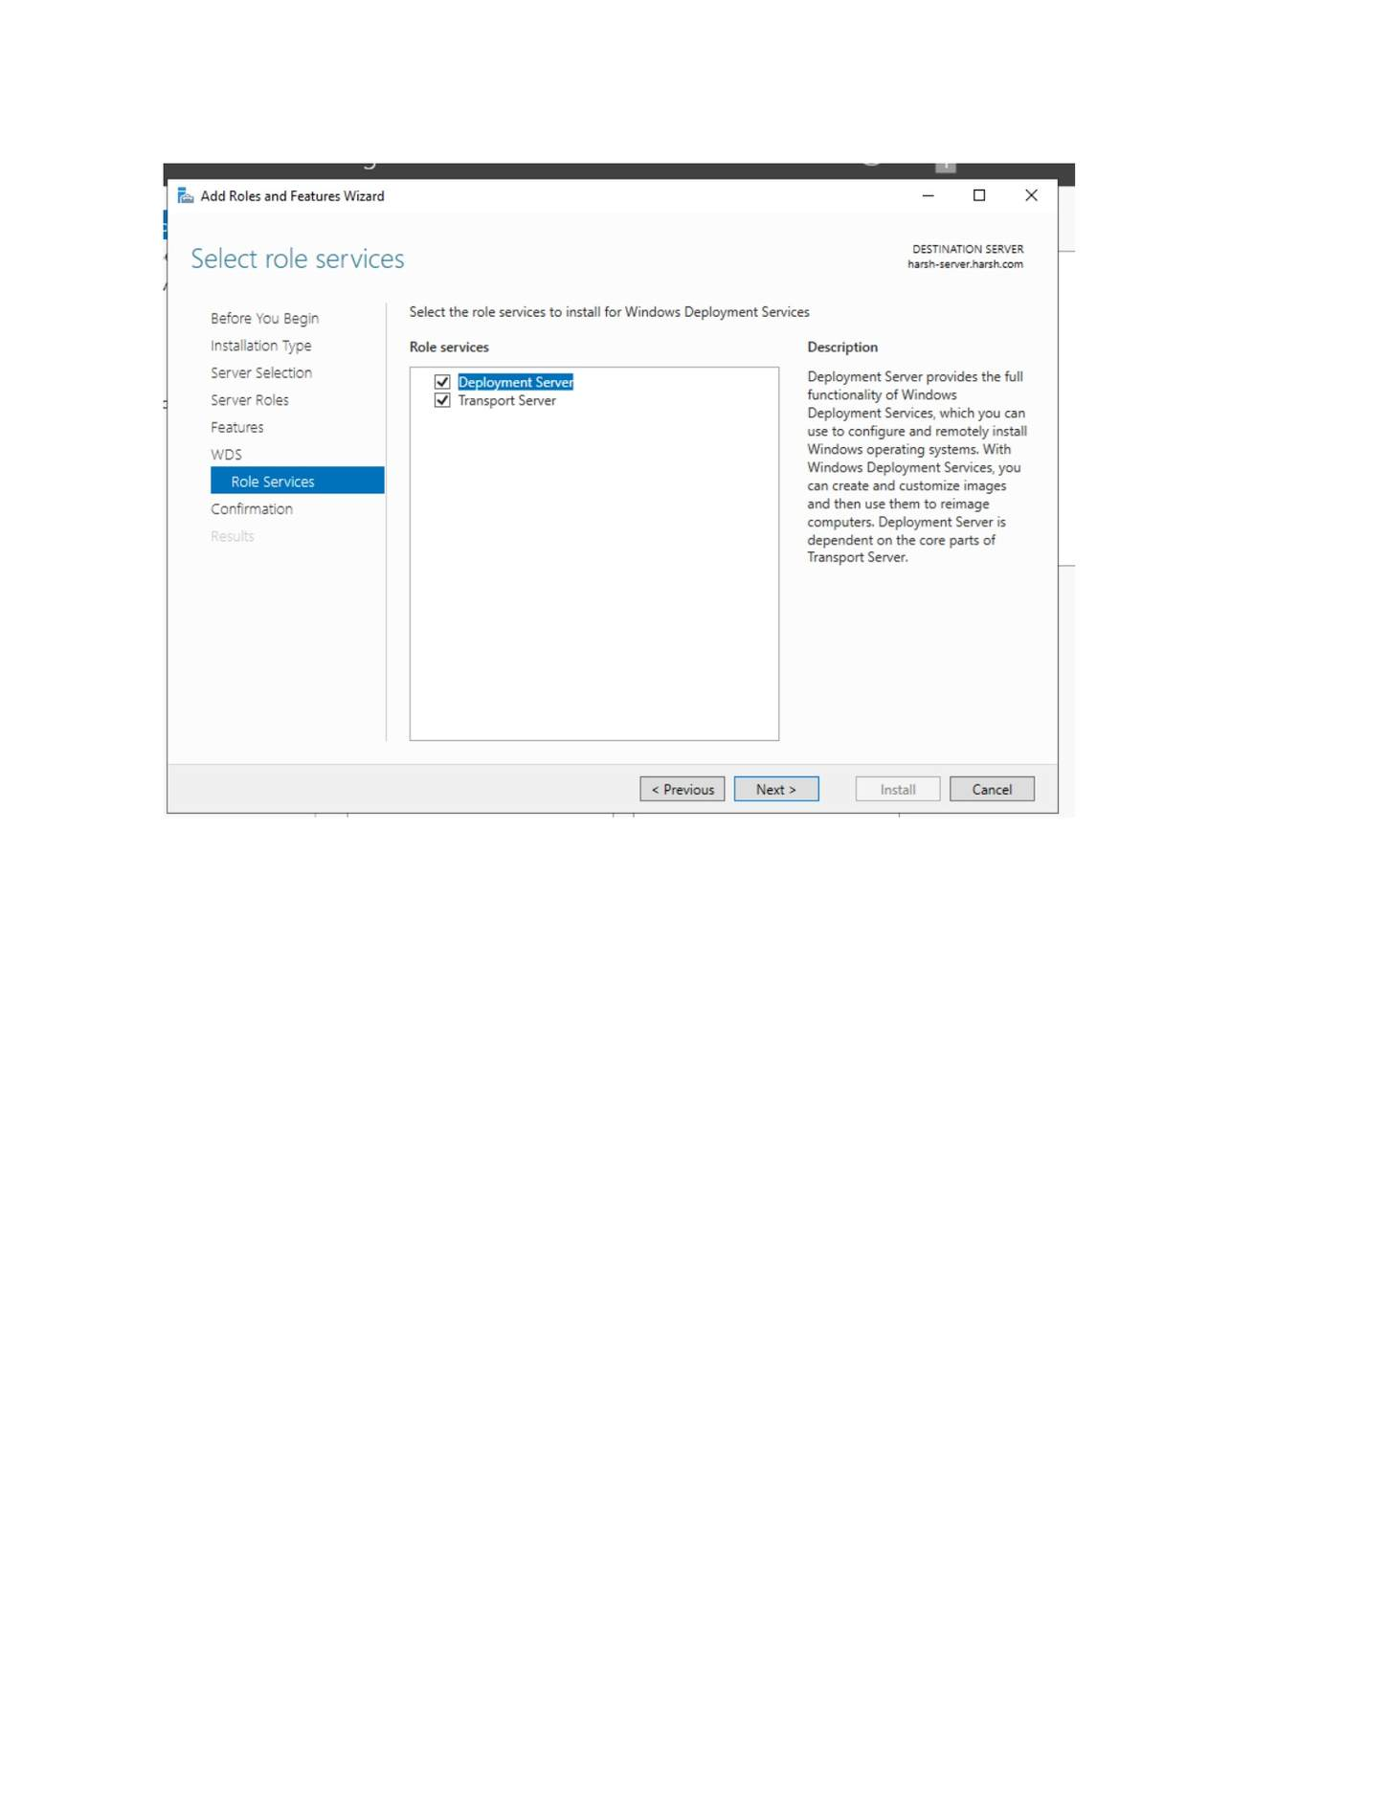
What I did: Selected the WDS role services required for deployment.

PAGE 199 — WDS (WINDOWS DEPLOYMENT SERVICES)
Topic: WDS (Windows Deployment Services)
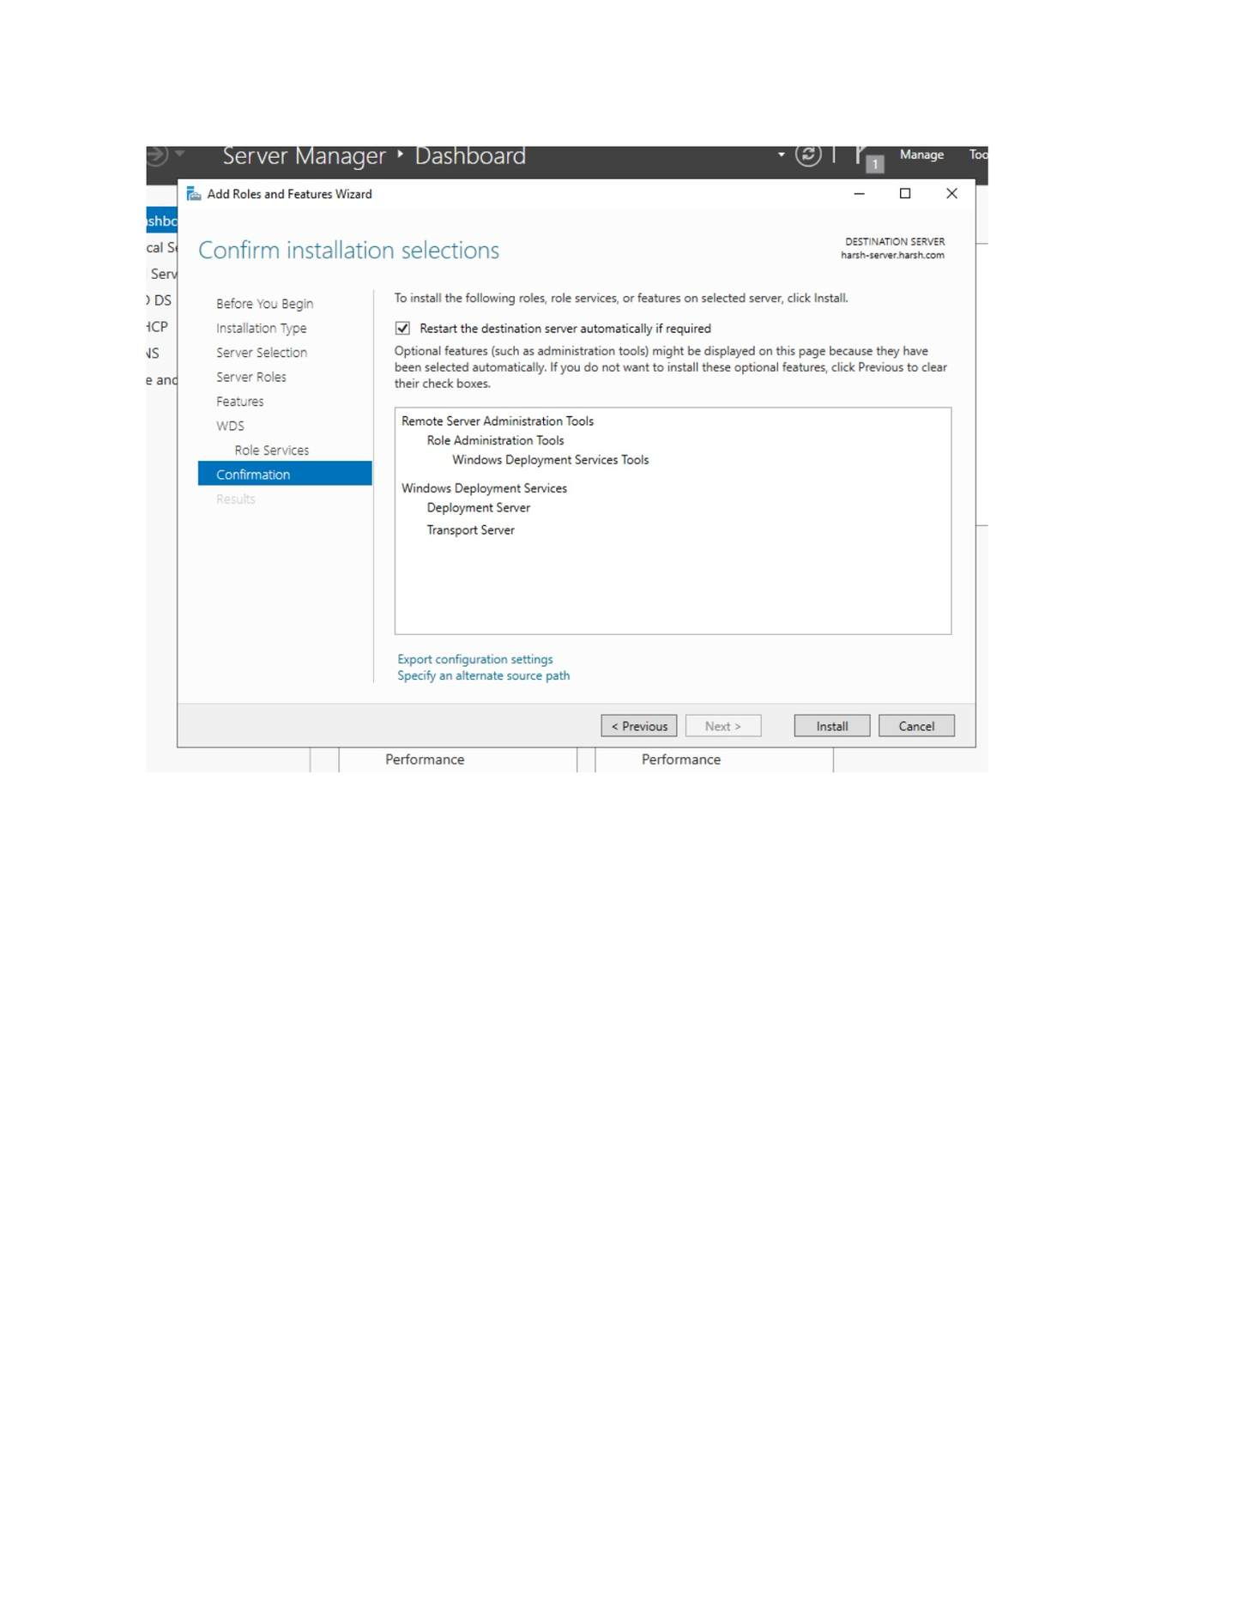
What I did: Confirmed the WDS installation selections.

PAGE 200 — WDS (WINDOWS DEPLOYMENT SERVICES)
Topic: WDS (Windows Deployment Services)
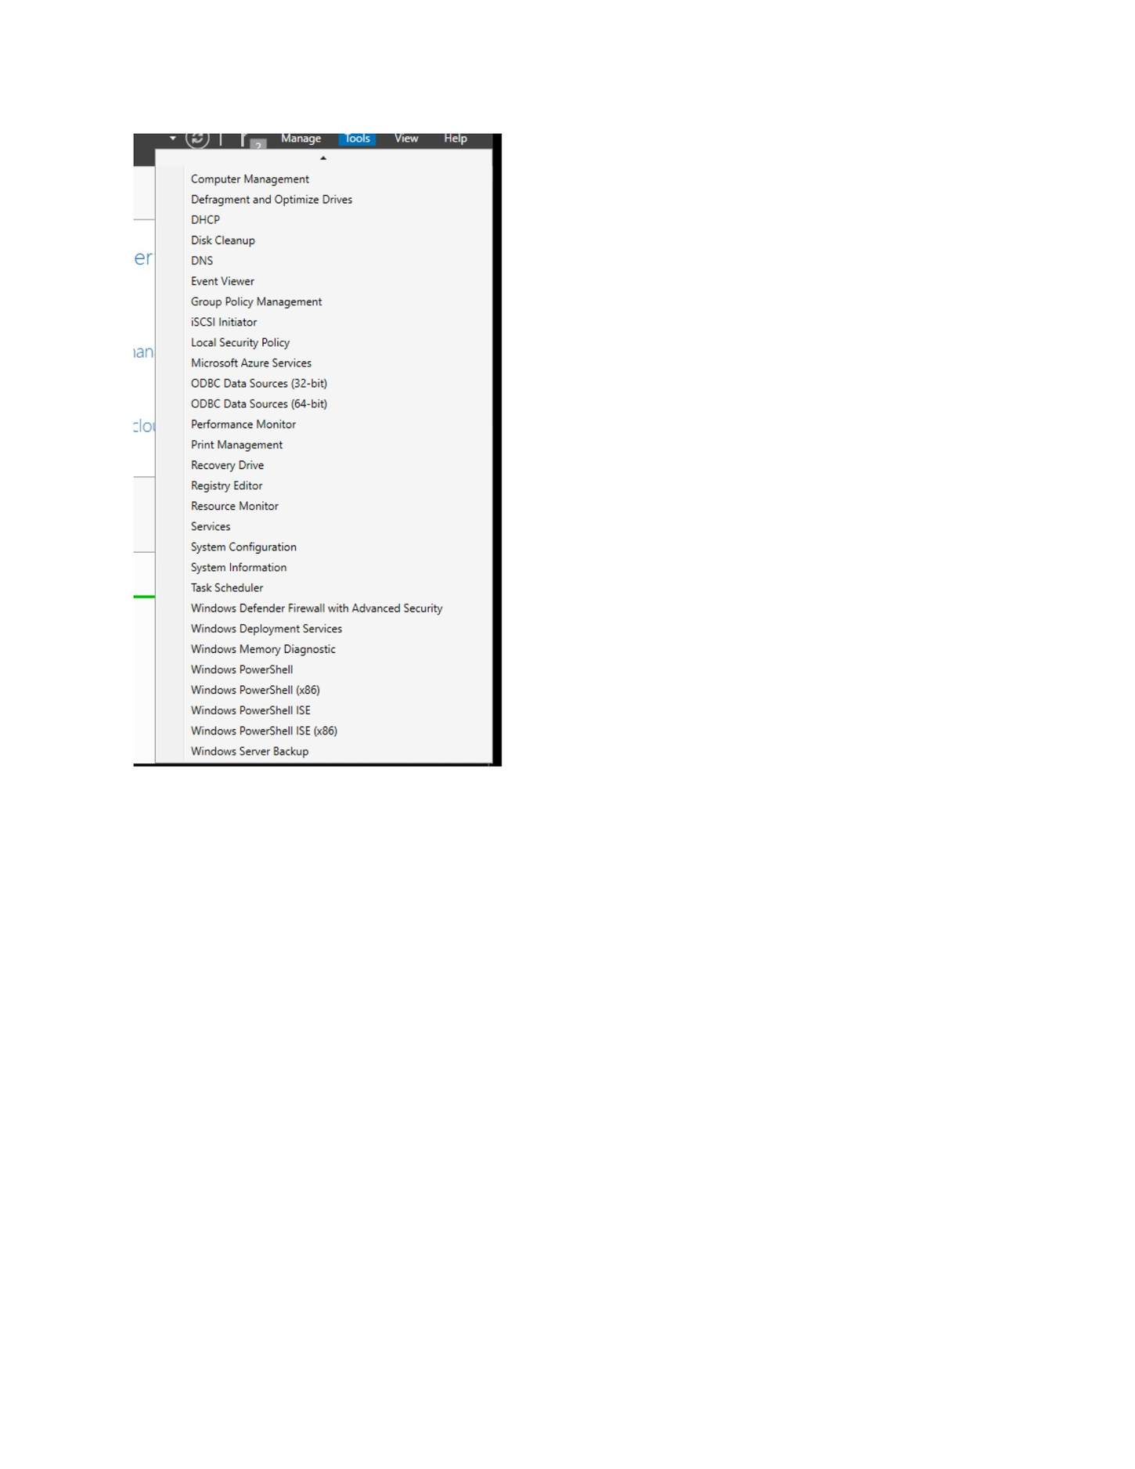
What I did: Opened the WDS management/administrative tools after installation.

PAGE 201 — WDS (WINDOWS DEPLOYMENT SERVICES)
Topic: WDS (Windows Deployment Services)
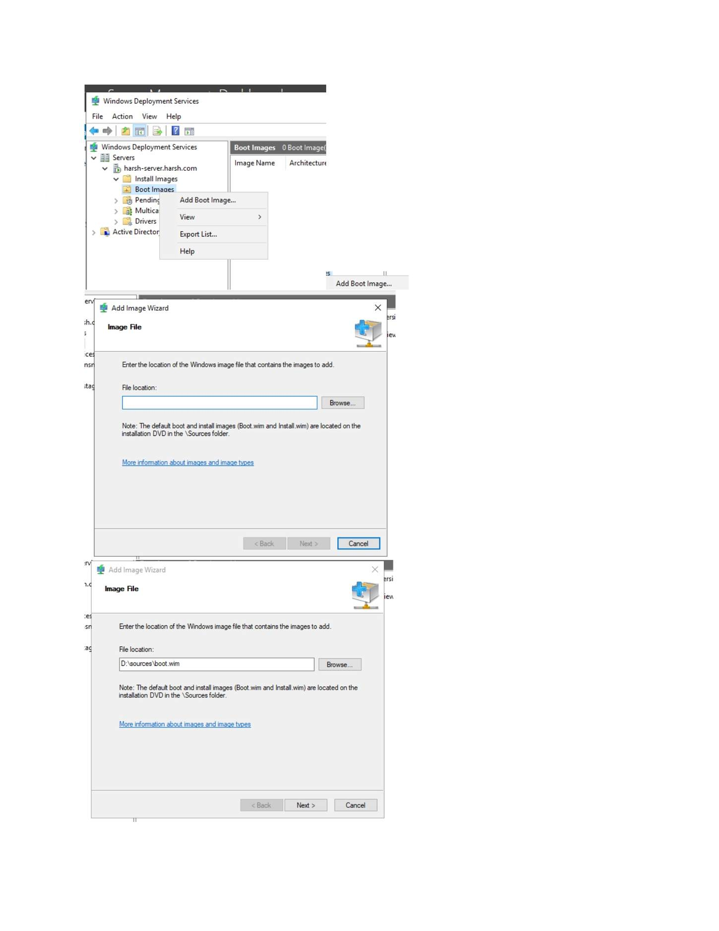
What I did: Opened the WDS server configuration and deployment options.

PAGE 202 — WDS (WINDOWS DEPLOYMENT SERVICES)
Topic: WDS (Windows Deployment Services)
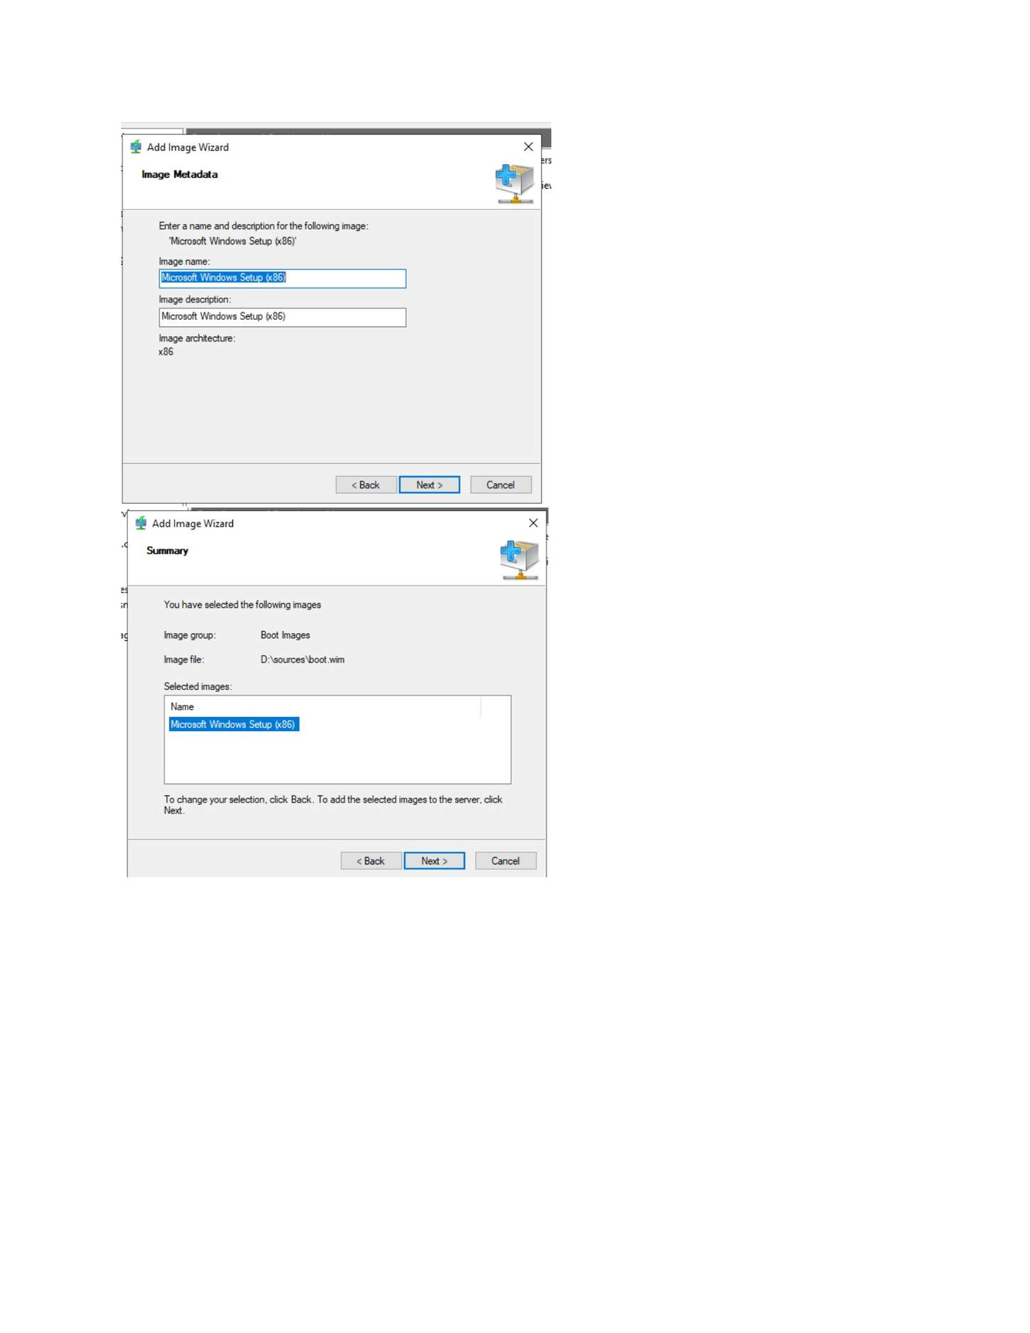
What I did: Started adding a Windows boot/install image in WDS.

PAGE 203 — WDS (WINDOWS DEPLOYMENT SERVICES)
Topic: WDS (Windows Deployment Services)
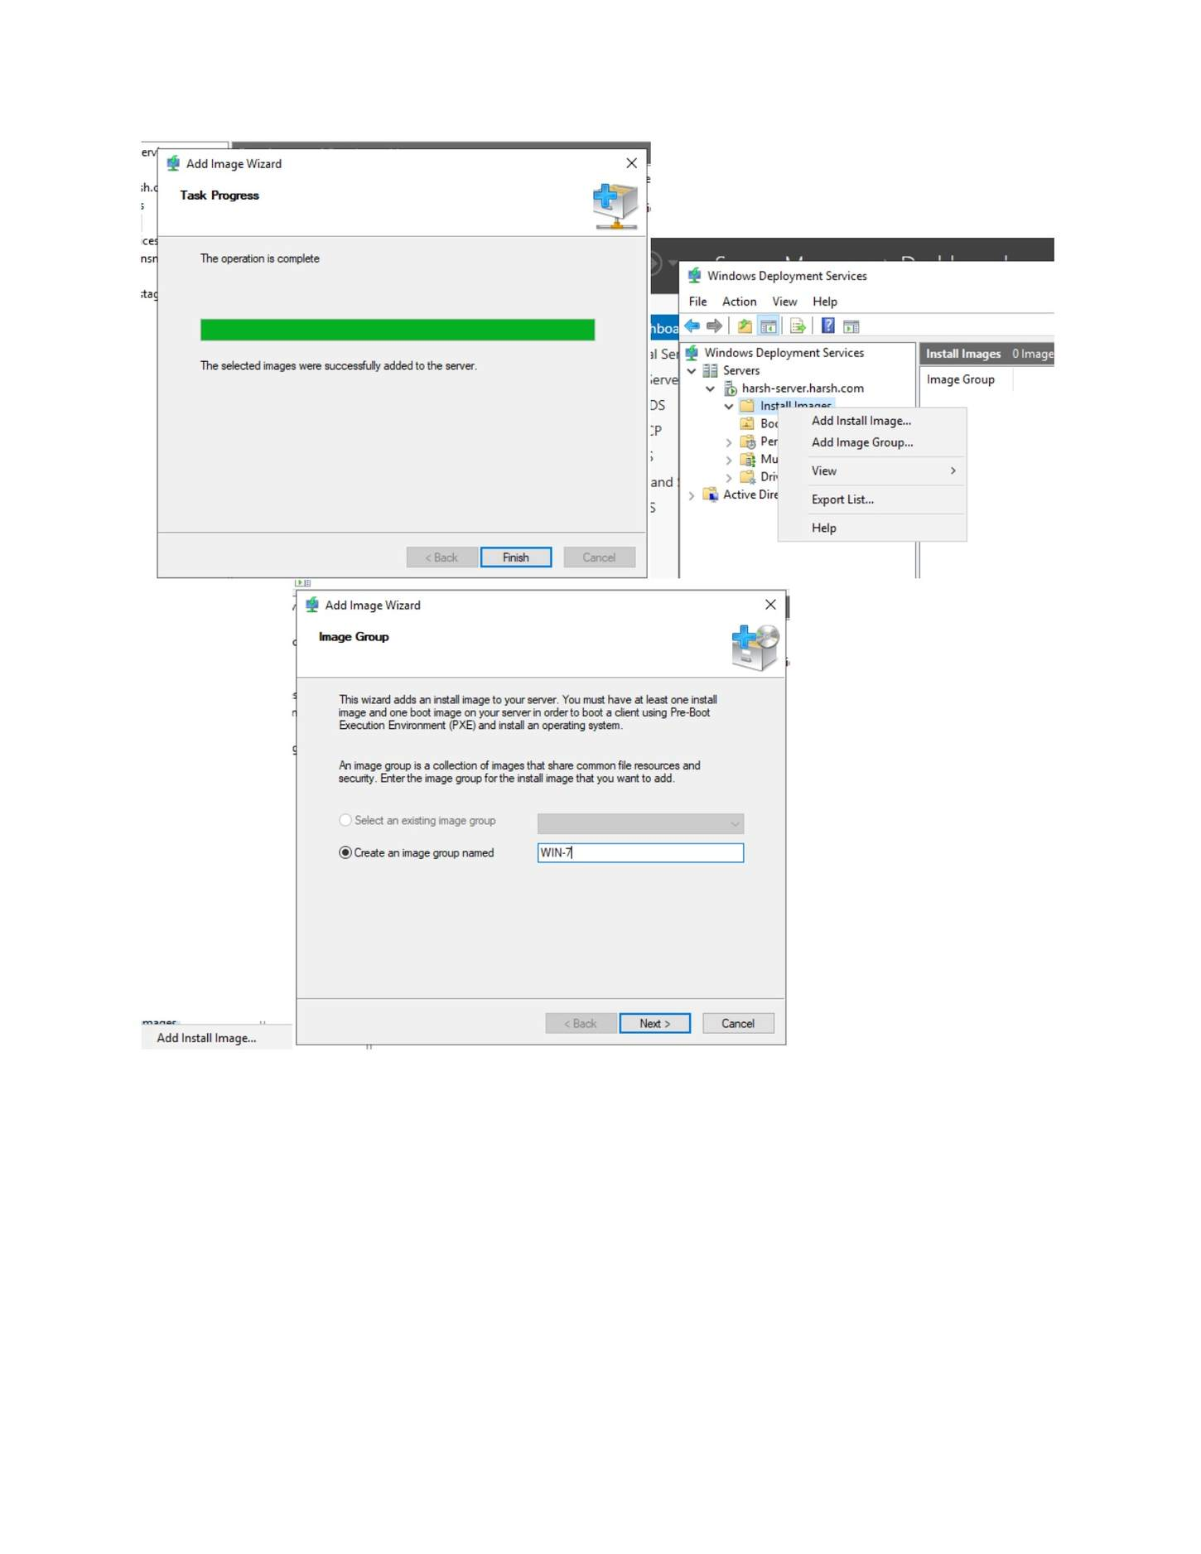
What I did: Created/selected the image group for the Windows image.

PAGE 204 — WDS (WINDOWS DEPLOYMENT SERVICES)
Topic: WDS (Windows Deployment Services)
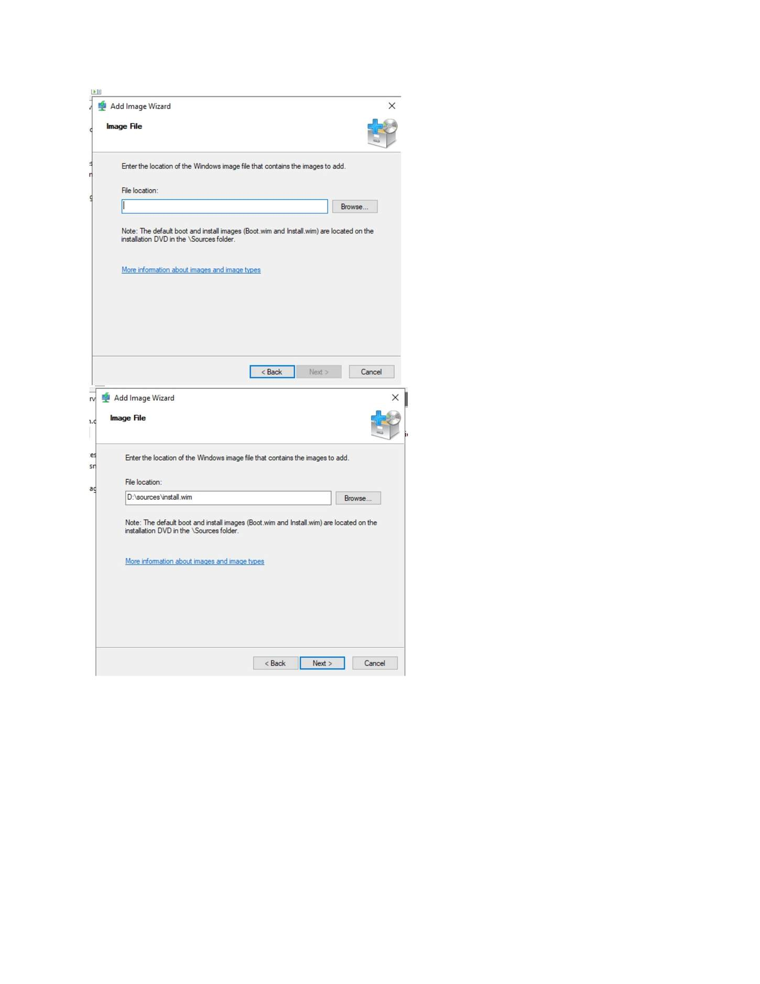
What I did: Opened the Add Image Wizard and selected the Windows installation image source.

PAGE 205 — WDS (WINDOWS DEPLOYMENT SERVICES)
Topic: WDS (Windows Deployment Services)
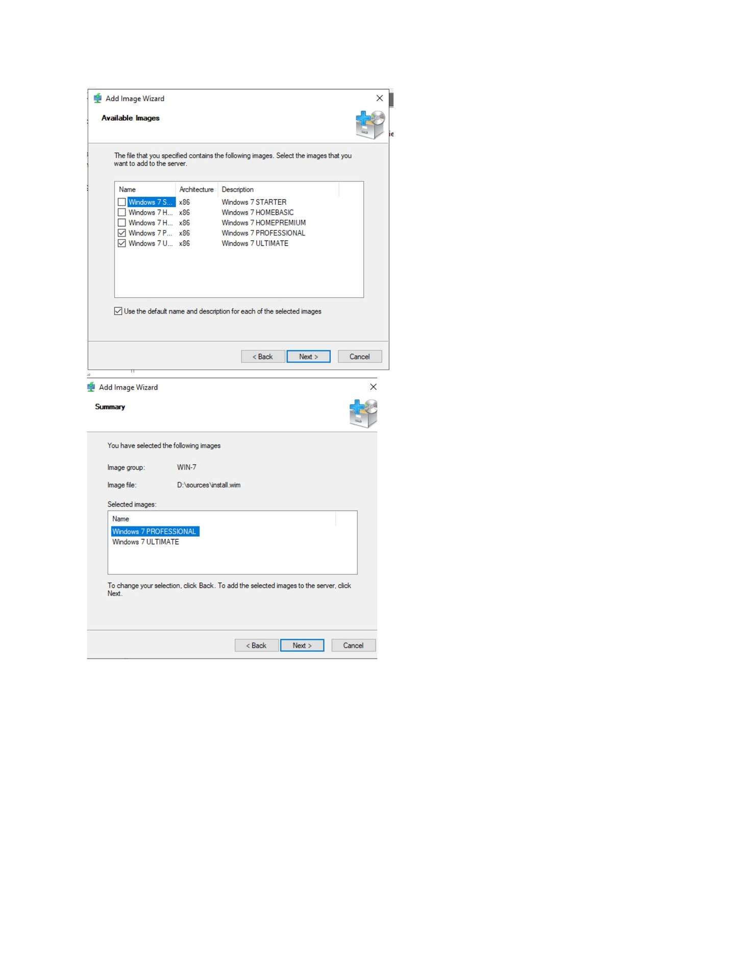
What I did: Selected the Windows image file from the installation media.

PAGE 206 — WDS (WINDOWS DEPLOYMENT SERVICES)
Topic: WDS (Windows Deployment Services)
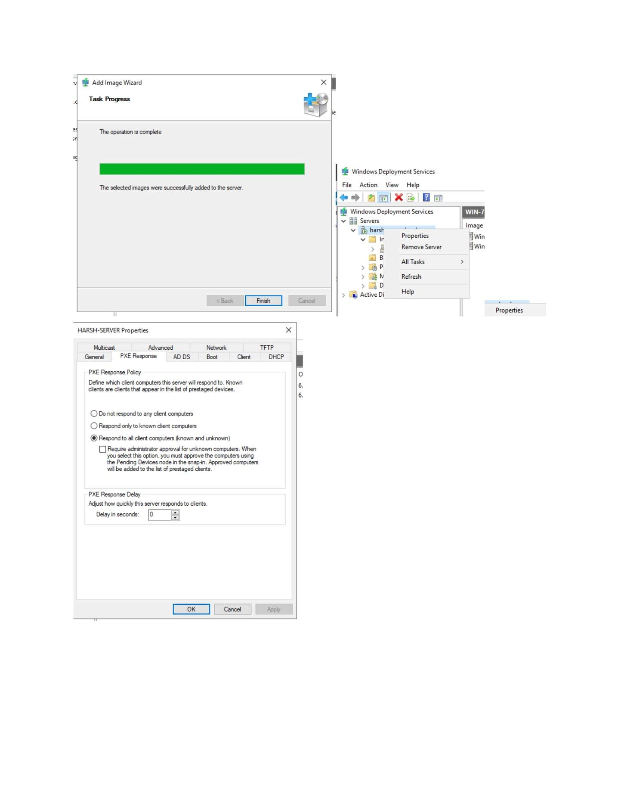
What I did: Entered/reviewed the Windows image name and description.

PAGE 207 — WDS (WINDOWS DEPLOYMENT SERVICES)
Topic: WDS (Windows Deployment Services)
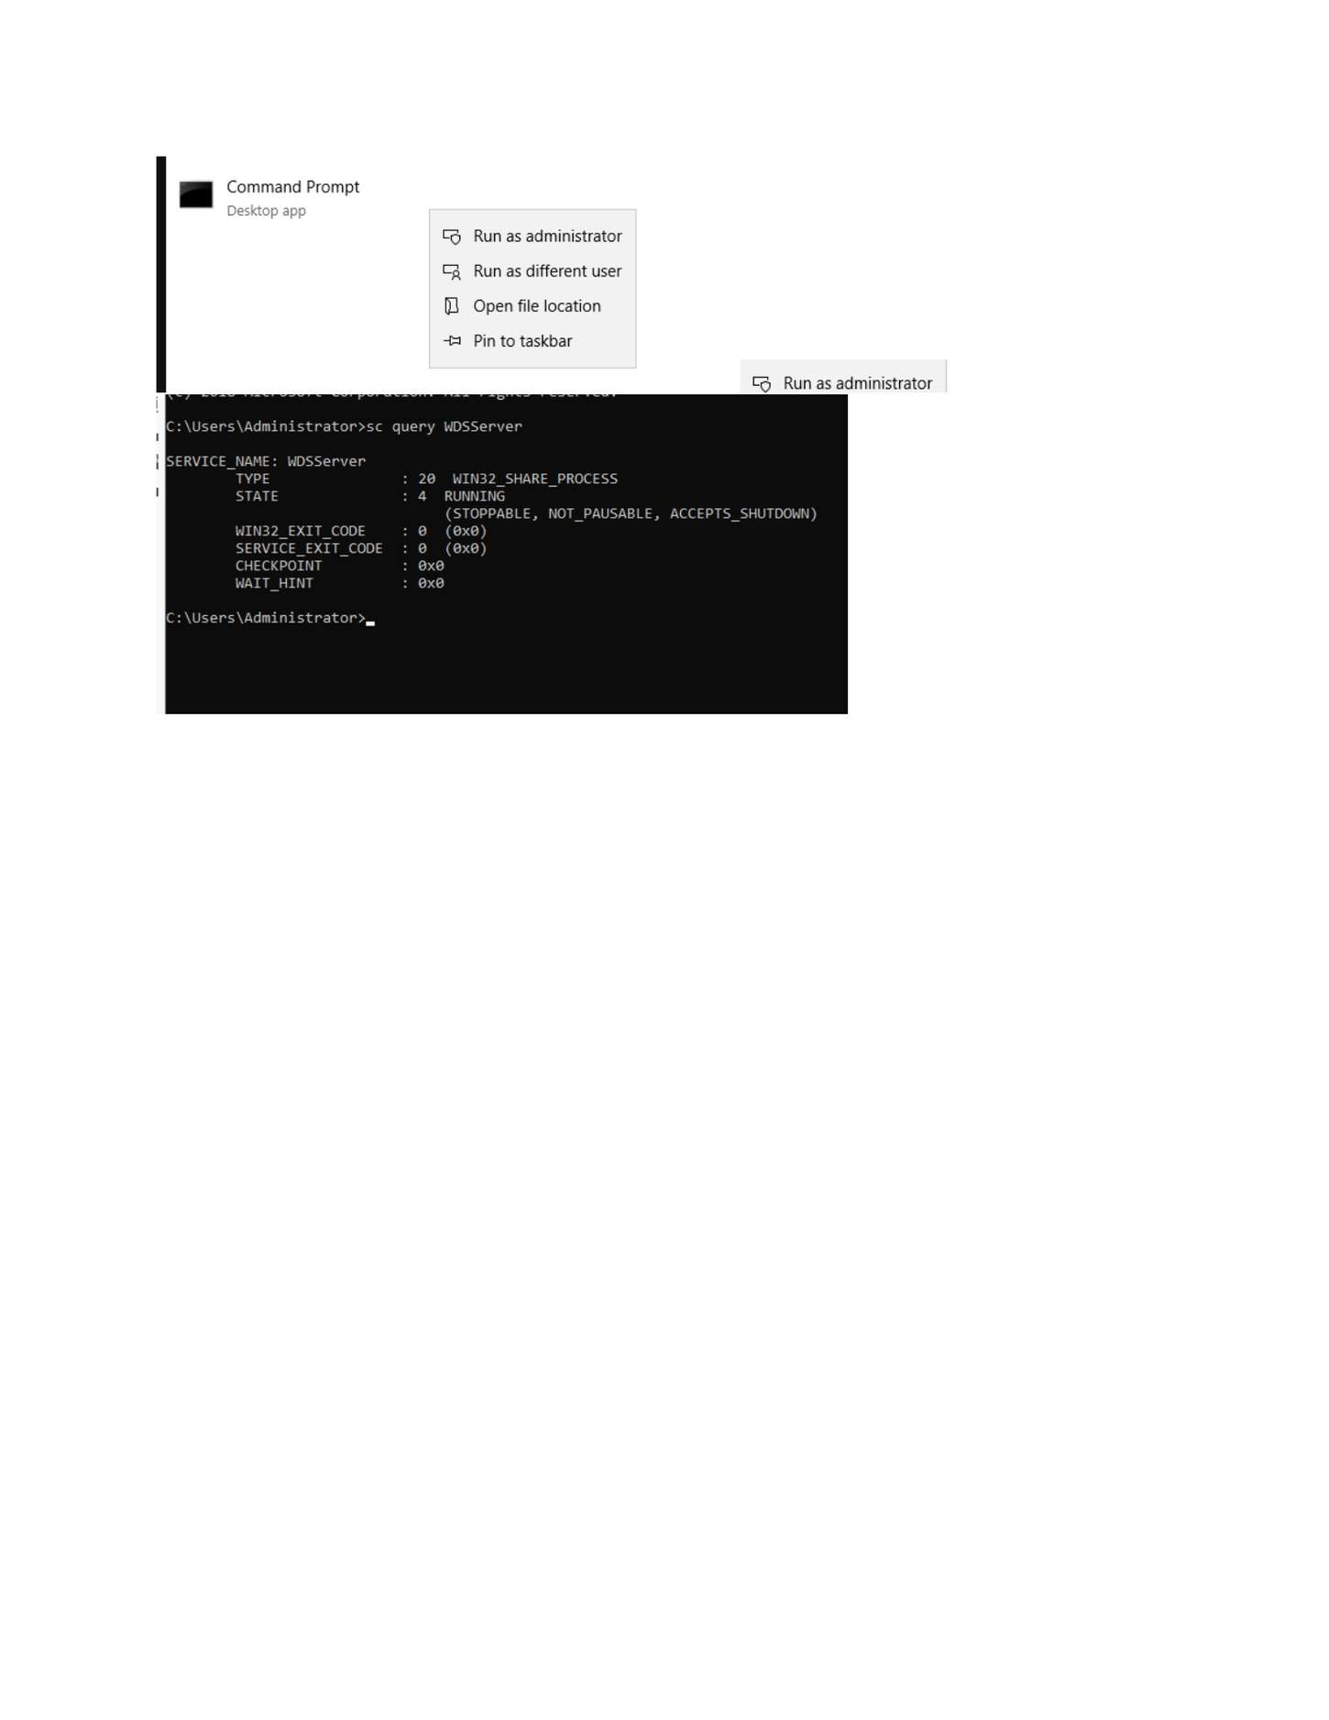
What I did: Completed the image import process and verified the image in WDS.

PAGE 208 — WDS (WINDOWS DEPLOYMENT SERVICES)
Topic: WDS (Windows Deployment Services)
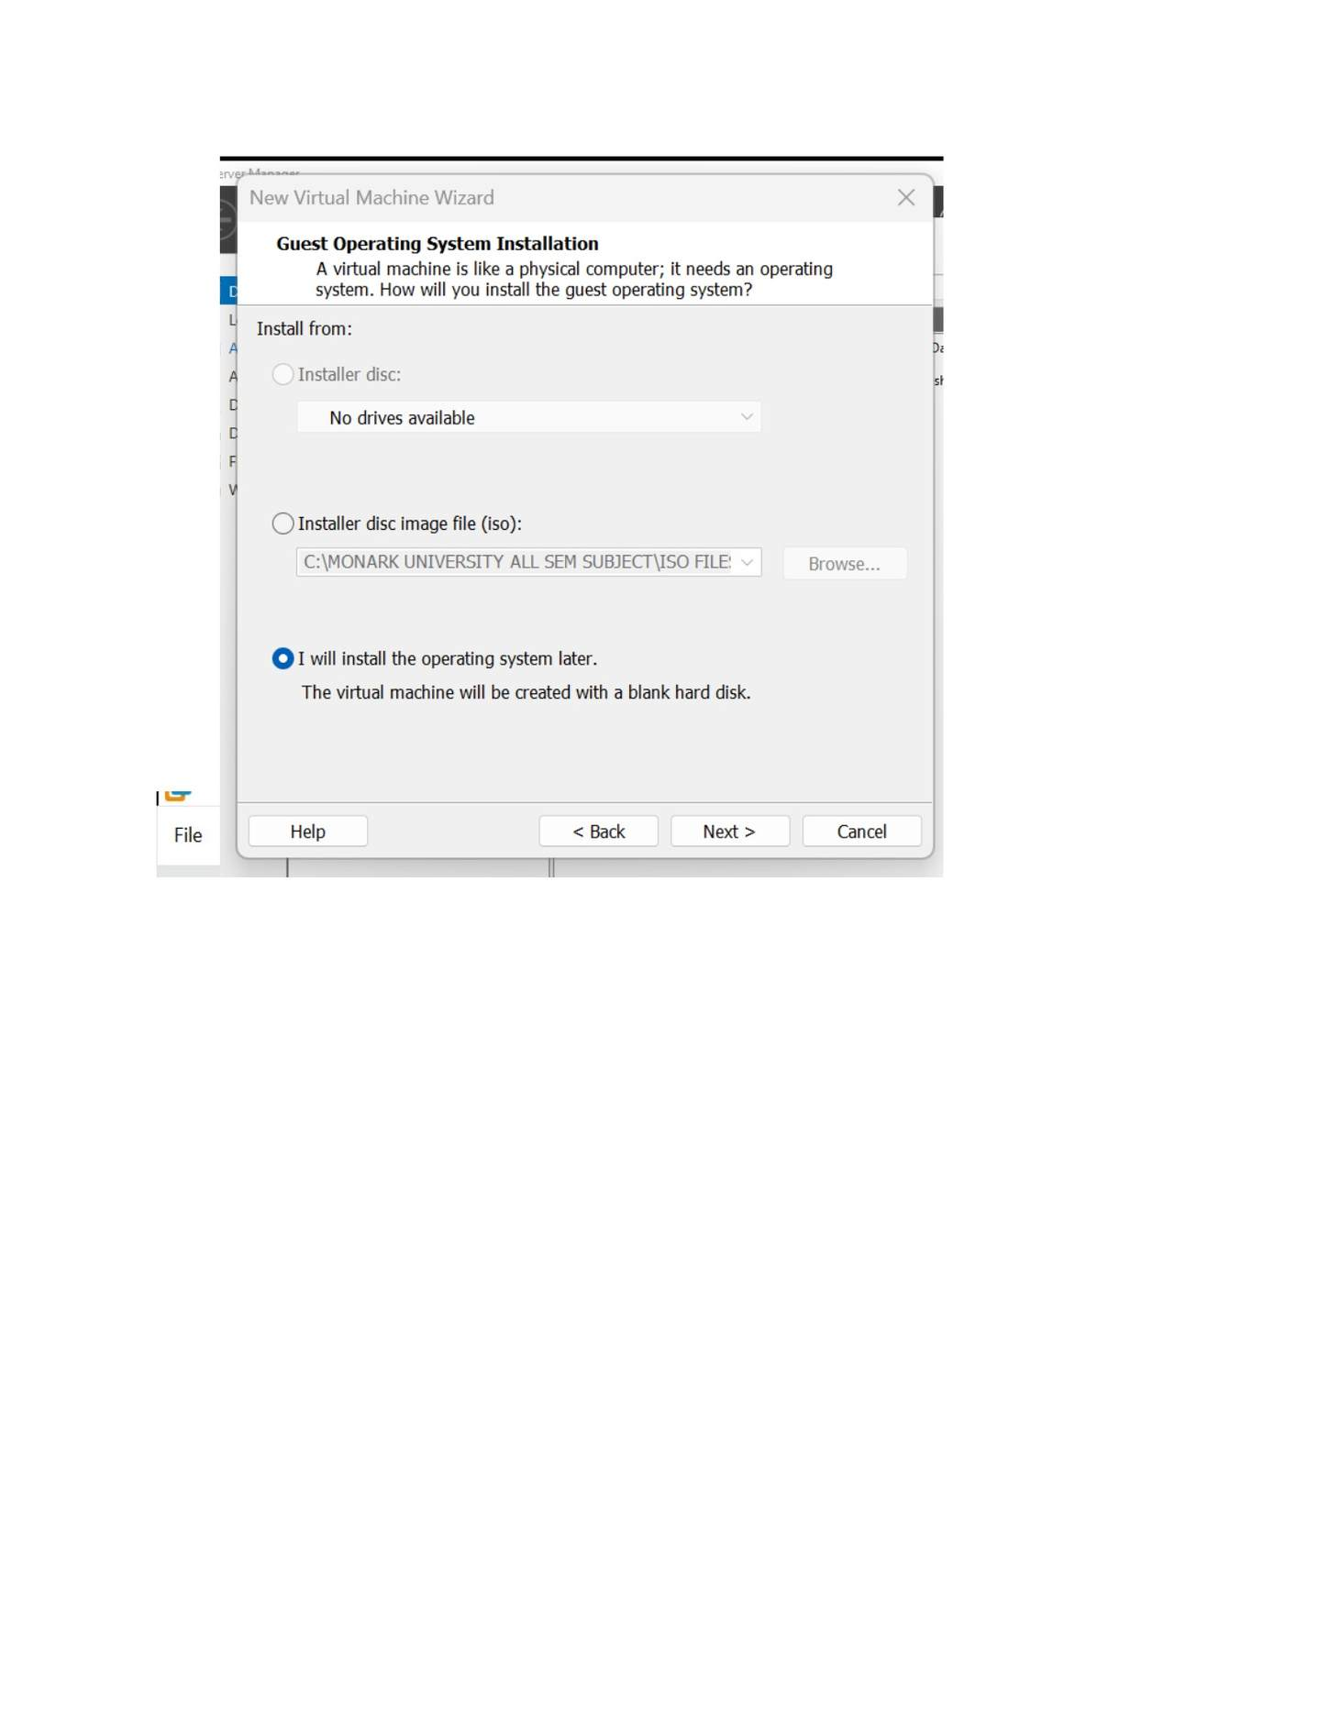
What I did: Reviewed the available boot/install image entries in WDS.

PAGE 209 — WDS (WINDOWS DEPLOYMENT SERVICES)
Topic: WDS (Windows Deployment Services)
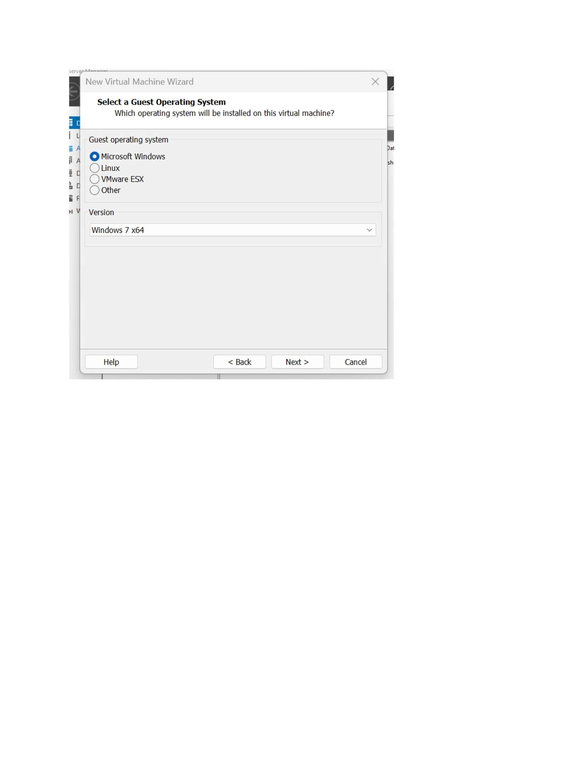
What I did: Opened the WDS server/image configuration to continue deployment setup.

PAGE 210 — WDS (WINDOWS DEPLOYMENT SERVICES)
Topic: WDS (Windows Deployment Services)
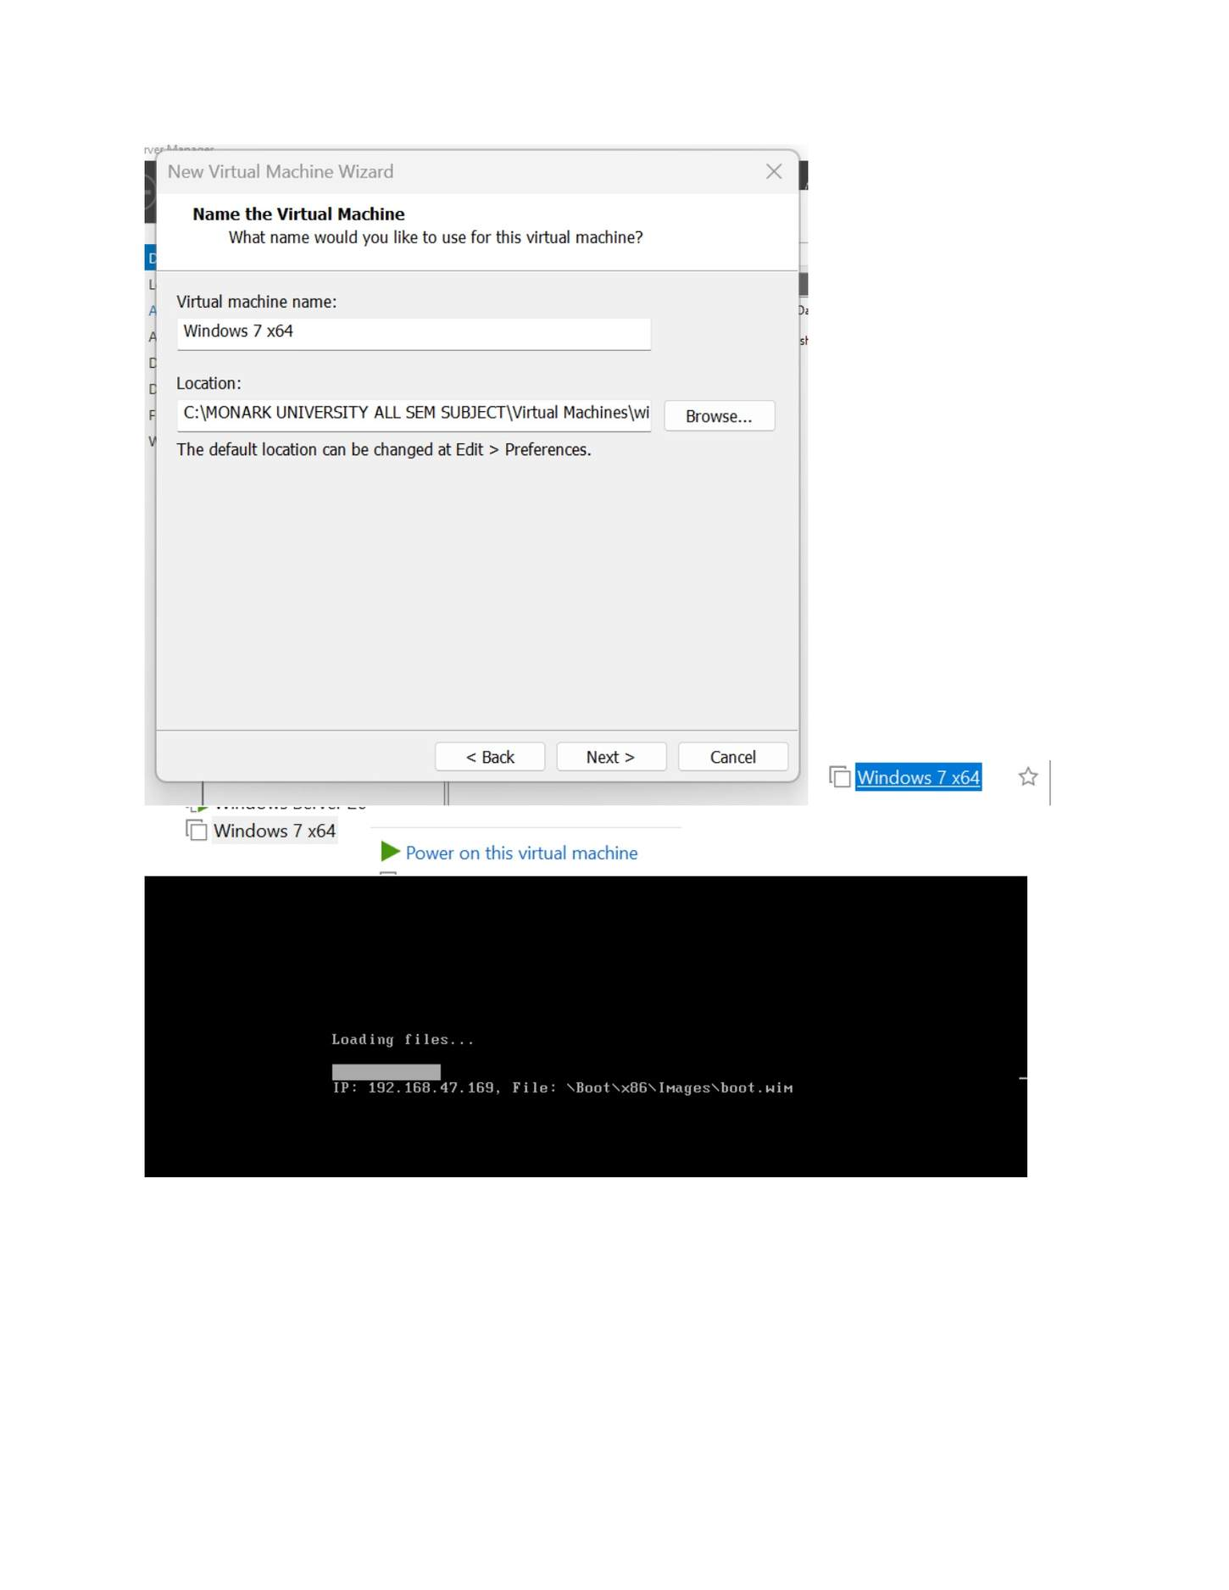
What I did: Checked the WDS command/administrative configuration shown in the screenshot.

PAGE 211 — WDS (WINDOWS DEPLOYMENT SERVICES)
Topic: WDS (Windows Deployment Services)
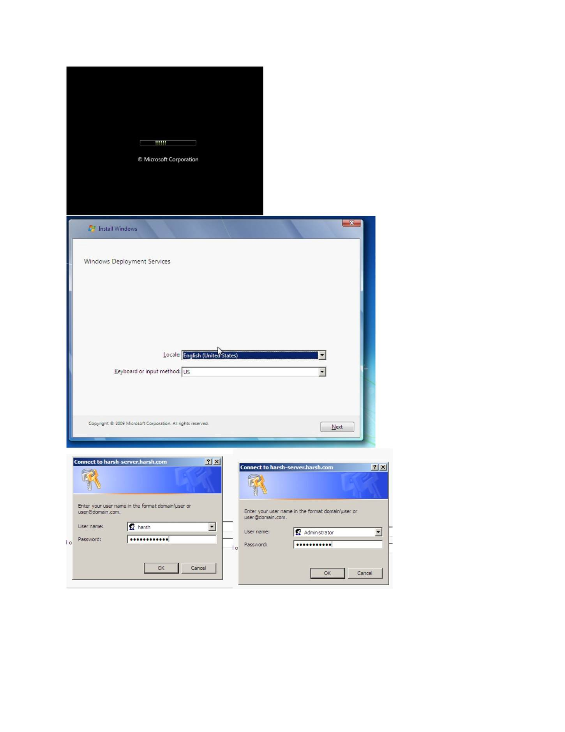
What I did: Opened Command Prompt with administrator privileges for the deployment/network setup.

PAGE 212 — WDS (WINDOWS DEPLOYMENT SERVICES)
Topic: WDS (Windows Deployment Services)
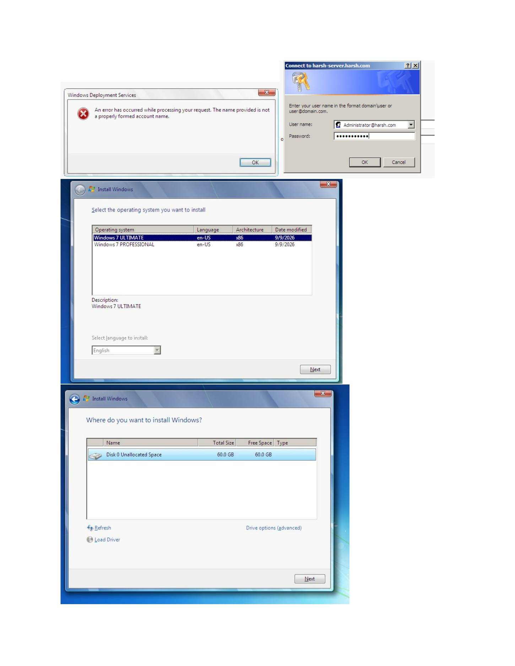
What I did: Started creating the Windows 7 client VM that would receive the WDS deployment.

PAGE 213 — WDS (WINDOWS DEPLOYMENT SERVICES)
Topic: WDS (Windows Deployment Services)
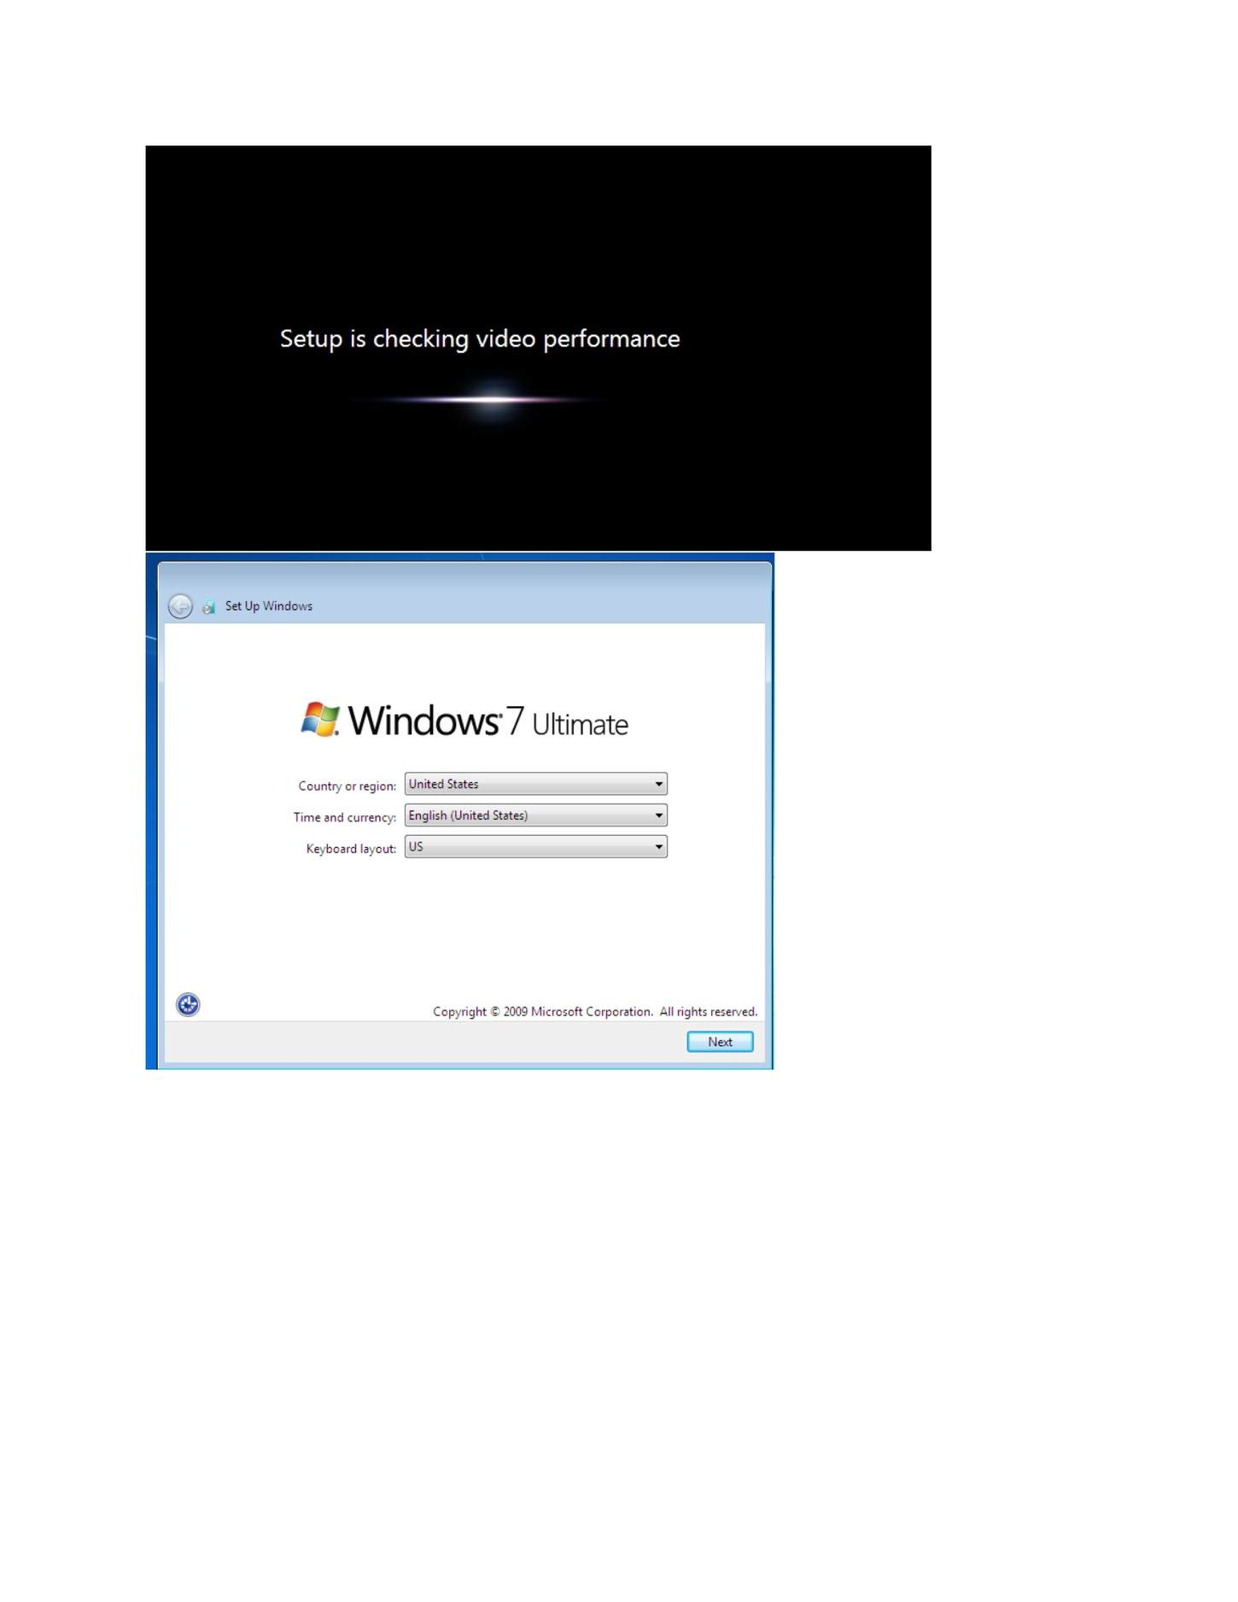
What I did: Selected Windows 7 x64 as the guest operating system for the WDS client VM.

PAGE 214 — WDS (WINDOWS DEPLOYMENT SERVICES)
Topic: WDS (Windows Deployment Services)
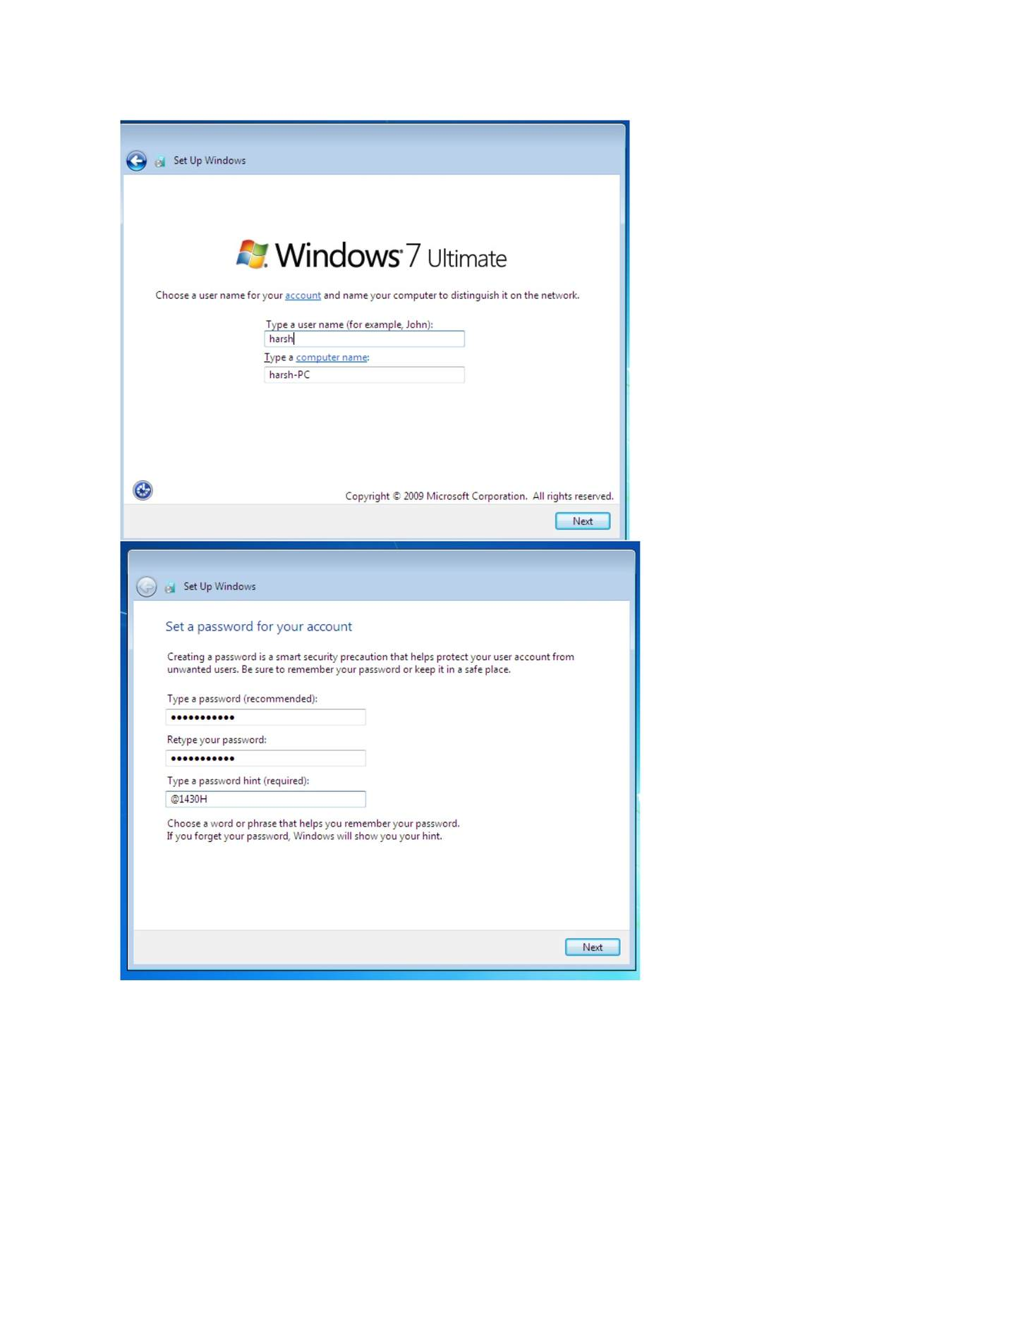
What I did: Entered the Windows 7 VM name and storage location.

PAGE 215 — WDS (WINDOWS DEPLOYMENT SERVICES)
Topic: WDS (Windows Deployment Services)
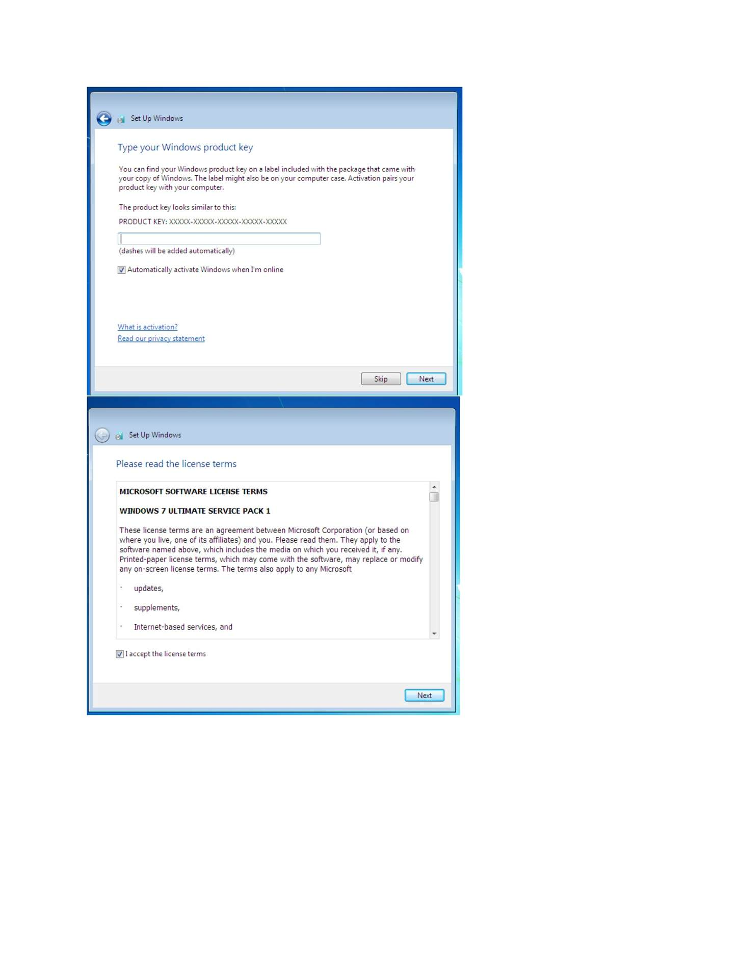
What I did: Reviewed the client VM/installation configuration before starting it.

PAGE 216 — WDS (WINDOWS DEPLOYMENT SERVICES)
Topic: WDS (Windows Deployment Services)
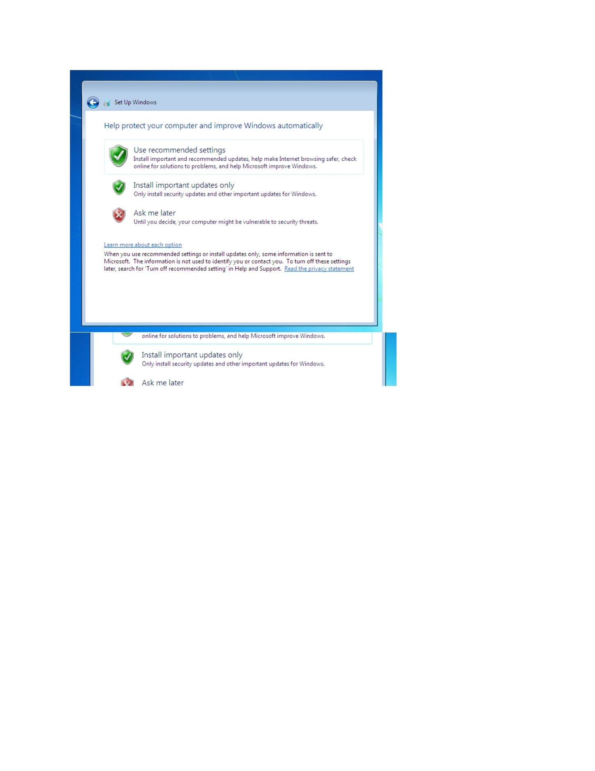
What I did: Started the Windows 7 installation/PXE deployment process on the client VM.

PAGE 217 — WDS (WINDOWS DEPLOYMENT SERVICES)
Topic: WDS (Windows Deployment Services)
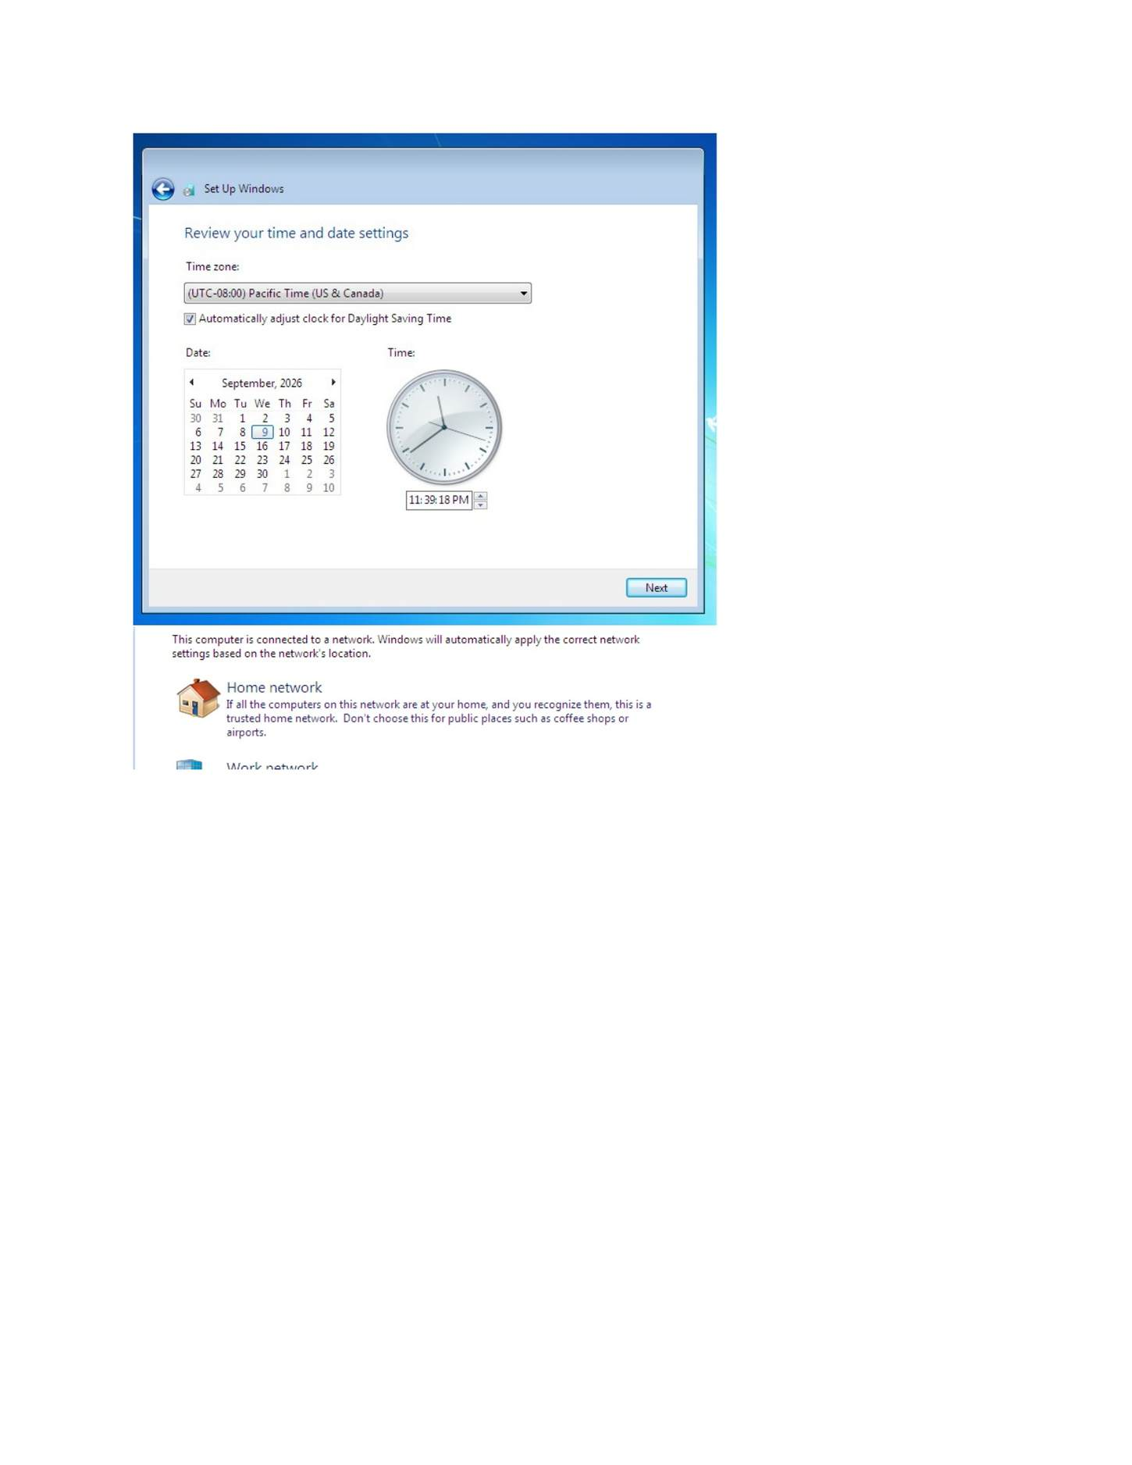
What I did: Windows 7 setup started and displayed the initial installation screen.

PAGE 218 — WDS (WINDOWS DEPLOYMENT SERVICES)
Topic: WDS (Windows Deployment Services)
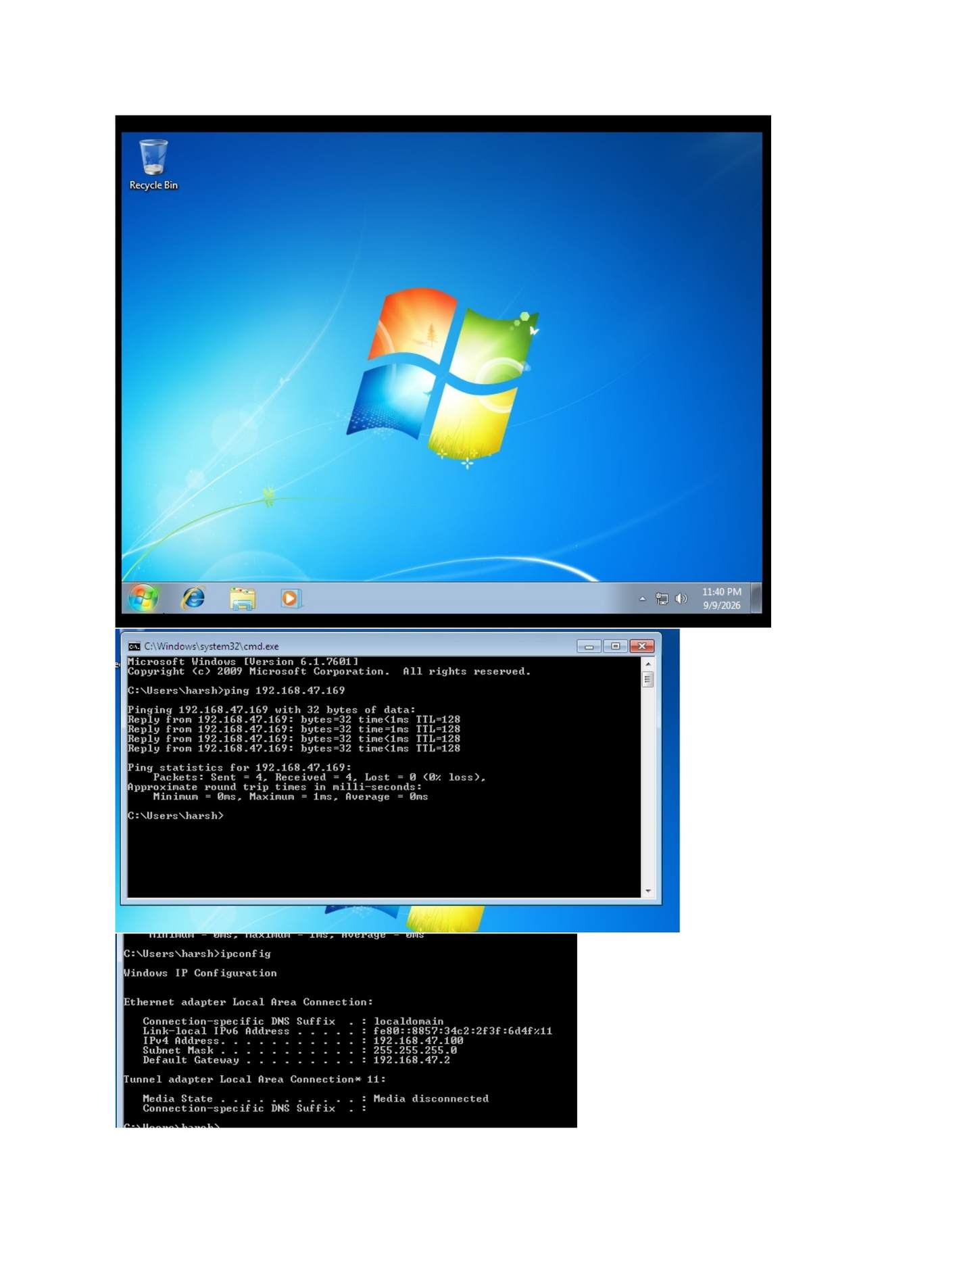
What I did: Continued Windows 7 setup and selected the required installation options.

